Escape Backpack re-assembly instructions

Congratulations on completing the backpack!
If you don’t mind putting it back together, below are the instructions to do so.
- Backpack overview
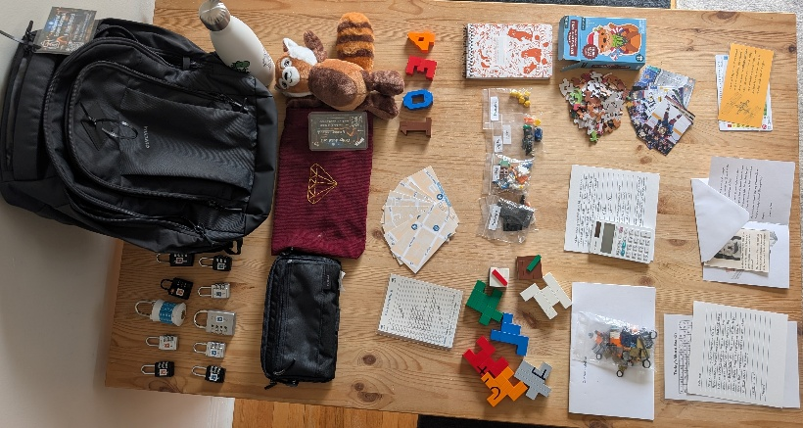
Here are all the items that you used throughout the game.

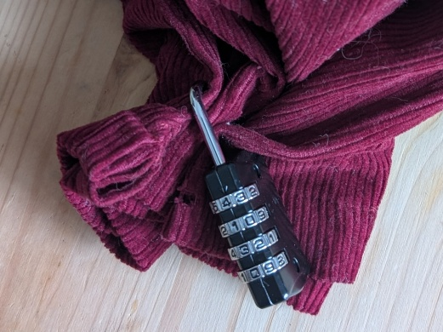
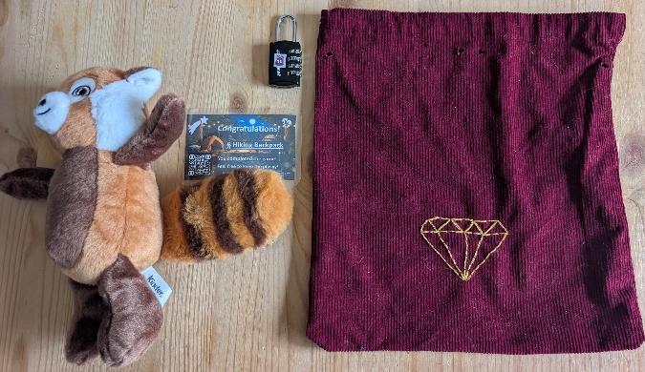
- Lock 10 – 4 1 3 0 – Treasure Bag
Please include the remaining plushies and the congratulations’ card in the treasure bag. You need to pinch the top of the bag to thread the lock.
Lock code: 4 1 3 0 – code to be displayed: 0 0 0 0
- Lock 9 – 6 3 2 – Pouch inside pocket
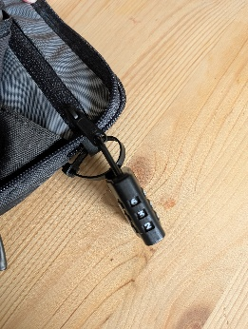
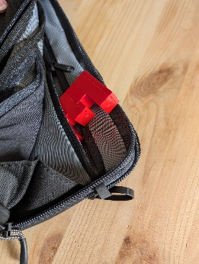
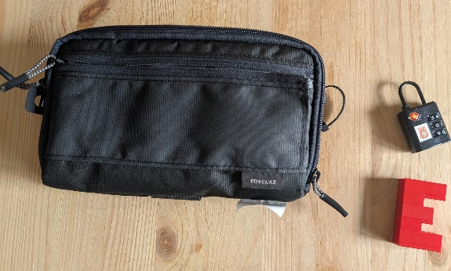
The inside pocket of the pouch contains the red 3 made of Legos. Lock to be looped inside the zip tie.
Lock code: 6 3 2 – code to be displayed: 0 0 0
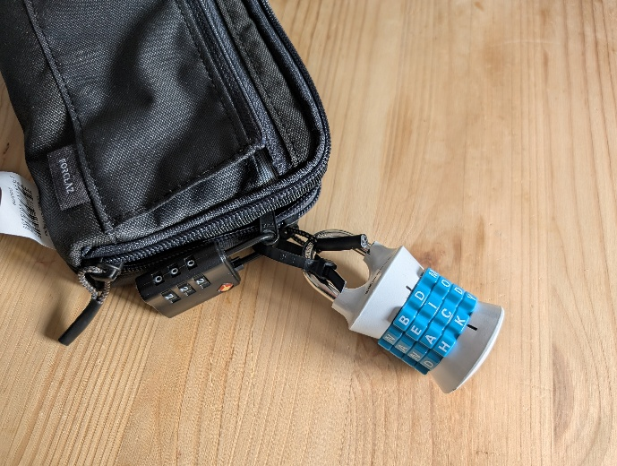
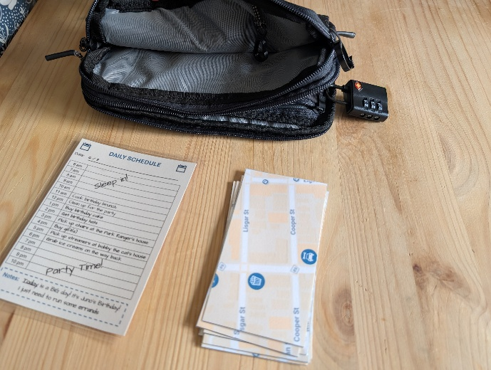
- Lock 8 – D I C K – Pouch back pocket
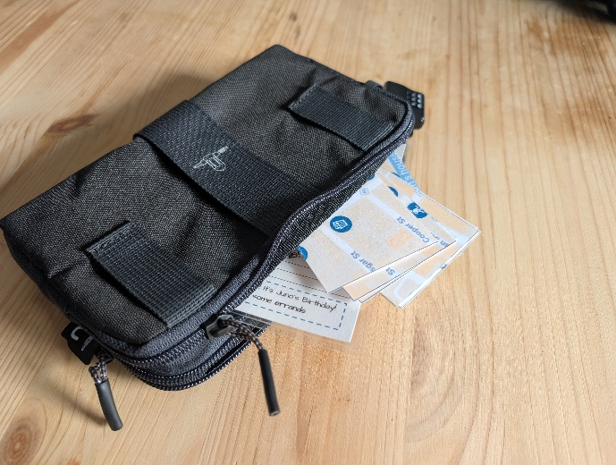
The pouch back pocket contains the birthday agenda and the map pieces. Lock to be looped inside the zip tie.
Lock code: D I C K – code to be displayed: L O S T
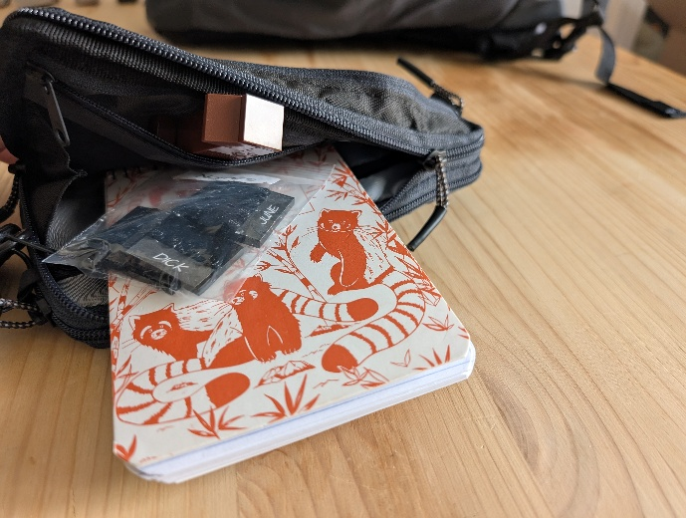
- Lock 7 – 5 1 8 – Pouch main pocket
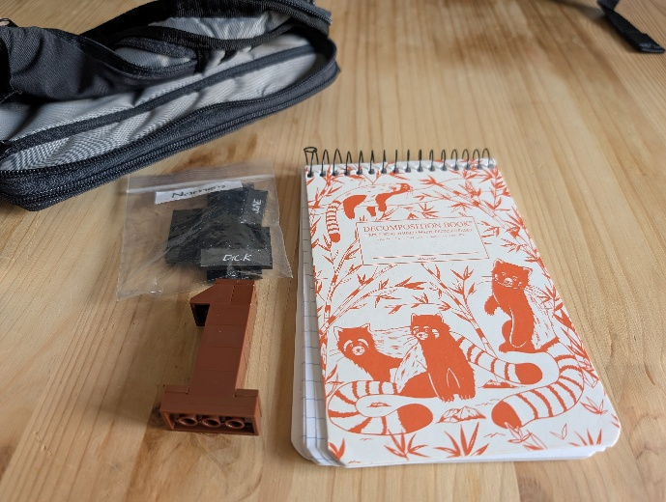
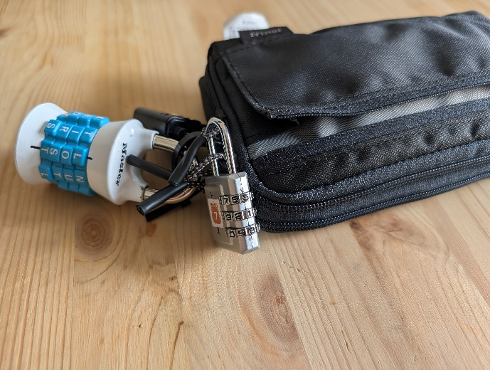
The pouch main pocket contains the notepad with the riddle, the brown 1 made of Lego and the “jobs” pieces. Lock to be looped inside the zip tie.

Lock code: 5 1 8 – code to be displayed: 0 0 0
- Lock 6 – 1 0 2 – Pouch front pocket
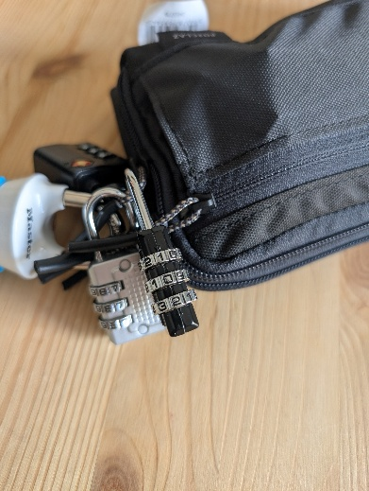
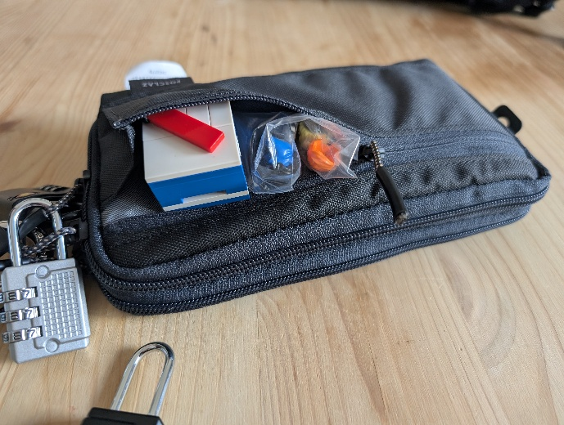
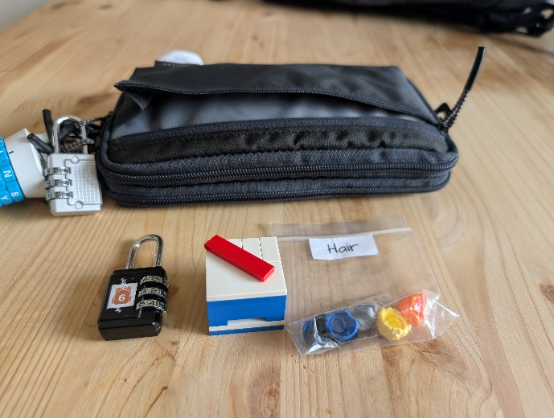

The pouch front pocket contains the blue squared Lego puzzle and the “Hair” pieces. Lock to be looped inside the zip tie.
Lock code: 1 0 2 – code to be displayed: 0 0 0
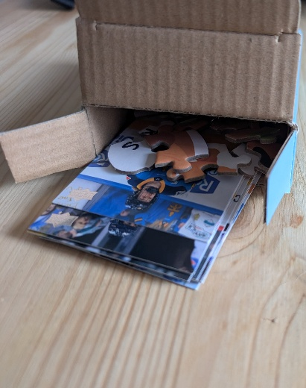
- Lock 5 – 4 1 4 – Backpack inside pocket
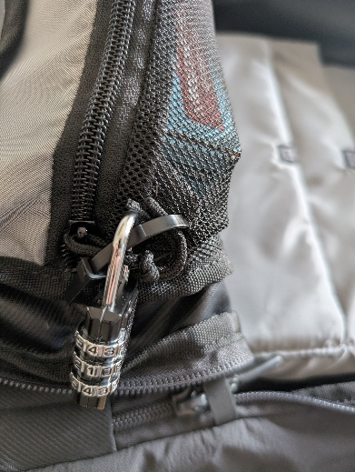
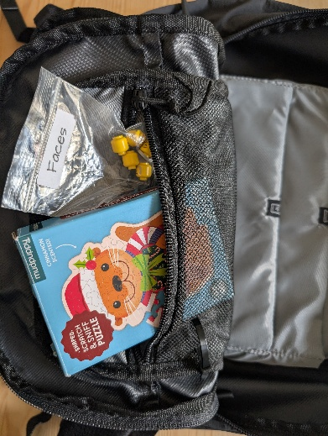
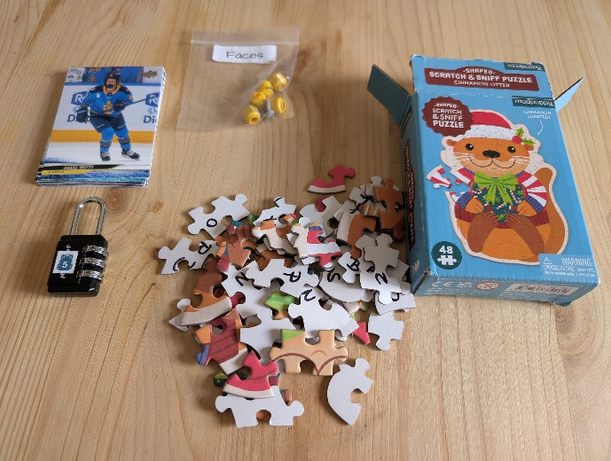

The inside pocket of the backpack contains the otter puzzles pieces, the PWHL hockey cards and the “faces” pieces. Please put the hockey cards and the puzzles pieces inside the cardboard box.
Lock code: 4 1 4 – code to be displayed: 0 0 0
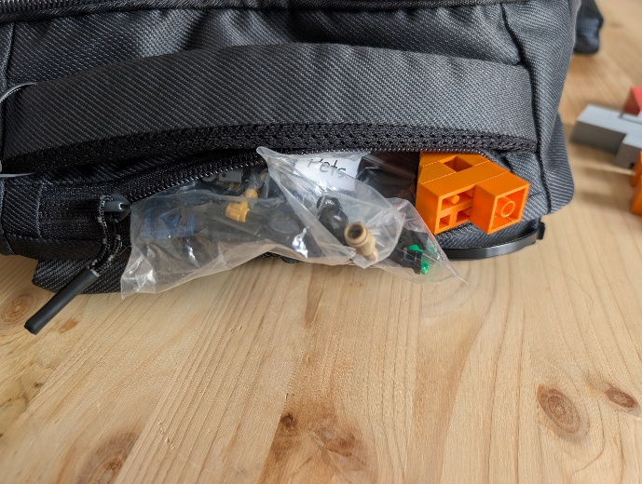
- Lock 4 – 3 2 6 – Backpack top pocket
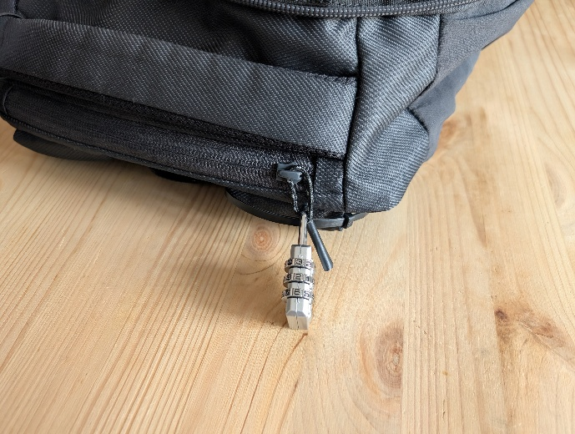
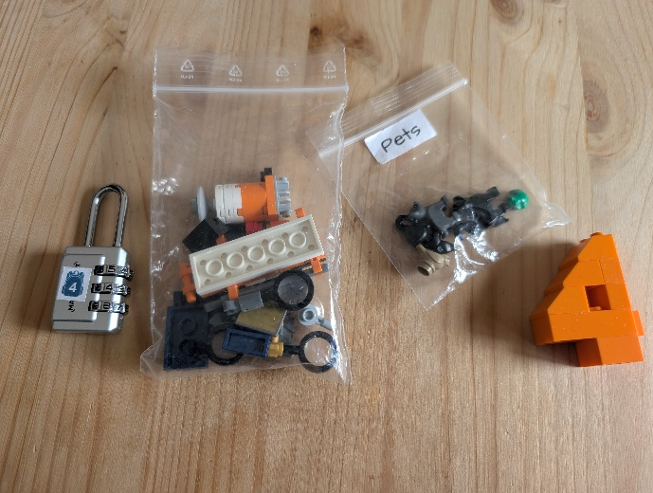
The top pocket of the backpack contains the Lego satellite pieces, the “Pets” pieces and the orange 4 made of Legos.
Lock code: 3 2 6 – code to be displayed: 0 0 0
- Lock 3 – M O O N – Backpack main compartment
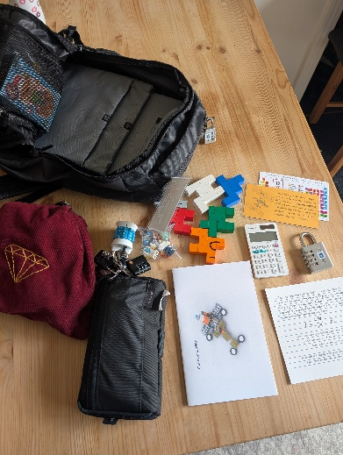
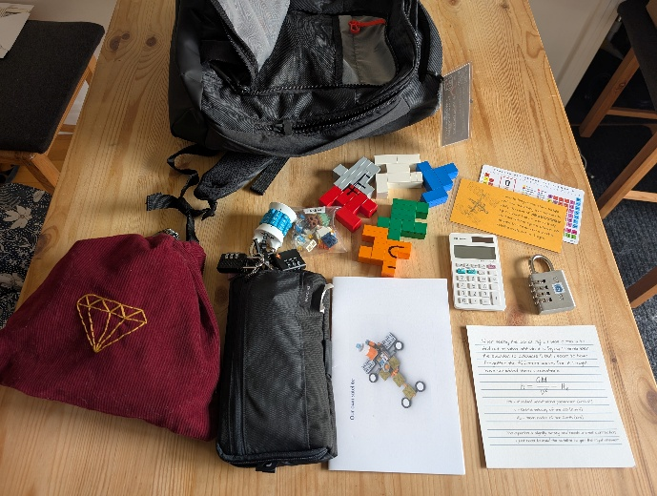
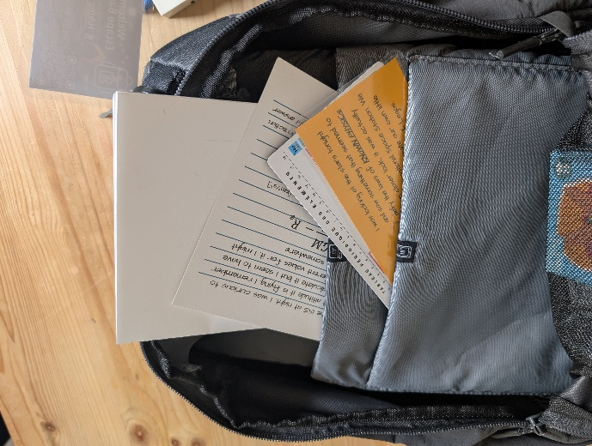
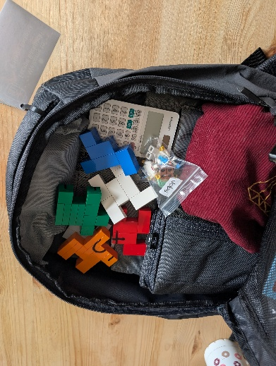
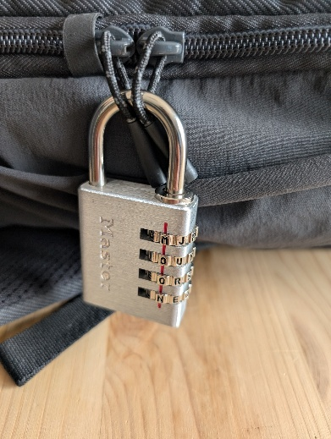

The main compartment of the backpack contains most of the items:
- In the back pocket: the Lego satellite instructions and the card with the equation
- In the middle pocket: the periodic table and the yellow card
- Loose in the main compartment: the treasure bag, the locked pouch, the calculator the Lego cube pieces and the “Jobs” pieces
Lock code: M O O N – code to be displayed: L O C K
- Lock 2 – 7 3 4 – Backpack front pocket
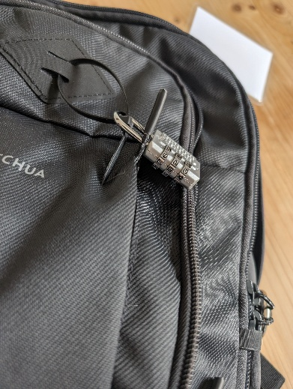
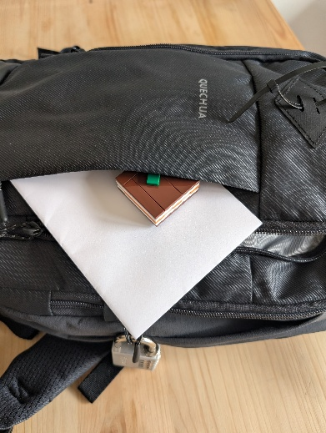
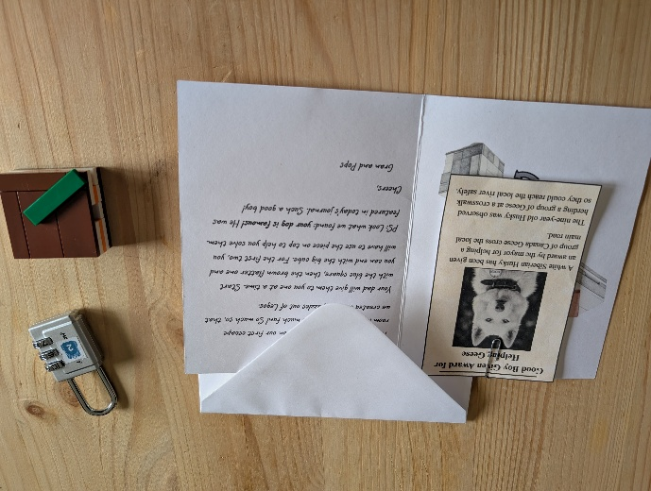

The backpack front pocket contains the grandparents’ card with the news clipping and the brown flat Lego puzzle.

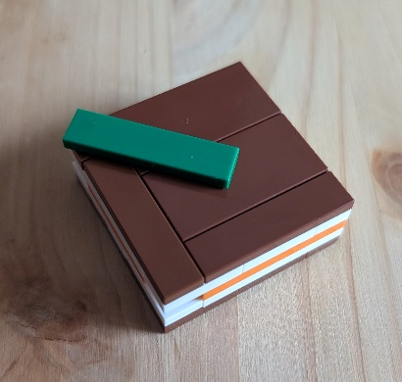
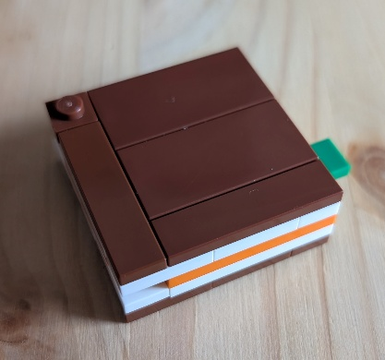
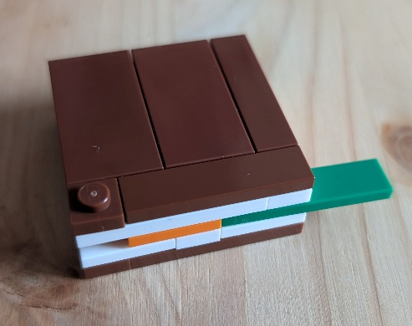
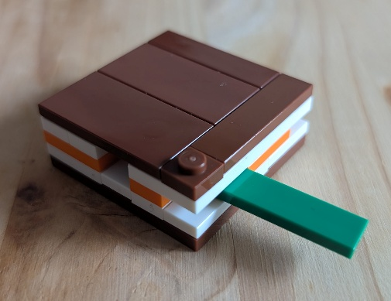
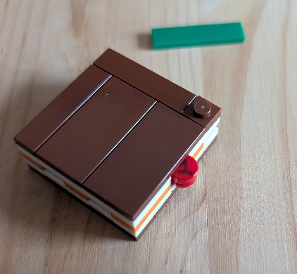
Lock code: 7 3 4 – code to de displayed: 0 0 0
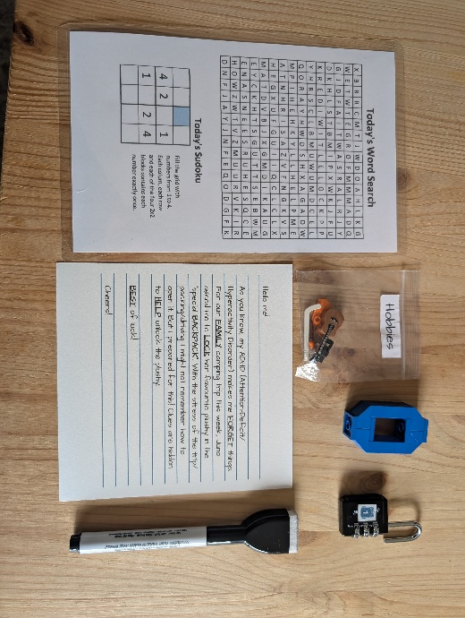
- Lock 1 – 7 4 9 – Backpack front compartment
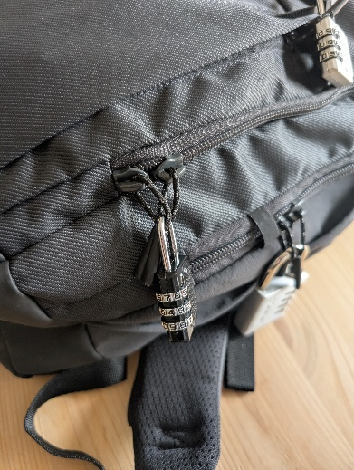
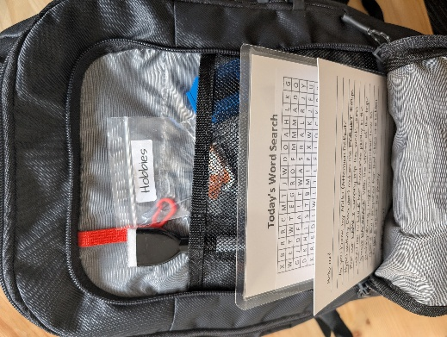

The front compartment of the backpack contains the word search/sudoku page, the note about the backpack, the blue 0 made from Legos, the “Hobbies” pieces and a marker.
Please place the marker, hobbies pieces and blue 0 in the net.
Lock code 7 4 9 – code to be displayed: 0 0 0
- The backpack
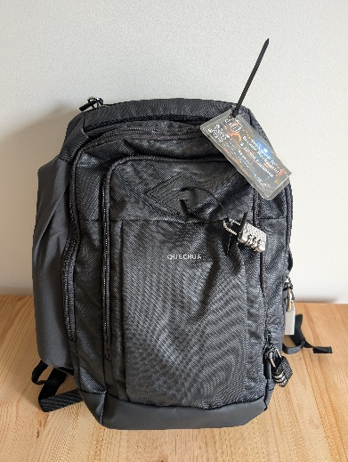
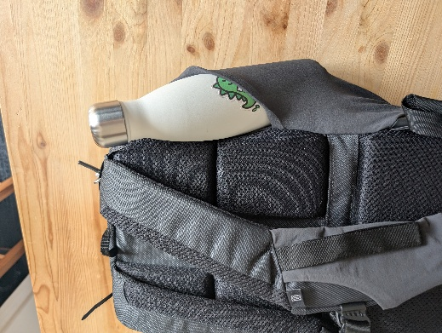
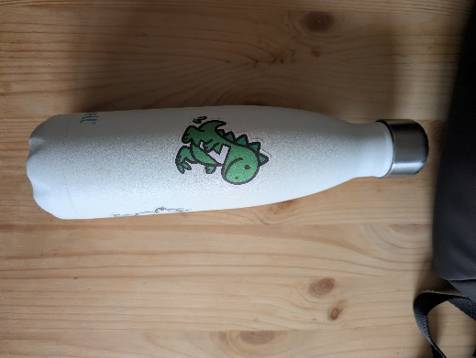
The last step is to put the water bottle back in the pocket for it and you’re done!

