Ian de Groot, 300896

November 3, 2020

WEBD-2007, Full-Stack Web Development

Instructor: Kyle Geske

**Ecommerce Rails Project - Planning Proposal**

Description of E-Commerce Site:

Greetings CEO of Not-Vought International

First of all congratulations that your totally unique and not at all copywritten intellectual property of the ‘Compound !V’ super hero serum has been approved for public commerce! After reviewing your requirements for your e-commerce site selling superpowers to the masses, I have a proposal to build this site in an expedient and cost-effective manner having a working prototype before the years end. I look forward to hearing from you and wish to partner with the Not-Vought family!

Since 1944 your business has seen success in being the first company to privatise the service and marketing of superhero’s. As you have thousands of employees across your marketing and film divisions to government security contracts I look forward to partnering with your research/development and product sales to bring the ‘Compound !V’ with its new customisable super power and supplements to the wide market. With Covid-19 and traditional health supplement stores on people have been moving their purchasing to online platforms and I believe this would be a perfect place to establish your ordering and distribution of sales.

This site would allow a customer to easily brows the superpower supplements and choose the quantity they wish to obtain (as an aside congrats to the RND team for making superpowers temporary and not at all addictive.) This site would easily allow you to add new versions of the compound and add or remove discounts on any product. The user will be able to search superpowers by their category such as Emission, Adaption, Enhancement.

Database Structure Description:

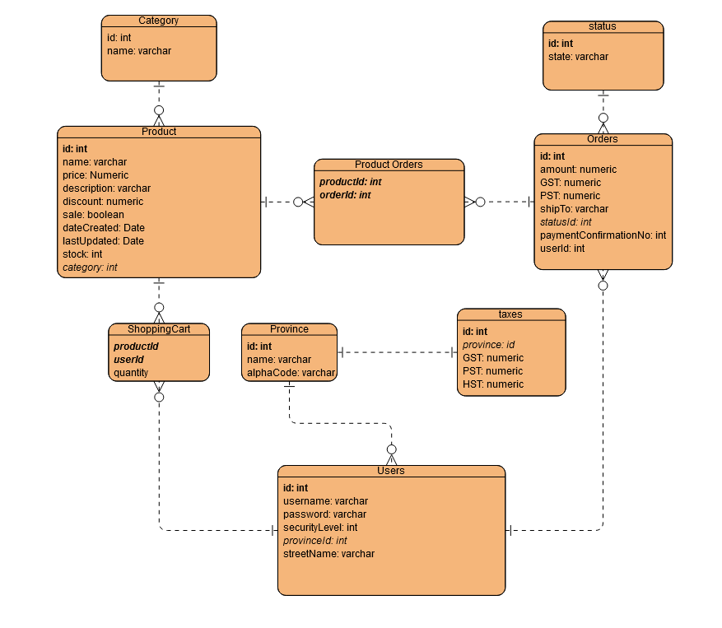

Upon reading over the requirements for your e-commers website this is my proposed early database structure.

Users Table:

Description: This contains all the user’s essential data for when they log in (user account information) and their shipping information.

Column names: The column names and datatypes are contained in the ERD.

Associations: A user can have multiple products in their shopping cart.

A user will be able to have multiple orders.

Product table:

Description: This is the primary table that contains information about the products being sold. There is some early debate as to weather to include a current discount onto this product this maybe moved to another table and association in development.

Associations: A product can be contained in multiple shopping carts

A product can be apart of multiple orders

Shopping Cart Table:

Description/ Association:

This helps with the many to many relationships between users and the products they wish to purchase. This table will allow many users to store many products that they can check out later.

Category:

Description: This allows each product to be searched for by their category title more easily as each category will have multiple products.

Association: Each category will have multiple products associated with it.

Orders:

Description: This table contains all the payment information in the transaction for records Including the amount paid the individual taxes at time of payment the shipping address and whether the current status of the order.

Association: Each order can contain multiple products

Product Orders Table

Description/ Association:

As each product can have multiple orders and each order can have multiple products in them this table will allow us to solve the multi to multi relationship problem.

Status Table

Description: As each order will have different states that it will be in ex: pending, shipping, and shipped this will allow us to more easily filter and contain orders.

Association: Each form of status will be able to have multiple orders

Taxes

Description: Each province will have different taxes associated with them and should be able to be updated independent of the Province

Association: Each single province will have one form of taxes associated with them.

Province

Description: List of provinces primarily used in the users shipping address information.

Association: Each user will have one province used in their shipping address.