Mini-Project for AI Programming MED6 – 2026
Clara Marie Pedersen –
GitHub: https://github.com/Otterly-Cute/AIProgrammingMiniProject
All code used in this project as well as figures and animations can be seen in above GitHub repository.

Acknowledgements:
AI has been used in this project....

1. Introduction

1.1 Purpose of the Project
Online shopping has become very normal and something consumers do not often think about is what happens after they have made their order. For physical items, the items must be picked up from where they are stored, packed, and shipped to the customer. Depending on the size of the warehouse/store where the items need to be picked, there is a lot to gain from route optimization. By optimizing the picking order, it can reduce both travel distance and travel time. This will make the order ready faster, resulting in reduced need for workers and with that less expenses for the company. It can also be used to create efficient automated picking systems in a warehouse or alike.
These kinds of problems are what is defined as NP-hard problems. This is because when the data input grows (more items to be picked), the time it takes to find the exact mathematical answer explodes exponentially. Trying to calculate the perfect answer, can take very long time, and thus we can use a genetic algorithm to find an acceptable solution in an acceptable time.

1.2 Objectives
The objectives of this project are:
- Simulate a store/warehouse environment represented as a grid containing obstacles, item locations, and a starting position.
- Implement the A* pathfinding algorithm to calculate realistic travel distances between locations within the warehouse.
- Develop a Genetic Algorithm (GA) to optimize the order in which items are collected.
- Minimize the total travel distance required to collect all items and return to the starting location.
- Compare the performance of the optimized routes against randomly generated routes.
- Investigate the impact of different GA hyperparameters, including population size, mutation rate, and number of generations.
- Evaluate different parent selection strategies, such as tournament, roulette wheel, rank-based, stochastic universal sampling (SUS), and random selection.
- Examine the scalability of the algorithm by testing problem instances with varying numbers of items.
- Identify the hyperparameter configuration that produces the best balance between solution quality and computational runtime.
- Visualize both the warehouse navigation paths and the evolutionary process of the Genetic Algorithm.
The overall aim of the project is to investigate the effectiveness of Genetic Algorithms for solving route optimization problems in store/warehouse environments and to evaluate how different algorithm configurations influence solution quality, convergence behaviour, and computational performance.

2. Background Theory

2.1 Pathfinding and A*
Pathfinding is the process of determining a route between a start location and a goal while avoiding obstacles. It is commonly used in robotics, navigation systems, video games, and logistics applications.
One of the most widely used pathfinding algorithms is A* (A-Star), an informed search algorithm that finds the shortest path between two points by combining the actual cost travelled with an estimate of the remaining cost.
A* evaluates nodes using the function:
$$f(n)=g(n)+h(n)$$
where:
- $g(n)$is the cost of reaching node $n$from the start node.
- $h(n)$is a heuristic estimate of the cost from node $n$to the goal.
- $f(n)$is the estimated total path cost.
At each step, A* expands the node with the lowest $f(n)$value. This allows the algorithm to focus the search towards the goal while still considering the cost already travelled.
The effectiveness of A* depends on the heuristic function used. For grid-based environments with horizontal and vertical movement, the Manhattan distance heuristic is commonly used:
$$h(n)=∣x_{1}-x_{2}∣+∣y_{1}-y_{2}∣$$
A* is complete and optimal when an admissible heuristic is used, meaning the heuristic never overestimates the true remaining cost. This ensures that the shortest path will be found whenever one exists.
Many other pathfinding algorithms also exist, such as Dijkstra’s algorithm, Breadth-First Search (BFS), cycle detection and more. A* was selected because it guarantees shortest paths while reducing the number of explored nodes through heuristic guidance, making it well suited to warehouse navigation problems.

2.2 Genetic Algorithms
Genetic Algorithms (GAs) are optimization algorithms inspired by the process of natural selection. They belong to a class of search methods known as evolutionary algorithms and are commonly used to solve complex optimization problems where finding an exact solution may be computationally expensive.
A Genetic Algorithm begins with a population of candidate solutions, known as individuals. Each individual is evaluated using a fitness function, which measures how well it solves the problem. Solutions with higher fitness are more likely to be selected for reproduction.
The algorithm iteratively improves the population through three main genetic operators:
Selection
Selection chooses individuals from the population to act as parents for the next generation. Individuals with better fitness have a higher probability of being selected, promoting the survival of stronger solutions.
Crossover
Crossover combines information from two parent solutions to produce one or more offspring. This allows beneficial characteristics from different individuals to be combined into new candidate solutions.
Mutation
Mutation introduces random changes to offspring solutions. This increases diversity within the population and helps prevent the algorithm from becoming trapped in local optima.
The evolutionary process is repeated over multiple generations. As selection, crossover, and mutation are applied, the population gradually evolves towards better solutions.
The quality of a Genetic Algorithm can be influenced by several parameters, including population size, mutation rate, selection strategy, and the number of generations. Choosing appropriate values for these parameters is important for balancing solution quality and computational efficiency.
Key Concepts
- Population – a set of candidate solutions.
- Individual (Chromosome) – a single candidate solution.
- Fitness Function – evaluates the quality of a solution.
- Generation – one iteration of the evolutionary process.
- Selection – choosing parents based on fitness.
- Crossover – combining parent solutions.
- Mutation – introducing random changes to maintain diversity.

2.3 Warehouse Routing Problem
The warehouse routing problem involves determining the order in which a set of locations should be visited while minimizing the total travel distance. This type of problem is closely related to the Travelling Salesman Problem (TSP), in which a salesman must visit a number of cities exactly once and return to the starting location while travelling the shortest possible distance.
Although the warehouse routing problem differs in its environment and constraints, it shares the same fundamental challenge of finding an optimal visitation sequence among many possible alternatives.
Travelling Salesman Problem Similarity
For a route containing n locations, there are n! (factorial) possible visitation orders. For example:
- 5 items: $5!=120$possible routes
- 10 items: $10!=3,628,800$possible routes
- 20 items: $20!≈2.43×{10}^{18}$possible routes
As the number of locations increases, the number of possible routes grows extremely rapidly.
Combinatorial Explosion
This rapid growth in the search space is known as combinatorial explosion. Each additional item significantly increases the number of potential route combinations that must be considered. Consequently, finding the optimal route becomes increasingly difficult as the problem size grows.
Why Brute Force is Infeasible
Number of items | Possible routes (n!)
5 | 120
10 | 3.628.800
15 | 1.307.674.368.000
20 | 2.432.902.008.176.640.000
A brute-force approach would evaluate every possible route and select the shortest one. While this guarantees an optimal solution, the computational cost becomes impractical even for relatively small problems. For example, evaluating all possible routes for 20 items would require examining over $2×{10}^{18}$combinations.

Because of this, heuristic and metaheuristic optimization techniques such as Genetic Algorithms are often used. These methods search for high-quality solutions without exhaustively evaluating every possible route, making them more suitable for larger routing problems.

3. System Design and Implementation

3.1 Store/Warehouse Environment
The store/warehouse environment was modelled as a two-dimensional grid, based on part of a real-life grocery store layout (Bilka Fields). Each cell represented either a traversable location or an obstacle, in this case shelves, which were represented as blocked cells that could not be entered by the agent. The grid is 42x42 with the lighter blocks representing shelves, and the green blocks representing traversable areas.
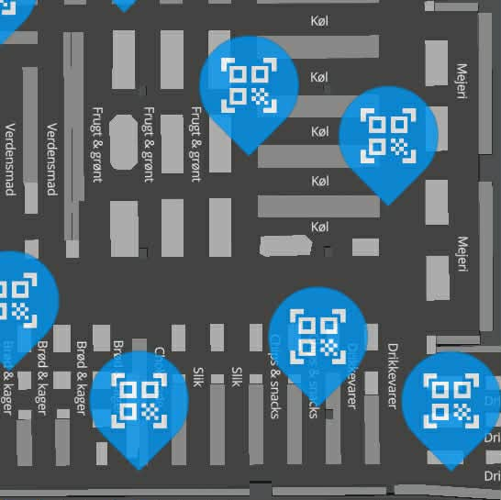  Figure 1, Part of Bilka Fields Layout |  | 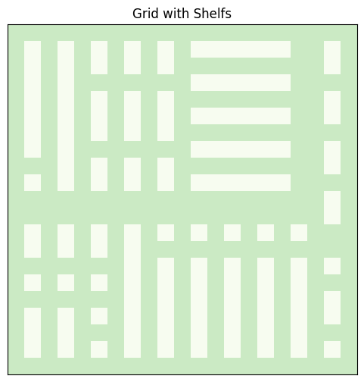  Figure 2, Grid with Shelves
A fixed starting position was defined to represent the picker's initial location, also based on the real-life grocery store layout. Item locations were distributed throughout the store and represented the targets that must be collected. Each item is marked with a letter going from A-T, with the first item being A, the second being B, and so on. The Start/End position are not marked by a letter but is simply the empty blue box. The first 10 items will be the main variable for this project (Figure 3); the remaining items is used for scalability analysis (Figure 4).
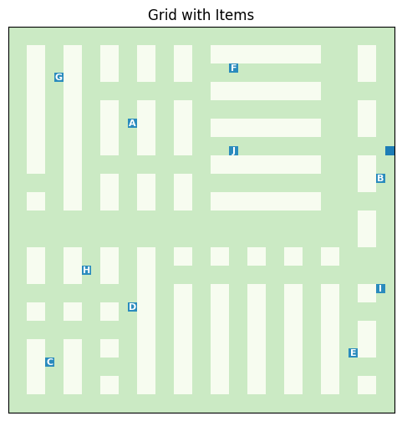  Figure 3, 10-Item Layout and Start/End Position | 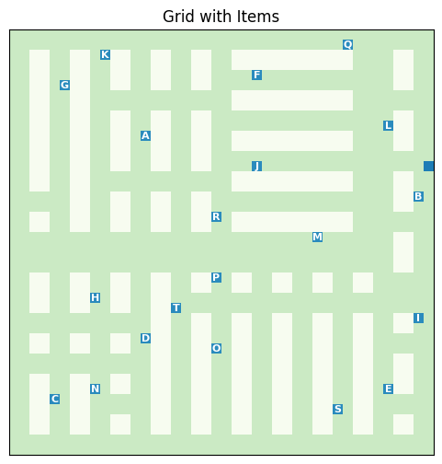  Figure 4, 20-Items Layout and Start/End Position
Movement was restricted to horizontal and vertical directions, creating a grid-based navigation problem suitable for A* pathfinding.

3.2 A* Distance Matrix
To determine realistic travel distances within the warehouse, the A* algorithm was used to calculate shortest paths between locations. A Manhattan distance heuristic was employed due to the grid-based environment and restricted movement directions.
Rather than repeatedly executing A* during optimization, pairwise distances between all relevant locations were precomputed and stored in a distance matrix, see Figure 5 and Figure 6.
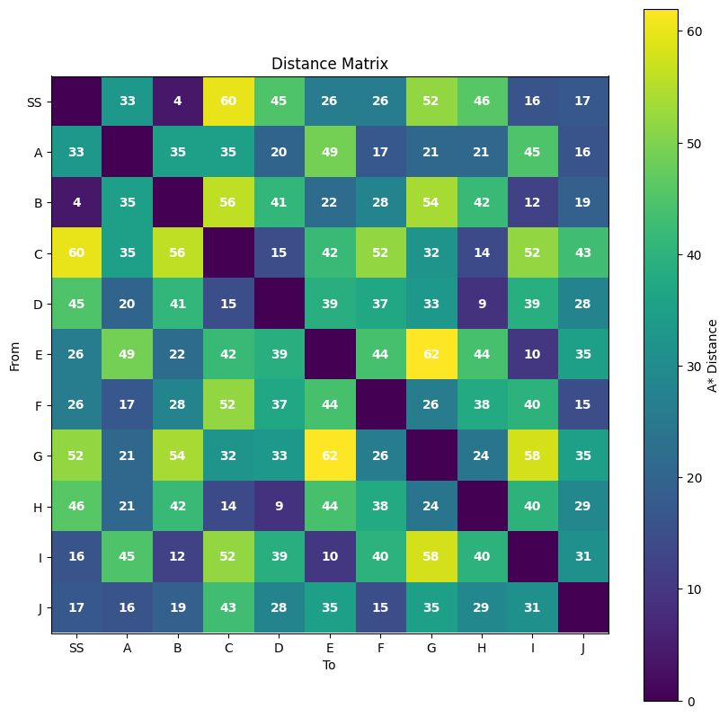
Figure 5, 10-Item Distance Matrix
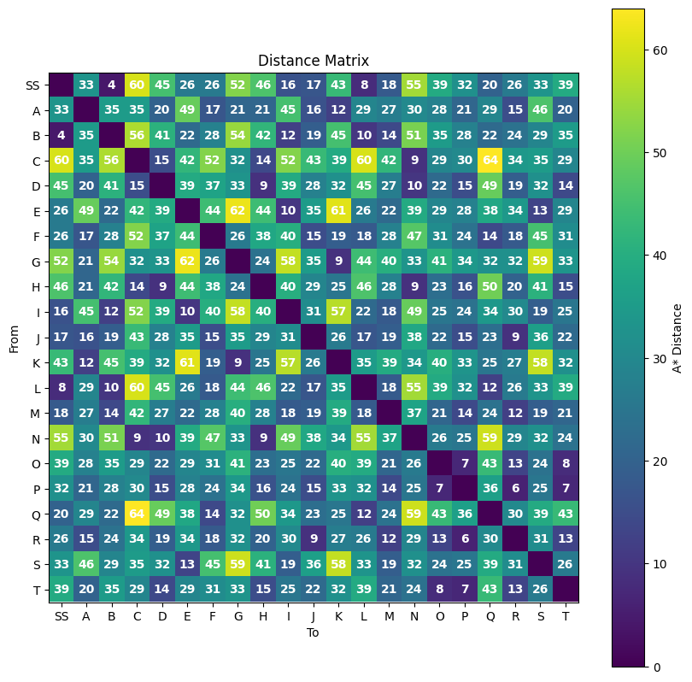
Figure 6, 20-Item Distance Matrix

3.3 Genetic Algorithm Design

The route optimization component was implemented using a Genetic Algorithm (GA). The algorithm evolves a population of candidate routes over multiple generations in order to minimise the total travel distance required to collect all items and return to the starting position. Each generation consists of fitness evaluation, parent selection, crossover, and mutation operations, allowing progressively better routes to emerge through evolutionary search.

3.3.1 Chromosome Representation
Each chromosome represents a complete picking route through the warehouse. A chromosome is encoded as a permutation of item indices, where the position of each index determines the order in which items are collected.
Item Index | Item Label
0 | A
1 | B
2 | C
3 | D
4 | E
For example: [3, 0, 4, 1, 2]
indicates that item 3 is visited first, followed by item 0, item 4, item 1, and finally item 2. This representation ensures that each item is visited exactly once and avoids invalid routes containing duplicate or missing locations.
Route: [D → A → E → B → C]

3.3.2 Fitness Function
The fitness of a chromosome is determined by the total distance travelled along the route. Distances between locations are obtained from the precomputed A* distance matrix.
The route distance consists of:
- Travel from the start position to the first item.
- Travel between consecutive items.
- Travel from the final item back to the start position.
$$Distance=Start→{Item}_{1}+\sum_{i=1}^{n-1}{({Item}_{i}→}{Item}_{i+1})+{Item}_{n}→Start$$
Routes with shorter total distances are considered better solutions. The fitness evaluation function therefore guides the evolutionary process towards routes that minimise overall travel distance.

3.3.3 Parent Selection
Parent selection determines which individuals are chosen to produce offspring for the next generation. Several selection methods were implemented and later compared experimentally:
- Tournament Selection
- Roulette Wheel Selection
- Rank Selection
- Stochastic Universal Sampling (SUS)
- Random Selection
Tournament selection chooses the best individual from a randomly sampled subset of the population. Roulette wheel selection assigns selection probabilities based on fitness. Rank selection assigns probabilities according to an individual's ranking within the population. SUS is a variation of roulette wheel selection that aims to reduce selection bias. Random selection serves as a baseline by choosing parents without considering fitness.
The selection mechanism influences the balance between exploration of new solutions and exploitation of high-quality routes.

3.3.4 Crossover
An Order Crossover (OX) operator was used to generate offspring routes. A randomly selected segment from the first parent was copied directly into the child chromosome. The remaining positions were then filled using the order of items from the second parent while excluding duplicates.
This approach preserves useful route structures from both parents while ensuring that each offspring remains a valid permutation containing every item exactly once. Order Crossover is commonly used for routing and Travelling Salesman Problem variants because it maintains feasibility without requiring additional repair operations.
Example:
Parent 1: [A B C D E] [B C D]
Parent 2: [D E A B C] [E A]
Child: [_ B C D _] [E B C D A]

3.3.5 Mutation
Mutation introduces random variation into the population and helps prevent premature convergence. A swap mutation operator was implemented. With a specified mutation probability, two randomly selected positions within a chromosome are exchanged.
Example:
Before: [A B C D E] Swap B and D After: [A D C B E]
Mutation increases genetic diversity and allows the algorithm to explore new regions of the search space that may not be reachable through crossover alone.

3.4 Visualization System
To support analysis and interpretation of the warehouse routing problem, several visualisation components were developed. These visualisations provide insight into the warehouse layout, pathfinding behaviour, route quality, and Genetic Algorithm performance.

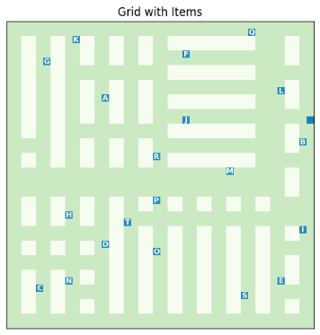
3.4.1 Warehouse Layout Visualisation
A static warehouse visualisation was implemented to display the grid environment, including shelves, item locations, and the picker's starting position. This provides an overview of the environment in which route optimisation takes place and allows the distribution of items within the warehouse to be examined. This is already shown in Figure 3 and Figure 4.

3.4.2 Route Visualisation
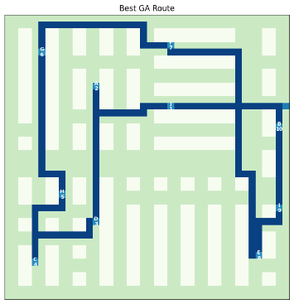
A route visualisation was developed to display the sequence in which items are collected. The visualisation overlays the complete route onto the warehouse grid and labels each item according to its visit order.
This allows optimised routes generated by the Genetic Algorithm to be compared with alternative routes and helps verify that all items are visited exactly once. See xxx for details.

3.4.3 Picker Movement Animation
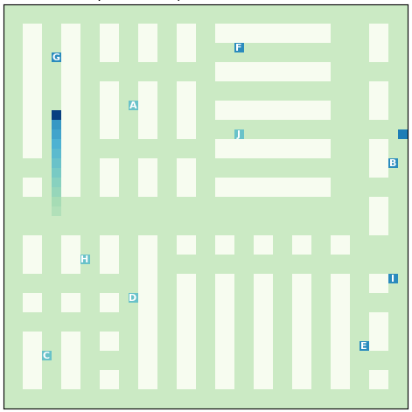
An animation was implemented to simulate the movement of the picker through the warehouse. The agent follows the calculated route while collected items are highlighted and a trail is displayed behind the moving agent.
This animation provides a dynamic representation of route execution and helps illustrate how the picker navigates around obstacles within the warehouse environment. Animations can be found in GitHub Repository folder “Animations”, and in main.ipynb.

3.4.4 Genetic Algorithm Evolution Animation
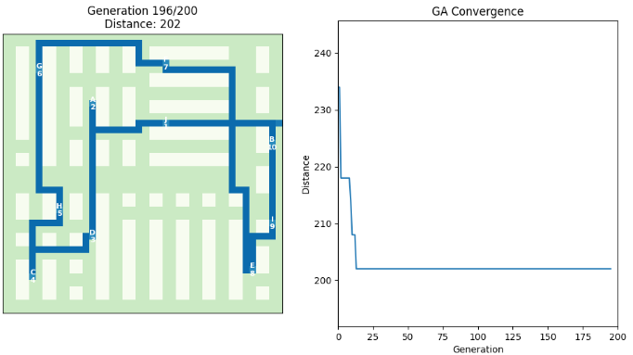
A second animation was developed to visualise the evolutionary process of the Genetic Algorithm. For selected generations, the current best route is displayed alongside a convergence graph showing route distance over time.
This visualisation makes it possible to observe how candidate solutions improve throughout the optimisation process and provides insight into the convergence behaviour of the algorithm. Animations can be found in GitHub Repository folder “Animations”, and in main.ipynb.

3.4.5 Performance Analysis Visualisations
Several graphical visualisations were developed to support experimental analysis, including:
- Selection method comparison charts (xxx)
- Fitness evolution graphs (xxx)
- Hyperparameter analysis plots (xxx)
- Parameter heatmaps (xxx)
- Scalability analysis graphs (xxx)
These visualisations facilitate comparison of different Genetic Algorithm configurations and help identify factors that influence solution quality and computational performance.

4. Experimental Setup
This chapter describes the experimental configuration used to evaluate the proposed store/warehouse routing system. The experiments were designed to assess route quality, computational performance, selection strategies, hyperparameter settings, and scalability.

4.1 Test Configuration
All experiments were conducted using the warehouse environment described in 3. System Design and Implementation. The Genetic Algorithm was configured using a fixed set of parameters unless otherwise specified. Candidate solutions were evaluated using the A*-based distance matrix generated from the warehouse layout.
The primary test configuration consisted of:
- Population size: 100 individuals
- Number of generations: 100
- Mutation rate: 0.02
- Item set size: 10 items
- Selection methods: Tournament, Roulette Wheel, Rank, Stochastic Universal Sampling (SUS), and Random Selection
Additional experiments varied population size, mutation rate, generation count, and problem size in order to investigate their impact on solution quality and runtime performance. Each experiment was repeated multiple times to reduce the influence of randomness and obtain more reliable performance measurements.

4.2 Evaluation Metrics
The performance of the Genetic Algorithm was evaluated using two primary metrics:
Route Distance
The total travel distance required to collect all items and return to the starting position. Distances were calculated using the precomputed A* distance matrix, with lower route distances indicating better solutions.
Runtime
The execution time required to complete the optimization process. Runtime was measured in seconds and used to assess computational efficiency. In addition, convergence behaviour was analysed by tracking the best route distance achieved throughout successive generations.

4.3 Baseline Comparison
To evaluate the effectiveness of the Genetic Algorithm, its performance was compared against randomly generated routes. Random routes visit all items exactly once but do not apply any optimization strategy.
For each test scenario, the distance of the best Genetic Algorithm solution was compared with the distance of a random route. The percentage improvement was calculated to quantify the benefit of evolutionary optimization.
This baseline comparison provides a simple reference point against which the effectiveness of the Genetic Algorithm can be assessed.

5. Results and Analysis

5.1 Random Route vs Optimized Route
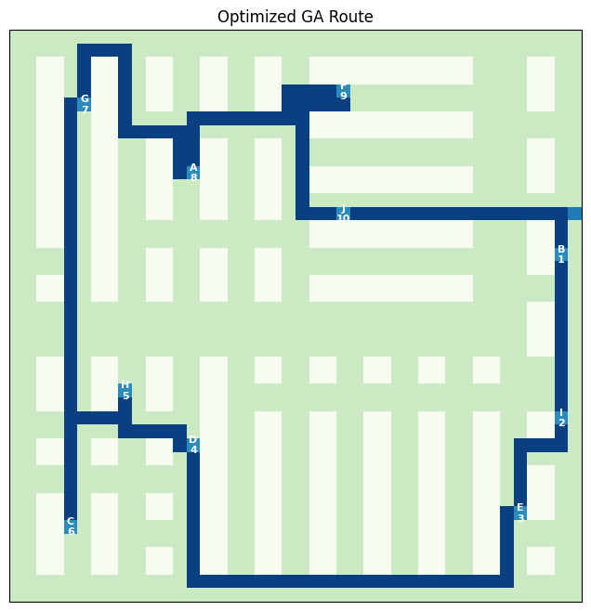  Figure 7, Optimized Route | 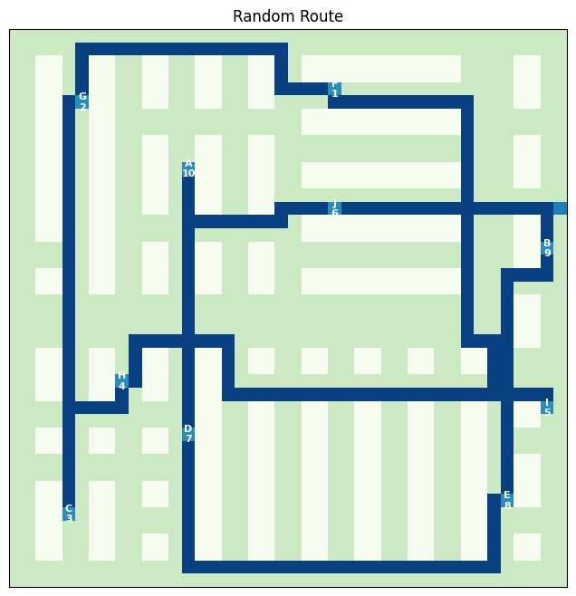  Figure 8, Random Route
Random route distance: 326
Optimized route distance: 190
Improvement: 41,72%
The optimized route produced by the Genetic Algorithm was substantially shorter than the randomly generated route. This demonstrates that the evolutionary search process successfully identified more efficient item collection sequences.
The optimized route reduced total travel distance by approximately 42%, indicating a significant improvement in store/warehouse navigation efficiency.

5.2 Parent Selection Analysis
Compare:
- Random
- Roulette
- SUS
- Tournament
- Rank
Include:
- runtime comparison
- best distance comparison
- convergence graphs
Then conclude:
Tournament selection was selected for subsequent experiments due to...

Method | Avg Distance | Avg Runtime
Tournament
Roulette
Rank
SUS
Random

5.3 Hyperparameter Analysis
Separate subsections:

5.3.1 Population Size
Graph:
- population vs distance
Discuss:
- diversity vs runtime

5.3.2 Mutation Rate
Graph:
- mutation rate vs performance
Discuss:
- exploration vs instability

5.3.3 Generation Count
Graph:
- generations vs convergence
Discuss:
- diminishing returns

5.3.4 Best Hyperparameter Combination
Explain:
- grid search
- chosen configuration
Example:
Population = 100
Mutation = 0.02
Generations = 100

5.4 Fitness Evolution Analysis
This is where your new fitness graphs go.
Include:
- best fitness
- average fitness
- worst fitness
Discuss:
- convergence behavior
- exploration
- lack of elitism
- fluctuations in fitness
This is now a very strong analytical section.

5.5 Best Configuration vs Optimized Configuration
This is an excellent section.
Compare:
- best possible distance
- fastest practical configuration
Example table:
Configuration | Distance | Runtime
Best Quality | 580 | 12s
Optimized Runtime | 610 | 3s
Discuss:
- quality/runtime tradeoff
This is a very mature analysis section.

5.6 Scalability Analysis
Include:
- 5 items
- 10 items
- 15 items
- 20 items
Graphs:
- runtime scaling
- distance scaling
Discuss:
- computational complexity
- increasing optimization difficulty

6. Discussion
This section is interpretation and reflection.
Discuss:
- why GA works well
- strengths of A*
- strengths/weaknesses of different selection methods
- why elitism was rejected
- exploration vs exploitation
- runtime limitations
- scalability observations
This is where you demonstrate understanding.

7. Conclusion
Summarize:
- project goals achieved
- best results
- optimization improvements
- successful visualizations
- major findings
Example:
The project successfully demonstrated that combining A* pathfinding with a Genetic Algorithm can significantly optimize warehouse picking routes compared to random ordering strategies.

8. Future Improvements
Very important section.
Possible ideas:
- reinforcement learning
- multi-agent systems
- dynamic obstacles
- real warehouse layouts
- parallel GA
- hybrid algorithms
This shows awareness of broader AI applications.

9. References

Elitism: (parent selection kind of??)
Elitism was experimentally evaluated by preserving the best individual between generations. However, this resulted in consistently worse route distances for the tested warehouse layouts and parameter configurations. The likely cause was reduced population diversity and premature convergence. Consequently, the final implementation used a non-elitist genetic algorithm.
Fitness evolution:
The fluctuating fitness curves indicate that the population continuously explored new regions of the search space. Since elitism was not used, high-quality individuals could occasionally be lost between generations, causing temporary increases in best and average route distances. However, this maintained diversity and ultimately produced better final solutions in this project.

https://www.geeksforgeeks.org/artificial-intelligence/a-algorithm-and-its-heuristic-search-strategy-in-artificial-intelligence/

