CSCE - 315 Team Project - 2

Sprint Backlog - 1

Yingjian Wang

Austin Peterson

Amarthya Sivakumar Annu

SPRINT BACKLOG

Green - All three members

Red- Amarthya Sivakumar Annu

Blue - Austin Peterson

Yellow - Yingjian Wang

Sprint-1

Tasks:

1. Brainstorm application ideas
2. Make a final design decision
3. Discuss requirements
4. Create product backlog
5. Create a burndown chart
6. Create a design document
7. Sketch initial design
8. Delegate jobs (writing reports, PM)
9. Design Sprint 1 backlog
10. Determine code methodology/language
11. Delegate backlog tasks
12. Make official design drawings
13. Determine website creation method (template, pure HTML/CSS, website element designer)
14. Planning for the user study
15. Coming up with user stories
16. Create the website files
17. Create site navbar
18. Create upcoming games section
19. Create a recent games section
20. Add league/sport pages
21. Add league/sport logos
22. Implement interactive aspects (scrolling, dynamic game block creation)
23. Search for the APIs
24. Choose the appropriate APIs
25. Format API return data
26. Link API data with website elements (game blocks)
27. Filter hot games for “home” page
28. Filter games by sport for sports pages
29. Get images for each game block
30. Design game block link page

INITIAL BURNDOWN CHART:

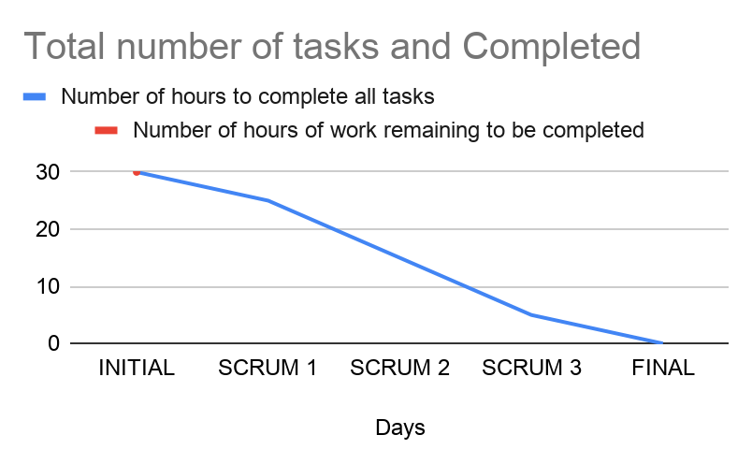

TENTATIVE SCRUM MEETING SCHEDULE:

MEETING 1: November, 4th. (1:50 PM)

MEETING 2: November, 5th. (10:25 AM)

MEETING 3: November, 7th. (10:25 AM)