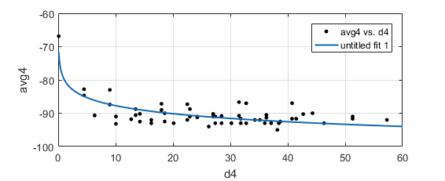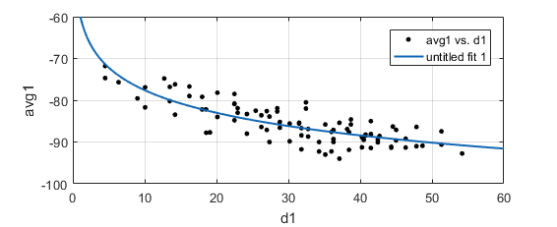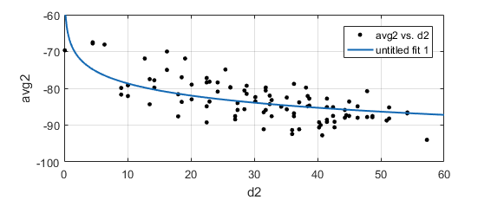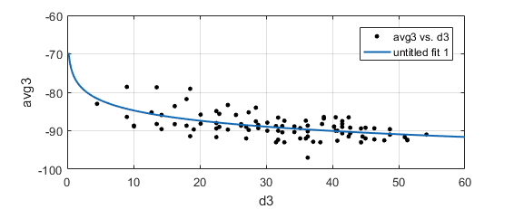

**-Referensi data Indoor**

|  |  |  |  |  |  |  |
| --- | --- | --- | --- | --- | --- | --- |
|  | AP1 | AP2 | AP3 | AP4 | AP5 | AP6 |
| Posisi 1 | 100 | 96.75 | 96.54351 | 91.55307 | 100 | 100 |
| Posisi 2 | 100 | 99.54839 | 96.76161 | 92.05075 | 100 | 100 |
| Posisi 3 | 94.67504 | 87.80308 | 91.46055 | 95.67719 | 90.77762 | 92.62697 |
| Posisi 4 | 85.77592 | 79.52392 | 100 | 99.93421 | 99.56579 | 85.40191 |
| Posisi 5 | 80.73171 | 90.91046 | 100 | 100 | 100 | 92.98877 |
| Posisi 6 | 93.59324 | 93.54013 | 100 | 100 | 100 | 99.95161 |

**Data 2**

|  |  |  |  |  |  |  |
| --- | --- | --- | --- | --- | --- | --- |
|  | AP1 | AP2 | AP3 | AP4 | AP5 | AP6 |
| Posisi 1 | 100 | 100 | 96.89189 | 91.83784 | 100 | 100 |
| Posisi 2 | 100 | 100 | 98.75676 | 90.43243 | 100 | 100 |
| Posisi 3 | 92.43243 | 91.24324 | 95.13514 | 99.67568 | 92.83784 | 92.24324 |
| Posisi 4 | 91.27027 | 81.7027 | 100 | 99.86486 | 99.10811 | 78.94595 |
| Posisi 5 | 87.54054 | 87.08108 | 100 | 100 | 100 | 95.18919 |
| Posisi 6 | 93.13514 | 91.45946 | 100 | 100 | 100 | 100 |

**Data 3**

|  |  |  |  |  |  |  |
| --- | --- | --- | --- | --- | --- | --- |
|  | AP1 | AP2 | AP3 | AP4 | AP5 | AP6 |
| Posisi 1 | 99.65 | 99.7 | 91.8 | 71.85 | 74.65 | 85.6 |
| Posisi 2 | 93.25 | 100 | 89.75 | 84.8 | 87.7 | 88.4 |
| Posisi 3 | 91.4 | 97.85 | 94.95 | 100 | 100 | 100 |
| Posisi 4 | 90.1 | 92.8 | 90 | 100 | 100 | 100 |
| Posisi 5 | 100 | 100 | 86.1 | 97.55 | 100 | 100 |
| Posisi 6 | 99.75 | 100 | 93.05 | 84.25 | 81.75 | 100 |

**Result data 2**

|  |  |  |  |  |  |  |  |
| --- | --- | --- | --- | --- | --- | --- | --- |
|  | Probability in x position | | | | | |  |
| Posisi Real | Posisi 1 | Posisi 2 | Posisi 3 | Posisi 4 | Posisi 5 | Posisi 6 | Hasil Tebakan |
| Posisi 1 | 5.263158 | 94.73684 | 0 | 0 | 0 | 0 | Posisi 2 |
| Posisi 2 | 36.84211 | 63.15789 | 0 | 0 | 0 | 0 | Posisi 2 |
| Posisi 3 | 0 | 0 | 65 | 0 | 25 | 10 | Posisi 3 |
| Posisi 4 | 0 | 0 | 0 | 80 | 5 | 15 | Posisi 4 |
| Posisi 5 | 0 | 0 | 5.263158 | 26.31579 | 68.42105 | 0 | Posisi 5 |
| Posisi 6 | 0 | 0 | 0 | 0 | 15.78947 | 84.21053 | Posisi 6 |

**Result data 3**

|  |  |  |  |  |  |  |  |
| --- | --- | --- | --- | --- | --- | --- | --- |
|  | Probability in x position | | | | | |  |
| Posisi Real | Posisi 1 | Posisi 2 | Posisi 3 | Posisi 4 | Posisi 5 | Posisi 6 | Hasil Tebakan |
| Posisi 1 | 95 | 5 | 0 | 0 | 0 | 0 | Posisi 1 |
| Posisi 2 | 15.78947 | 89.47368 | 0 | 0 | 0 | 0 | Posisi 2 |
| Posisi 3 | 0 | 0 | 100 | 0 | 0 | 0 | Posisi 3 |
| Posisi 4 | 0 | 0 | 0 | 47.36842 | 52.63158 | 0 | Posisi 5 |
| Posisi 5 | 0 | 0 | 0 | 47.36842 | 52.63158 | 0 | Posisi 5 |
| Posisi 6 | 0 | 0 | 0 | 21.05263 | 31.57895 | 47.36842 | Posisi 6 |