**关运通Docker开发环境使用手册**

1，下载windows版的docker

浏览<https://hub.docker.com/editions/community/docker-ce-desktop-windows>

下载地址：<https://download.docker.com/win/stable/Docker%20Desktop%20Installer.exe>

2，安装docker

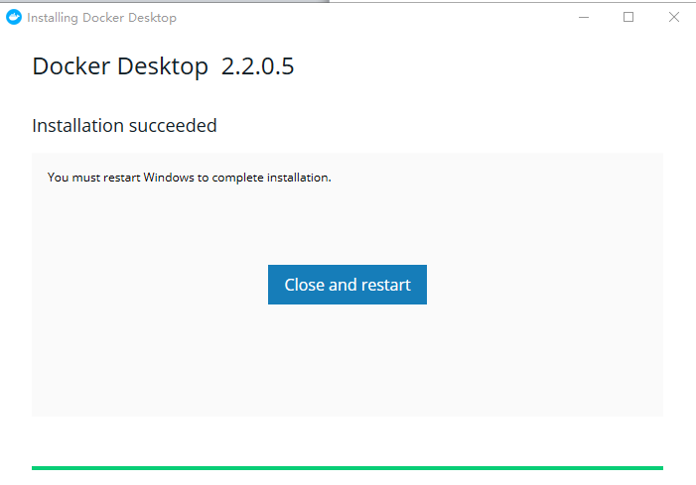

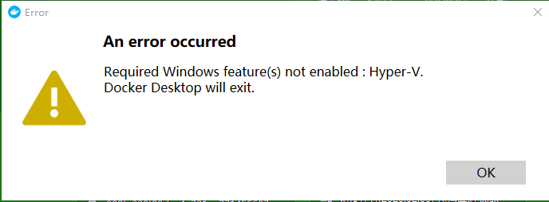

如果报上面的错误，请参考：

https://blog.csdn.net/u012359995/article/details/64192637