**GenZ++**

**1. Keywords (Reserved Words)**

Keywords cannot be used as variable names or function names.

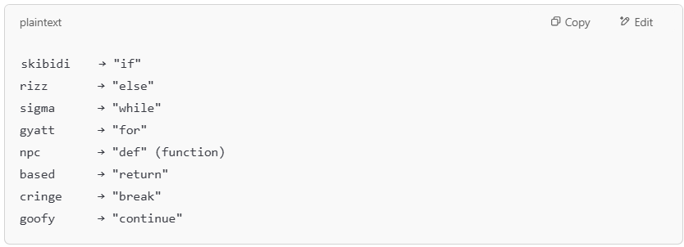

**Rule:**

A keyword is any of the above words appearing exactly as written, case-sensitive.

**2 . Identifiers (Variable & Function Names)**

These are custom names used by the programmer.

**Rule:**

* Must start with a letter (a-z, A-Z) or underscore (_).
* Followed by any combination of letters, digits (0-9), or underscores.
* **Cannot** be a reserved keyword.

**Valid Identifiers:**

**✓** sigmaMove  
**✓** _gyattSpeed  
**✓** npcFunction

**Invalid Identifiers:**

✘ 1skibidi (Cannot start with a number)  
✘ skibidi (Reserved keyword)

**3. Literals**

* **String Literals**

Strings are enclosed in **yapping("...")**.

**Rule:**

* Must start and end with **yapping("** and **")**.
* Can contain any characters inside.

**Example:**



* **Number Literals**

Numbers are just standard numeric values.

**Rule:**

* Must be a sequence of digits (0-9).
* No letters or special characters.

**Example:**

**✓** x = 10  
**✓** pi **=** 3.1415

**4. Operators**

Used for arithmetic and comparisons.

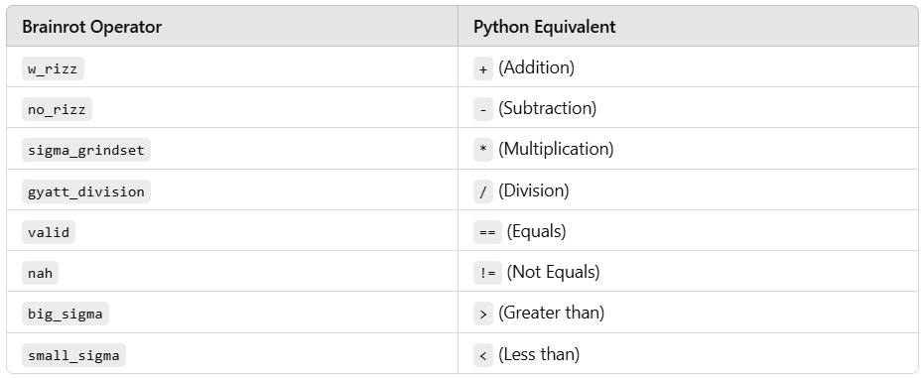

**Example:**

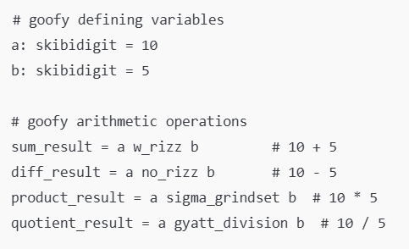

**5. Comments**

Comments are written in goofy style.

* **Single-line comment:** Starts with # goofy



* **Multi-line comment:** Uses triple quotes

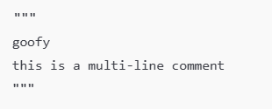

**6. Data Types**

