# Team

|  |  |  |  |
| --- | --- | --- | --- |
| Phone | Email | Name | ID |
| 01144424795 | Eldon7917@Gmail.com | Mahmoud El-sayed fateaha | 20120351 |
| 01159466224 | Meeedo_2030@yahoo.com | Mohamed Fathy Sayed | 20120331 |

# Document Purpose and Audience

**What is this document?**

This document is about to show you the steps that we follow to create the social media site.

**The target audience to read this document.**

**Developers ,project manager, software engineering manager and some TA in FCI faculty.**

# Introduction

## Software Purpose

This software aims to represent a something that we can interact through it like Facebook , twitter and LinkedIn then this software will be delivered as project in the faculty.

## Software Scope

this software will provided something we all know like we can create an account on this site and add people who we know and manage this account as we want , also we can create group for something we want or for life and make it any one see its posts or just member can see its posts, also we can create pages as we want for actor person (famous person) or a product for a company , we can also post on our personal page like exactly in Facebook , we can also connect with other by message and make a hash tag conversation for all world , simply this software is a small version for Facebook site

# Requirements

## Functional Requirements

this software allows you to enter your user name and password then you get access to this social site and communicate with your friends or with your Coworkers and see what's news with the way you like to do it posts, groups, pages, Hash tag or messages

## Non Functional Requirements

|  |  |
| --- | --- |
| **Details** |  |
| Every one can have one account or more ,but if someone have no account, can't access to this site. | **Usability** |
| Login to this site may take a few seconds, but to create group or fan page may take some minutes. | **Performance** |
| this site will be security and no one can hacked on it . | **Security** |
| Every week will be the maintains and add or change something in it. | **Maintainability** |

# System Models

## Use Case Model

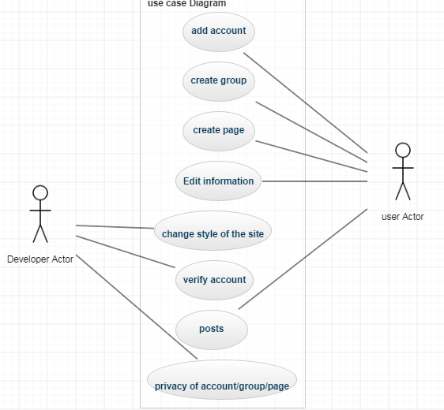

## Use Case Tables

|  |  |  |
| --- | --- | --- |
| Use Case ID: | 1 | |
| Use Case Name: | Add account | |
| Actors: | User | |
| Pre-conditions: | Open the page that contains his personal information and some steps to follow it. | |
| Post-conditions: | Have the account and then can do any thing he like. | |
| Flow of events: | **User Action** | **System Action** |
| 1- User open the link and add account . | Page open and some steps to open. |
| 2.after finish . | System send an email to confirm this account. |
| 3-after confirmation | System enable user to use it |
|  |  |
|  |  |
| Exceptions: | No exception | |
| Includes: |  | |
| Notes and Issues: | There will be some steps to follow | |

|  |  |  |
| --- | --- | --- |
| Use Case ID: | 2 | |
| Use Case Name: | Create group or page. | |
| Actors: | User | |
| Pre-conditions: | Click the button create ,then choose what he want | |
| Post-conditions: | Have a page or group that can share it and people like it | |
| Flow of events: | **User Action** | **System Action** |
| 1- user click on create . | Show the list and choose from it . |
| 2- follow some steps about info of this page or group. | At the end he click finish then system create his choose. |
| 3- if this page is public. | System share this page. |
|  |  |
|  |  |
| Exceptions: | No exception | |
| Includes: |  | |
| Notes and Issues: | There will be also some steps to follow. | |

|  |  |  |
| --- | --- | --- |
| Use Case ID: | 3 | |
| Use Case Name: | Change the style of system. | |
| Actors: | Developer | |
| Pre-conditions: | What the site look like. | |
| Post-conditions: | New style in shape ,color or options in this site. | |
| Flow of events: | **User Action** | **System Action** |
| 1- he enter on function style . | Show message to users that will be anew style for the site. |
| 2- after he finish . | System asks users if they want to update this or not. |
|  |  |
|  |  |
|  |  |
| Exceptions: | There maybe some exception about stops the site for working | |
| Includes: |  | |
| Notes and Issues: |  | |

|  |  |  |
| --- | --- | --- |
| Use Case ID: | 4 | |
| Use Case Name: | Edit information | |
| Actors: | User | |
| Pre-conditions: | Old information | |
| Post-conditions: | Update information (new) | |
| Flow of events: | **User Action** | **System Action** |
| 1- User choose edit from settings | System open page contains all about the user. |
| 2-user chose what he want to update and click edit. | System update atomically his choose. |
|  |  |
|  |  |
|  |  |
| Exceptions: | No exception | |
| Includes: |  | |
| Notes and Issues: | No issues . | |