  
Institute of Technology of Cambodia

Department of Information and Communication Engineering

Subject: internet programming

Professor: TIN Hok

Assignement: TP02

Name: yen oudom

Id: e20181269

Department: GIC4-C

Objective: Create file to upload picture and do with canvas, upload file in gifHub.

(2021-2022)

Git repository url: https://github.com/Oudom1/TP01_Internet_Programming.git

Branch: TP02

Capture screen: attached file.

Ex1: draw an uploaded image to a **Canvas**

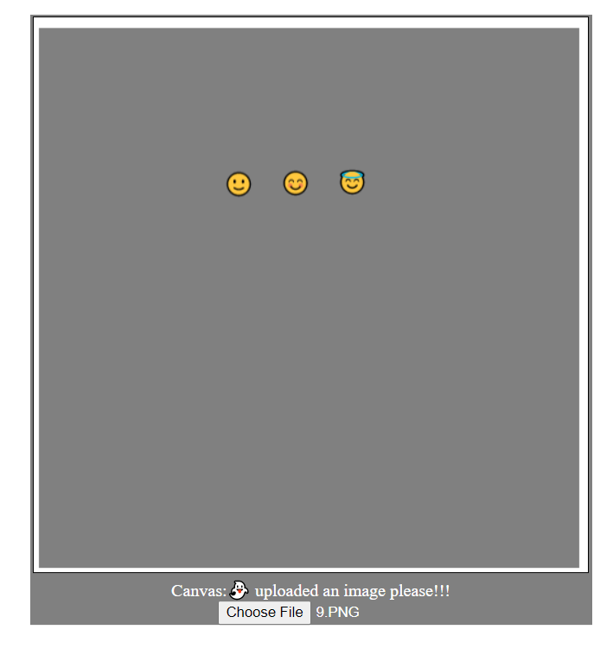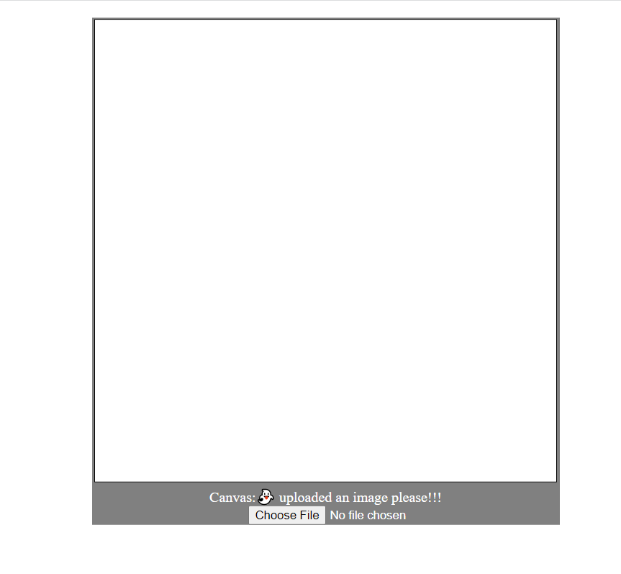

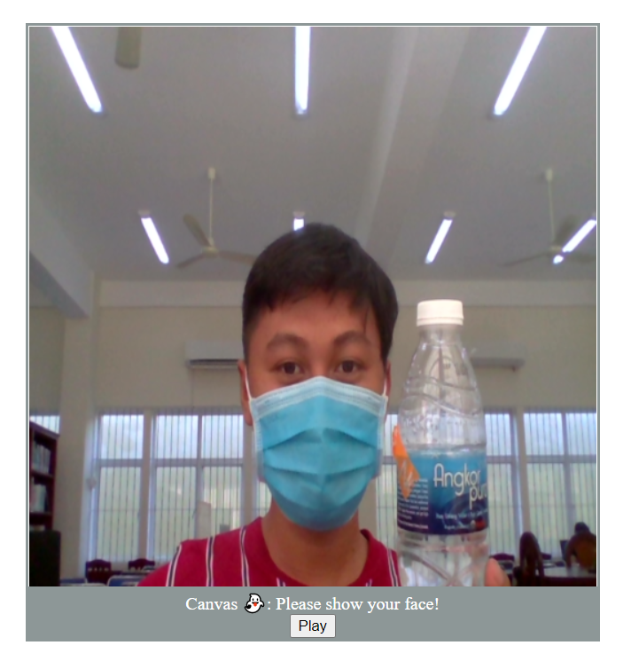Ex2: draw a live video camera in to a **Canvas**

Ex3: draw a live camera video into projection within **Canvas**

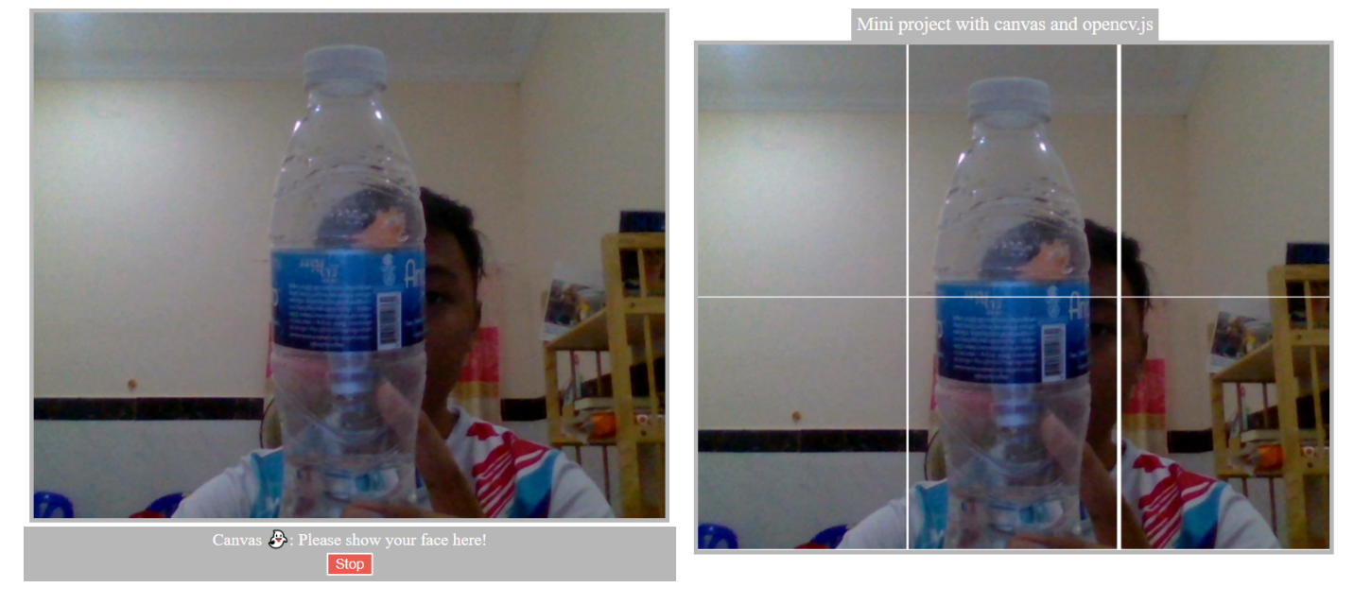

Ex4: Book shop CRUD (Create, Remove, Update, and Delete)

