  
Institute of Technology of Cambodia

Department of Information and Communication Engineering

Subject: internet programming

Professor: TIN Hok

Assignement: TP03

Name: yen oudom

Id: e20181269

Department: GIC4-C

Objective: Local storage, cookie, and session.

(2021-2022)

Git repository url: https://github.com/Oudom1/TP01_Internet_Programming.git

Branch: TP03

Capture screen: attached file.

Ex1: Book shop CRUD with Local storage

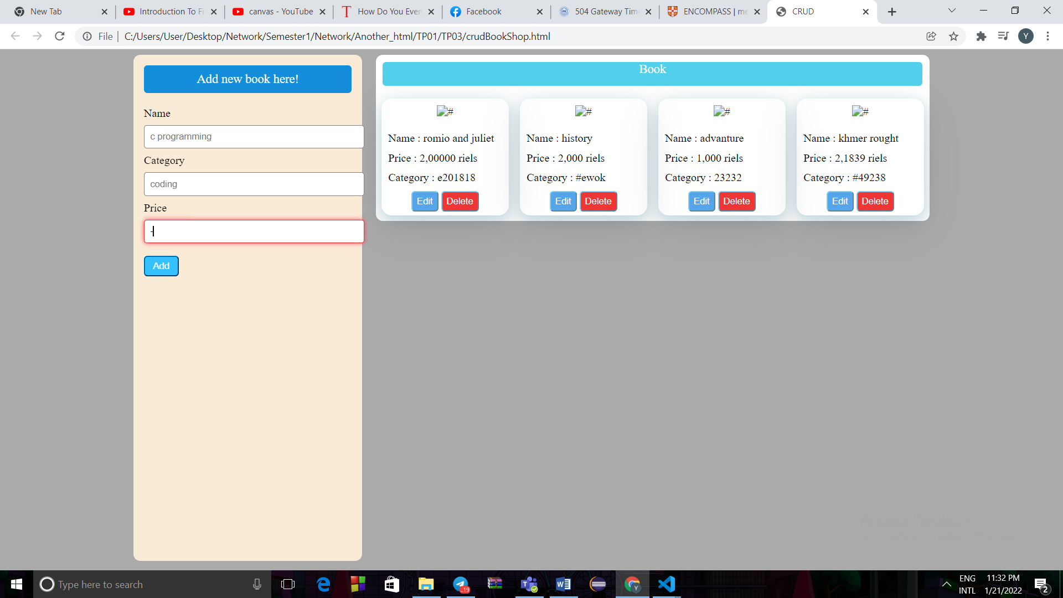

Ex2: logIn form with cookies

