  
Institute of Technology of Cambodia

Department of Information and Communication Engineering

Subject: internet programming

Professor: TIN Hok

Assignement: TP04

Name: yen oudom

Id: e20181269

Department: GIC4-C

Objective: Promise and Fetch

(2021-2022)

Git repository url: https://github.com/Oudom1/TP04.git

Branch: TP05

Capture screen: attached file.

Ex1. Build a number counter app with class/object concept and local storage

Exercise1:

Consider you’re working a big project which the one user information may be stored in many database. Design “Promise” object to handle the process in order to get a complete user’s information. Apply “Promise.all” to run all promise objects.

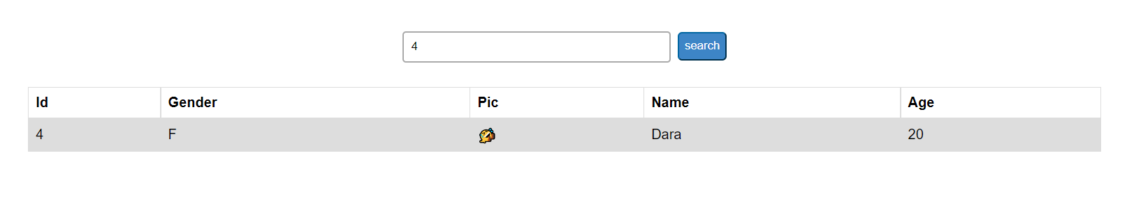

Exercise2:

Apply the fetch function to our previous book app. Free Api from jsonpacehoder.typicode.com

