Research

Pediatrics sponsors two multifunctional programs to facilitate intra-departmental research. The Office of Research Programs specializes in comprehensive support of regulatory compliance and study coordination for clinical trials research. The Biomedical and Behavioral Methodology Core (BBMC) houses faculty and staff who specialize in biostatistics, measurement, computational programming, database management, and general research methods.

*Overview of Support Programs*

***Office of Research Programs***

The Office’s mission is to enhance and facilitate Departmental research activities through a coordinated, centralized system leading to increased productivity and revenue from research. It provides a comprehensive array of support services; helps assure compliance with federal regulations and institutional policies and procedures; and coordinates efforts with OUHSC's Office of Research Administration and Institutional Review Board.   
  
For more information in regards to our Office of Research Programs please contact Kathy Redmond by email at [kathy-redmond@ouhsc.edu](mailto:kathy-redmond@ouhsc.edu)

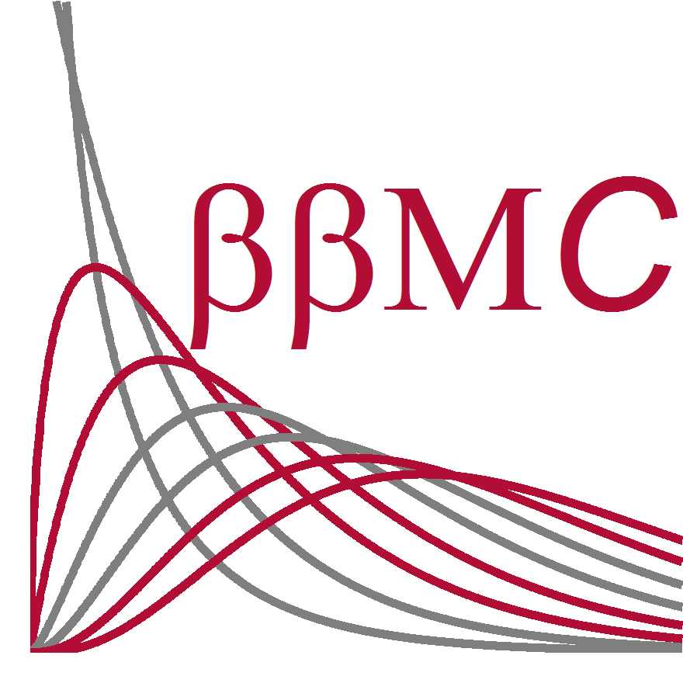**Biomedical and Behavioral Methodology Core**

The BBMC mission is to support and enhance study design, data capture, and analytics for Pediatrics research. The Core offers a variety of support services for projects at any stage of development, to include: database design and management, study design and management, manuscript/proposal/presentation development and review, and biostatistics consultation and support. To request any of these services, please visit the BBMC homepage, [BBMC](https://miechvprojects.ouhsc.edu/redcap/redcap_v4.11.2/MIECHV/BBMC.html)

In addition to these support services, the BBMC actively pursues in its own interdisciplinary research programs involving new method developments and applied research on Adverse Childhood Experiences (ACES). BBMC also provides general and advanced research training opportunities for researchers at all levels of experience. For more information about these research programs, collaborative opportunities, or training please contact our BBMC Director, David Bard, Ph.D., by email at [david-bard@ouhsc.edu](mailto:david-bard@ouhsc.edu)

***Overview of Current Research***

To view current departmental awards, go to:

* [**Federal Awards**](http://www.oumedicine.com/docs/ad-pediatrics-workfiles/federal-awards.pdf?sfvrsn=0)
* [**State Awards**](http://www.oumedicine.com/docs/ad-pediatrics-workfiles/state-awards.pdf?sfvrsn=0)
* [**Foundation and Pharmaceutical Awards**](http://www.oumedicine.com/docs/ad-pediatrics-workfiles/foundation-and-pharmaceutical-awards.pdf?sfvrsn=0)