Proposed Mission

Development of a sustainable, comprehensive prevention infrastructure that reflects research and promising practices in promotion of development, health, education and well-being and prevention of child abuse and neglect.

All qualitative data collection and reports complied by: Lana Beasley, Leigh Ridings, Tyler Smith, and Nelda Ramsey

Proposed Vision

All Oklahoma children grow up in healthy and nurturing environments with an equal opportunity to reach their full potential.

|  |
| --- |
|  |
| White Paper Report on Home Visitation in Oklahoma |
|  |
|  |

**Report compiled by evaluators at the university of Oklahoma Health Sciences Center**

July 16, 2013

David Bard, Ph.D., Jane Silovsky, Ph.D., Lana Beasley, Ph.D., William Beasley, Ph.D., Thomas Wilson

White Paper Report on Home Visitation in Oklahoma

While Oklahoma has been a leader in the Nation in early childhood and home visitation, we continue to struggle with poverty (e.g., 23% of Oklahoma children) and academic struggles (e.g., 23% of students not graduating on time, 59% of children not attending preschool). We have made great strides in developing programs to reduce child maltreatment risk, but the rates of reduction have not been sufficient. Home-based parent programs have been the central modality for Oklahoma’s efforts at child abuse and neglect prevention and improvements in child and family well-being. Under Representative McCullough’s leadership, this Home Visitation Workgroup has been organized to examine current practices in Oklahoma and make recommendations for improving the safety net of home-based parenting programs, known nationally as “home visitation programs”.

This report provides initial review in the format of a S.W.O.T. analyses (Strengths, Weaknesses/Challenges, Opportunities, and Threats) – to review progress and examine the challenges in order to facilitate strategic planning to improve prevention planning to reach our mission and vision. Though not designed to be comprehensive, we will discuss challenges identified by the Home Visitation committee members and discuss Oklahoma data relevant to examining current opportunities and plan activities to improve outcomes.

# Strengths in Oklahoma: Supporting the Vision and Mission

*“Oklahoma is ahead on early childhood development and home visitation*

*relative to the rest of the Nation.”*

*-Jack Tweedie, NCSL*

1. Oklahoma has a strong commitment to investment in early childhood development (e.g., Sooner Starts, Pre-K program, Early HeadStart, Educare, Early Foundations, Smart Start, OK-CEO).
2. Oklahoma is committed to local communities collaborating to improve access, identify and overcome barriers to services, and coordinate care (e.g., Systems of Care, Sooner Success, Interagency Child Abuse Prevention Task Force, Home Visitation Leadership Advisory Coalition).
3. Oklahoma has a long history implementing a range of nationally recognized evidence-based home visitation programs. In addition to core work with parenting young children, programs have distinctions in population served and outcomes targeted (e.g., school readiness, maternal and child health, child abuse and neglect prevention). The variety provides a continuum and wide net of prevention services for Oklahoma families.
4. Oklahoma has a history of systematically examining and adapting home visitation programming for families at high risk, which has been monitored by a sustainability committee with memberships from state agencies, nonprofit agencies, university researchers, program developers, legislative staff, and local businesses and foundations.
5. Oklahoma has rigorously evaluated home based parenting programs for families involved in child protective services and with high risk prevention cohorts and have found reductions in child abuse and neglect referrals. State pilot data have enhanced competitiveness for federal research grants, allowing for rigorous research studies within Oklahoma (see below).
6. Oklahoma is committed to including consumers’ voices in the planning and implementation. Parent Partnership Board helps inform programming, evaluation, and marketing.
7. Oklahoma has extensive local expertise to evaluate implementation process and child and family outcomes.
8. Blended funding for home visitation services, training, and evaluation has included State appropriations, Federal grants, private foundation support, Medicaid, specialty license plates and local millage.
9. Oklahoma has local expertise in training and technical assistance in nationally renowned models for parenting and child behavior problems and emotional issues.

## Findings from Oklahoma home based parenting program evaluations

#### Panel A.

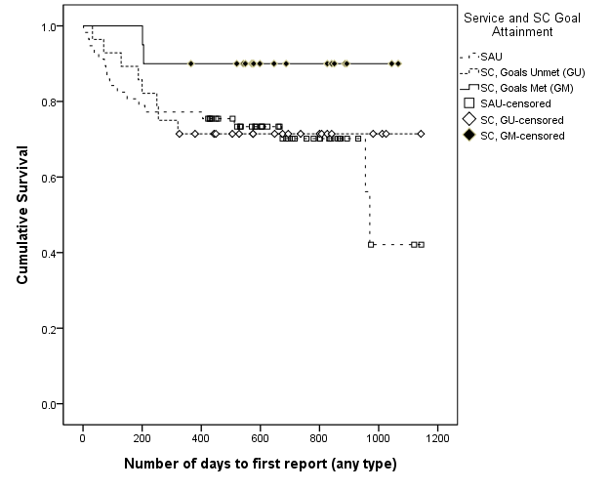

Panel A. Results from a home-visitation secondary prevention trial comparing SafeCare to standard community mental health services in a rural Oklahoma community. SafeCare participants who met all treatment goals (42% of those enrolled in SC) evidenced marked improvement in the rates of future abuse and neglect relative to their peers (those enrolled in standard care and those enrolled in SC who did not manage to meet treatment goals).

#### Panel B.



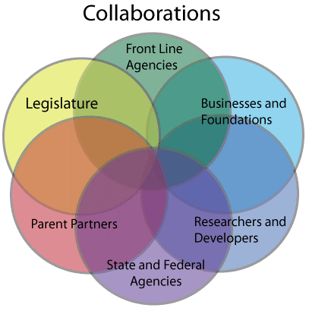Panel B. Results from a state-wide implementation of SafeCare (SC) within a tertiary prevention trial. SC version of service with outperformed services as usual (SAU) with regard to future maltreatment reports. For every 1000 treated cases, SC in this trial was estimated to prevent (relative to SAU) 64 to 104 first-year recurrences of abuse and neglect. Results were strongest for a SC condition that also included fidelity *C*oaching of home visitors (SC/C).

## Overarching Goals and Approach to the Prevention of Child Maltreatment

The willingness of the Oklahoma Legislature, State agencies, researchers, program developers, advocacy organizations and provider agencies to engage and collaborate to prevent child maltreatment in Oklahoma families has resulted in service quality improvement, rigorous research demonstrating reduction in child maltreatment, recognition of the State’s efforts nationally, and an influx of Federal research and development funding. Capitalizing on this collaboration to develop statewide strategic planning will facilitate maximizing the potential of prevention program to meet goals for Oklahoma children and their families.

## Oklahoma’s Evidence Based Home Visitation Programs

|  |  |  |  |  |
| --- | --- | --- | --- | --- |
| Program | Parents as Teachers | Children First | Start Right | SafeCare |
| Agency | Oklahoma State Department of Education, Oklahoma State Department of Health, and Choctaw Nation | Oklahoma State Department of Health | Oklahoma State Department of Health | Oklahoma Department of Human Services, Parent Child Center of Tulsa, and Cherokee Nation (Planning stage) |
| Model | Parents as Teachers (PAT) | Nurse-Family Partnership (NFP) | Healthy Families America (HFA) | SafeCare |
| Staff | Bachelors prepared or Paraprofessional with additional training | Registered Nurses | Bachelors prepared or Paraprofessional with additional training | Bachelors prepared professionals with additional training |
| Client Enrollment Criteria | The program enrolls:  -all expectant parents as well as parents with children birth to age 3 | Participants must:  -Be expecting their first child;  -Have a household income at or below 185% FPLc; and  -Be less than 29 weeks pregnant at the time of enrollment. | The program enrolls:  -expectant women after the 29th week of the first pregnancy, or at any time during pregnancy for subsequent births, or  -family with a child age 1 or younger. | The program enrolls:  -families with at least one child age 5 years or younger; and  -have risk factors such as substance abuse, domestic violence, or mental health issues. |
| Targeted Area in addition to Child Abuse & Neglect* | School readiness | Maternal and Child Health | Nurturing Parent-Child Relationship | Domestic Violence, Parental Depression, Substance Abuse |
| Families Served  SFY 2012 | Numbers not available at the time of print | 3,547 Families Served | 1,068 Families Served;  1,837 Children Served | 121 Families Served in Oklahoma County |
| Locations | 43 programs throughout the state | 69 Counties | Fifteen programs in 38 counties | Tulsa and Oklahoma County |

# Challenges in Oklahoma to Reaching the Proposed Vision and Mission

The questions below are concerns and potential challenges raised by members of the Home Visitation (HV) committee. Oklahoma is not alone in facing these challenges, as these are concerns across the nation. Further, these concerns are not unique to home visitation, but rather are common when implementing service programs.

1. Are home visitation programs able to identify vulnerable families with young children and successfully recruit them to home visitation programs?
2. How best can families be quickly linked to the program that is the best fit for them? How can recruitment efforts overcome barriers to cross-agency referrals of families?
3. How can we best engage families into HV services, particularly those at highest risk?
4. How can home visitation programs be administered with greatest efficiency and quality? What is the ideal dose/response level of HV services?
5. How can child, parent, family, and administrative outcomes be best linked and examined across different agencies’ databases while respecting individual privacy and protections?
6. How do we manage inefficiencies due to State agency contracting procedures?
7. What are the best methods to estimate and conduct cost benefits analyses for Oklahoma’s home visitation efforts? How best to calculate and compare costs of programs, given different targets, intensities, durations? How do you best determine the tipping point of maximum benefit?
8. Home visitation alone cannot solve all the ills and challenges for our families who are struggling the most. How do programs best address and collaborate with services on issues of a). safe and stable housing, b). self-sufficiency, c). medical care for parents and children, d). mental health services for parents and children, e). domestic violence, f). substance abuse services, g). basic needs, h). child care and early education, and g). sense of belonging, support, and faith?
   1. What are best methods to improve collaborative partnerships with businesses, private foundations, faith communities, and parent partners?

For each of these areas, we have provided a statement of the problem, summary of the research and activities in Oklahoma, and address any known opportunities and activities presently designed to speak to the issue.

1. **Are home visitation programs able to identify vulnerable families with young children and successfully recruit them to home visitation programs?**

Statement of Problem: Across Oklahoma, some local home visitation programs have continuous waiting lists, while other programs struggle to find and recruit families. This variation is found across different areas of the State using the same model, different models in the same area, and has been found to vary across time.

Summary of Research: Research on recruitment for home visitation programs and for services that reach vulnerable populations support the following strategies:

* Build relationships with referral sources and caregivers
* Consult local community families and referral sources
* Use programs that address community needs
* Are flexible, convenient, and eliminate barriers to recruitment and participation
* Target referral agencies that have longer contact and relationships with families
* Use a wide range of targets for marketing
* Use catchy, but simple, straight-forward materials
* Use giveaways to attract potential consumers and referral sources
* Identify and overcome any “turf” issues

Findings in Oklahoma:

A**. Referral sources need to take into account the specific community**. Urban and rural differences have been found in research in Oklahoma when recruiting families at high risk:

## Urban and Rural Referral Source Differences: Percent of Enrolled by Referral Sources: SafeCare Pilots

For further investigation, we will be comparing recruitment activities and sources across the range of success for Children First and Start Right programs.

B. **Vulnerable families will volunteer for and engage in home based parenting programs.** Parents of young children (5 years and younger), with high rates of domestic violence (over 40% assaulted in last year) and depression (over a third clinically depressed), and living in impoverished conditions (Median income around $600 a month) in urban and rural Oklahoma were successfully engaged in home visitation. EBHV engagement efforts were more successful than standard care.

## Service Engagement and Billable Hours for SafeCare and Community Mental Health Services (SAU) in a Rural County in Oklahoma

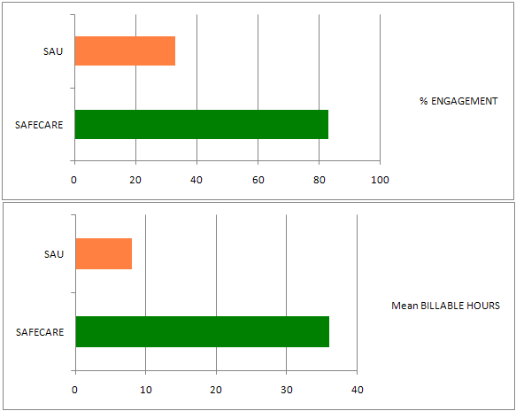

In the MIECHV study (see box above), potential consumers (those who qualify for EBHV but are not active in a program) are participants in a community survey that includes questions about their openness to enroll in an evidence-based home visitation program. Overwhelmingly, their response has been positive. We have utilized the Stages of Change (Prochaska & DeClemente) behavior measurement system. As indicated below, the large majority of those surveyed (76% of the total sample and 79% of the Medicaid subsample) and informed of EBHV programs state that they are either planning to or have already contacted (i.e., Contemplation, Planning, and Action stages) ParentPro to receive EBHV services.

The Maternal, Infant and Early Childhood Home Visitation (MIECHV) state allocation and competitive grant provides an opportunity for Oklahoma to examine important next steps in improving the well-being of children and their parents and prevent child abuse and neglect. MIECHV is

* Targeting six high risk counties in Oklahoma
* Building and supporting a continuum of home visitation services to reach families with young children
* Developing an umbrella organization – ParentPro – who will educate and market the home visitation programs to facilitate connecting with hard to reach families
* Facilitating identification and coordination of other key services for families at high risk
* Evaluating program outcomes and outreach efforts for continuous improvement, with internal and external evaluators examining home visitation program and administrative data, a community sample longitudinal research, and qualitative research with consumers, providers, agency personnel, and policy makers.

## Stages of Change for Enrolling in Home Visitation Services

1. **Opportunities:** MIECHV funded qualitative research includes conducting focus group and individual interviews with consumers and with home visitors (providers). Results presented in this report are from Children First (C1) programs in Oklahoma and Tulsa counties. Results from previous focus groups with SafeCare program participants are also provided.

*Theme: Getting connected with Children First.* Children First participants were asked to disclose how they learned about Children First services. Below is a representative chart of referral sources.

## How Engaged and Unengaged participants found out about the Children First Programs: Results from Qualitative Research with Mothers

## Mothers who Engaged in C1 Mothers who Dropped out before Birth

*Other: Includes Church, Therapist, Internet, Mail

*Theme:* *Best ways to advertise home visiting programs*. Children First participants were also asked the best ways to advertise programs for children and families. Below is a representative list of referral sources from both engaged and unengaged participants and the frequency:

* Best ways to advertise: Results from Mothers who Engaged with Children First
  + Word of mouth (17%)
  + Online/Texts (22%)
  + Television/Radio (17%)
  + Other: ER/Hospital, WIC, Doctor’s Office/Clinic, School/College, Fast food restaurant, Bus/Bus Stops, Magazines, Billboards, Park Benches, Grocery Stores, Mailouts/flyers
* Best ways to advertise: Results from Mothers who Dropped out of Chidlren First before birth of their child
  + Doctor/Clinic (14%)
  + Mail/Flyers (14%)
  + Online (14%)
  + Other: Hospitals, Schools, Television, Daycare, Wal-Mart/Grocery Stores, Word of Mouth, Family Expectations, DHS, Radio

Overall, the themes on best ways to advertise and reach out to families found in previous focus groups with SafeCare engaged/not engaged participants had similar results to those found with Children First. Parents reported they found out about the program by either (a) being referred to SafeCare by a local agency or (b) sought out a parenting program due to parenting stress or concern about their child’s development, medical condition, and/or behavior. Parents recommended that efforts to market home visitation programs should separate the program from child protective services and reduce fear associated with being reported.

1. **Opportunities:** A focus of the MIECHV efforts is to explore and test marketing, messaging, and outreach efforts for referral sources and potential consumers.

While the variety of home based parenting programs (Home Visitation) is a strength in Oklahoma, the multiple programs and names cause confusion for referral sources and families. A single campaign to emphasize core components was recommended.

Two activities have been developed in response: marketing and messaging campaign and community collaborators in each of six targeted counties.

**Marketing**. Oklahoma Department of Health contracted with Visual Images (VI) to develop messaging and marketing materials. Multiple names and messages were explored with professionals and consumers. The ParentPro name, logo, and tagline was developed. Marketing materials have been in the process of being developed, including brochures for professionals, flyers for parents, bus advertisements, infomercial to be used at health fairs and educational outreach efforts, and commercials for television and radio. These marketing materials are designed not only for the home visitation programs, but also for community connectors, who will be described in more detail in the next section.

**Terminology matters**. “Home Visitation” terminology does not appear to resonate well with Oklahoma parents, according to initial results of the MIECHV community sample study in Oklahoma and Tulsa counties. Participants were shown the phrases Home-Visitation, parentPRO, and Home-Based Parenting Program. They were then asked for the first four words that came to mind for each phrase. Home Visitation brings concerns about child protective services. Home-based Parenting and ParentPro have more positive responses by parents.

## Positive and Negative Responses for Word Associations

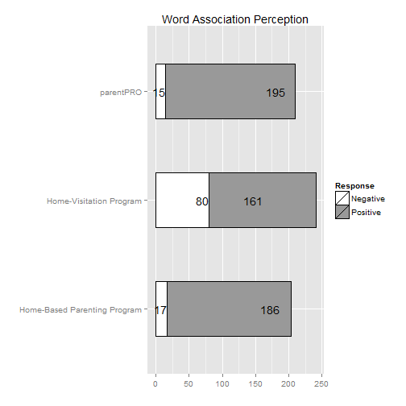

## Word Cloud Response to “Home Visitation Program”

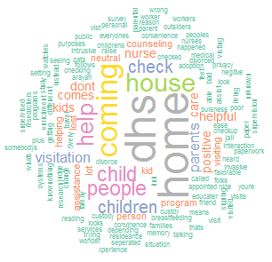

## Word Cloud Response to “Home Based Parenting Program”

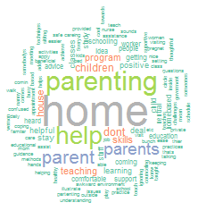

## Word Cloud Response to “ParentPRO”

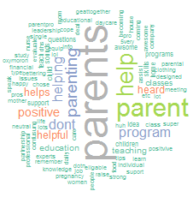

Note: A word cloud is a visual representation of the words reported with font size reflecting relative frequency.

1. **Targeted Marketing**: Within some counties, specific neighborhoods maybe at particularly high risk and would be beneficial to target for home visitation and other prevention efforts. Initial work in using zip code data, include data from Oklahoma Department of Human Services child protective services reports, confirmations, and removals for child protection, may facilitated targeted marketing campaigns. Preliminary review suggests that referrals to SafeCare in Oklahoma County have primarly targeted those zip codes with greatest rate of monthly referrals of families with young children to child protective services.
2. **What is the best method to quickly link families to the program that is the best fit for them? How can recruitment efforts overcome barriers to cross agency referral of families?**

Oklahoma is implementing and testing the use of “community connectors” in six counties. 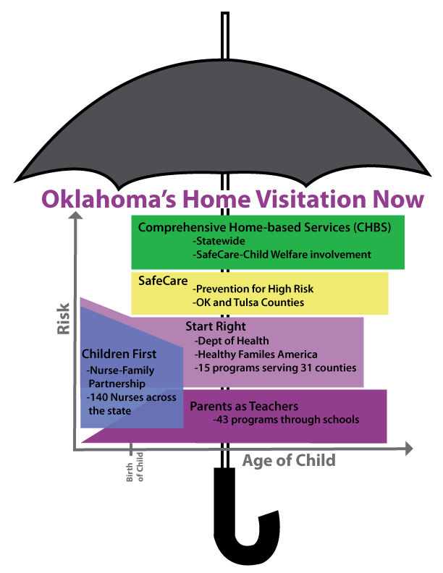Recognizing the need to improve outreach and recruitment, as well as triage families to the home visitation program and other services that best fits their family’s needs, their goals are to:

* Develop local home visitation coalitions
* Recruitment of families
* Communicate about resources
* Triage families to home visitation program that best fits needs and wants of family
* Identifications of gaps in resources and coordinate efforts to fill gaps when warranted
* Improve coordination with other early childhood resources and Child Guidance

Oklahoma is not alone in their efforts to determine the best ways to triage families to the home visitation program that best fits their needs and wishes.

Some States and jurisdictions use a centralized intake process for evaluating the caregivers and children and determining the home visitation program that best fits, as well as link to other resources. New Jersey and Wyandotte County, Kansas (Kansas City) are to locations. ODHS and OUHSC team members visited the Kansas program, as well as had multiple phone conferences with New Jersey officials to learn more about their approach.

* Benefits of the centralized triage process appeared to be:
  + A centralized system for referrals and data management
  + A streamline referral and intake process
  + Assessment of needs, wishes, and resources to facilitate match with home visitation and other programing
  + Dedicated outreach, education, and recruitment personnel
* Challenges of the centralized triage progress appeared to be:
  + Need for collaborative relationship among home visitation programs and trust in centralized intake process
  + Workforce to conduct all intakes and triage
  + Potential for repeated assessment and evaluation of families
  + Efficient process to have documented report on intake process needed
  + Release of Information forms can be intimidating to potential clients

Other States and jurisdictions utilize a community navigator who conducts outreach, education, and facilitate coordination of services. The initial plans for the triage efforts in Oklahoma, follow this recruiter/navigator model. A central navigator, rather than intake process, was chosen in part due to cost. The centralized intake process team in Wyandotte County, Kansas is 5.6 FTE and has a $400,000 annual budget (1 director, 3 intake specialists in the home; 1 intake specialist/recruiter; 1 triage specialist; .6 administrative support). Further, most of the evidence-based home visitation programs in Oklahoma have extensive intake assessment requirements, such that significant negotiation and coordination would need to be in place to determine a central intake procedures and measures that would satisfy program requirements. The community navigator was determined to be the best first step, with goals to have them build community coalitions of the local programs in addition to the outreach, recruitment, and triage. With funding support from the Potts Family Foundation, a website is being developed to facilitate out reach and triage of families to EBHV.

OSDH Continuous Quality Improvement (CQI) and OUHSC’s external evaluation of MIECHV competitive counties (i.e., Oklahoma, Tulsa, Comanche, and Muskogee) are evaluating the activities and impact of the Community Connectors. The questions to be examined are

1. will the Community Connectors marketing and outreach efforts lead to greater number of referrals to home visitation programs, and
2. will families be triaged appropriately, as evidence by initial engagement rates as well as child and family outcomes.

OUHSC will also be piloting with two of the counties using a data base procedure to track outreach efforts, track referrals and triage, and facilitate referrals to local resources. We will be exploring options for the best way to link families to services:

* Person serving as navigator
* Web resources
* Phone resources
* Resource and referral center run by navigator team and used by other professionals and families
* Types of resources targeted: How narrow is too narrow and how broad is too broad?

Oklahoma Research on Triage Decisions for Home Visitation: Results from two current research studies are designed to help address best practices around triage among home visitation programs and components.

One study is examining Oklahoma’s Start Right (Healthy Families American model with Parents as Teachers curriculum) and SafeCare using a Hybrid Regression Discontinuity Randomized Control Design. The evaluation design was selected to accommodate several aspects of the implementation

1. The SafeCare and the Start Right models were intended to serve somewhat different but overlapping populations along the continuum of risk. SafeCare is designed for the highest risk families, but is applicable to moderate risk. Start Right is not designed for high risk families.
2. The implementing agency’s SafeCare adoption decision was based in part on their wish to acquire a model designed for their families at highest risk, while still wishing to retain the Start Right model for families at moderate risk.
3. If there is differential efficacy across levels of risk, it would be important to clearly articulate where decision cut-points might more efficiently be drawn as the project moves from initial investigation into a sustainability phase.

OUHSC selected a hybrid design which merges aspects of the simple regression discontinuity (RD) design with aspects of the simple randomized trial design. In RD designs, the mechanism for selection into treatment condition is made on the basis of cut scores on some at least ordinal scale outcome predictor. The hybrid design incorporates two cut points, defining a middle zone of risk predictor scores in which randomization determines treatment selection.

In the second study, we are researching strategies to enhance the child maltreatment prevention outcomes with high risk populations by examining the relative importance of comprehensiveness vs. focused services and consumer vs. data driven decisions of service provision.

* Comprehensiveness of treatment has long been promoted among and, in many instances, required of psycho-social-behavioral interventions.
* While the face-validity of treatment comprehensiveness is obvious, many have begun to question whether this aspect of treatment might do more harm than good. In fact in our Oklahoma trials of tertiary prevention of child physical abuse, evidence based behavior parent training (Parent Child Interaction Therapy, PCIT) alone was more effective than a comprehensive service that included PCIT plus any other services the family identified as needed (e.g., psychotropic medication for depression, marital therapy, home-based services, etc.) (Chaffin et al., 2004).
* Focused rather than diffused parent training programs have been found to have greater efficacy in a recent meta analyses (Kaminski, Valle, Filene& Boyle, 2008). The reasons for deteriorating impact with greater comprehensiveness of services are yet to be determined. Is there a point, for example, beyond which a client chooses to no longer process new knowledge or gain new skills? Is there a point where new information simply overwrites or de-emphasizes past knowledge and skills?
* While the effect of comprehensiveness on treatment outcomes is largely speculative, the impact of this factor on spending would be obvious. Its downstream economic impact would involve a combination of reduction in treatment expense and effectiveness.

Operationalization comprehensiveness is tricky, however, particularly in the background of other studied factors like order of module exposure. We are utilizing a comprehensive factor that varies the number and possible intensity of modules. Three new supplemental modules of SafeCare have been added to the standard SafeCare protocol for this study: Healthy Relationships for family violence prevention, Managing Child Behavior, and Behavioral Activation for depression. The addition of these three modules to the existing SC package reflects a response to the myriad of underserved client needs not addressed by the Safety, Health, or Parenting-alone modules.

* In the Comprehensive Approach, all modules are covered, dedicating a feasible number of sessions to each so that the entire package can be completed within a reasonable window of time (e.g., 9 months of treatment).
* In the Focused approach, parenting plus one other module is provided with the goal of *mastery* of a limited set of modules.

The study is also designed to address triage or order of the modules so that SafeCare might be delivered more effectively and efficiently. One possible remedy allows for modules of greatest perceived, immediate impact (those addressing the most immediate, client-specific risks) to get first exposure. We refer to this efficiency adaptation as the “Data-Driven” approach to determining order. While addressing immediate risks sooner rather than later seems like a good idea, this approach might also have unintended negative consequences with regard to service initiation, engagement, and maintenance. There is growing evidence that treatment/service compliance and outcomes can be improved when service providers share the treatment decision-making burden. This has been most evident in medical decision-making contexts, but has also been applied to the consumer choice literature more broadly. The implementation of SafeCare in our past studies has allowed for some shared client-provider decision-making, at least in terms of order of module coverage. Members of the Sustainable Implementation Committee strongly encouraged us to systematically examine the “consumer-driven” aspect of treatment. In this study, we will be examining the “data-driven” and “consumer-driven” approaches to care, with special focus on improvements for both future referrals and client satisfaction.

Barriers to Triage Process:

Interpretations of privacy requirements have created significant hurdles to linking families to home visitation services.

* A toll free number to OSDH is available. OSDH can give the numbers of the programs or the local ParentPRO Community Connector to the caller, but cannot provide the family name and contact information to home visitation programs (unless they are part of OSDH) or the local ParentPRO Community Connector without a signed Release of Information form.
* Local ParentPRO Community Connectors also cannot provide the family name and contact information to home visitation programs without a signed Release of Information form from the parent. This reduces the impact of the Community Connector, which was designed to ease the process for referral agencies and parents.
* The required Release of Information Forms are cumbersome and intimidating to potential clients.
* Developing the business agreements across all home visitation agencies to develop the local release of information form has been a challenge in some communities.
* Connection to frequently involved other services (e.g., Sooner Starts, health care, education services) that the families may qualify for and desire, requires additional signed release forms.
* Social media (e.g., face book, twitter, etc.) appears to be critical to engagement, communication, and outreach with youth, including young parents who could benefit from home visitation services. Current state agency barriers to use of social media are extensive.

1. **How can we best engage families into HV services, particularly those at highest risk?**

Many child maltreatment prevention programs have become home-based to increase families’ engagement in services. Despite the convenience of home-based service, programs continue to have high rates of attrition (20-67%; e.g., Gomby, Culross, & Behrman, 1999; Navaie-Waliser et al., 2000) and families still facing obstacles to participation. Research is needed to identify factors related to enrollment and attrition in home-based programs. A mixed-methods study has addressed reasons for enrollment and retention in SafeCare compared to the services as usual (SAU) condition, of community mental health, in Oklahoma (Damashek et al., 2008; Beasley et al, 2012).

Three main themes of what helped families stay engaged in home visitation programs were:

1. Convenience of being in the home and not needing to find transportation and child care
2. Provider characteristic (see table below)
3. Program helped the family, including themes of skills taught helped, topics relevant, and connection with important goods and services for the family

Two additional themes emerged regarding what factors made it difficult to stay in the program:

1. Chaotic life situation and competing demands (e.g., moves, job, phone disconnected)
2. Fear and trust issues (e.g., fear child welfare will be called)

Provider characteristics were strong themes of what made the program helpful and kept them engaged. The home visitor became a strong source of educational, emotional, and social support.

## Themes of Provider Characteristics Related to Program Engagement: SafeCare and SAU Study

|  |  |
| --- | --- |
| Engaging Provider Characteristics | Negative Provider Characteristics |
| * Being someone you feel comfortable with * Expert – knows what she’s talking about * Someone the children likes * Checked in - respectfully * Understands when life is chaotic / not give up on family * Reliable and trustworthy * Flexible | * Personality conflict * Poor communication * Rude * Judgmental * Work seen as a job rather than genuinely care about family |

Individual factors impacted enrollment and engagement in the program, including maternal depression, psychological aggression by partner, and substance use. Families were much more likely to enroll and remain in SafeCare than Services as Usual. Differences in provider and program characteristics are potential influence, including the flexibility home visitation approaches allows which facilitates developing trust through multiple informal visits, drive-bys, calls, and other means to connect with families, which is not feasible in fee for services SAU environment. SafeCare providers also received extensive training in Motivational Interviewing. Engaged consumers of SafeCare noted the program components topics and approach helped, in addition to the quality relationship established with the provider.

McCurdy and Daro proposed a model to conceptualize enrollment and engagement of families in home visitation services. The Oklahoma research supported components of the model, and suggested additional factors to consider of recruitment efforts and social context.

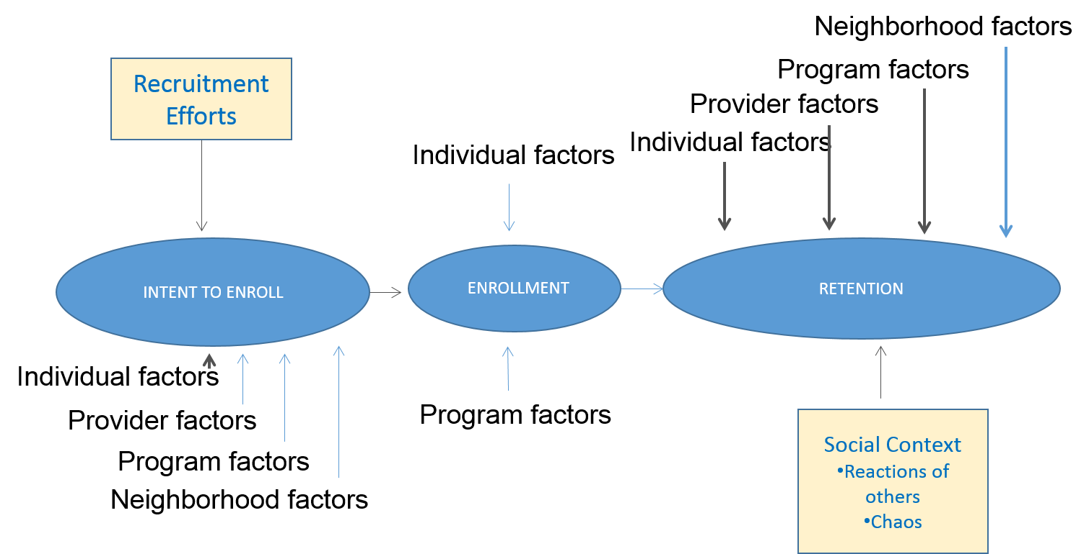

Adapted from: McCurdy, K., & Daro, D. (2001). Parent involvement in family support programs: An integrated theory. *Family Relations, 50,* 113-121.

For the current external evaluation through MIECHV, qualitative data (focus groups and individual interviews) have been conducted with engaged and unengaged families as well as providers in the home visitation programs for the competitive counties (Oklahoma, Tulsa, Comanche, and Muskogee). Results from the Children First program in the urban counties are available and are presented below.

## Preliminary Results of Interviews with P**articipants of Children First** Oklahoma and Tulsa County

**Participant demographics**

Participants involved in the Children First (C1) program consisted of families that were considered engaged versus unengaged in the program. To be considered engaged in the program a participants were involved in five or more home visits with at least one visit taking place after the birth of their child. Unengaged parents were referred but dropped out of the program before the birth of their child. The current study consisted of 27 engaged participants and 15 unengaged. The families were diverse (31% Caucasian (non-Hispanic), 31% African-American, 26.2% Hispanic or Latino, 7.1% American Indian or Alaska Native, and 4.8% Asian}. In terms of relationship status, 40.5% of the sample reported being married, 7.1% separated, 21.4% living together, and 31% never married. Education of the sample consisted of 16.7% not receiving a high school diploma, 23.8% receiving a high school diploma, 4.8% receiving a GED, 28.6% having some college (no degree), 7.1% completing vo-tech or training program, 7.1% completing an associate’s degree, 7.1% completing a bachelor’s degree, and 4.8% receiving a master’s degree. The median monthly income for the sample was $1062.50.

**Themes** When text segments were analyzed, several themes emerged regarding participant’s perceptions of the Children First program. Some themes were constant across all participants while other themes emerged with unengaged versus engaged participants. An idea or a cluster of ideas is defined as a theme when it is mentioned by at least half of the interviewees.

***Theme: Reasons for enrolling in home visiting program.***Participants were asked to explain reasons for enrolling in a home visiting program. **Participants overall expressed a positive attitude toward Children First and home visiting.** Several key reasons emerged as being most important to enroll in a home visiting program regardless of whether families were engaged or unengaged. It is important to note that frequency varied depending on group classification (engaged vs. dropped out) but sub-themes were similar. Themes for why the participant enrolled in home visiting were as follows:

“Didn’t really have, well I have family, but you know, no one was helping me through the pregnancy and all that, so basically this is what I reached out to the program for, is just to get that support and information” Mother who enrolled in Children First

* Information/Education
* Insecure/Anxious
* Stress/Overwhelmed
* Support
* Isolation

***Theme: Factors for engaging in Children First program.*** There were definite themes that emerged for reasons why participants engaged in the Children First program. Below are some sub-themes and representative quotes specific to the groups. Included are the frequency that each theme was mentioned in the engaged versus unengaged groups. Similar to the results with SafeCare, the Provider characteristics, approach, and support was found to be critical to keep families in Children First services. Multiple characteristics of the providers were listed as important. See table on page 16 for list of provider characteristics that support building the relationship and engagement, as well as characteristics that led the parent to not stay with the program. Similar themes were found with these interviews with Children First participants.

“Patience. I mean sometimes you don’t understand the first time when they are trying to teach you something and show you or when the baby is crying, you have to listen too. You know, check a few things. So I mean the first time we may not get it but they still say, ‘Okay you do it like this’”. Mother from Children First program.

* “Other” reasons for engagement reported by parents who engaged in Children First.
  + Approach of program 4%, program material 5%, program medical 4%, Program education/info 6%, provider education 3%, provider enjoys/cares about job 1%
* “Other” reasons responses from the mothers who dropped out of Children First before having their baby.
  + Approach of program 6%, Content of program 6%, Provider education 3%

*“But that’s one of the reasons I loved my nurse so much because I feel like my autonomy is respected and she makes me feel more confident as a mother and I feel like she empowers me and doesn’t step in and say “Well you’re doing it this way, you should be doing it this way.” Mother from Children First*

***Theme: Primary reason for engaging in Children First program.*** Participants that were engaged in the program were asked to disclose the *primary* reason for remaining in the Children First program. Representative themes were:

* Flexibility (29%)
* Education/Information (29%)
* Provider Support (21%)
* Monitoring child’s development (14%)
* Convenience/in-home (7%)

“Definitely flexibility. Cause we… well I’m still in the program because my daughter is not yet two. We have had a couple of family deaths during… since my daughter has been born and so there was a time where like we were out of town for things and the nurse was not only flexible to be accommodating that I had to reschedule an appointment, but she actually checked in with me afterwards to ask how I was doing emotionally and things like that.”

*Mother from Children First*

“I think one of the things that have made me stay or stick around is just knowing the status of what my child has going on, like his weight and you know, his development. Because you can’t always find that out without making an appointment. At least I have my nurse visiting every other week or every month to discuss these things with me versus me going to a specialist or going to the doctor, you know.”  *Mother from Children First*

***Theme: Factors for not engaging in Children First program.***  Participants that were considered engaged and unengaged in the program were asked describe factors that would contribute to a family not remaining (dropping out) of home visitation programs. Once again, provider characteristics, personality, and approach appear critical to building the relationship and trust necessary to keep families engaged in services. Similar things as noted in the table on page 16 were found.

Individual Interviews were conducted with providers. The following provides results relevant to engagement of families.

Provider demographics

Providers involved in the Children First (C1) program consisted of nurses that provided home visiting services to families with the current study consisting of 25 nurses. There was a variety of ethnicity indicated by providers including 20% Caucasian (non-Hispanic), 4% African-American, 8% American Indian or Alaska Native, and 8% Asian. In terms of field of study, 92% indicated nursing, 4% dual nursing/psychology, and 4% dual nursing/public health. Some providers indicated prior experience working in C1 (28%) with most reported no prior experience (72%). Education of the sample consisted of 12% receiving an associate’s degree, 76% bachelor’s degree, 8% master’s degree, and 4% reported some college no degree.

***Theme: Primary reasons for participant engagement.*** Providers were asked the primary factors that facilitated families staying with the Children First program and not drop out of services. Some of the factors mirrored the information from the parents. Being flexible and building a trusting relationship are themes for both Providers and Parents. Genuinely caring about families and young children are important characteristics for successful home visitors, including nurses. Providers also elaborated on the characteristics of the parent that facilitates engagement, particularly being personally motivated and interested in learning material to improve parenting and well-being of their child. Representative themes and graphs are below:

* Provider Characteristics (44%)
* Participant Characteristics (34%)
* Other: Support System, Basic Needs Met, Clean Home, Transportation, Telephone, Good Financial Situation, Convenience of In-home, Education Level, Culture

***Theme: Participant barriers to engagement.*** Providers were asked to disclose the barriers that families face to remaining in home visitation and lead to dropping out of services. Below is a representative chart of participant barriers:

* Chaotic/Unstable Life (24%)
* Other Priorities/Limited Time (18%)
* Negative Family Influences Regarding Program (7%)
* Mental Health Issues (6%)
* Provider Filing Child Welfare Report (6%)
* Keeping Scheduled Visits (6%)
* Lack of Support System (6%).”
* Other: Basic needs not met, Denial, Young age, High-functioning, invasive questions, substance use, don’t want in-home visits, financial burdens, Feeling pressured into program)

1. **How to run home visitation programs with greatest efficiency and quality? How do you measure productivity of home visitation services? What supports and training would facilitate efficient and effective service delivery? When do you decide what activities are priority and useful?**

These questions are not unique to home visitation, but are important in most if not all service delivery system. OSDH is implementing Continuous Quality Improvement (CQI) plans to examine and improve productivity and efficiency of home visitation program funded through their office. Productivity requirements for home visitation have to consider a number of factors unique to that system, not relevant to clinic based services. To initially examine these questions, interviews were conducted with providers and supervisors of the SafeCare Prevention Model in Oklahoma. For SafeCare program, high risk families volunteer for services, and because their chaotic life styles, keeping regular appointments is challenging. The SafeCare prevention teams indicated for a full-time position in order to meet the needs of their clients, they recommended 10 visits a week and a case load of 10-12 active families. The following lists activities that are regularly conducted that fills their full time work load.

* travel to and from visit (up to 30 minutes one way) for sessions and no shows, as well as drive bys to try to connect with hard to reach families
* 90 minute session average (verified by process data)
* phone call reminders day before and day of session, letter reminders
* case management activities (e.g., problem-solving and connection to resources)
* documentation and assessment – 30-45 minutes per client outside of session
* transporting families to appointments
* training – 1-2 days a month of training
* outreach
* supervision, case consultation
* agency training and meetings

Comprehensive Home Based Services (CHBS) also provides SafeCare, though the cases are court ordered, and thus are less likely to miss appointments. They can more regularly see 12-14 clients a week.

Staff turnover has been a major concern for OSDH run EBHV programs. Below are summaries of preliminary HR data on nurses who deliver C1. In the first plot, data on the sample employed in 2009 or later are presented as a survival curve of employment (a failure event being the firing, transfer, or resignation of a nurse). The two vertical lines depicted display the end of C1 training and the end of a year of service post-training. Retention rates for these two markers are roughly 85% and 65%. In the second plot, while sample size inhibits sound statistical conclusions, we see the turnover rate may be trending upward since 2009. For example, among nurses hired in 2011, less than 45% remained in the workforce after seeing clients for a year; the 2012 hires appear to be following a similar or lower trajectory. In contrast, about 80% of the 2010 hires remained after a year with clients; the 2009 hires had an even higher retention rate at the same point.

## Nurse Tenure

#### Graph A.

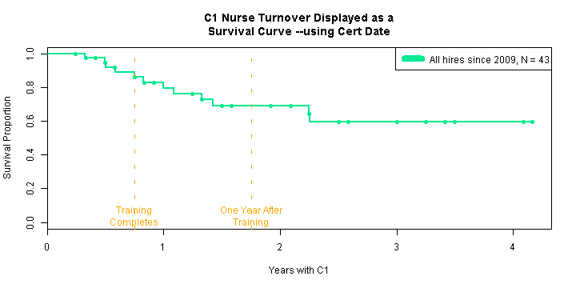

#### Graph B.

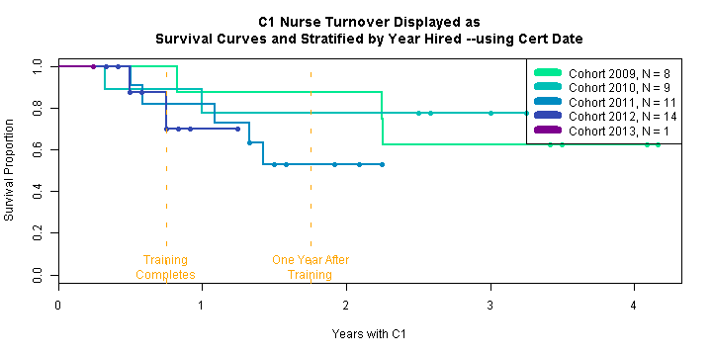

1. **How can child, parent, family, and administrative outcomes be best linked and examined across different agencies’ databases while respecting individual privacy and protections?**

Although data on outcomes and risks among children in the state have become more and more abundant, access to these data has become increasingly difficult and has, arguably, become a major impediment to progress on the fronts of EBHV program triage and long-term continuity of care. This negative relationship between the amount of data and free access to data is directly proportional to the growing demands and importance placed on protections of consumer privacy, in particular privacies involving consumer health as stipulated by the Health Information and Portabiltiy and Accoutability Act. While all states have struggled to overcome these data sharing obstacles, some states have been more successful than others are securing methods to enhance efficiencies in their system referral, retention, and outcome evaluations. Two such states, Massachusetts and Ohio, are being featured in an upcoming Chapin Hall webinar titled “State Perspectives on Data Linkages in Home Visiting Programs.” To a large extent, the data sharing success in these states has been predicated on a re-interpretation of what constitutes “health” information and greater focus on the risk:benefit ratio of EBHV data sharing. Moderate strides have occurred locally (e.g, OSDH issued RFP this week to obtain a new EBHV data system; a MIECHV referral partnership developing with the Assuring Better Child Health & Development program) but with very little impact on overall system efficiencies. It is our hope that the accelerated progress demonstrated in other states could eventually be used as precedence for seeking state and/or agency policy changes here in Oklahoma.

1. **How do we manage inefficiencies due to State agency contracting procedures?**

The current contracting procedures and process creates barriers and delays in activity and productivity. Delays have been notable in contracting with the approved marketing firm, issuing request for proposals for expanding evidence-based home visitation services in six counties (12-18 months) and for developing a comprehensive data management system across home visitations programs, business agreements with programs, and contracts. Efforts to improve the timeliness and efficiency of the contracting process are recommened.

1. **What are the best methods to estimate and conduct cost benefits analyses for Oklahoma’s home visitation efforts? How best to calculate and compare costs of programs, given different targets, intensities, durations? How determine the tipping point of maximum benefit?**

Accurate understanding of costs and potential cost savings, given short-term and long-term outcomes are critical to sustainability of programming.

1. **Home visitation alone cannot solve all the ills and challenges for our families who are struggling the most. How do programs best address and collaborate with services on issues of a. safe and stable housing, b. child care and early education, c. medical care for parents and children, d. mental health services for parents and children, e. domestic violence, f. substance abuse services, g. basic needs, h. self-sufficiency, and g. sense of belonging, support, and faith?**

As discussed in the triage section starting on page 13, efforts are being made to pilot and evaluate different methods for linking families to service product and program needs. Helping families establish a medical home and link to Sooner Starts and other educational services are common goals of parents with young children participating in home visiting services. Options are being explored for expanding successful referral systems to include home visitation in collaboration with the Oklahoma Health Care Authority, Department of Education, and the University of Oklahoma Health Sciences center.

A critical barrier to linking families to basic needs and product needs is state and federal policies prohibiting provision of goods to families. Chaffin, Bonner, & Hill (2001) found better child abuse prevention outcomes in Oklahoma among basic needs programs. Efforts are in place to explore other options for funding these services, such as through private foundations and case donations as well as product donations by relevant stores.

* 1. What are best methods to improve collaborative partnerships with businesses, private foundations, faith communities, and parent partners?

The Sustainable Implementation committee has been exploring options for partnerships with private business as well as the faith communities. The Private Business and Foundation sub- committee has been meeting regularly and have developed initial goals to target supporting basic needs support and the website, which will be designed to not only facilitate triage but also link families to support and resources. Another subcommittee designed to engage the faith community will meet in August, 2013.

# Bibliography

Aarons, G.A., Sommerfeld, D., Hecht, D., Silovsky, J.F., Chaffin, M. (2009). The impact of evidence-based practice implementation and fidelity monitoring on staff turnover: Evidence for a protective effect. *Journal of Consulting and Clinical Psychology.* 77(2) 270-280.

Bard, E., Silovsky, J.F., Schmidt, S., Pitts, S., Whitaker, D. (2011). In the Spotlight: Preventing and Addressing Domestic Violence in EBHV Programs. *EBHV Connecter*, 1(8), 1-2.

Chaffin, M., Hecht, D., Bard, D., Silovsky, J. F. & Beasley, W. (2012). A statewide trial of SafeCare home-based services model with parents in Child Protective Services. *Pediatrics,* 129 (3), 509-515.

Chaffin, M.C., Silovsky, J.F., Funderburk, B., Valle, L.A., Brestan, E.V., Balachova, T., Shultz, S., Lensgraf, J., & Bonner, B.L. (2004). Parent-child interaction therapy with physically abusive parents: Efficacy for reducing future abuse reports. *Journal of Clinical and Consulting Psychology, 72(3),* 500-510.

Damashek, A., Doughty, D., Ware, L., & Silovsky, J.F. (2011). Predictors of Client Engagement and Attrition in Home-Based Child Maltreatment Prevention Services, *Child Maltreatment, 16*, 9-20.

McCurdy, K., & Daro, D. (2001). Parent involvement in family support programs: An integrated theory. *Family Relations, 50,* 113-121.

Silovsky, J.F., Bard, D., Chaffin, M., Hecht, D., Burris, L., Owora, A., Beasley, L. & Doughty, D., & Lutzker, J. (2011). Prevention of child maltreatment in high-risk rural families: A randomized clinical trial with child welfare outcomes. *Children and Youth Services Review,* 33 (8), 1435-1444.