1.usestaticarray.c

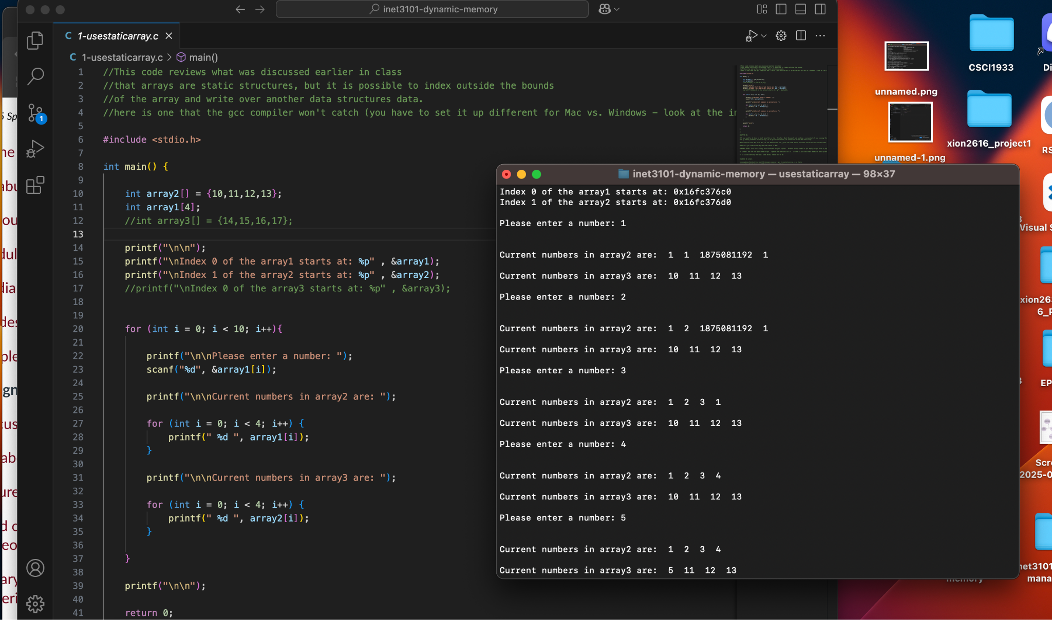

3. Modify the code and explain the approach and why it solves the problem.

In this approach I turned the for-loop into an infinite while loop, it is setup in a way such that when entering strings it will end the loop/program. I also made a variable that would count the numbers in the array and if it reaches the current size then it will resize utilizing the method in 7-managing allocation. Finally, the array size and current numbers get printed, this solution works because we increase the size of the array by 10 meaning there will be enough space for more numbers.

4. Simple-dynamic-example

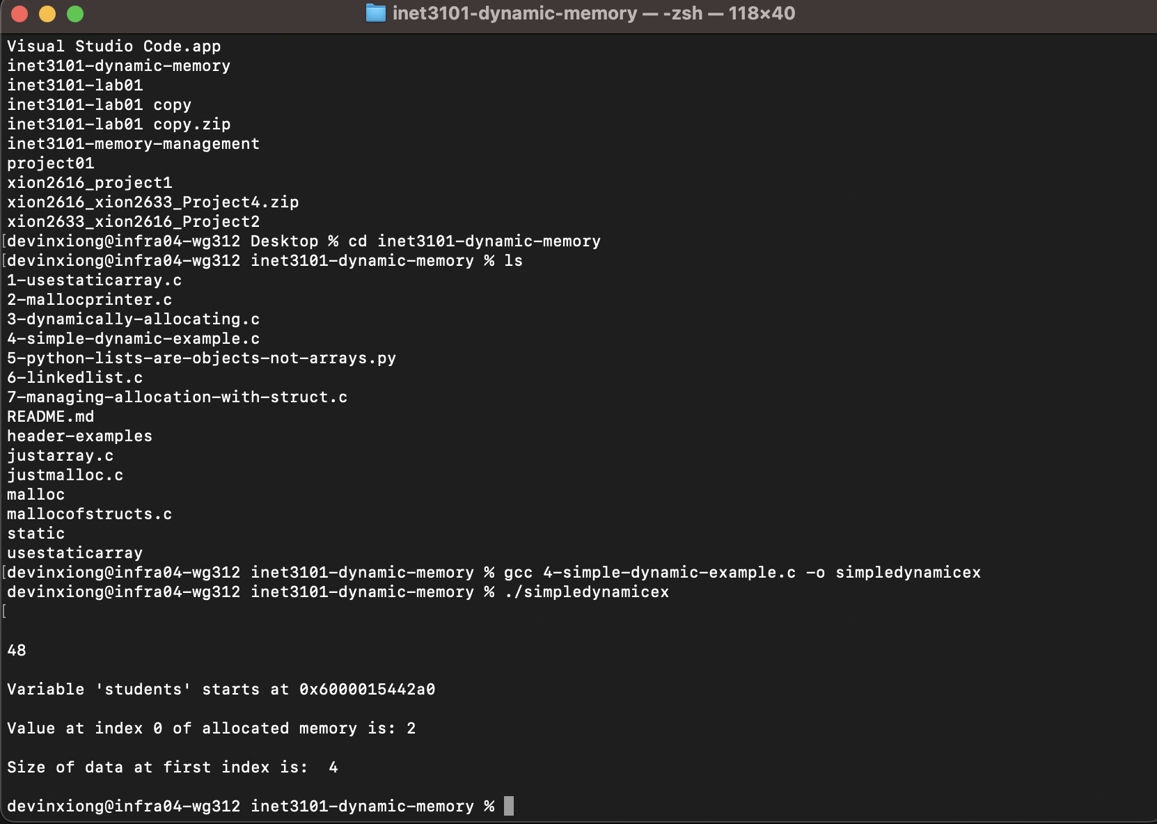

5.Define what an Object is in terms of the Object Oriented Programming paradigm.

In terms of object oriented programming, objects are essentially units based on real-world concepts combining two main aspects. These are attributes, which are the characteristics of the object, and methods which are the functions that are able to be performed with said object.

6. How does using a linked list solve some of the same problems we are trying to overcome when using dynamic memeory?

Using a linked list solves the issues with resizing arrays since they can expand or shrink on the spot without the need to allocate new memory to copy over. Another issue linked lists solve is the efficiency of inserting and deleting elements which in arrays for example, removing or inserting an element in the middle of will require other elements to be shifted before it can be reached.