Virtual environnement :
> python -m venv env
> env\Scripts\Activate
Installation dependencies :
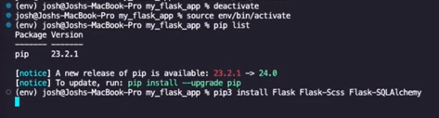
Create requirements.txt :
>pip freeze > requirements.txt
Basic flask app :
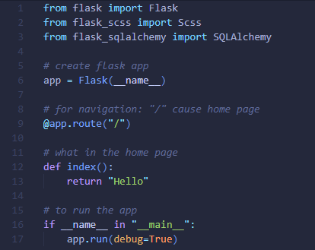
Project architecture :
- Templates: where there’s the pages of the app (route).
- Static: CSS files.

