Developing a Mission & Vision Statement

Mission Statement
Snapshot description. Should be concise, outcome-oriented, and inclusive. This is your mandate and purpose.

What do we do and why do we do it?

1.Purpose and reason for existence
2.Who we serve (membership), what makes us different
3.Geographic area served or operated within
4.Function of the organization

A good practice is to keep this statement to one or two sentences; if not possible consider an additional slogan or tagline

Example: ”We proactively bring to market natural, organic, and local food products within a co-operative network” Ontario Natural Food Co-op

Vision (The Dream)
Provides future direction.

•What would be our ideal end state?
•How would things look if issues were perfectly addressed?
•Makes your beliefs and governing principles clearer to the greater community and your members
•Can motivate the group, prioritize use of limited resources, and keep discussion on-track

Exercise. Imagine you are reading a newspaper 5 years from now about your group’s achievements that makes you happy. What does it say? What does success look like?

- Everyone jots down some ideas in the chat box or to send to me via email to summarize for the next meeting
- We look for overlapping themes
- LOOK FOR 2-4 STRONGEST WORDS/THEMES to describe your group
- Use those key words to write your vision

Example: A local food community built on shared responsibility for a sustainable and inclusive food system. “ West End Food Co-op

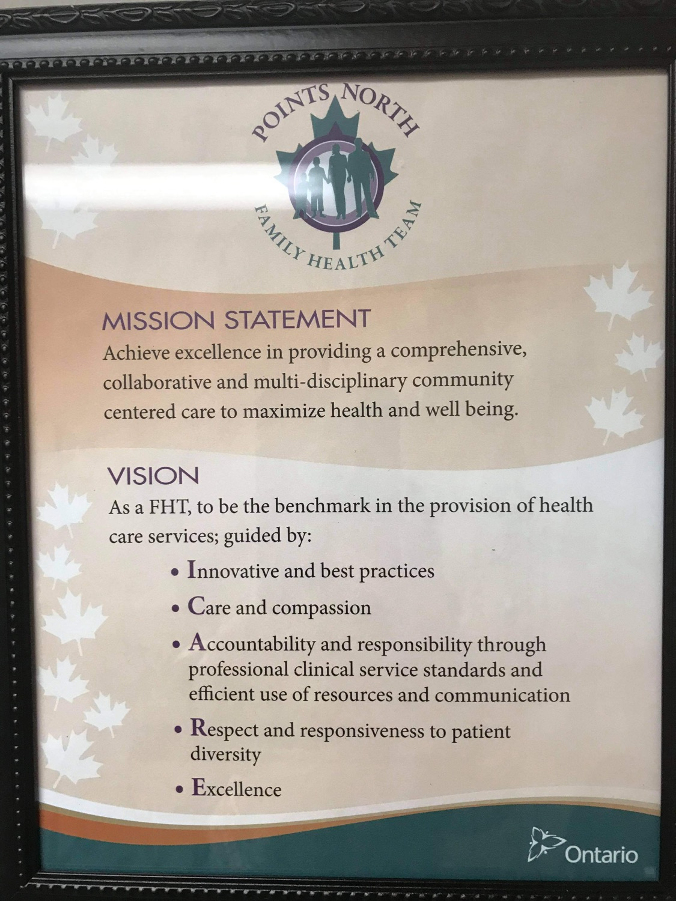
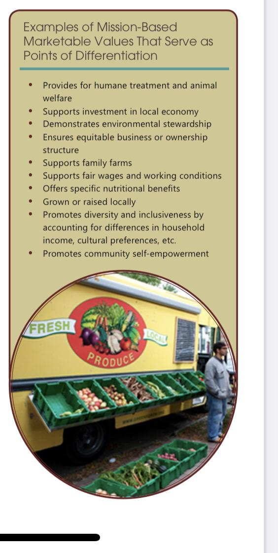
LFFC:

Mission: Fostering vibrant, resilient, connected and sustainable food and farm co-operatives

Vision: In addition to general endorsement of the Seven Co-operative Principles, and recognizing food as a human right, the Local Food and Farm Co-operative Network values Ontario food systems that are:

1) Accountable to local producers and consumers

2) Fair, just and democratic business in all forms of food and farm co-ops)

3) Open and accessible

4) Ecologically sustainable

5) Compassionate and built on solidarity

6) Fostering good food knowledge

Mission Statement group notes:

BT:

Purpose : Local food made and created in the 807 area, local/fresh = more nutrients, eco-friendly, food security

Serving 807 area, members, local food box- individual personalities, brands

SH:

Connecting food producers & consumers in the 807 area through a creative & inspired weekly/monthly? Local food box

BF:

- providing support for membership to reach a broader market and make the shift from exclusively direct to consumer-wholesale
- Small-to-medium scale producers and food preparers
- Northern Ontario
- Business incubator, Food hub distribution, shared capital resources

NW:

- Local Food Producers coming together to offer an easier way for customers to access their goods.
- We serve the 807 and have access to local foods grown in the area.
- The 807
- To create local food demand and need.

Key words discussed:

Collaborative, united, local, fresh, 807 area, nutrient dense, nutritious, eco-friendly, food security, locally made products beyond food

(Consider if culturally appropriate or self-determined food systems play a role in our region)

Eco friendly, environmentally conscious??

BParr- brainstorm notes

Providing/Building a resilient /sustainable/self-determined (local)(food) system/ community through the creation of a one-stop shop that benefits (local) consumers, producers and our (local) economy.

Providing flexibility and convenience to the 807 region through a resilient and

Providing a grassroots localized/ decentralized food supply for NWO consumers and producers which benefits the local economy.

Fosters self -suf

Vision statement group notes:

BF-
Local Dryden Food Hub exemplifies successful collaboration between forestry, agriculture and food expanding local producer and food preparer markets and permitting them to scale up and become competitive with imports. This has resulted in lowering food costs in Northern Ontario while improving access to fresh food, increasing food quality and improving health throughout the region.

SH-
Vision? Growing and supporting the local food movement in the 807 area by connecting local food producers with local food supporters through the use of an inspired collaborative loca food box

NW - Ever evolving, ever changing to fit the needs of customers or producers, The 807 Company has brought local foods and products to everyone in NWO with their collaborations.

FINAL
The 807 Food Co-op inspires collaboration and growth for producers in our region. We do this by:
- Recognizing food as a human right
- Building & strengthening relationships across the food value chain
- Inviting more consumers to participate and become educated in local food exchange
-Providing a framework for 807 producers to support collaborative marketing & distribution
-Driving the local economy through self-determined, sustainable food choices

Mission Statement:

“Providing quality, locally grown and crafted products through a grassroots food system to foster self-sufficiency and sustainability in Northwestern Ontario.”

Vision:
The catalyst towards an innovative, self-sustaining local food system to improve our NWO economy and the health of our communities. Changing with the times, producers will effectively collaborate
Key words: growth, collaboration, expansion, strong regional value chain, competitive, lower food costs, food security, food access, quality, improved health
DOES THIS SOUND LIKE SOMETHING YOU WOULD WANT TO BE INVOLVED IN? MEMBERSHIP IS OPENING SOON TO SELL ON OUR ONE STOP MARKETPLACE.

