Business Plan
Above Parr Solutions Inc.
Dryden, ON
October 12, 2022

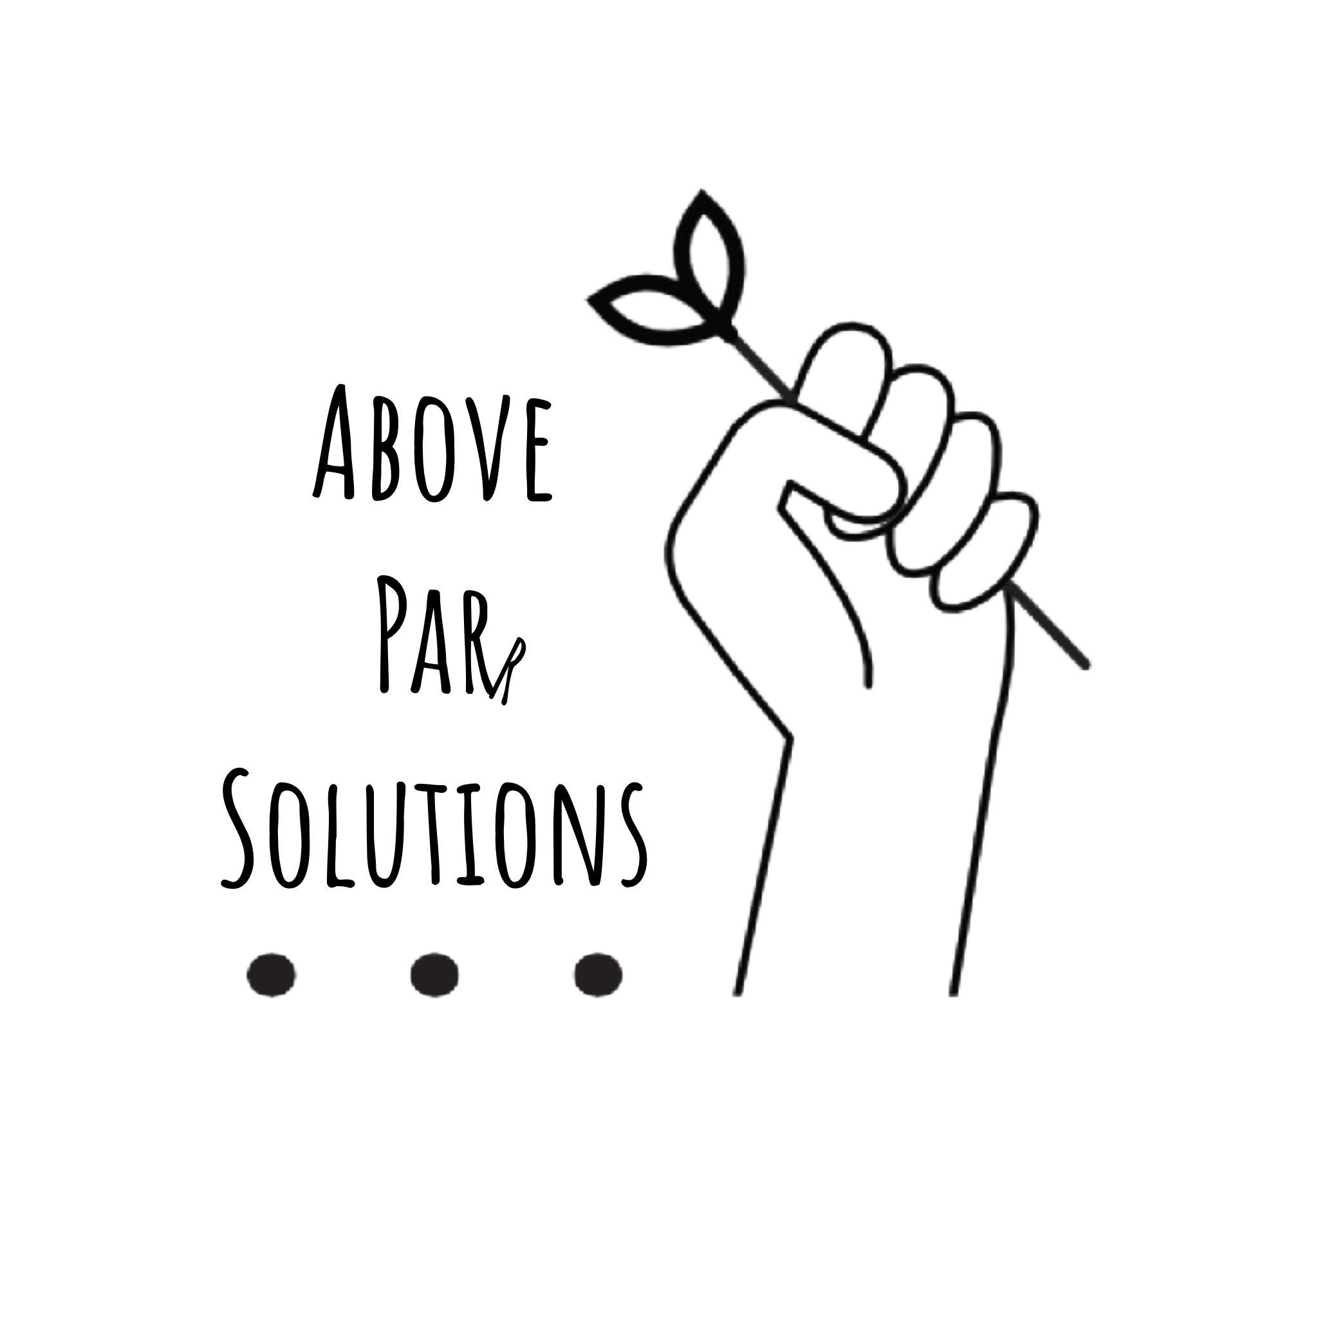

Table of Contents
Company Profile 1
Business Overview 1
Models to Promote Food Security 1
Why a Cooperative? 1
Food Box Programs 1
Farmers’ Markets 2
Company History 2
Management 3
Legal Structure 5
Mission 5
Vision 5
Short-Term Milestones 6
2021-2022 Goals 8
Market Research 9
Industry Profile and Outlook 9
Template for Expansion 10
Local Market 11
History 11
Economic Characteristics 11
Market Size 12
Top-Down Methodology 12
Demographic Summary 12
Primary Research Results 13
SWOT Analysis 13
Competitive Analysis 15
Target Market 16
Barriers to Market Penetration 16
Lack of Infrastructure 16
Lack of Distribution 17
Lack of Facilities 17
Keys to Success 18
Sales & Marketing 19
Product/Service Description 19
Pricing Strategy 19
Sales Process 19
Strategic Alliances 20
Marketing Resources 20
Marketing Strategies 22
Operations 24
Location 24
Legal Issues 24
Insurance 24
Human Resources 24
Process/Production 24
Planning and Preparation 25
Acquisition 25
Compilation 26
Distribution 27
Producer and Consumer Payments 28
Equipment & Technology 28
Operational Personnel 28
Workshops 30
Risk Assessment 31
Financials 37
Start Up Costs 37
Expansion Costs 37
Sales Projections 37
Year 1 37
Year 2 38
Projected Cash Flow 38
Year 1 38
Year 2 39
Year 3 39
Works Cited 40
Appendices 41
Appendix A – Pre-Pilot Survey Results 41
Appendix B – Management Resumes 41
Appendix C – Incorporation Documents 41
Appendix D – Post-Pilot Survey Results 41

Company Profile

Business Overview
Above Parr Solutions is a membership based service which offers opportunities for individuals and communities to learn about Lifestyle Design, Build Relevant Skills and Design a “New Normal” that brings them peace of mind.

Why a membership & online course model?
With what seems like endless global problems and many industries shifting rapidly, there is likely to be increased social upheaval and less community stability. People will be searching for a better life. Free floating anxiety often stems from living unfulfilled, unsure of how you want your life to look. Compound that with a loss of faith in institutions over the last few years and that many people have continued feelings of helplessness with many things that are beyond their control. Above Parr Solutions empowers individuals by helping them diagnose their unique challenges and barriers while focusing on actionable solutions for the future. Online courses offer an increased impact over 1on1 by enabling support for more people to reach their destination of a better life.

Courses
With a rapidly changing economy, it can be challenging to know how to adapt in these circumstances. We offer courses for things like: growing food indoors, food preservation, homesteading, lifestyle design, permaculture, homeschooling, “truly” diversifying assets and so much more to help you gain the resilient life that you desire!

1on1 Coaching
With fear of the unknown at an all time high, we can provide you thorough, personalized guidance towards a life that works for you. Taking into account global forces, most likely challenged and individual barriers, we help you through the rabbit hole and out the other side into the life that you deserve.

Membership & Affiliate Program
Above Parr Products is our affiliate program that offers a way to support the work we do at no cost to you! When you find a lifestyle design solution that works for you and intend to start towards that goal, there is often equipment you’ll need to make this a reality! When you purchase through the link provided, we both get value from our affiliates to compound our impact! We can help more people get started and you can be rest assured you’re starting out your journey with quality products.

Company History
Above Parr Solutions is a venture by Bobbie Parr, owner of Parrs Jars. Bobbie Parr graduated with a degree in Recreation Management & Community Development from the University of Manitoba. With a keen interest in grassroots development, Bobbie loves to spark joy in others by tailoring practical, life changing solutions to current challenges we face. With the belief that flourishing communities are built by internally motivated individuals, she takes aim to provide frameworks and guidance towards living a life of self-sufficiency. Lifestyle Design is the arrow she uses in this online content model to hit her target of developing resilient communities.
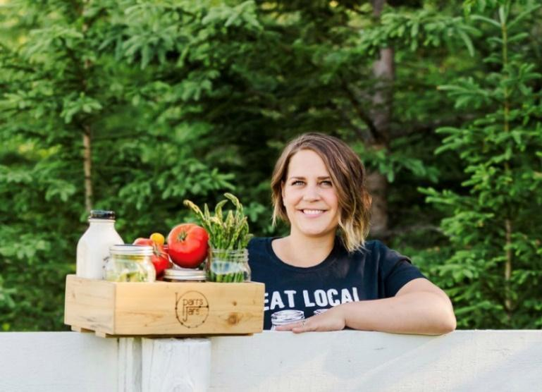
Figure 1: Bobbie Parr

Legal Structure
“ABOVE PARR SOLUTIONS INC.” has been issued a certificate of incorporation under the Cooperative Corporation Act effective ??, 2021, as a Cooperative Without Share Capital. The appropriate documentation is attached as Appendix C – Incorporation Documents.

Mission
Providing members with practical solutions to the coming times through education based content on lifestyle design, food preservation and skill building.

Vision
To foster an environment which empowers a community of individuals rooted in self-sufficiency, mutual support and collaboration to succeed, through education based content delivery.

Short-Term Milestones
Major Goal | Strategy | People | Specifics | Time Frame &  Project Status
Develop courses, sponsor and affiliate programs | - Establish committee for developing master business plan document as a living document.  - Establish committee to develop new bylaws and policies for board approval.  - Establish committee to develop operations plan for board approval. | Business Plan Committee:  - Ben  - Nat  - Bobbi T.  Policy/Bylaw Committee:  - Brent  - Jen  - Ben  Operations Committee:  - Bobbie P.  - Bobbi T.  Software Planning Committee:  - Ben F.  - Nat | - One submission or review per meeting, per committee, on rotation.  - Ongoing reviews of bylaws and policies following completion of documentation. | - Full set of bylaws to be ready for December 31, 2021  - Draft business plan to be ready for December 31, 2021.  - Operational Plan draft to be ready for July 31, 2021, with a final deadline to be decided upon during review.
Develop social media, YouTube and podcast schedule  Marketing objective | - ensure consistent content creation to be available for free in the form of weekly podcasts, YouTube videos (ripped audio and one-offs) as well as twitter, odysee and fountain development.  - Bobbie P.: Incorporate customizations because almost every customer doesn’t want something in the subscription box.  - Bobbi T.: Booth at Fall Fair Aug 26-28. Collect both producer and consumer contact info via a mailing list sign-up.  - Ben F: Feature box customizations for next 6Wk box cycle as a social media campaign. Utilize feedback from this next 6Wk cycle to prepare marketing for the following year. Feature customizations as adding value, you only get what you wand and you can save money that way too! | Suppliers:  - Bobbie P.  - Nat  Customers:  - Bobbie P.  - Nat  - Bobbi T.  - Ben | - Reaching out to additional Northern Ontario suppliers directly and scheduling into the boxes, which is creating relationships with suppliers in advance of membership bylaws being ready. Eventually convert into membership when bylaws are ready.  - Focus on producers interested in scaling.  - Booth at Fall Fair Aug 26-28.  - Social media campaign for next 6Wk cycle, utilize feedback to prepare for 2022 social media campaign.  - Postseason market survey with subscribers to collect information to inform 2022 campaigns.  - Get better & additional photography of food boxes and recipe cards to feature in social media.  - Ben F.: Academic partner acquired, Ohio University, to conduct Market Communications Strategy (B2C) in Fall of 2021. | - Incorporate three additional suppliers for the next 6Wk Subscription Box (Starting August 26, 2021).  - Keep bylaws on schedule and recruit supplier membership for 2022.  - Attend Fall Fair to feature the new 6Wk box, sell any remaining subscriptions, final of the season.  - Prepare 2022 social media campaign proposal by December 31, 2021.  - Prepare marketing plan via Ohio University by December 31, 2021.
Generate operating funds through funnel creation into content delivery and online offerings.  Financial objective | - Ben F: Opening supplier membership for 2022 will generate additional operating capital.  - Ben F: Pending government funding applications will generate additional infrastructure funding, permitting scaling to meet additional demand and a larger catchment.  - Bobbie P.: 15%+ margin + administration fees for weekly payments are generating working capital for the co-op and can be used as matching funds for the government funding opportunities. | - Bobbie P.  - Ben F.  - Bobbi T. | - Bobbie P.: managing operations, including collections/payments.  - Ben F.: generating funding application content.  - Bobbi T.: Tracking funding opportunities and finance. Eventually collections/payments will shift to Bobbi T. once Quickbooks file is fully established. | - Bobbi T. to establish Quickbooks by August 31, 2021.  - Bobbi T. to take over collections and payments by August 31, 2021.  - Ben F. Complete at least one major funding application related to infrastructure by December 31, 2021.

2021-2022 Goals
- Develop educational content and digital offerings alongside an affiliate, membership and sponsorship program.
- Create online presence and generate weekly free content on twitter, YouTube, odysee, TikTok and fountain.
- Develop a funnel to acquire new audience members and individuals seeking practical solutions for self-sufficiency.

Market Research

Industry Profile and Outlook
The nature of the agricultural sector in the region is that it has remained largely unchanged in regards to the size and quantity of farms and farmland, but there has been a continual small-scale decline in the industry while the farms benefit from reduced operating costs over time but have largely unchanged profits, likely due to innovation and other capital improvements that are only keeping pace with agri-food pricing. (Dungannon Consulting Services, 2011; Statistics Canada, 2017)
Four prior mini profiles of food security projects operating in Ontario are provided in Dungannon’s report: the Dryden Locavore Project, the Ottawa Valley Food Cooperative, Eat Local Sudbury, and the Thunder Bay Country Market. We will briefly outline the findings of these three models, which informed the 807 Food Co-op’s direction.
The Dryden Locavore Project offered food subscription boxes on both a full payment up-front and bi-weekly payment schedule. The boxes were distributed on a bi-weekly basis, with each box valued at $22 or $200 for the season, totaling 18 weeks (10 Boxes). There were 30 participants in the program and a waiting list was required due to such high interest in the region. All participants were satisfied with quanlity at least “most of the time,” and more than half (62%) were satisfied with the value. The box contained bread, meat, salad dressing, and vegetables such as carrots, potatoes, peas, and beans. A newsletter was generated that outlined the box contents and provided recipes to accompany the box program. Time to operate the program was in-kind by a Health Educator and Kenora District Soil and Crop Improvement Association (KDSCIA), lowering the costs of operation to only having to pay for the products being provided to consumers. All proceeds were forwarded on to producers; the program retained no fees.
The Ottawa Valley Food Cooperative listed more than 974 different products from 41 producers on a website for consumers to purchase. Consumers can order only within an eight-day window for an upcoming month. The co-op then conveys orders afterwards in a five-day window, during which adjustments to consumer orders may be required as stock is confirmed. Final invoices and payments are then generated. Boxes are assembled by volunteers, including distribution to consumers’ homes. 10% fees are charged to a seller and 5% is charged to the buyer. The co-op was structured as a without-share capital non-profit co-op. Consumers must pay a $50 membership fee for a lifetime membership. For a producer to become a member, they must first register as a consumer and then pay an additional $50 fee to become a lifetime producer member. Producers must go through a jury process to be admitted as a producer to the co-op. All members are equal in democratic processes, in a single class of membership. The on-line ordering system was noted to provide flexibility to both consumers and producers. This model offers the most flexibility to the producer on how to price their product and what quantity they wish to make available. A downside was the consumers having to coordinate their pick-up times around a very short pick-up window. A reliance on volunteers was also noted as a weakness.
Eat Local Sudbury went as far to operate a local food grocery store, which was likely more feasible due to the higher population density in Sudbury, ON. The co-op provides products from 55 local producers sourced from within 150 miles of Sudbury. The co-op is non-profit with a volunteer board of directors elected by members. It is a multi-stakeholder co-operative with consumers and producer memberships. Every member is entitled to a vote at an Annual General Meeting (AGM). A public health nutritionist is on the board. Producer memberships are $50. Non-member producers are permitted to sell through the co-op but only receive 75% of the retail price. Members, on the other hand, receive 80-90% of the retail price. Consumer memberships are $15 for an individual or $25 for a family, a vote is provided at the AGM, and a 4% discount is provided off the retail price except fresh produce in the summer. Co-op cred is offered to consumer members, enabling deeper discounts in exchange for volunteer time (16 hours in a month qualifies for a 20% discount). Product is generally marked up 20-30% to enable the co-op to be self-sustaining. A separate non-profit, the Sudbury Good Food Box was established to handle food box subscriptions and was specifically geared towards lowering the cost of fresh food in the region.
The Thunder Bay Country Market is a non-profit operating a farmers’ market in Thunder Bay, ON. It features 40-70 vendors on a weekly basis. Almost all product is local, and non-local is required to be labelled as such, and local product is given preference. 64 vendors were featured on the website, with approximately 40% being farmers. Membership is open to the public and costs $100 for five years. Vendors are eligible to be members.

Template for Expansion
The following section is a direct quote from the Dungannon report, because it expresses quite succinctly, the longer-term strategy that the 807 Food Co-op has also identified as an appropriate epath through independent surveys and pilot projects.
“While the goal … should be to aggressively expand the number of boxes in the basic food box program, eventually that number will reach a plateau. Moreover, [a low-cost] box places some constraints on which products can be placed in the box, and effectively excludes better cuts of meat or speciality products. To remedy this, the … Co-op should plan to “diversify” … by offering custom boxes.
It is suggested that research and planning be undertaken to devise an on-line ordering system similar to the Ottawa Valley Food Cooperative, where producers identify what is available, set their own price, and then pay a service fee to the cooperative for the access to the consumers. Such a mechanism would allow greater participation by meat producers and producers of higher value speciality products. It also allows the consumer greater choice, more control over what comes in their basket, and the option to spend much more of their food budget on local product. … The on-line ordering service does not necessarily have to use the distribution technique of the Ottawa Valley Co-op (at least at first). Pick-up of custom boxes could remain in Dryden, and be scheduled to occur on a regular food box day, on a farmers’ market day, or on an entirely different day.
The second stage of expansion would be to examine the viability of delivering monthly custom food boxes through a regional network to communities around Dryden, in a similar manner to the Ottawa Valley distribution routes. The communities of Red Lake (4500), Ear Falls (1100), Ignace (1100), Vermillion Bay (1200) and Sioux Lookout (5300) all have the potential to serve as distribution points that could more than double the potential customer base for the higher value custom boxes.
The addition of the custom box service would be a significant advance in terms of economic impact and number of people impacted. If this expansion achieves significant sales, the next logical step in the progression would be to examine the viability of a retail space for local food products. Unfortunately, this appears to be a distant objective given the population constraints of Dryden.
…
It would be foolish to categorically rule out the possibility of a … Cooperative eventually operating a retail outlet. This could only occur though after a lengthy period of sustained growth, and high levels of membership retention. Only once a sizable and loyal membership is established (and supported by corresponding sales) could such a venture be realistically evaluated.
In the meantime, there is every reason to believe that a thoughtful and strategic approach to providing custom content boxes of local food can form the economic basis for the longer-term sustainability of the Locavore Cooperative.” (Dungannon Consulting Services, 2011)

Local Market

History
The following quote is from Wikipedia, as it summarizes very well the fact that Dryden was founded on the agricultural industry but has shifted to pulp and paper about 20+ years ago and has reduced to pulp in the last 12+ years. AgriTech North will breathe new life into the City of Dryden’s history of agriculture.
“The settlement was founded as an agricultural community by John Dryden, Ontario's Minister of Agriculture in 1895. While his train was stopped at what was then known as Barclay Tank to re-water, he noticed clover growing and decided to found an experimental farm the following year. The farm's success brought settlers from the Uxbridge area of southern Ontario and the Bruce Peninsula and the community came to be known as New Prospect. It became a town in 1910 and a city in 1998 after merging with the neighbouring township of Barclay. Dryden's eastern boundary is located near Aaron Provincial Park on Thunder Lake.
Pulp and Paper came to the town in 1910. Today, its main industries are agriculture, tourism and mining. Paper/pulp industries in Dryden were a major contributor in its local economy. In 2008 the mill ceased production of fine paper as the second of two paper machines was shut down. Production of pulp has continued and the mill and associated logging operation continue to be major employers. The town came onto the national consciousness from the early 1970s because of mercury contamination when the Dryden pulp and paper operations discharged ten tons of mercury directly into the Wabigoon River from 1962 to 1970, causing persistent environmental damage, poisoning river systems and lakes, and resulting in members of the Grassy Narrows community suffering severe mercury poisoning—known as Minamata disease.” (Wikipedia, 2021)

Economic Characteristics
There is a substantial lack of food security in Northern Ontario, especially for Far North communities. (Martin, et al., 2016) According to the Thunder Bay + Area Food Strategy of October 2017, (Harry Cummings and Associates, 2017) the leading reasons people do not buy local is due to “High-cost concerns, Consistency in availability and/or seasonality concerns, and Consistency in food standards / quality concerns.” These issues are symptoms of a larger problem in Northern Ontario; a lack of year-round crops being grown in the region. When those crops are grown in greenhouses within Ontario, the food is largely being sold to food processors in the USA instead of Canadian consumers, perpetuating a reliance on low-quality and unsustainable imports.
The first issue of “high-cost concerns” is in part due to an increasing quantity of businesses being burdened with the learning curve when they endeavor to establish their own production, while also having to invest significantly in capital expenditures due to the high cost of entry for farming operations, for example. (Kanda, 2021) High utility, labor, and construction costs transfer onto the price of locally produced food, exacerbating the issue. 807 Food Co-op intends to consolidate supply and distribution chains for membership, contributing to reduced costs of operation for Northern Ontario producers which is expected to reduce consumer costs.
Regarding the “consistency in availability and/or seasonality concerns,” AgriTech North will be the first facility to be equipped specifically to meet Northern Ontario communities’ fresh produce needs year-round. We intend for our clients to have consistent access to our products year-round rather than leaving them to find their own solutions to food security during the most difficult times of year to acquire food. In addition, despite there being numerous other greenhouses in Ontario, over 70% of their yield is exported to the USA, (Farm & Food Care Ontario, 2021) removing the highest quality food from our communities. AgriTech North’s social enterprise mission is dedicated to ensuring that the highest quality food available in the region (the food produced in their facilities) is reserved for meeting the needs of our Northern Ontario communities, especially Far North communities that are most at risk when food security issues arise. This capability expands our memberships’ access to the Northern Ontario market year-round because other members can have their products packaged with AgriTech North products, which are the only local source of fresh produce year-round.
Regarding “consistency in food standards / quality concerns,” all food processors will be utilizing appropriate food safety standard certifications, and producers will be labelling according to applicable standards as well. It is part of the 807 Food Co-op’s purpose to assist small producers in accessing wider market, which in part is attributable to labelling and packaging standard conformance.
By meeting these needs identified in the Thunder Bay + Area Food Strategy, we intend to meet market needs and thus generate immediate collaborations and supply chain relationships since these needs were expressed directly by potential clients. We need a strong business case and an established cost per pound of yield, to ensure we can also sell competitively in the market. Customers are willing to pay more for local food, but beyond a certain threshold (16%) they will default back to less expensive imported foods. (BMO Financial Group, 2012)

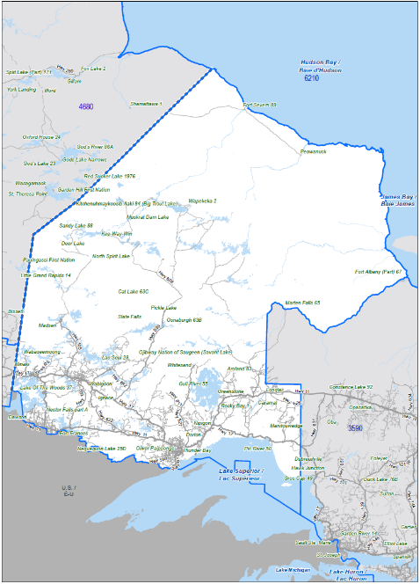
Market Size

Top-Down Methodology
- Canada-wide population is estimated to be 31,131,104. (Statistics Canada, 2021a)
- Ontario’s population is estimated to be 13,448,494. (Statistics Canada, 2021a)
- Northwest Ontario, as defined by Statistics Canada and illustrated in Figure 1: Northwest Ontario as Defined by Statistics Canada, is estimated to be 231,691 as of the 2016 Census Profile. (Statistics Canada, 2017)

Demographic Summary
“In 2001, the population of Dryden was 8198 and was essentially unchanged in the 2006 census (8195). Current 2010 estimates place the population at 8705, representing a 6.2% increase [over] four years. This is projected to see very small growth over the next 10 years, in the range of 1-2%. Population estimate for the Dryden Labour Shed in 2010 is 16,796 and this is projected to remain constant over the next 10 years. The Kenora District had a 2006 population of 64,419 which represents a 4.2% increase from the prior census…”
Figure SEQ Figure \* ARABIC 1: Northwest Ontario as Defined by Statistics Canada
“The 2001 average earnings for persons employed full-time and year-round were $48,051 for Dryden and $43,060 for the Kenora District. By the 2006 census, the figure for Dryden rose by 4.3% to $50,109 while the figure for the Kenora District fell by 3.9% to $41,376. According to the non-census data estimates, the 2010 average earnings for full-time, year-round employment in Dryden were $41,693 which would represent a 16.8% decrease.” (Dungannon Consulting Services, 2011)

Primary Research Results
807 Food Co-op has conducted a market survey, for which the results are included in Appendix A – Pre-Pilot Survey Results. There were 219 respondents, and the results informed decisions regarding how a food subscription box was created (contents, pricing, etc.) and marketed.
An additional post-pilot market survey was completed in October of 2021, evaluating two different subscription box sales methods that were distributed in the pilot, and how a new year-round subscription box in 2022 should be marketed and operated. The results are provided in Appendix D – Post-Pilot Survey Results.

SWOT Analysis
There are significant producers throughout Northern Ontario willing and eager to collaborate, that have shown significant entrepreneurial ability and that adapt to changing circumstances. (Dungannon Consulting Services, 2011) However, low population concentration throughout Northern Ontario poses significant issues for producers to achieve a scale that makes their business viable, even when collaborating with some other producers. Logistics and storage infrastructure are currently lacking and cause issues within the region when transporting food for the purposes of consolidation, processing, or delivery to the end-client. The following strategy is suggested by Dungannon Consulting Services, 2011 to establish a “Feasible Cooperative.”
- “Seek a Broader Vision: the notion of food security is a holistic concept that is good for producers, but also addresses the needs of the broader community.
- Next Generation: the drive behind food security innovations comes from a younger demographic. The average producer in Northwestern Ontario is 54 years old, the average food security activist is in their 20’s or 30’s.
- Collaboration: Cooperatives may often be the structure, but the underlying theme is collaboration. Partnerships with public health educators, eaters, producers, local non-profits are a key feature of these initiatives
- Self-Help: Co-ops are a long standing form of self-help, and these food security projects emphasize that. While grants might be a necessary part of the equation, fees, mark-ups and volunteer contributions are required to sustain initiatives dedicated to local foods.
- Self-Interest: While food security initiatives can be partly altruistic, they can never forget to provide value to everyone involved. A producer has to receive value for supplying product, consumers have to receive value for purchases, and community stakeholders have to receive value through public health or social outcomes.”

Strengths | Weaknesses
- Downtown location in Dryden, Ontario.  - Central to Northern Ontario.  - Established customer base.  - Cold storage is available.  - Space to grow (Domtar).  - We are local producers and there is local product demand.  - No competition with us.  - We have producers interested in making the project successful.  - General community social mission to be economically independent.  - The Board of Directors provides a broad spectrum of business capabilities that are well paired.  - Good team and leadership. | - Lack of sufficient freezer storage.  - First project, and as a result, will run into unforeseen problems.  - Relatively new to software tools being utilized.  - Relatively new to collaborative subscription boxes.  - Unable to plan for same-year production requirements.  - Lack of a complete business plan.  - Lack of secured public funding.  - Lack of matching funds (need to generate revenue).  - Lack of local capacity to fill the demand.  - Lack of distribution channels established.  - No urban market to capitalize on.
Opportunities | Threats
- More producers are interested in getting involved.  - High household income in the target region.  - Interest from funders in supporting value chain work given COVID-19 circumstances.  - Public awareness of food security issues and emphasis on supporting local producers.  - Many communities without storefronts that could be regularly served by a subscription box program.  - Food costs in Northern communities even as close as Sioux Lookout make a subscription box program a lower-cost alternative to local products.  - Remote communities could have central drop-off locations established to facilitate distribution throughout a community.  - Stimulating the local product market could result in new businesses that haven't existed before, expanding the local product market. | - All the Cloverbelt producers are having difficulty generating yield.  - Current local produce growers are vulnerable to weather conditions.  - Long acquisition timeline on larger public funding opportunities..  - Northern community grocery stores, where they exist, could potentially lower their costs to match or beat our own offerings to those communities.  - Distribution could raise costs, making the subscription boxes more expensive.  - Aging farming population could progressively reduce available locally sourced products without stimulating the industry.

Competitive Analysis
Competition | Strengths | Weaknesses | Competitive Edge
Cloverbelt Local Farmers Market  - Oxdrift  - Dryden | - Well known and loved.  - Many producers. | - Online/winter opportunities unclear.  - Seasonal only right now so producers have to make customer connections. | - Have year-round connection with consumers.  - Ease of downtown pick up location with large window.  - Online subscription so high rate of purchase commitment.
Large Grocery Stores  - Dryden and Area | - One-stop-shopping for household and groceries.  - Routine-based for customer.  - Cheaper. | - Increasing product contamination.  - Supply chain dependency.  - Poor quality/nutrient value.  - Wasteful packaging. | - Nutrient dense food.  - Stable food supply.  - Waste free packaging.  - Value added for convenience.  - Improves local economy.
Local Restaurants  - Dryden and Area | - Easy meal.  - No dirty kitchen.  - Take out or dine in most hours. | - Expensive  - Takeout makes waste | - Prepped food to save time.  - Local ingredients.  - Waste free.  - Comfort of home.  - Drive-through.
Online Food Box Subscriptions (i.e.: Hello Fresh)  - Ontario  - Canada-wide | - “autopilot” meals.  - Personalized.  - Trending. | - Incredibly wasteful.  - Uses a lot of dishes.  - Dampens kitchen creativity.  - Not enough for leftovers.  - Costly. | - Local  - Waste positive  - Recipes in season  - Saves fridge space  - Beautiful packaging
Farmers and producers directly  - Dryden and Area | - Personal connections.  - Knowing where money is spent.  - Feels good to purchase from grower/cooks. | - Time consuming for producers (Must make products, do own sales and distributions).  - Time consuming for the customer (must travel all over or attend the seasonal market). | - Routine of choosing online and drive thru pick up.  - Easier on everyone to have a single point-of-contact.  - Can showcase producer collaboration for the “feel good” aspect.

Target Market
807 Food Co-op intend to have a B2B and B2C strategy, fulfilling both wholesale contracts and direct-to-consumer sales. For B2B, specific focus will be placed on community organizations that would provide a strong social benefit to Northern Ontario communities. Local Dryden organizations will first be emphasized, and the scope of this work will continuously grow as scaling infrastructure is obtained and operations is prepared for the additional load. Dryden Native Friendship Center is a prime example and ideal starting point not only due to being a community organization, but also Indigenous-oriented.
The primary B2C target market resides in Northern Ontario, is between 30 and 55 years of age, has an annual family income of over $75,000, is married or partnered, and has children. A secondary demographic would be single individuals with additional time for self-improvement. These demographics should value nutrition and general health, have intentions of supporting the local economy, have healthy lifestyle habits, and remain active day-to-day with some sort of sports or other physical activity. As avid label readers, they care about everything they put into their body and are constantly trying to improve the quality of life of their family, friends, and selves, and as such, they notice improvements in the quality of their food. By acquiring our product on a regular basis, these target markets may experience improvements in general health, such as a reduction in the incidence of diet-related disorders such as diabetes, and the quality of their meals will improve. 807 Food Co-op products will be marketed to the target markets through presence in supermarkets, in-person visits to vendors and clients, social media campaigns, workshops, farmers’ markets, presence on marketing materials of our clients (such as restaurant menus), and via our website.

Barriers to Market Penetration
During the initial launch of the 807 Food Co-op Food Subscription Boxes in 2021, several factors effecting the organization’s ability to achieve market penetration became apparent. The primary factors currently effecting the ability to scale are:
- Lack of infrastructure to support a larger volume of supplies.
- Lack of distribution infrastructure and staff that won’t cut into profits or add significant cost.
- Lack of facilities suitable for reliable, larger-scale operations.
“For food hubs based in rural areas at farther distances from urban markets, the logistics of aggregating and distributing product is a major burden that limits growth and the potential to generate income. Two external factors were found to be important for enabling regional food hubs to scale up: (1) the active improvement of consumer education and (2) infrastructural-based support for food hub distribution channels” (Rogoff, 2014)

Lack of Infrastructure
In our existing small-scale facilities, there is a general lack of infrastructure that can handle the volume of supplies required to meet demand. This includes primary cold storage and freezer space of a significant enough size to be functional and efficient. The largest bottleneck to current operations is sufficient freezer storage to accommodate the volume of beef that current subscription boxes require to enable fulfillment.
Freezers require expensive condenser units that are also subject to failures over time, and thus require an initial capital investment, regular maintenance, and eventually component replacements which need to be stocked locally to avoid potential losses of large quantities of product. Alternatively, back-up freezer storage locally would be adequate in an emergency but represents a significant capital cost relative to the current operating revenue of the organization.

Lack of Distribution
The largest factor in food costs throughout Northern Ontario is distribution. This is due to the region generally having a low population disbursed over a large area, some of which lacks year-round road access. To tackle this significant distribution cost problem, centralizing distribution operations within the non-profit 807 Food Co-op can reduce food costs throughout the region by lowering the costs of both supplies and products delivered to consumers. In addition, small-scale producers who otherwise don’t have the resources to offer delivery of their products can suddenly access a delivered-to-your-door market much like Amazon Fresh, but exclusive to local producers.
When setting up a distribution network centered around a local producer market, the cities and towns which the 807 Food Co-op expands to first would be best centered around its own supply chain. For example, since eggs are currently sourced from Emo, that community might be an ideal town to market food subscription boxes to, since distribution can bring the boxes on its way to Emo, and return with eggs to supply the next cycle. Delivery days can be coordinated accordingly, but remote deliveries can result in issues such as consumers not being present during a delivery. For this reason, centralized locations in long-operating-hour storefronts or homes that are willing to host freezers and cold storage for their community’s pick-ups is ideal. Resolution of remote community freezer and cold storage requirements in these centralized locations is a natural extension of the prior issue discussed, Lack of Infrastructure.
To make this non-profit distribution network possible, the 807 Food Co-op would require external funding that includes rolling stock; a vehicle that can offer both cold and freezer storage in the same vehicle (since food subscription boxes have both frozen (i.e., beef), cannot-be-frozen but should be cooled(i.e., fresh greens), and shelf-stable (i.e., pasta) products. The vehicle thus would need to be able to offer cooling in the Summer but heating in the Winter, potentially requiring a more expensive outfitted vehicle. To ensure compatibility with future potential facilities, the vehicle might be best equipped with a liftgate so that it can facilitate both street-level and dock-level loading.

Lack of Facilities
The 807 Food Co-op does not currently have its own facility. The current temporary operations location at Parrs Jars has already outgrown its capabilities, without leasing additional space specific to the 807 Food Co-op’s needs. As a result, a new facility should be considered within one to three years, wherein medium-scale infrastructure could be part of a tenant improvement, and there is sufficient room to expand operations as a larger market is accessed and infrastructure to meet that need is obtained. Over time, the infrastructure will grow to include processing equipment for suppliers to access a wholesale market in addition to direct-to-consumer food subscription boxes, but the general lack of facility space will result in a delay in providing this service to suppliers.
AgriTech North is in the process of launching phase on operations within the Dryden pulp mill site. Once those operations have been shown to be profitable and successful, the Dryden pulp mill site intends to move that organization to a larger facility so it can scale, and the 807 Food Co-op would move into the same facility to take advantage of a similar agreement with the mill, wherein it would achieve lower-than-market lease and utility rates and benefit from establishing carbon-negative operations. Furthermore, the power grid within the mill is more reliable than off-site, since Dryden periodically experiences power outages that can result in the loss of a large quantity of stock.

Keys to Success
- Broaden infrastructure available by acquiring public funding for capital expenditures.
- Establish a non-profit distribution network to reduce the costs added to food throughout the region.
- Move to a facility with lower costs and more functionality than currently available options.

Sales & Marketing

Product/Service Description
The 807 Food Coop has created a local food box subscription, sourcing ingredients from local farmers and producers. This allows producers to reach more customers and customers to reach more producers. Our add ons can include any overflow producers have, which creates sustainable food supply channels and gives access to healthy, locally produced food.
Bringing the farm to the table is what separates us from mass produced meal kits subscriptions that are currently available. Customers will form better relationships with their food, where it’s grown, how it’s grown, how it’s picked and how it’s prepared but above all, they will know WHO is cultivating that food. Creating these relationships are important, new habits need to be formed to overcome the instability of the current food system.

Pricing Strategy
The value we provide far surpasses competitors, but we have to match what the market will truly pay for our offering. Established local brand reputations (Busters BBQ, Pure Blend, Parrs Jars etc.) will bolster this. The pricing strategy should enable revenue and market share goals and maximize profits.

Sales Process
807 Food Coop is mapping it’s sale process and has set to sell an extra 20 boxes on top of current number by the end of the next cycle.

Sales Process | Prospecting | Connecting | Researching | Releasing | Handling Objectives | Closing
807 Food Coop | Research Market  Define bylaws  Generate leads  Create UVP  Unique Value  Propostion | Engage prospects  Ask questions  Introduce 807 Food Coop Box | Analyze project needs  Create content  Ask questions again | Release all marketing material  Speak to first customers for feedback | Address questions concerns  Analyze new objections and present solutions | Refigure contents or producers for next cycle  Simplify checkout
Customer | Becomes aware of 807 Food Coop  Locavore | Respond to inquiry  Answer and ask qualifying questions | Research company, visit website, read testimonials  Evaluate other potential food boxes | Receive First Box  Pilot test product  Gives us feedback | Ask questions and express concerns | Begin Payment and Service Again  Sign subscription contract

Strategic Alliances
807 Food Coop is based solely on strategic alliances, and they are within the vision and mandate of this project. Parrs Jars, The Pure Blend, Busters BBQ, AgriTech North, Northwest Beef and all the other farmers and producers involved combine their respective resources, mutual interests in the distribution of local food and the creation of sustainable food systems. As a producer-only co-op strategic alliances are at the essence of the organization. Membership of additional producers will be possible once the bylaws have been completed, which is expected December of 2021.

Marketing Resources
During a 2021 pilot, the Board of Directors conducted a social media campaign and launched a food subscription box as a form of market research. As a product of this process, a base of marketing resources was generated that forms a foundation for future development. A full farmers’ market compilation of resources is scheduled to be generated between October 2021 and January 2022.
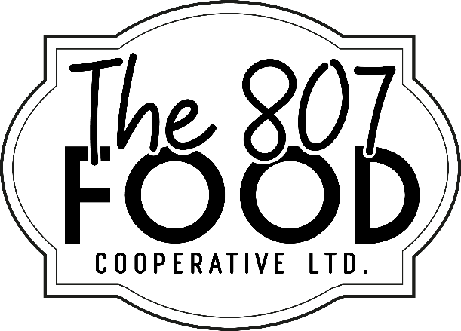
Figure 2: 807 Food Co-op Logo
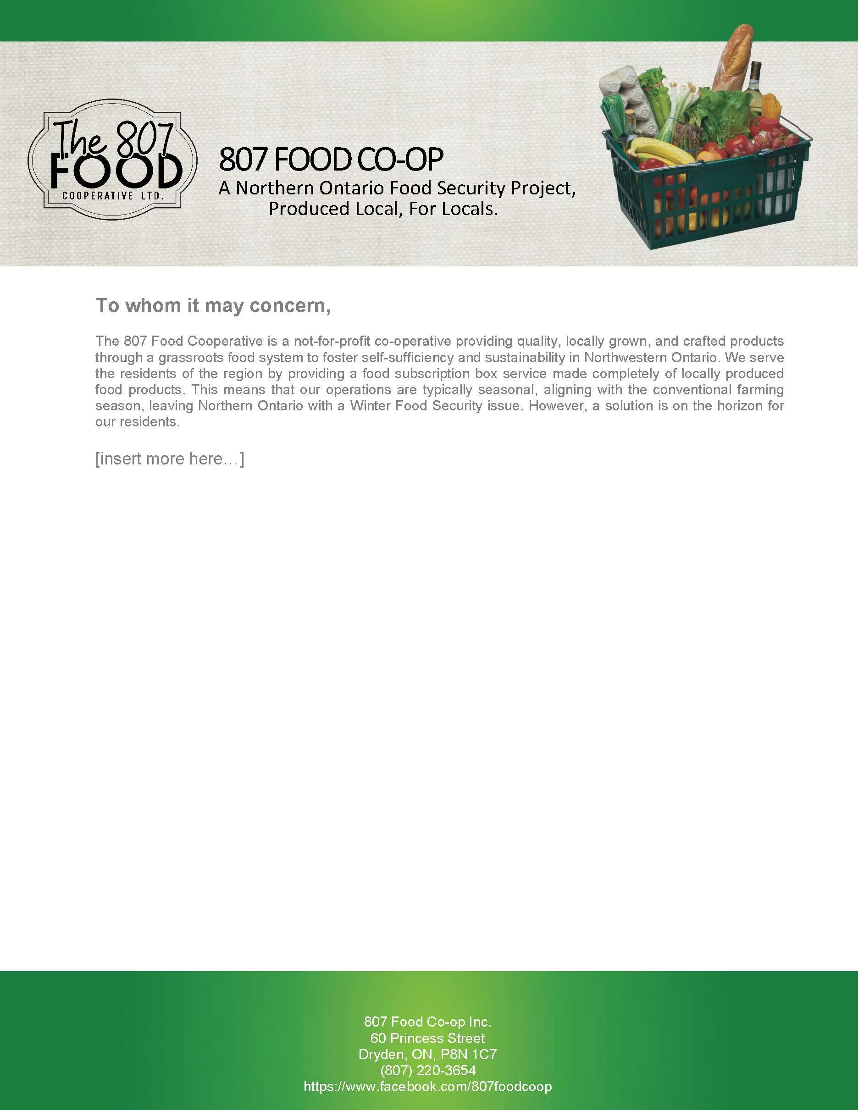
Figure 3: Letterhead Template
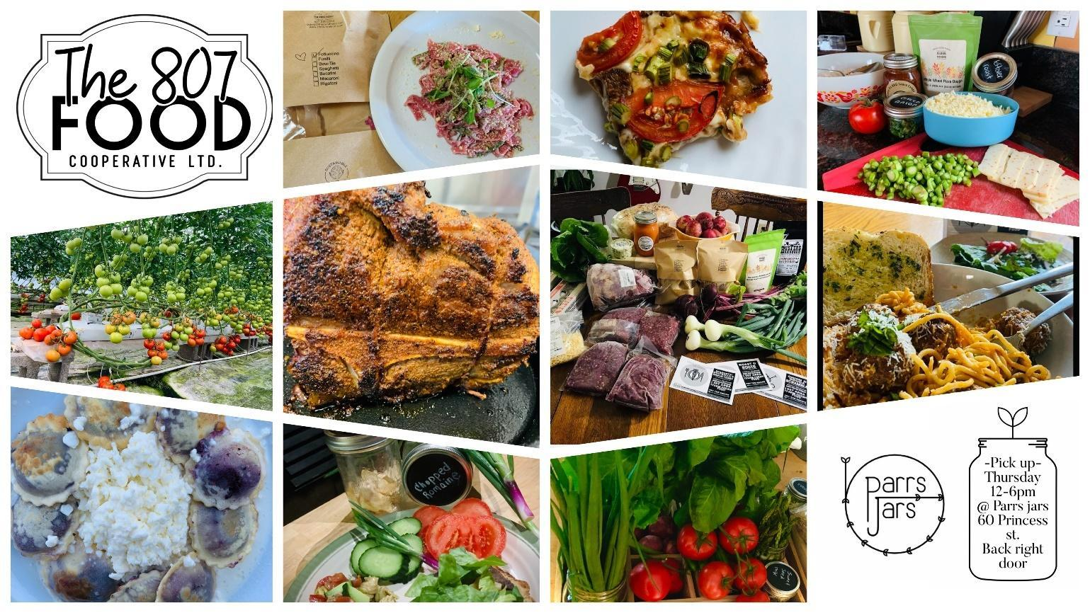
Figure 4: Examples of Food Subscription Boxes

Marketing Strategies
Date | Marketing Description | Objective of Strategy | Target Audience | Budget
Wednesdays during conventional season | Kenora Farmers’ Market | B2C Sales to Liquidate Excess Stock.  Food Subscription Box client registration.  Workshop advertising and attendance induction. | Kenora region. | $500 per occurrence
Thursdays during conventional season | Dryden Farmers’ Market | B2C Sales to Liquidate Excess Stock.  Food Subscription Box Registrations.  Workshop advertising and attendance induction. | Dryden region. | $300 per occurrence
Starting January 1, 2022 | Social Media Campaign | Membership Induction | Producers throughout Northern Ontario | $100 annually
Starting February 1, 2022 | Social Media Campaign | Food Subscription Box Client Induction | Clients throughout the Dryden, Sioux Lookout, and Kenora areas. | $50 every month
Special Events | Booth Presence | B2C Sales to Liquidate Excess Stock.  Food Subscription Box client registration.  Workshop advertising and attendance induction. | Region served by the special event. | $300-500 per occurrence

Operations

Location
807 Food Co-op is currently basing most of its operations out of Parrs Jars, a local business in Dryden, Ontario that already had a prepared food business in progress and can best facilitate a similar operational process for food box distribution with semi-prepared and/or unprepared foods during the start-up phase. There is currently no street-facing marketing or storefront.
Parrs Jars
60 Princess St., Unit 106
Dryden, ON, P8N 1C7

Legal Issues
807 Food Coop has not had any legal issues to date and does not project having legal issues.

Insurance
807 Food Co-op does not currently retain its own insurance policy. By January 1, 2022, the 807 Food Co-op will retain Board of Directors Liability Insurance. However, once the co-op establishes its own facility or delivery mechanism, appropriate commercial and/or automotive insurance will be retained.

Human Resources
807 Food Co-op does not currently employ any staff.

Process/Production
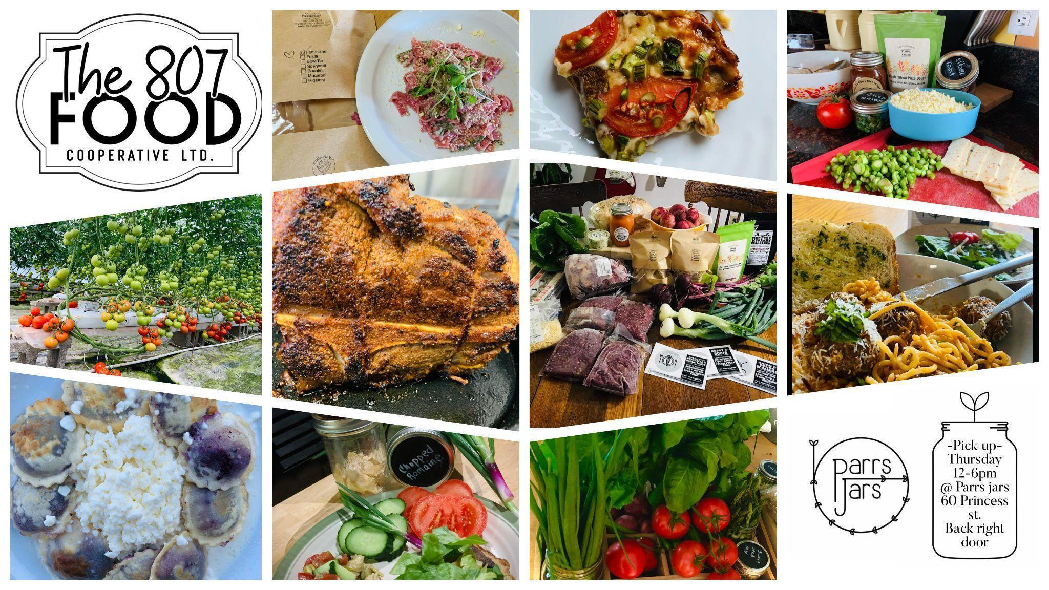
Figure 1: Examples of Food Subscription Box Meals

Planning and Preparation
- Recipe preparation, inventory acquisition, and newsletters are to be completed in two-week blocks, one week prior to the next two-week cycle. This is to be completed by Parrs Jars and information will be uploaded to the 807 Food Co-op Google Drive in the “2 week blocks” folder.
- Team will be alerted via slack when two-week block is ready for producer verification.

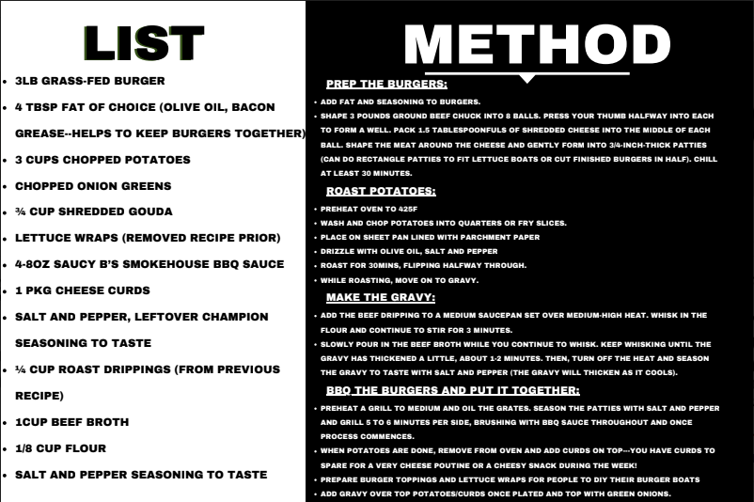
Figure 2: Example of Two-Week Block Plan

Acquisition
- Producers to look at “2 week blocks” folder within “Operations” folder of the Google Drive a week before the new scheduled block to ensure contents are manageable. If alterations/substitutions need to be made it must be by Monday morning of the following week to allow an alternative to be put in place before recipe cards are printed.
- Recipe cards are to be sent to Mac Print on Monday afternoon for pickup by Parrs Jars Wed/Thursday for two-week block and receipts to be submitted via expense sheet in the financials folder on Google Drive
- Producers must drop off between 10:00AM-12:00PM Tuesday morning, Wednesday 10:00AM-5:00PM or Thursday 8:00AM – 10:00AM to allow time for box compilation.
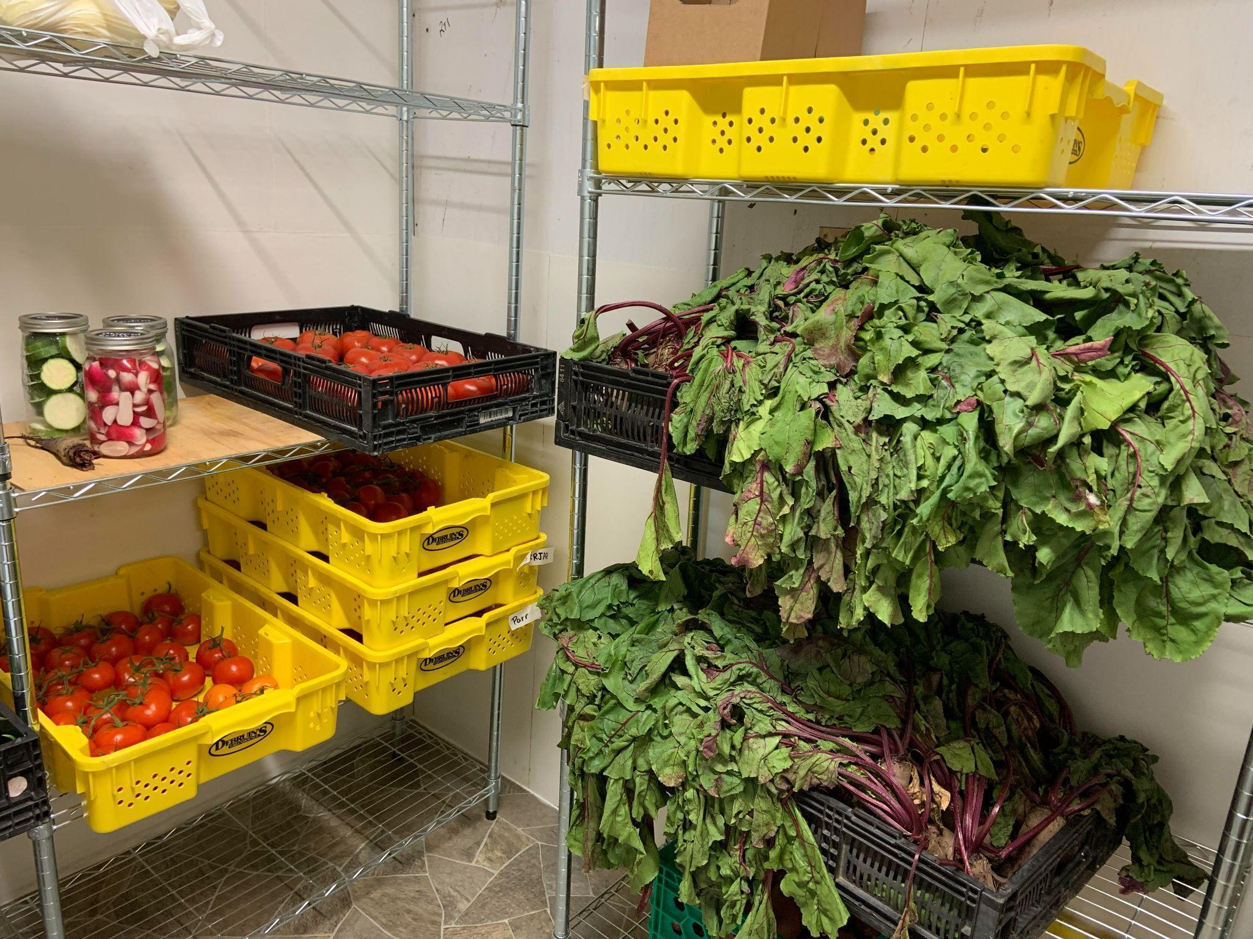
Figure 3: Example of Unprepared Foods Stored for Box Compilation

Compilation
- Parrs Jars will store excess box contents at its location as able and earmark for co-op (in event wholesale prices are in effect).
- Boxes are compiled in a cold storage room and cold storage trailer using harvest crates Wednesday through Thursday, weekly.
- Customer box contents are currently prepared in groups of 10 (Group A and Group B for a total of 20 boxes), Group A getting one set of recipes and Group B getting another. Each group will get both weeks of the two-week block.
  - Subdividing removes pressure on fresh items which are difficult to predict quantities for currently, allowing more flexibility weekly (i.e., one category gets greens and fruits, another gets greens and roots).
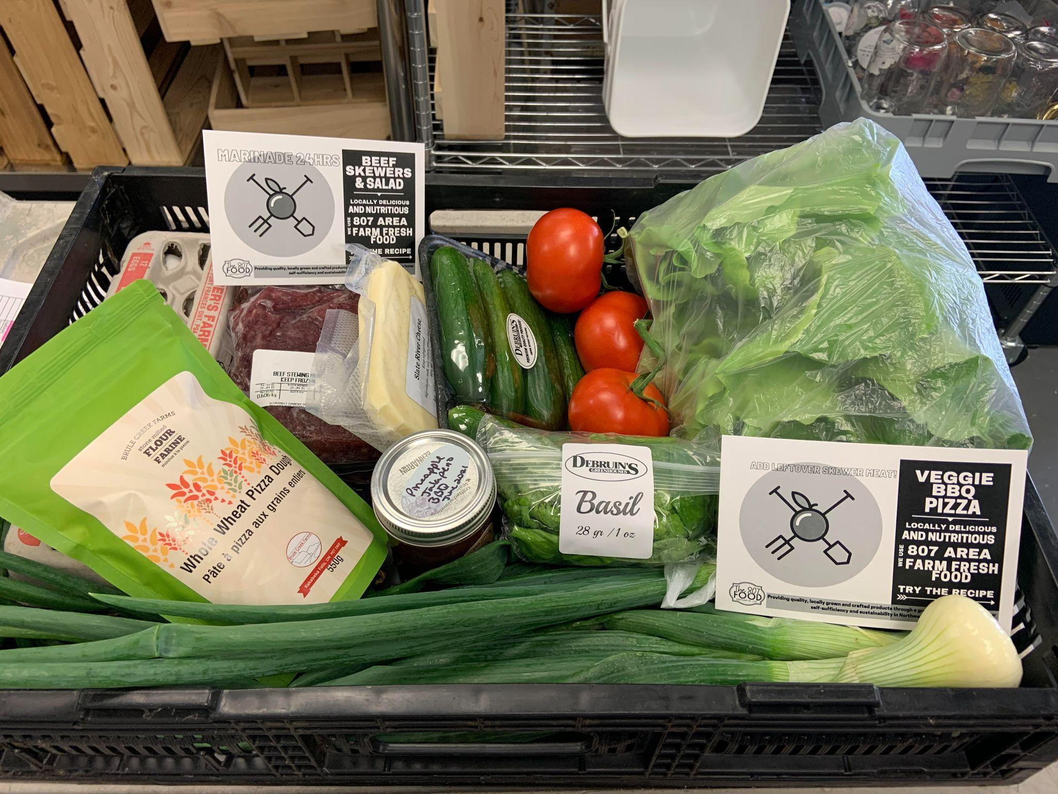
Figure 4: Example of a Compiled Box with a Harvest Crate

Distribution
- Customers pick up their box between 12:00PM-5:00PM Thursdays at 60 Princess St., Dryden, ON (door is to the back-right of the facility).
- Brown paper bags are provided for this cycle however next cycle a refundable deposit will be added for waste-free harvest crates. A tracking system will be developed by Parrs Jars to ensure refunds of deposits are properly managed.
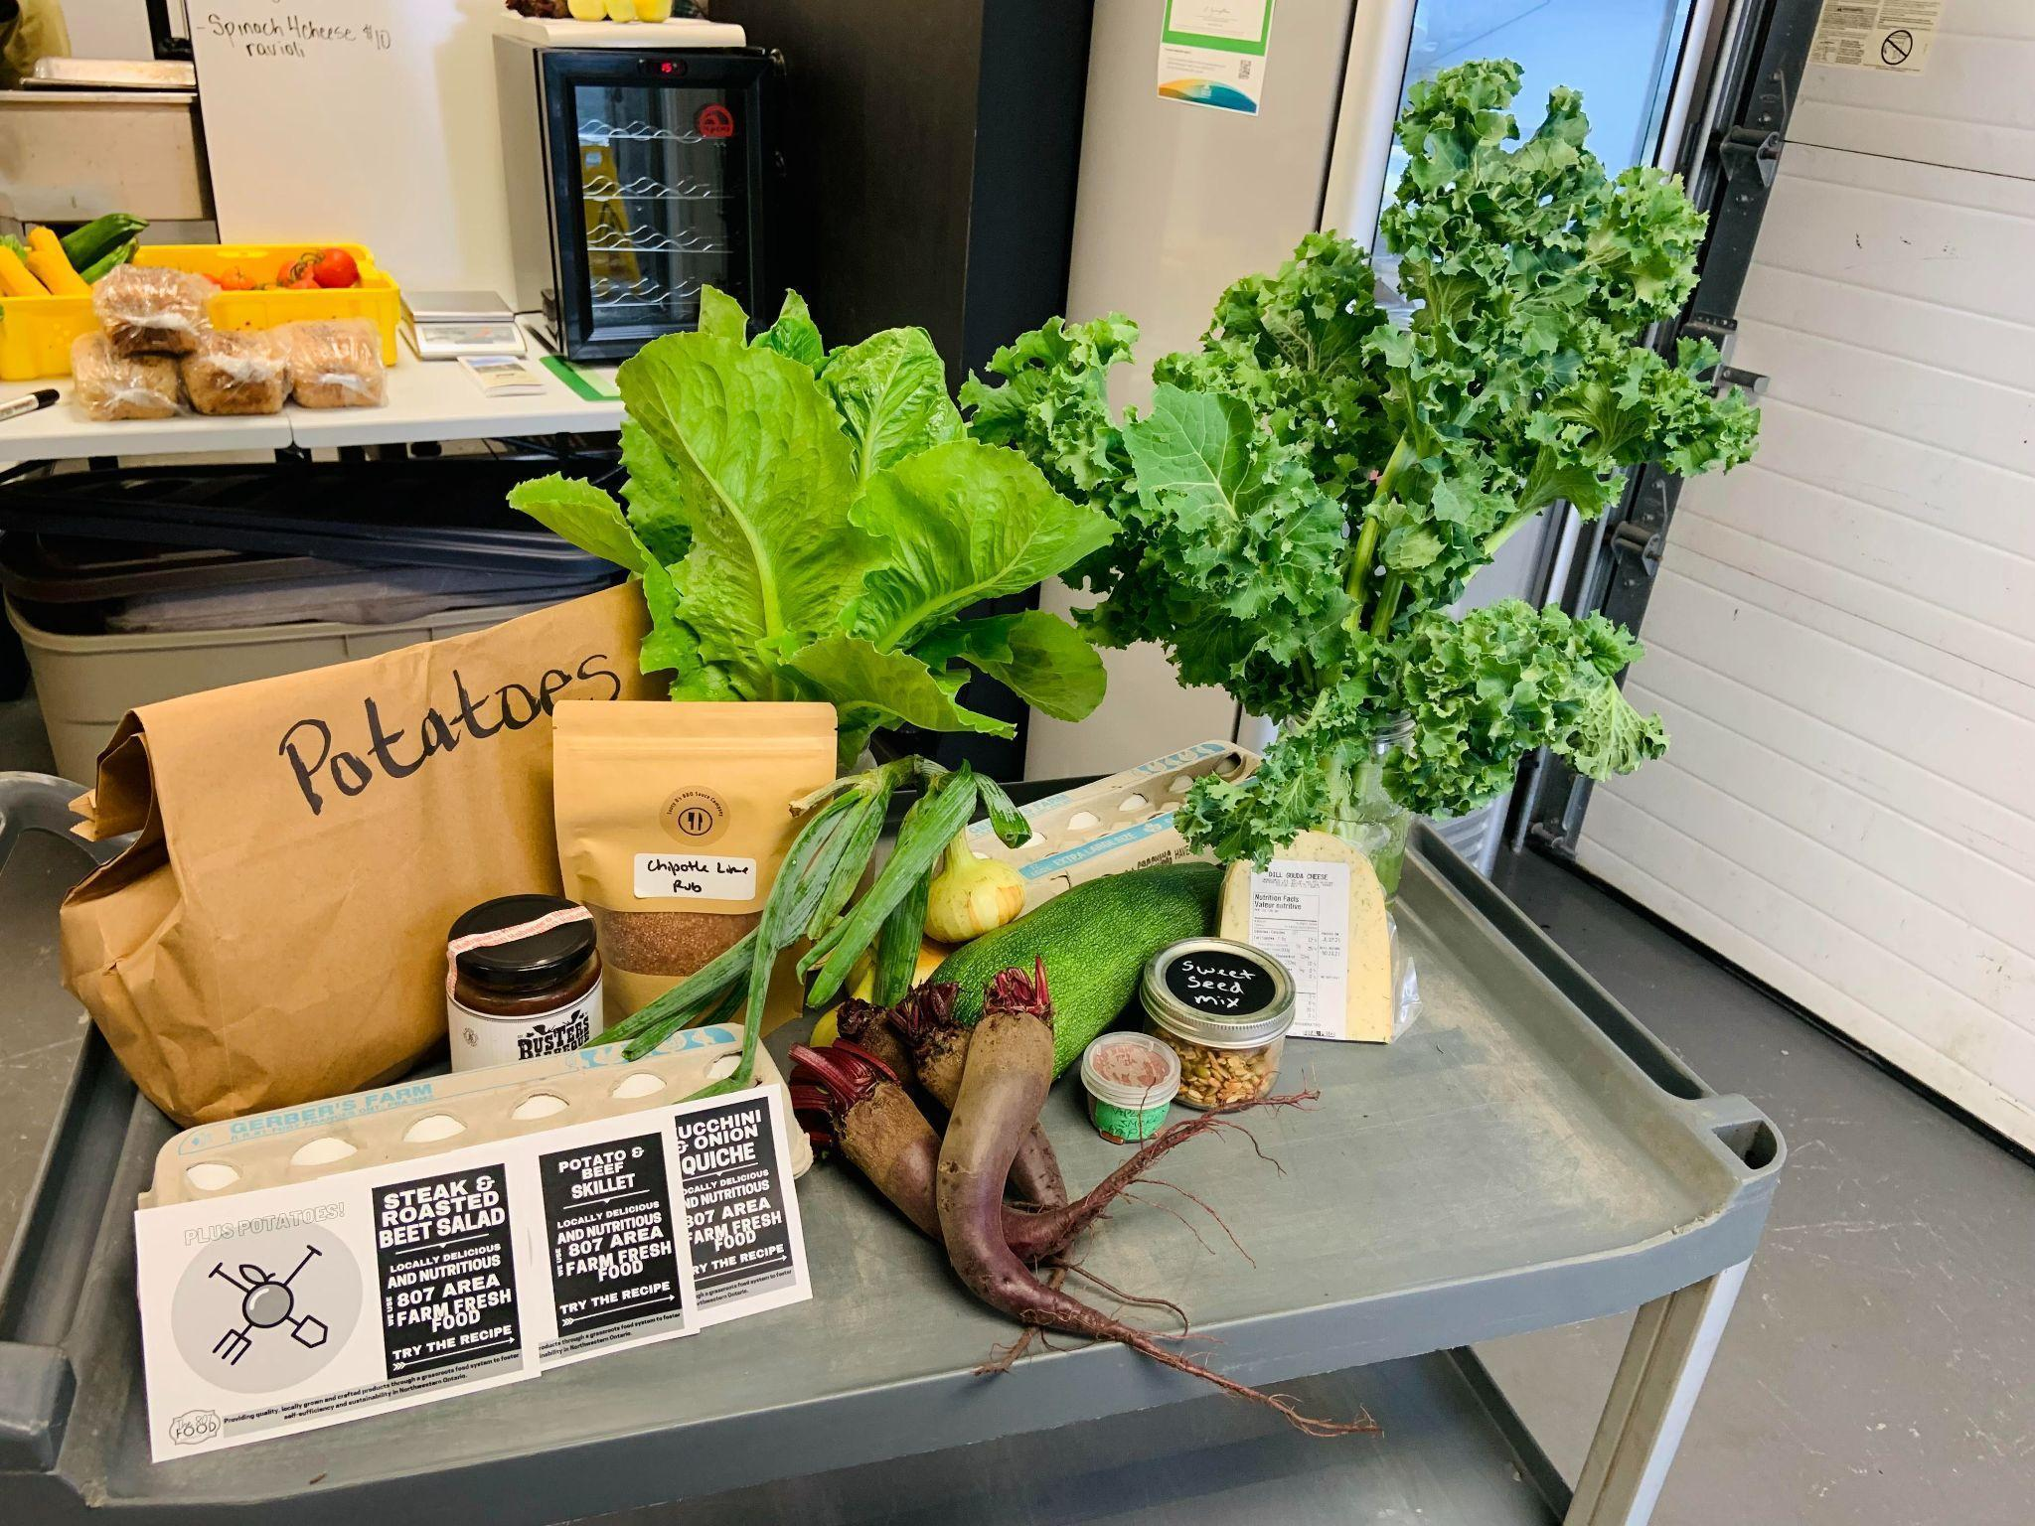
Figure 5: Another Example of a Compiled Food Box without a Harvest Crate

Producer and Consumer Payments
- Consumers pay for a six-week subscription in advance by electronic funds transfer of credit card or can opt to be charged weekly after an initial advance payment via manual billing enacted by Benjamin Feagin Jr. (Board Member and Secretary of 807 Food Co-op) at this time.
- Producers are to be paid out following each two-week block (currently via email money transfer) based on their contributions to those subscription boxes.

Equipment & Technology
- Cold room with shelving.
- Cold truck and trailer.
- 5 Freezers and large walk-in.
- Open Food Network online marketplace.
- Harvest crates.
- Produce bags.
- Computer and printer.
- Recipe card printing (by Mac Print).

Operational Personnel
Bobbie Parr
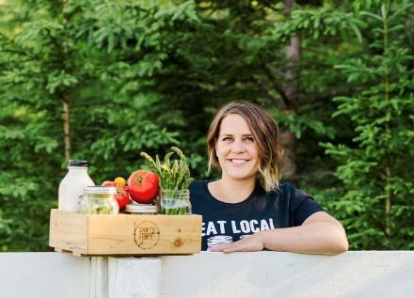
- Newsletter.
- Recipe formation.
- Supply acquisition coordination.
- Food subscription box compilation.
- In-person customer service.
- 12 hours/week.
Natalie Welniak
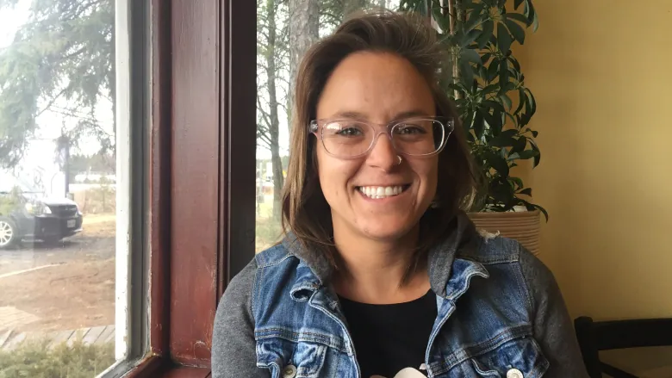
- Social media,
- Graphic design, and
- Marketing.
- 2 hours/week.
Bobbi Turpin

- Bookkeeping and financials.
- 4 hours/week.
Brent Cadeau
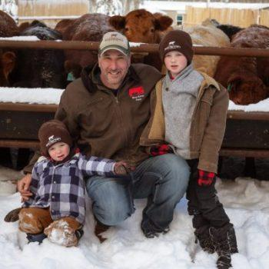
- Providing meat products on consignment.
- Conducting deliveries and coordinating inventory.
- 4 hours/week.
Benjamin Feagin Jr., MSc


- Open Food Network (OFN) Canada marketplace management.
- OFN subscription and development management.
- Online customer service.
- Business Plan Development.
- Bylaw Development.
- 12 hours/week in-kind (Pro Bono).

Workshops
Consumer and producer education is an essential capacity-building agenda to ensure the success of the 807 Food Co-op and its members. Workshops will focus on both the public and producers, but at different workshops. Six total workshops will be delivered per year, with three being consumer-focused, and three being producer-focused.
Consumer-focused workshops will cover topics such as how to cook with fresh produce, how to incorporate herbs and spices into your recipes, the health benefits of eating healthier, what constitutes a healthy diet, home preservation to combat food security, and more! These seminars are intended to add value to producer product offerings from the perception of the consumer base, and collect feedback from producers to help accelerate the evolution and success of local producer product offerings and new small business ventures.
Many local producers are unable to access a broader market throughout Northern Ontario simply because they are unaware or unable to understand more complex legal requirements of standards that must be employed to sell on certain markets. This may be as simple as making a product shelf-stable, or as complex as integrating into a multi-modal Northern Ontario distribution network that already facilitates other 807 Food Co-op members. Workshops are intended to help producers access a broader market segment, increase the quality of their yield, and benefit from broader visibility in the marketplace while strengthening relationships between producers.

Risk Assessment
Risk 1 – Power or cold storage room failure.

Risk 1 |  | Probability
 |  | Low | Medium | High
Impact | Low
 | Medium
 | High | Power or cold storage room failure

Strategy

Mitigate the Risk
- Remote access to temperature of cold room through cool bot system
- Back up generator available in case of emergency that will run cold room and gas storage system enacted
- Freezers will be fine up to 3 days, use blankets/sleeping bags to insulate and DO NOT OPEN

Contingency Plan
If power failure remains longer than 3 days moving forward, we will explore alternative options such as utilizing outdoor trailer storage (deep winter only) or finding another location if power is available elsewhere.

Optimistic Outcome -
Any alerts to phone are met with prompt generator supply and maintained until power is restored.

Risk 2 – Producer unable to fulfill order.

Risk 2 |  | Probability
 |  | Low | Medium | High
Impact | Low |  | Producer unable to fulfill order
 | Medium
 | High

Strategy

Mitigate the Risk
Ensure all producers are aware of their commitments by communicating regularly via Slack regularly.
Contingency Plan
Substitute like item(s) and alert customer(s) of swaps when they occur.
Optimistic Outcome
Advance planning with producers and avoiding changes within a subscription box cycle will avoid potential situations of a producer being unable to fulfill an order.

Risk 8 – COVID-19 Mitigation 1 of 3
Is there information that you can share about the impacts of the COVID-19 pandemic on your proposed project or your community/organization?

Risk 1 |  | Probability
 |  | Low | Medium | High
Impact | Low |  |  | While the probability of COVID-19 measures is high, the impact is low because as a start-up our operations have limited in-person contact.
 | Medium
 | High

Strategy

Mitigate the Risk – In the start-up phase, food subscription boxes containing only unprepared food products can be assembled with a single person, enabling operations during the pandemic. Prepared foods sourced from small producers are often processed by one person or a family unit, ensuring containment of the virus and limited potential for transmission. Medium to large scale producers may be unable to meet demand for larger contracts, however, 807 Food Co-op is not at a scale requiring a source of product from these vendors.
Contingency Plan – Establish a longer time cycle for preparation of food boxes. Potentially establish an additional facility that contributes to the process in some way to limit potential for transmission by separating off tasks according to quantity of personnel required and distance or physical separation required between workers. Vary working schedules as required or possible, to better utilize single-occupant spaces.
Optimistic Outcome – The scale at which 807 Food Co-op operates already limits the potential for transmission. Work required during the pandemic will not adversely effect operations.
“Despite the adverse economic effects of the COVID-19 (coronavirus) pandemic in 2020, revenue is still expected to steadily rise over the five years to 2021.” (Kanda, 2021)

Risk 9 – COVID-19 Mitigation 2 of 3
Are there current or anticipatory measures planned to protect those involved in the project from COVID-19? For example, alternative work shifts, maximum number of employees on site at a time, additional safety gear and equipment.

Risk 1 |  | Probability
 |  | Low | Medium | High
Impact | Low |  |  | While the probability of COVID-19 measures is high, the impact is low because as a start-up our operations have limited in-person contact.
 | Medium
 | High

Strategy

Mitigate the Risk – Conduct work without the risk of in-person contact with others by utilizing space that is physically distant from any other occupants. Always wear face masks during COVID-19 precaution conditions. Conduct deliveries and pick-ups via a contactless method.
Contingency Plan – Establish additional single-occupancy spaces at members’ facilities, that can facilitate portions of the food subscription box process, when possible. Vary work shifts to avoid in-person contact and conduct work as a single occupant during more severe COVID-19 precautions.
Optimistic Outcome – As a start-up operation, the size of the operation does not exceed the capabilities of the team to continue with appropriate COVID-19 precautions.

Risk 10 – COVID-19 Mitigation 3 of 3
Have you considered the impact of COVID19 restrictions on your project? What changes will be necessary to complete the project within the time period outlined in your application?

Risk 1 |  | Probability
 |  | Low | Medium | High
Impact | Low |  |  | While the probability of COVID-19 measures is high, the impact is low because as a start-up our operations have limited in-person contact.
 | Medium
 | High

Strategy

Mitigate the Risk – Contactless deliveries and pick-ups. Pre-process goods being assembled into food boxes at an alternative members’ facility, to limit the overhead burden on the Parrs Jars central location.
Contingency Plan – In the worst case scenario, delay the food subscription box program until COVID-19 measures are loosened and operations can continue safely. The continuation of the program is not critical to 807 operations as there is currently limited to no ongoing operational expenses.
Optimistic Outcome – The small scale of current operations will not require a shut-down of operations or otherwise adversely effect the continuation of this essential food service.

Financials

Start Up Costs
Items | Amount ($)
Accounting | 712
Advertising | 1,000
Bank/Online Payment Processing Fees | 1,128
Cost of Goods Sold | 79,907
Depreciation | 972
Incorporation | 300
Labour Fees | 9,180
Marketing | 3,550
Membership Fees | 300
Software | 250
Storage & Facility Fees | 4,080
Total Start-up Costs | 101,379

Expansion Costs
Items | Amount ($)
Capital Equipment | 25,000

Sales Projections

Year 1
Month | Amount ($)
July | 17,000
August *includes $8,718 government grant funds | 19,726
September | 0
October | 0
November | 0
December | 0
January | 0
February *includes $22,500 government grant funds | 23,250
March | 15,750
April | 16,750
May | 17,750
June | 19,750
Total Year 1 | 129,976

Year 2
Month | Amount ($)
July | 18,166
August | 18,166
September | 18,166
October | 18,166
November | 18,167
December | 18,167
January | 18,167
February | 18,167
March | 18,167
April | 18,167
May | 18,167
June | 20,167
Total Year 2 | 220,000

Projected Cash Flow

Year 1
OPERATING ACTIVITIES | TOTAL ($)
Net Income  Adjustments to reconcile Net Income to Net Cash provided by operations  Depreciation  Total Adjustments to reconcile Net Income to Net Cash provided by operations  Net cash provided by operating activities  INVESTING ACTIVITIES  Capital Expenditures  Net cash provided by investing activities  FINANCING ACTIVITIES  Opening Balance Equity  Net cash provided by financing activities  NET CASH INCREASE FOR PERIOD  CASH AT END OF PERIOD | 28,597  972  972  29,569  (25,000)  (25,000)  0  0  4,569  4,569

Year 2
OPERATING ACTIVITIES | TOTAL ($)
Net Income  Adjustments to reconcile Net Income to Net Cash provided by operations  Depreciation  Total Adjustments to reconcile Net Income to Net Cash provided by operations  Net cash provided by operating activities  INVESTING ACTIVITIES  Capital Expenditures  Net cash provided by investing activities  FINANCING ACTIVITIES  Opening Balance Equity  Net cash provided by financing activities  NET CASH INCREASE FOR PERIOD  CASH AT END OF PERIOD | 18,429  2,667  2,667  21,096  (15,000)  (15,000)  0  0  6,096  6,096

Year 3
OPERATING ACTIVITIES | TOTAL ($)
Net Income  Adjustments to reconcile Net Income to Net Cash provided by operations  Depreciation  Total Adjustments to reconcile Net Income to Net Cash provided by operations  Net cash provided by operating activities  INVESTING ACTIVITIES  Capital Expenditures  Net cash provided by investing activities  FINANCING ACTIVITIES  Opening Balance Equity  Net cash provided by financing activities  NET CASH INCREASE FOR PERIOD  CASH AT END OF PERIOD | 23,297  4,209  4,209  27,506  (23,000) (23,000)  0  0  4,506  4,506

Works Cited
BMO Financial Group. (2012). BMO Survey: Canadians Willing to Pay a Significant Premium to Eat Local Food. Retrieved July 26, 2021, from https://newsroom.bmo.com/2012-08-02-BMO-Survey-Canadians-Willing-to-Pay-a-Significant-Premium-to-Eat-Local-Food
Dungannon Consulting Services. (2011). Towards a Feasible Cooperative. Dryden, ON: Dryden Local Foods Coalition.
Farm & Food Care Ontario. (2021, July 26). Facts & Figures About Canadian Greenhouse Vegetables. Retrieved July 26, 2021, from Farm & Food Care Ontario: https://www.farmfoodcareon.org/wp-content/uploads/2017/05/Fact-Sheet-GreenhouseVeg-2016.pdf?fbclid=IwAR031l_nEC0iAuzxozAZuTDK_hVSbN0vpEJnzhH1xpa5w9GC84zNuTnbN2g
Harry Cummings and Associates. (2017). Thunder Bay + Area Food Strategy. Thunder Bay, ON: Thunder Bay and Area Food Strategy. Retrieved July 26, 2021, from http://tbfoodstrategy.com/files/3115/1130/0273/TBFoodStrat_MarketStudy2017_web.pdf
Kanda, S. (2021). Vegetable Farming in Canada. Los Angeles, CA, USA: IBISWorld.
Martin, D., Jamal, A., Ramsay, M., Stothart, C., Veeraraghavan, G., Burnett, K., . . . Williams, P. (2016). Paying for Nutrition: A Report on Food Costing in the North. Montreal, QB, Canada: Food Secure Canada. Retrieved July 26, 2021, from http://tbfoodstrategy.com/files/3115/1130/0273/TBFoodStrat_MarketStudy2017_web.pdf
Rogoff, J. (2014). Improving Systems of Distribution and Logistics For Regional Food Hubs. MIT Department of Urban Studies and Planning. Cambridge, MA, USA: Massachusetts Institute of Technology (MIT). Retrieved 09 22, 2014, from https://dusp.mit.edu/sites/dusp.mit.edu/files/attachments/project/Food%20Hub%20Report%2010_12_14.pdf
Statistics Canada. (2017, November 29). Northwest [Economic region], Ontario and Ontario [Province] (table). Census Profile. 2016 Census. Statistics Canada Catalogue no. 98-316-X2016001. Ottawa, Ontario, Canada: Statistics Canada. Retrieved August 18, 2021, from https://www12.statcan.gc.ca/census-recensement/2016/dp-pd/prof/details/page.cfm?Lang=E&Geo1=ER&Code1=3595&Geo2=PR&Code2=35&SearchText=Northwest&SearchType=Begins&SearchPR=01&B1=Population&TABID=1&type=0
Statistics Canada. (2021a). Quarterly Demographic Estimates: January to March 2021. Ottawa, Ontario: Statistics Canada. Retrieved August 18, 2021, from https://www150.statcan.gc.ca/n1/pub/91-002-x/91-002-x2021001-eng.htm
Wikipedia. (2021). Dryden, Ontario. Retrieved July 26, 2021, from https://en.wikipedia.org/wiki/Dryden,_Ontario

Appendices

Appendix A – Pre-Pilot Survey Results

Appendix B – Management Resumes

Appendix C – Incorporation Documents

Appendix D – Post-Pilot Survey Results

