WHAT IS THE FORMULA FOR IDENTIFYING YOUR UNIQUE MICRO-NICHE?

Step 1, is to answer the following questions to get clarity on your unique micro-niche that
can have a massive impact on the people who need you most:

1. What is your career expertise or experience?
- Degree in Community Development
- Experience in:
  - Self-Reliant Lifestyle Design
    - Self-Sufficiency Practices
      - Growing food through a variety of methods (garden, sprouting, microgreens, hydroponics, etc)
      - Foraging and Preserving Food
      - Hunting, Trapping, Fishing
      - Building Cold Rooms & Cold Trailers
      - Building Hydroponic Beds
      - Building Soil Life
      - Keeping Chickens
      - Food Rotation Methods and System Planning
      - Trade, Barter & Bitcoin
    - Lifestyle Needs Assessments (Could create printable workbook quickly)
    - Entrepreneurship
    - Homeschooling
    - Building Co-operatives (Food, Homeschooling)
  - Local Food System and Food Hub Development
  - Food Product Development (Ontario)
  - Person-Centered Care Planning and facilitation for children, people with disabilities and dementia
  - Overcoming individual Barriers
  - Remote Team Management
2. What do people ask you for help with?
- Growing / Preserving food
- Building Networks
- Business
- How to be as motivated as we are to do all the things
3. What could you deliver a TED talk on right now without any preparation?
- The Importance of Self-Reliant Lifestyle Design
4. What is a skill you have mastered?
- Food preservation
- Resilient Household & Community Development
5. What is a transformation you have created for yourself or for other people?
- Going from dependent on systems and institutions (health care, education, city services) to a self-reliant hunters homestead.
6. If you rewrote the story of your life and positioned yourself as the hero, how would that story go?

-Went down the rabbit hole and had a nervous breakdown
-Found personal resiliency
-Spent 13 years building a resilient lifestyle
-Covid made us shift focus to community resiliency through food system development
-Homeschooling trajectory
-Resilient Lifestyle has made my dreams come true.
***It took me 13 years, here is how I can help you do it in a fraction of the time***

UNIQUE SELLING PROPOSITION
TRANSFORMATION > INFORMATION

The biggest mistake you can make when you are trying to impact more people with your skills
and expertise is to share as much information as possible.

People want transformation, they don’t need more information.

Now that you’ve answered the questions above, the next step is to create your unique selling
proposition which we call your transformation statement. This statement is what allows you to
stand out and position yourself as the go to authority for your clients.
The best way to think about it is that you are taking your clients from 0 to HERO.

HOW DO YOU CREATE A TRANSFORMATION STATEMENT?
Start by filling in these blanks:
“I HELP ________ GO FROM _______ TO ______ SO THAT THEY CAN ________”

“I HELP FAMILIES GO FROM SCARED TO PREPARED SO THAT THEY CAN TACKLE AN UNCERTAIN WORLD WITH CONFIDENCE”

This becomes your transformation statement. This clearly articulates who you help, how you
help them, and the desired outcome you help them achieve.

The most effective way to do this is by packaging your expertise into an online curriculum that
takes your client from 0 to HERO and allows them to study and implement your method and
strategy at their own pace.

How do you create the curriculum? You need to be clear on the client journey, also known as
the hero’s journey.

Your curriculum simply bridges the gap between where the client is now and where they want
to go.

To create an outline for your curriculum, start by studying your transformation statement
Above:

“I HELP FAMILIES GO FROM SCARED TO PREPARED SO THAT THEY CAN TACKLE AN UNCERTAIN WORLD WITH CONFIDENCE”

1. Identify the 0 state of where your client is at when they need your help OR where you were at when you needed the most help
- Terrified once learning how the world works and that we are likely to see a massive economic depression
- Uncertain about what will happen in the world and how that will affect their family
- Feel stuck in what they thought the future would look like and now have no idea how to move forward upon learning that it will likely crumble before they reach retirement.
- Want to keep your children close to avoid being corrupted
- Overwhelmed by all the changes needed to gain self-sufficiency

2. Identify the HERO state which is the desired outcome they
want to achieve
- Understand your families’ unique needs and desires in regards to a resilient lifestyle
- Have a game plan on what steps to take to move forward independent of the systems of support
- Feel ready to tackle the world and build a self reliant lifestyle one step at a time

3. Create a list of all of the actions and steps required to go from that 0 state to that HERO state based on your experience
That list becomes your curriculum, which you will then pre-record in order to serve more people
and create more transformations via an online program.

IDENTIFYING YOUR IDEAL CLIENT
The depth of the impact and transformation you can create on your clients is a direct reflection
of how specific you are about your ideal client.
We have found that there are 3 key factors to identifying your ideal client.
• 1 specific ideal client: Mother who is scared and uncertain about the world/future
• 1 specific tipping point on their journey where they must make a change: They are deep in the rabbit hole and completely disempowered with no idea how to prepare for the future. May be on the verge of a nervous breakdown, having trouble sleeping and deeply concerned about the state of the world.
• 1 specific desired outcome: Empowered to make a massive change for their family with a clear, personalized step by step plan on how to achieve a self-reliant lifestyle.

Knowing the tipping of your client’s journey makes your curriculum incredibly impactful because
every client will come in at the same place, seeking the same outcome, which allows you to
support more people and create incredibly transformative results.

VALUE BASED PRICING

Undercharging is the result of pricing your online program based on the amount of information you include in it or the amount of time it takes your client to go through the material.

Important: the price of your program has nothing to do with how much information you stuff into it or how long it is.

The price of your program is solely based on the value of the outcome you are providing. When it comes to choosing a price point for your program, we use a simple equation:

COST TO YOUR CLIENT + INCOME GOALS - BARRIER TO ENTRY = PRICE
50000+8000/120 = $485

Cost to your client:
What is the cost to your client of not having the outcome you provide on a mental, emotional, financial, and/or spiritual level? 12 months average income if they go on disability. Complete dependency.
• Therapy costs $100/hour on average
• Mental stress which is costing them focus at work and potentially risking their job
• Emotionally depleted which is costing them patience and time with friends and family
Value of the outcome to the client:
Saving themselves from breakdown, spending less time being afraid and more time focusing on the important things in life, no more impulse purchases of things you don’t really need to feel more prepared, feelings of security and peace despite poor world outcomes.

Income goals:
What do you need to earn in your business per month to feel secure?
$8000

Barrier to entry:
What is the average price point on the market for the expertise or skill set you provide? You always want to be slightly above average to be seen as the best and most sought after authority and to weed out people who aren’t serious about doing the work.
$120

EXAMPLE
Program Topic:
Helping men on the brink of divorce save their marriages.
Cost to the client of not having the outcome:
• Divorce costs $13,000 on average
• Therapy costs $100/hour on average
• Mental stress which is costing them focus at work and potentially risking their job
• Emotionally depleted which is costing them patience and time with friends and family

Value of the outcome to the client:
Saving themselves from divorce, spending less time arguing and more time focusing on the important things in life, no distractions at work so they can focus and have more earning potential, human connection, true intimacy.

Value based price:
Anywhere between $5,000 - $10,000 per client.

DECODE THE ALGORITHM
Marketing is not complicated, we make it complicated.
When it comes to marketing your business and leveraging social media to reach your ideal
clients, the algorithm only needs to know 2 important pieces of information:

WHO you want to reach:
Mothers concerned about the world trajectory

WHAT you want to be known for:
Resilient Lifestyle Design

Every piece of content you create needs to clearly portray those 2 factors, otherwise, you
confuse the algorithm and it doesn’t know how to support you to show your content to
more people.
When you are clear about those 2 factors in every piece of content you create, the algorithm
knows exactly how to support you and uses its internal traffic sources to reach more people
like that. This is what it looks like to decode the algorithm and for social media platforms to
start working in your favor:

“Resilient lifestyle design” exudes a sense of adaptability, strength, and proactive living, which resonates well with modern consumers looking for products or services that promote sustainability, well being, and a resilient mindset. It communicates a positive and forward thinking approach that aligns with contemporary trend in wellness, sustainability and personal empowerment.

While self-reliance and self sufficiency convey independence and individual capability, RLD carriers a more dynamic and appealing connotation that is likely to captivate the attention of a broader audience, making it a compelling choice for marketing and branding efforts.

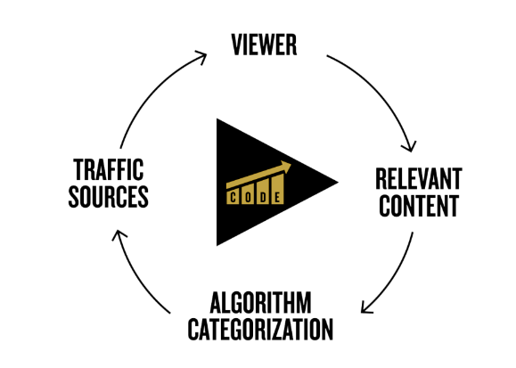

Creating content without understanding your ideal client is setting yourself up for disaster.
Having clarity on your ideal client means you’re only going to make relevant content for that
person which allows the algorithm to categorize your channel to then leverage internal traffic
sources to reach even more of those people.

BECOME A CLIENT MAGNET
Regardless of which platform you are creating content on, you need to know how to create
content that turns a stranger into a client. After years of testing, I identified there is a specific
formula for create magnetic messaging that attracts your ideal client and inspire them to take
action to work with you.
This is the profitable content template to use to create content that turns into clients:

Address Pain Point: “Feeling uncertain about the state of the world and what it might mean for your family? Here’s how to become prepared for the future in 3 simple steps.”

Educate and Execution: Give step by step instructions and action plan.

Experience:

Problem Solve:

Take Action:

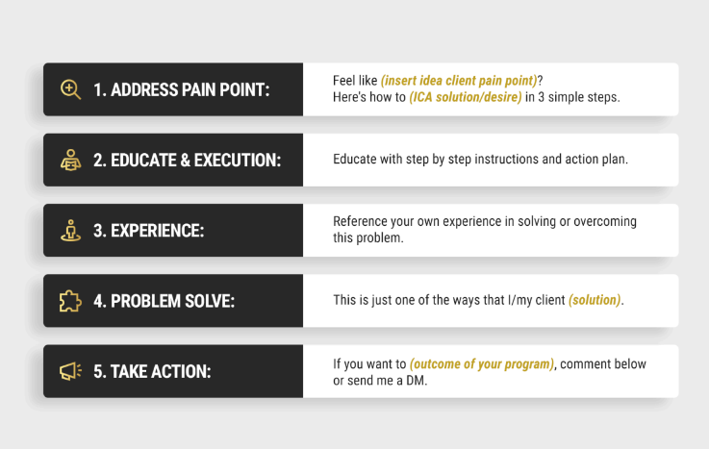

EVERGREEN SALES MACHINE

YouTube is one of the most powerful search engines on the planet and it is the only social
media platform that magnetizes your ideal clients to you without having to constantly
create content.

Leveraging YouTube as a marketing channel for your online program allows you to build
authority, impact and generate leads on autopilot.
You want to think about each video you create as its own evergreen sales machine that will
continue to bring in clients for years to come without any extra effort.

Creating content that is discoverable in the search results allows you to generate FREE traffic
and leads, all day, everyday.

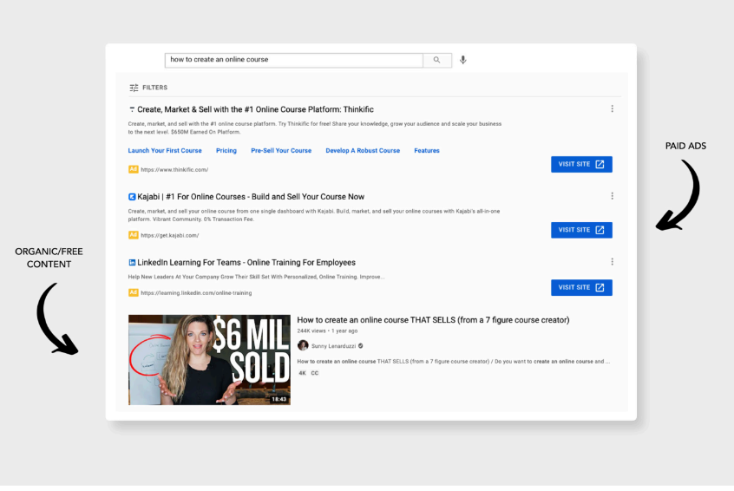

BUT, HOW DO YOU BECOME DISCOVERABLE ON YOUTUBE?
The key is to choose titles that are highly relevant to the pain points and challenges of your ideal
client.
From there, the formula for ranking your video at the top of the search results to be discovered
by your ideal clients is:
HIGH SEARCH VOLUME + LOW COMPETITION
When you identify a video title that is being searched by your ideal client and there aren’t
millions of other videos on that topic, you have the perfect combination to rank your video #1
on YouTube.
One of our clients used this exact strategy to scale his real estate coaching business to
$1,000,000 in 1 year without spending a dime on paid advertising.

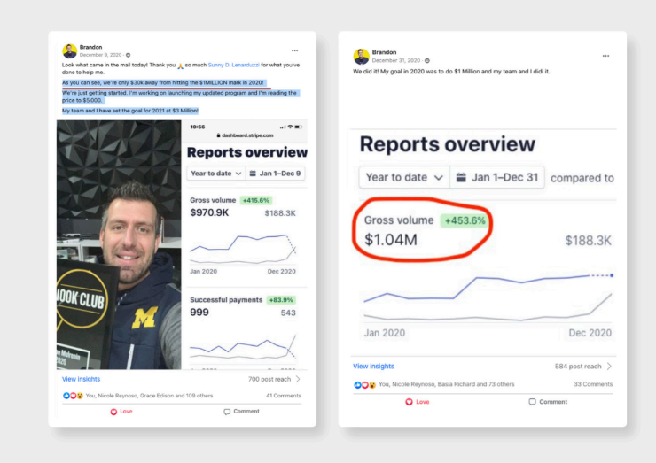

10X YOUR IMPACT & CREATE PREDICTABLE INCOME
Now, how do you turn all of this into consistent income month over month? It all comes down
to a very simple equation.
So, the next step is to reverse engineer your financial goals for your online education business.
The average conversion rate from turning a stranger into a paying client is 20%, so we
want to use that to create achievable goals in terms of how many clients you will attract on
a monthly basis.

FOR EXAMPLE:
Program Price:
$5,000
Financial Goal:
$10,000/month
# of Clients Needed Per Month:
2 clients
Multiply the # of clients by 5 to identify how many leads you need to achieve
a 20% conversion rate to attract that # of clients.
# of Leads Needed to Enroll 2 Clients a Month:
10 (2 x 5 = 10)
This makes it easy and predictable for you to hit your financial targets.
2 clients a month = $10,000/month
24 clients per year = $120,000/year

ELIMINATE THE COMPETITION
All of the steps leading up to this point have helped you identify your authority and unique
category, so we’ve already eliminated the competition in a lot of ways.
But, what is the true key to eliminating competition and becoming the sought after, go-to expert?
SOCIAL PROOF
As you attract clients into your program, your #1 focus is to ensure they are getting results and
achieving the HERO outcome you identified.

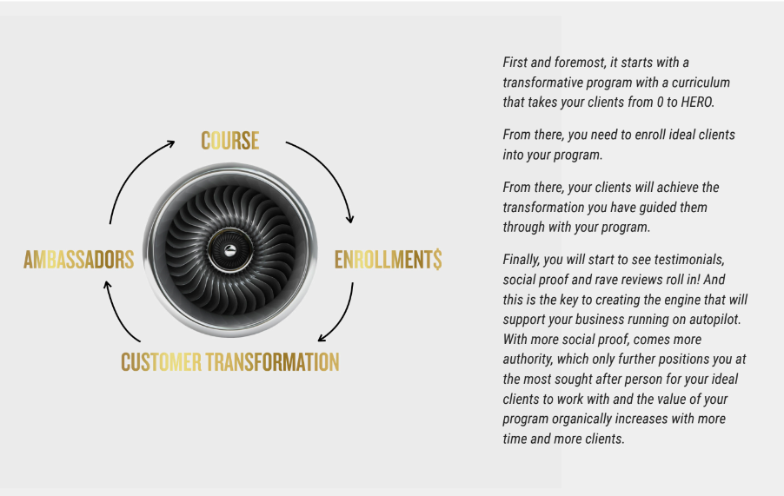

RESEARCH

Instead of expecting, plan
Expectations are one way to set yourself up to be disappointed. It is possible to guide your life tomorrow but you have no control over your exact outcome. This can cause you to have negative or positive expectations. If you have negative ones, you will become too close-minded to seize the opportunities that occur around you. On the other hand if you have positive expectations, you might create a vision that will be difficult to live up to. As such, the uncertainty of life can transform your expectations into stressors. Therefore, instead of expecting, create plans. This is because through them you can control your present. This is much more logical than trying to control your future.

Map out your life
Uncertainty often comes with the fear of getting lost. This is the main cause of discomfort among many. An effective way to prevent yourself from getting lost is to have a map. While these are available for geographical locations, you have to create a map for your own life. One of the most effective examples is the GTD productivity map. This is a resource you can create for yourself. It allows you to know where you currently are, where you are going, the means to get there and the possibilities available for you once you arrive. This personal productivity map also shows you what you need to do in case something unexpected occurs along the path. Through this form of life mapping, you have a system that helps you to maneuver in case you lose perspective.
Suggested Reading : Blueprint for a Great Future: 10 Simple Steps Towards Your Greatest Life

Prepare yourself for various possibilities
The most challenging part of being uncertain is the inability to feel in control. Being human, we want to know how things will go so as to be comfortable. Uncertainty takes this from us. Things change too fast for us to experience this. Therefore, instead of expecting specific outcomes of life, it makes more sense to simply prepare yourself for various possibilities. For example, you can make lists of the activities that you will perform in case things go one way or another. One of the characteristics of an uncertain future is luck. This is when things go exactly as you desired. It is important to know that luck happens when preparation and opportunity meet.

Become confident in your ability to cope and adapt to your circumstances
Assure yourself that you can actually cope and adapt in case the worst happens. This does not mean that you become a pessimist. It simply means that you are confident in your ability to handle whatever life throws at you. This form of thought is explained in detail in a book known as "The Positive Power of Negative Thinking" by Julie K. Norem. Thinking about the worst and adapting for it is known as defensive pessimism. This strategy has been observed to assist people to reduce their day to day anxiety.
Suggested Reading : 10 Activities You Need to Do Daily to Build Your Self Confidence

Transform yourself into a feeling observer
It is actually not uncertainty that bothers us. It is the tendency to get lost in feelings about an uncertain future. The moment that you begin to experience fear about the future, you get stuck in a collection of thoughts caused by a reaction stimulus. You begin to speculate. In this activity, your thoughts waver between optimism and pessimism. This cycle can last for a long time and cause you stress. To avoid this, observe your inner condition. Whenever you discover that you are geting stuck in a collection of thoughts, observe and catch yourself before your emotions get out of hand.
Suggested Reading : Meditate Your Way to a Better Life: 5 Benefits of Daily Meditation

Keep an eye on what you can control right now
Maintain focus on the things that you can control in the your short term. There are many activities which you can conduct today so as to create a clearer vision of what can occur in future. Examples of such are focusing on your career, talents, hobbies or profession. By maintaining focus on these activities, you can prevent yourself from getting unnecessarily paralyzed.

Accept risk and use it to your advantage
Whenever there is uncertainty, there is risk. It is important to minimize your risk and accept that which you cannot eliminate. If managed well, risk can be a good thing. It can help you to learn how to navigate difficult moments of life. It also helps you to learn how to manage your emotions. There are various resources around us that can help with handling risk. Examples of these are risk management manuals.

Embrace the possibility of chaos
The future has a collection of characteristics that make us anxious. One of these is complete failure. Often interpreted as chaos, this is where things go wrong without the possibility of correction. Whenever we face an uncertain future, we have to deal with chaos. It is created by our brains through a phenomenon known as the negativity bias. To protect us, our brains always make the most negative conclusion of a situation. This is so that we can prepare possible solutions in case that happens. If left unchecked, this bias can create chaos where there is none. As such, face uncertainty with confidence in a positive outcome. This overrides the negative bias and keeps your mind open. As such, even if things go completely wrong, you are open minded enough to see an opportunity in the challenge.
Suggested Reading : 10 Life Lessons That Will Sum Up All Your Self-Help Books

Do what makes you happy
When facing an uncertain future, it is necessary to wait. You have to wait and see how things go. This an agonizing activity. To relieve its pain, simply engage in the activities which make you happy. This can be a hobby, a talent or even a bucket list activity. Do what makes you happy. You will pass the time faster and in a more pleasurable way. This helps you to forget about the uncertainty for a moment and enjoy life.
Suggested Reading : 15 Key Elements of a Healthier and Happier Lifestyle

Accept that surprises can occur
Whenever something happens that we had not prepared for, it is a surprise. They occur no matter what we do. Therefore, it is best to be prepared for surprises. They are a constant characteristic of the future and they cause uncertainty. Surprises can be good sources of knowledge. By embracing them, you can get to experience things that you never even dreamed of.

The Important Take Away
Uncertainty is a reality for all of us. This is because it is a characteristic of the future. No matter how much we plan, we are always bound to experience some uncertainty. Instead of panicking, the tips above can help you to handle it. They are beacons to guide you through the oceans of your future.
LOOK AT JACKS LESSONS AND BREAK THEM DOWN

