Time Manager: User Guide
October 14, 2026

1. What is Time Manager?
Time Manager is a web app for tracking working time. Employees clock in and out and take breaks. Managers follow the attendance of their team. Admins look after users, roles and teams. What you see depends on your role.
Role | What you can do
Employee | Clock in and out, take breaks, view your own hours and history
Manager | Follow your team's hours and status, manage your team, email team members
Admin | Manage all users and roles, and organise every manager's team

2. Getting started
- Open the app. If you are not signed in, you land on the Sign in page.
- Enter your email and password, then sign in.
- New here? Use the Sign up button on the sign-in page. A new account starts as an Employee. An admin can change your role later.
- To leave, select Log out at the bottom of the left menu.
The left menu is how you move around. It changes with your role:
Role | Menu
Employee | Home, My Times, Feedback, Profile
Manager | Statistics, My team, Profile
Admin | Teams, User management, Profile

3. Employee guide

3.1 Home: clock in, clock out, take a break
Home is your daily page. It shows your current working time, today's hours, your weekly hours and your latest entries.
- Clock in when you start working. The card shows your current working time.
- Take a break while you are clocked in. The card changes to "You are on break" and shows when the break started.
- End Break when you are back at work.
- Clock Out when you finish.
- Refresh (top right) reloads the latest data.
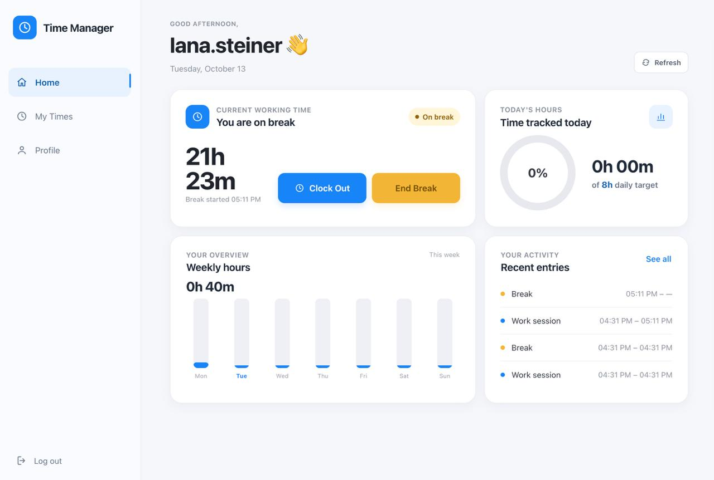
Figure 1: Employee Home page
What each card shows:
Card | What it tells you
Current working time | Your status (working or on break) and the running time
Today's hours | Time tracked today, against the 8 hour daily target
Your overview | Hours worked each day this week, with the weekly total
Your activity | Your most recent work sessions and breaks. Select See all for the full list

3.2 My Times: your history
My Times lists every work session and break you have recorded. Each row gives the type (Work or Break), the date, the start and end times, and the duration.
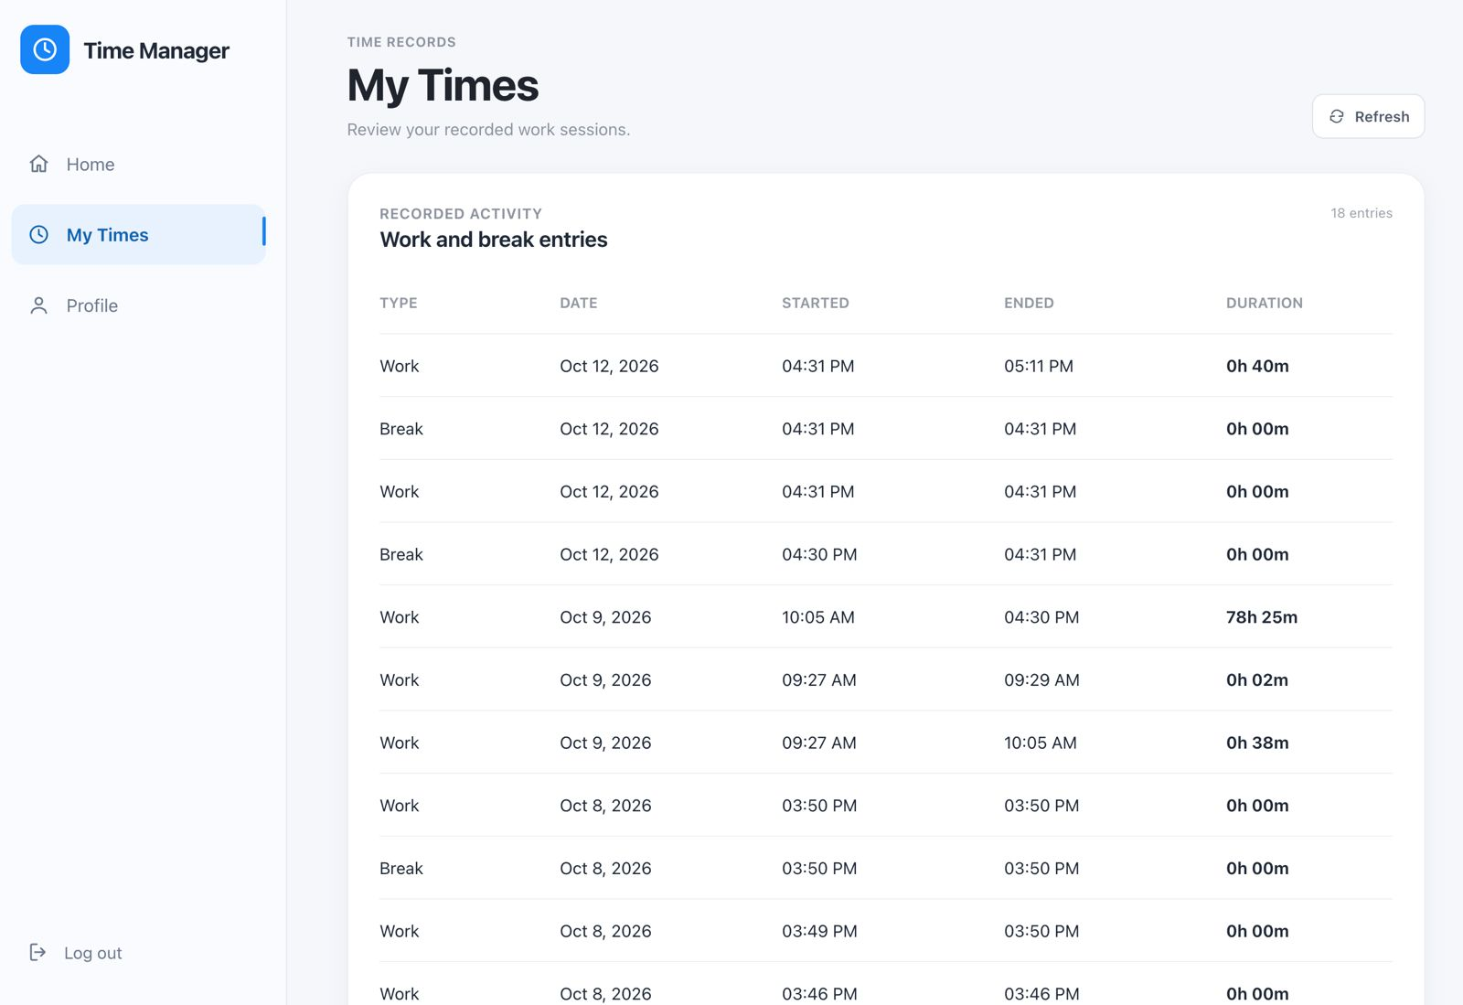
Figure 2: My Times page

3.3 Feedback: message your manager
The Feedback page sends a private message to your assigned manager.
- Open Feedback in the left menu.
- Add a short subject (optional) and write your message.
- Select Open email draft. Your email app opens with the draft, and you send it from there. Your email app chooses the sender account.
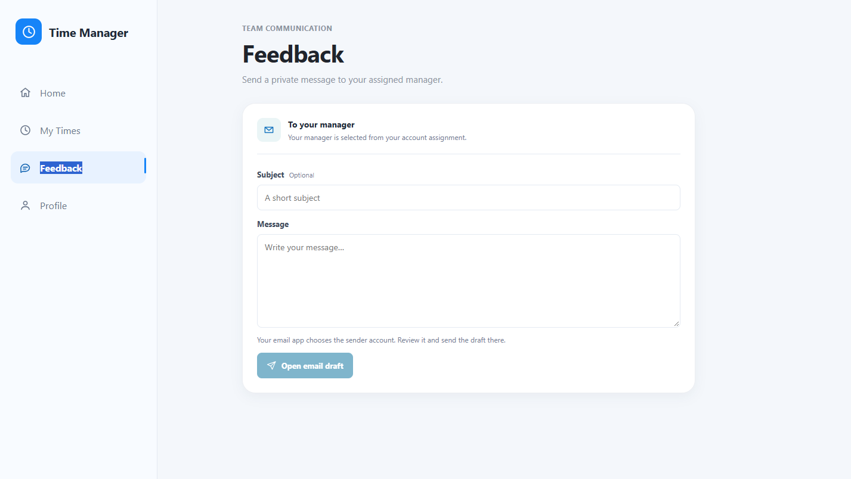
Figure 3: Feedback page

4. Manager guide

4.1 Statistics: your team at a glance
After signing in, a manager lands on the Statistics page.
- Summary cards show the number of team members, how many are clocked in now, how many are on break, and the team's hours today.
- Team working hours shows hours per day for the week, with the weekly total.
- Live team status counts how many members are working, on break or off the clock.
- Team members lists each person with their status, hours today and hours this week. Use the search box to find someone.
Clock status refreshes automatically. Hours come from the recorded work times.
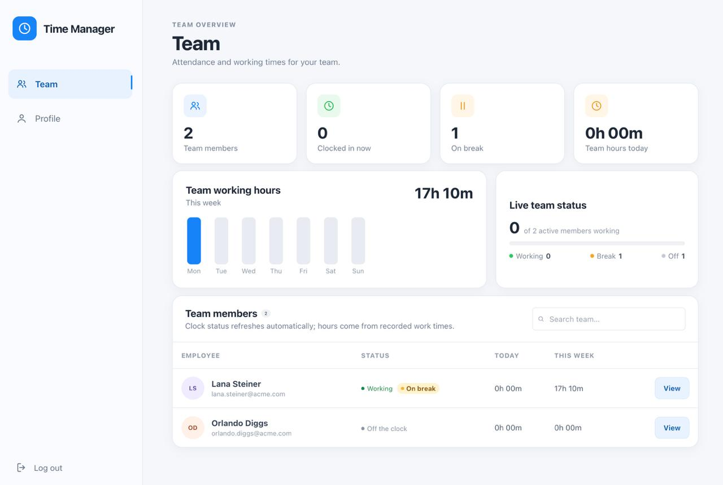
Figure 4: Manager Statistics page

4.2 My team: looking at one employee
Open My team in the left menu. It has two lists: Current team (employees assigned to you) and Unassigned employees.
- Select an employee in Current team. A panel opens.
- Read their hours today, hours this week, the weekly chart and their current status.
- To contact them, add an optional subject and a message, then select Open email draft. Your email app opens with the draft, and you send it from there.
- To take them out of your team, select Remove from my team.
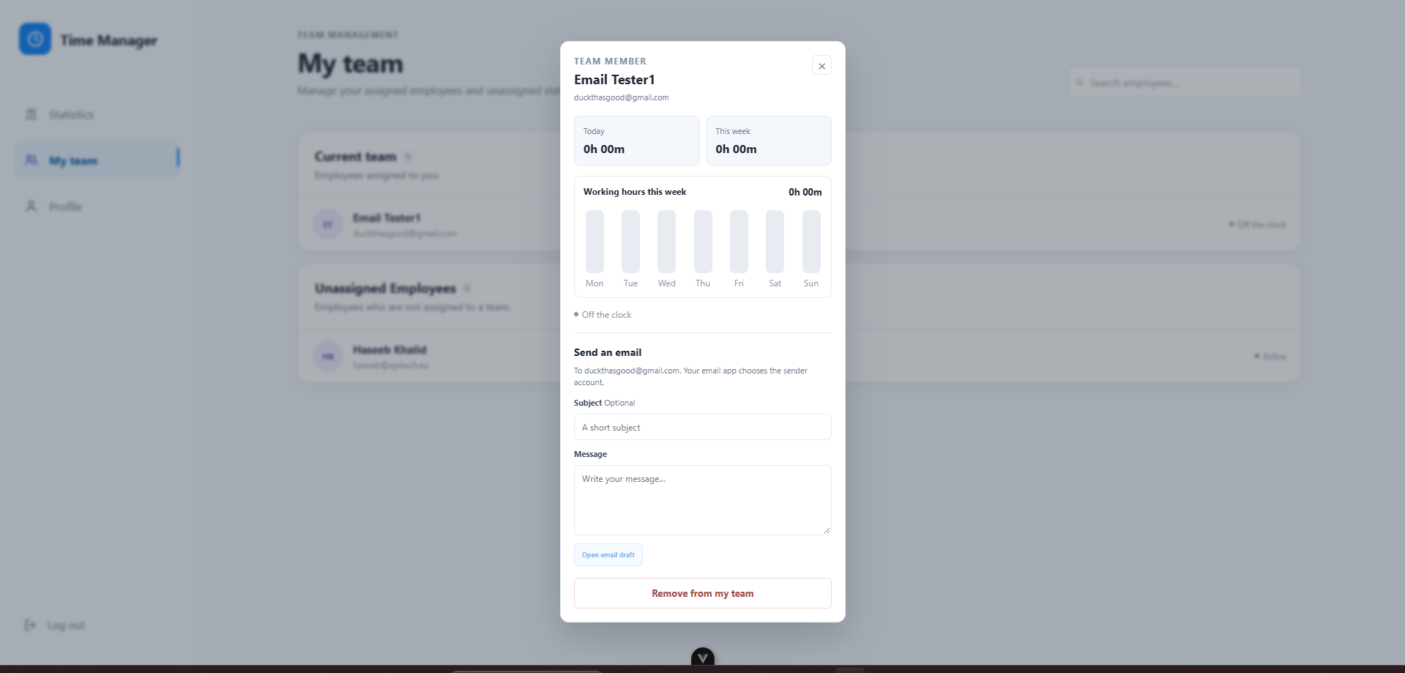
Figure 5: Team member panel

4.3 Managing your team
- To add someone, select them in Unassigned employees, then select Add to my team. Their statistics appear once they have joined your team.
- You can only remove employees from your own team.
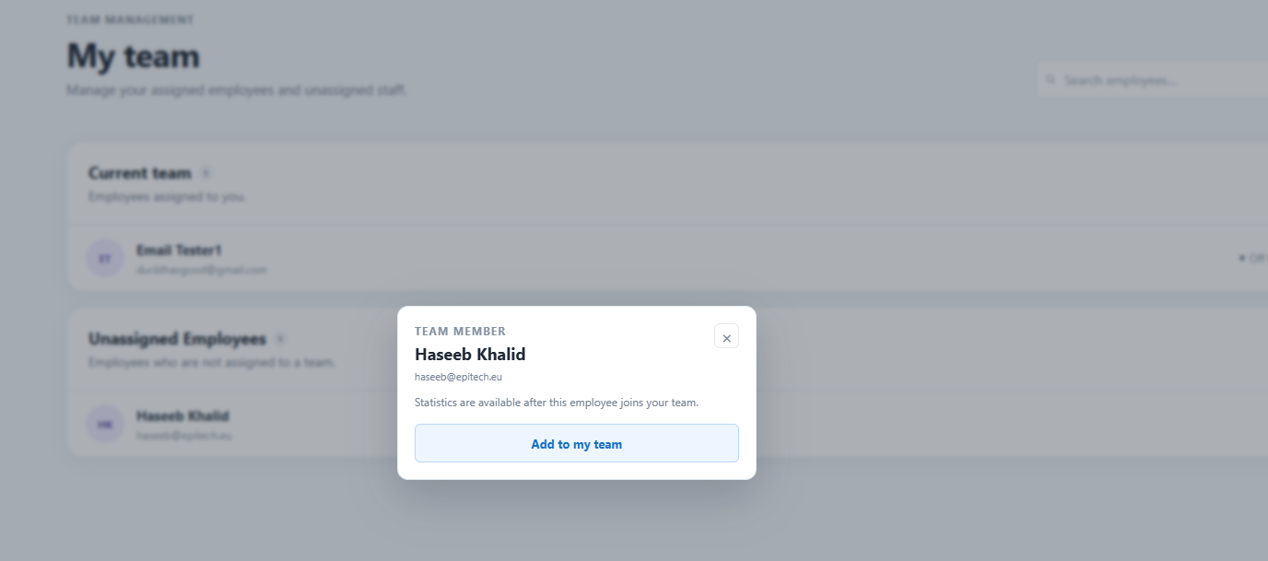
Figure 6: Adding an unassigned employee

5. Admin guide

5.1 User management
The User management page lists every user with their role, status and join date.
- Use the search box to find a user by name or email.
- Use the All statuses and All roles filters to narrow the list.
- Select a user to view their statistics.
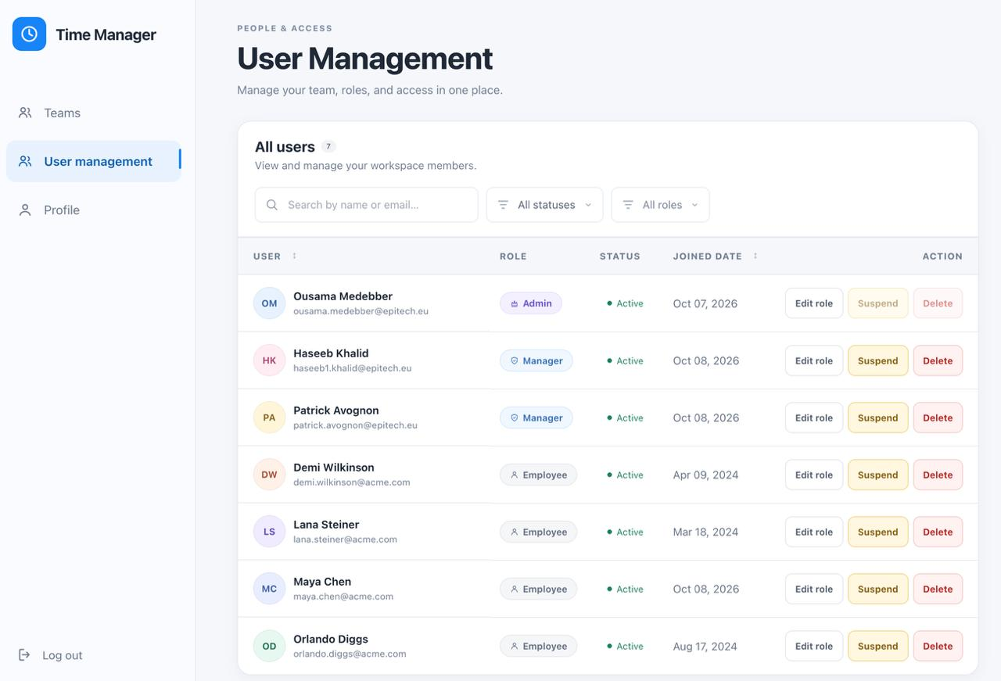
Figure 7: User management page
Three actions are available on each row:
Action | What it does
Edit role | Promote or demote the user to Employee, Manager or Admin
Suspend | Temporarily block the user
Delete | Remove the user permanently

The Suspend and Delete buttons are greyed out on your own account.
Select a user's name to open their Member statistics panel. It shows hours today, hours this week, current status and a weekly chart. From there you can also select Remove from team to take them out of their team, and send them an email.
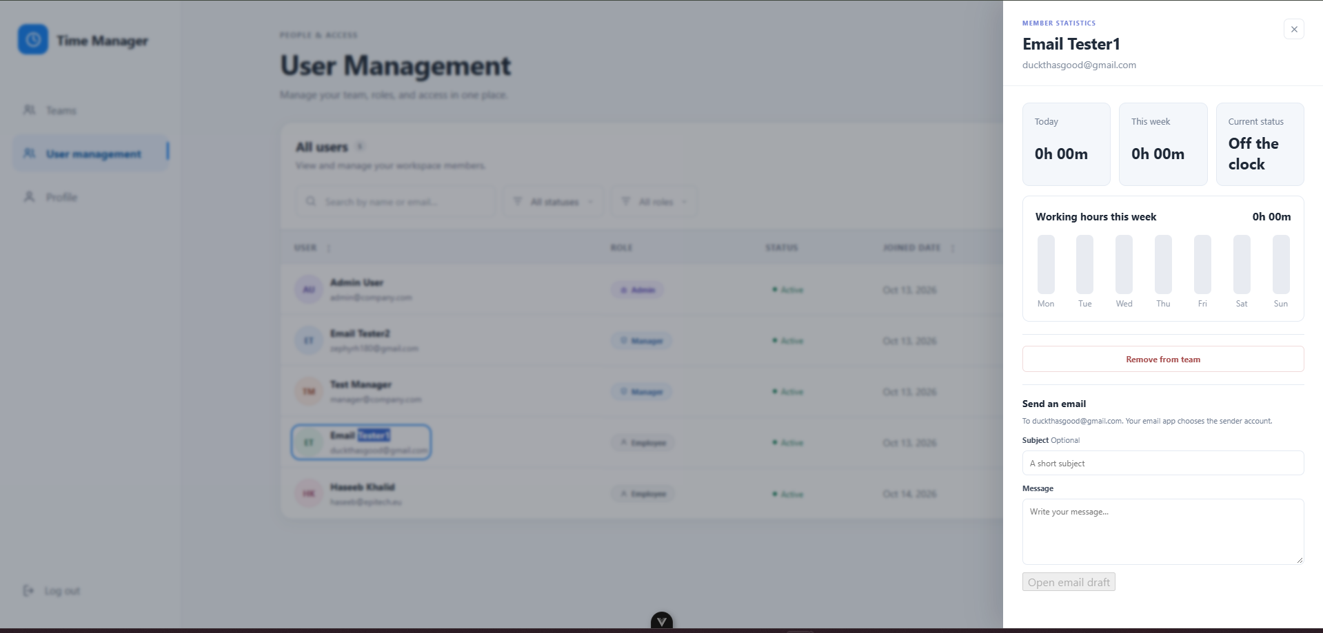
Figure 8: Member statistics panel

5.2 Changing a role
- Select Edit role on the user's row. A panel opens on the right.
- Choose Employee, Manager or Admin.
- Tick I understand this role changes the user's access.
- Select Save role changes, or Cancel to close without saving.
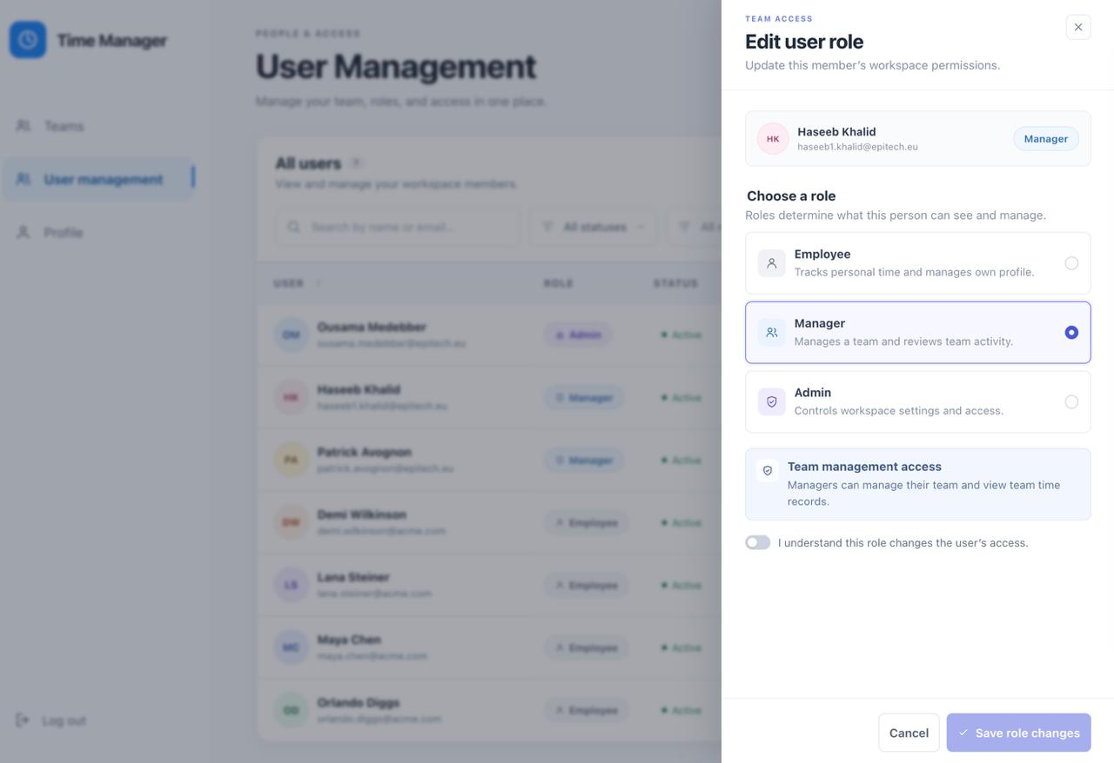
Figure 9: Edit user role panel
Role | Access
Employee | Tracks personal time and manages their own profile
Manager | Manages a team and reviews team activity
Admin | Controls workspace settings and access

5.3 Teams
The Teams page shows every manager with their team members.
- Remove any employee from any manager's team.
- Add any unassigned employee to any manager's team.
- Select a manager to see their statistics and how their team is performing.
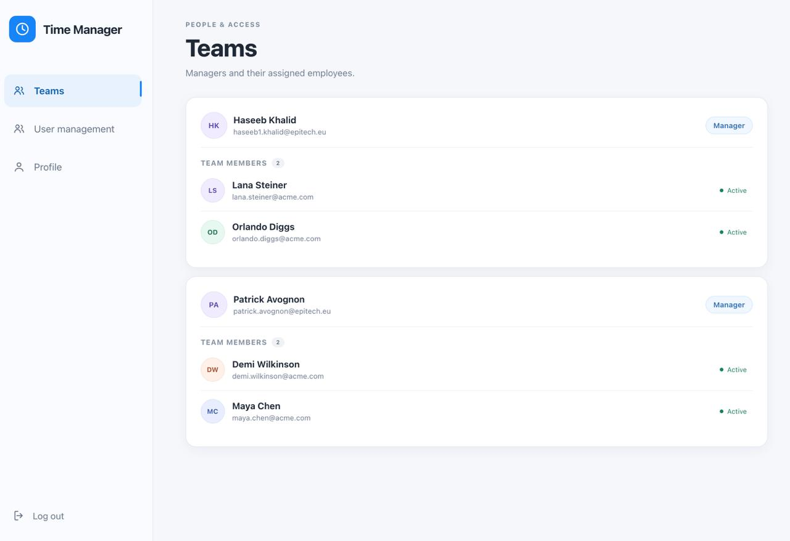
Figure 10: Teams page

6. Quick reference
Task | Who | Where
Clock in, clock out, break | Employee | Home
See your time history | Employee | My Times
Message your manager | Employee | Feedback
See team hours and live status | Manager | Statistics
Add or remove team members | Manager (own team), Admin (any team) | My team, Teams
Change a role | Admin | User management
Suspend or delete a user | Admin | User management

