**HG14 DATASET**

HG14 (Hand Gesture) dataset contains 14 different hand gestures for hand interaction and application control in augmented reality applications. For this dataset, 14 different hand gestures were determined. 1000 images were taken for each gesture using different backgrounds from 17 different people. And a Hand Gesture dataset with a total of 14000 3 colored (RGB) channel images was created. Our dataset is named as HandGesture14 (HG14) dataset since it contains 14 different hand gestures. The HG14 dataset consists of 256×256 pixel color images. The difference of the dataset we have developed from other datasets is that it consists of images taken directly with the camera, not including data such as RGB-D, depth, and infrared with special cameras and, sensors. In HG14 dataset, hand gesture images taken from the first-person view were used, especially for use with augmented reality applications and wearable Technologies.

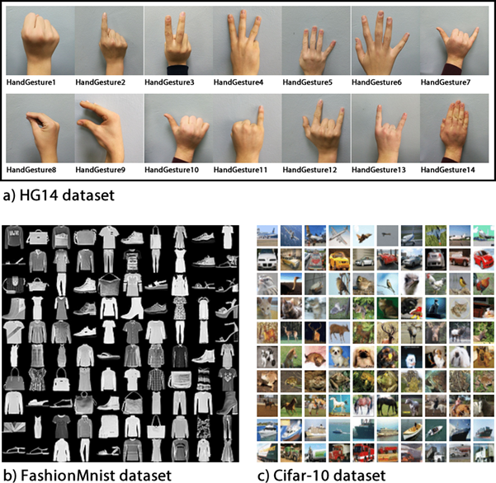

### For HG14 dataset, Cite this article;

Güler, O., Yücedağ, İ. Hand Gesture Recognition from 2D Images by Using Convolutional Capsule Neural Networks. *Arab J Sci Eng* (2021). <https://doi.org/10.1007/s13369-021-05867-2>

***HG14 dataset The HG14 dataset is labeled as follows.***

label[0:999] = Gesture_0  
label[1000:1999] = Gesture_1  
label[2000:2999] = Gesture_2  
label[3000:3999] = Gesture_3  
label[4000:4999] = Gesture_4  
label[5000:5999] = Gesture_5  
label[6000:6999] = Gesture_6  
label[7000:7999] = Gesture_7  
label[8000:8999] = Gesture_8  
label[9000:9999] = Gesture_9  
label[10000:10999] = Gesture_10  
label[11000:11999] = Gesture_11  
label[12000:12999] = Gesture_12  
label[13000:13999] = Gesture_13