**JAVA/JEE DEVELOPEMENT**

**MINI-PROJECT**

* DEVELOPMENT OF A WEB APPLICATION-



**MANAGEMENT OF AN ONLIGNE LIBRARY**

**- DIGITAL BIT RARY -**

**(DBR)**

Realized by: SGHAIER Med Oussema

GMAIL : [stratosphur4basic@gmail.com](mailto:stratosphur4basic@gmail.com)

Summery

1. **INTRODUCTION**
   1. Problem Specification ……………………………………………………………….3
   2. Objectives .……………………………………………………………………………….3
   3. Workflow steps …………………………………………………………………………3
2. **SERVICES & FUNCTIONS**
   1. Functions Description ……………………………………………………………….4
   2. Users Registration .…………………………………………………………………..4
   3. Athentification & login ………………………………………………………………5
   4. Upload and Save ……………………………………………………………………….6
3. **QUALITY & PERFORMANCE**
   1. Quality Attributes Requirements ………………………………………………9
   2. Performance…………………………………………………………………………….10
4. **WORKSHEET**
   1. Web Application Architecture ………………………………………………....11
   2. Analysis Models ..……………………………………………………………………..13
5. **DEVELOPEMENT**
   1. Tools & Programs ..…………………….................................................15
6. **PAGES & LAYOUT**
   1. SignUp page ………………………………………………………………………………15
   2. Login page …………………………………………………………………………………16
   3. Home page ………………………………………………………………………………..16
   4. Upload book page ……………………………………………………………………..17
   5. Examine book page …………………………………………………………………………17

# **INTRODUCTION:**

## 

## 1.1 Problem Specification:

Develop an online library that holds various e-books, allowing users to read books anytime, anywhere.

## Objective:

**D**IGITAL **B**IT **R**ARY (**DBR**) is a web platform that allows users to access a library of electronic books (e-books).

User can login to **DBR** platform throw his acount and:

* Examine
* Modify/Update
* Publish
* Save

Any exibited book(s) that his wishes easily from any device that supports

Web browsing.

Users can build an acount and log in anytime. User can costumize (add,edit,view) his information.

## Workflow steps:

1. Basic Need Analysis
2. General Concept
3. Detailed Concept
4. Dévelopement
5. Testing

# **SERVICES & FUNCTIONS:**

## Functions Description:

There is a numerous functions that DBR offers as services that define the basic structure of this application such as :

* User Registration (Sign In)
* User authentification (Login)
* Publish and Save
* Collect

## User Registration

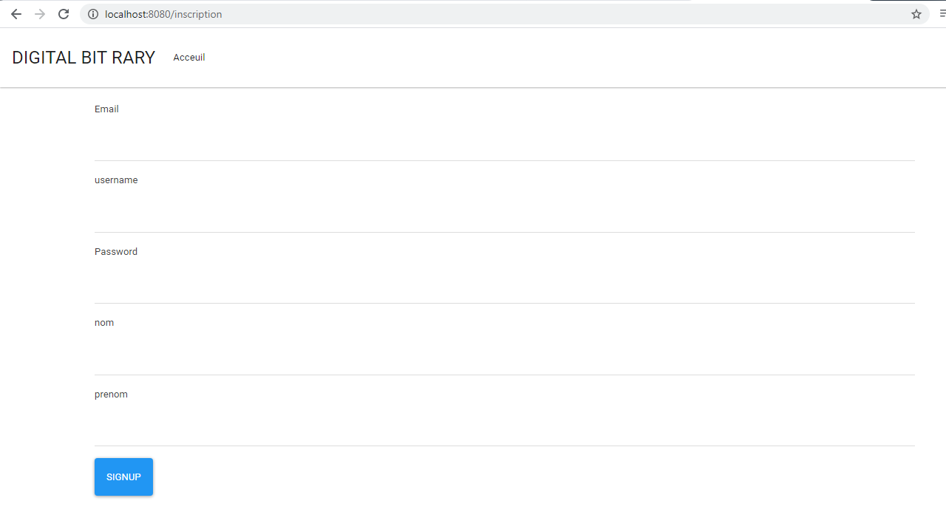

**Description:** - For registration, new users have to create an account (user profile), that contains Users infomation,which are :

* First Name
* Last Name
* Username /Email
* Password

All of the fields must be filled with valid information and respects input parameters an dimensions for succefull registration.

The name should not exceed 30 characters. The password should be at least 8 characters long, at most 15 characters.

## Authentification & Login:

**User Authentification:**

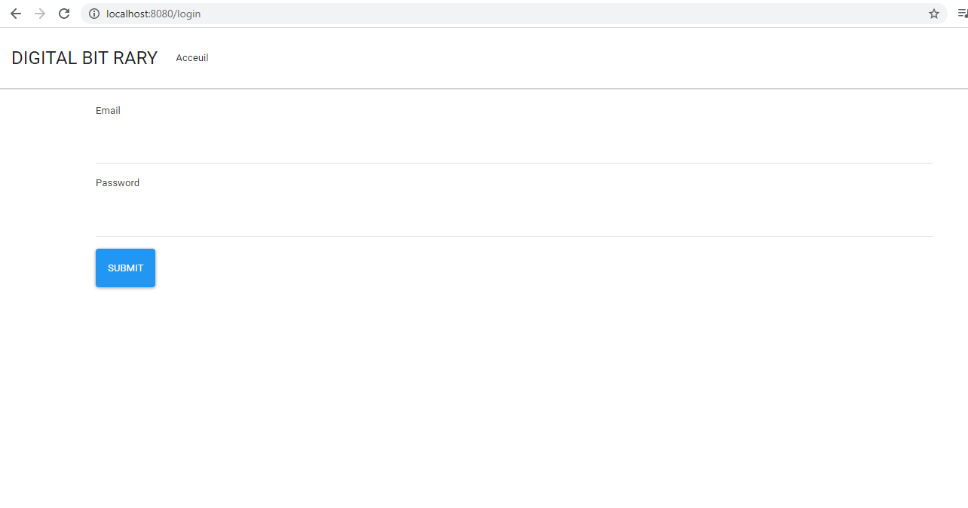

**Description:** - For logging in **DBR** platform User have to verify his identity First.this require two parameters : **ID** (E-mail) and the **password** of the logger.

Once the parameters is matched with Input data. Those user parameters are pre-defined in **Data Base** tabels.

**View/Edit account information:**

**Description:** - A part of viewing user profile informations. Users should be able to edit the account details like First name,Last name, email and password.

Users must be logged in. Input to each field must be validated.

**Delete Acount :**

**Description:** - The user may delete his account permanently from **DBR** depending on his wish. All of his data will be cleared.

## Upload and Save:

**Upload:**

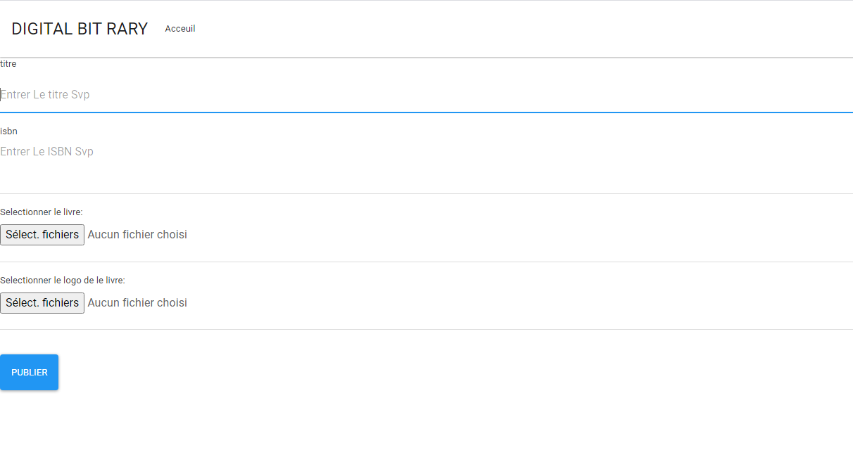

**Description:** - This functionality allows both the User/Admin to add book(s) (**PDF** format file) to the platform.

Each book has a name-**ID** and **Cover picture**, So the visitor can separate between books.

* Admin book **add-ons** will be **publicly available** on **DBR** homepage for all users.
* User book **add-ons** will be saved on his profile for storaging.

**Save:**

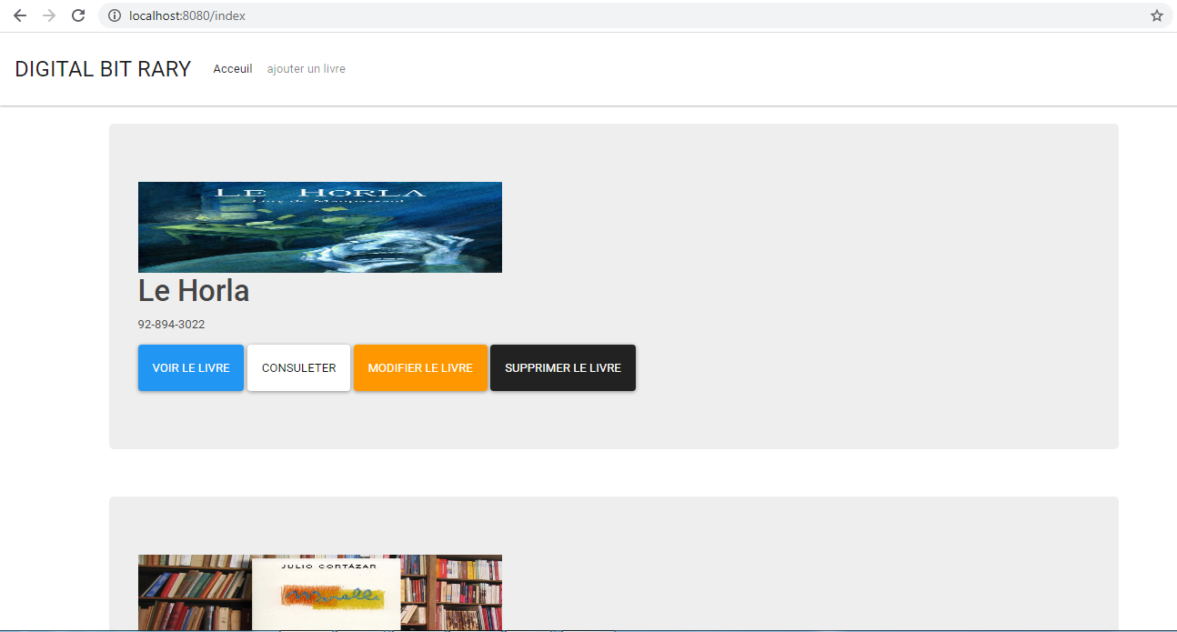

**Description:** - User can save (download) pre-collected books directly on his memory disc, when he is logged in. downloaded books will have PDF format ,and saved at default downloading path of his device.

**Examine:**

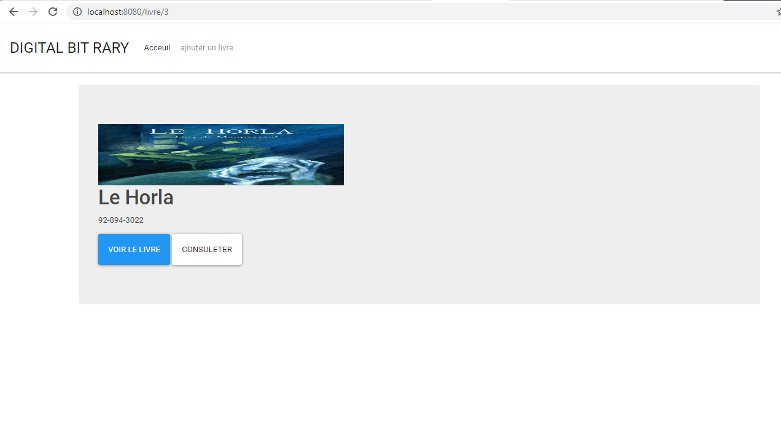

**Description:** - User can open and read e-books directly online from the application, without the need for downloading it. Pages layout must be wide and big, text must be clear for the reader to see. With read only permission for the integrity of the file.

**Remove:**



**Description:** - A remove option is used, Once the user wants to delete a book from his account, this unsupend the undesired book from user-profile.

**Book List :**



**Description:** -when the User logs into **DBR**, he can see a list of Book posts published in his homepage. This posts is displayed in a large clearance for easier reading, and paging will be implemented for more posts.

Every post has the name, price and cover of the book.

**Upload Book Cover:**

**Description:** - Admin can add book cover on book-posts.

Book cover must be an image format with a small size dimension for better visibility.

# **QUALITY & PERFORMANCE:**

## Quality Attributes Requirements:

#### **Usability**

* DBR User interface should be simple and clear and easy to navigate to be able to understand by any Visitor.

#### **Availability**

* The system should be available anytime/anywhere. It should be solid, rebust against saturation or parasites and ensured that there should be minimum downtime for smooth user experience.

#### **Reliability**

* The system should be reliable. And can handle numurous users, proccessings at the same time without crashing.

#### **Testability**

* The application must be developed in a way that is easier to test by Quality test engineers. So they can test the application for stability, bugs, performance.

#### **Maintainability**

* The system must be Up-To-Date. Therefore, source code parametres, variables, classes and object must be symbolic and well defined. So i twill be easy to inderstand to modify and incorporate new features requirements or accommodate a change in the existing parameters.

## Performance:

## **Efficiency**

The system must be accessible at all time, for all users. Providing a good serviceability and straightforward information accessibility and simple layout.

## **Speed**

The application should be fast and responsive. And should adapt with massive loads of processing and saturation and gives fast feedback for better end-user experience and to be respond to user actions in real time.

### **Security**

User password is a **hash** value in **data base**. It should be at least 8 characters long.

# **WORKSHEET:**

## How Web Apps Work - Web Application Architecture Simplified | ReinventlyWeb Application Architecture:

**DataAccess layer**

**JAVA**

**Data store layer**

**Presentation layer**

**Business layer**

**MYSQL**

**HTML**





Spring-boot

Starter-web

Spring-boot

Starter-

Security

Spring-boot

Starter-JPA



**DIGITAL BIT RARY Web Application Architecture Diagram**

**DATABASE**

The **spring framework** will be used as a backend for developing **DIGITAL BIT RARY** web application(Rest API), and for the frontend, I used **Thymleaf**.

Classic Architecture **MVC** is used as a base, which divides the application into three parts :

1. **Presentation Layer**

Thymeleaf is used in the presentation layer of the application for HTML paging and display for the user. Serving the rôle ofS displaying information and to read inputs from the user.

1. **Controller Layer**

The controller initiates the commands to the model to make changes to the database. It also sends commands to the presentation layer views associated with the models.

1. **Data Access Layer**

Data access layer responsable for database access and data updating .

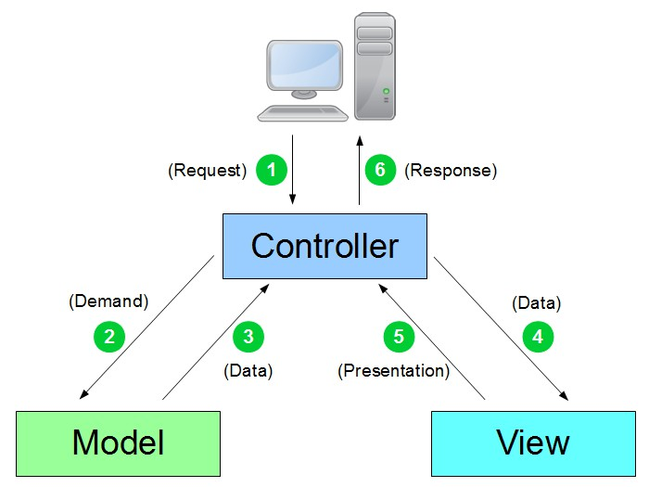

**MVC model architecture**

## Analysis Models:

### **Use Cases:**

Inscription

Authentification

USER

Read books

Book management

Modify/ Remove books

Upload books

ADMIN

### 

### **Class Diagram:**

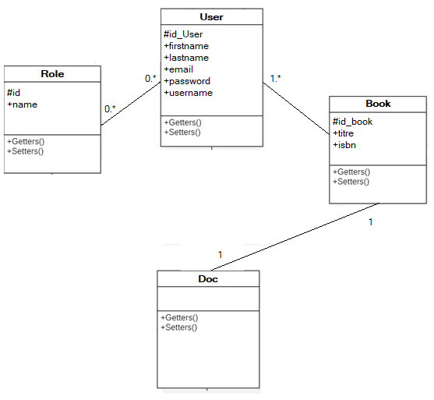

### **Sequence Diagrams:**

- Registration -

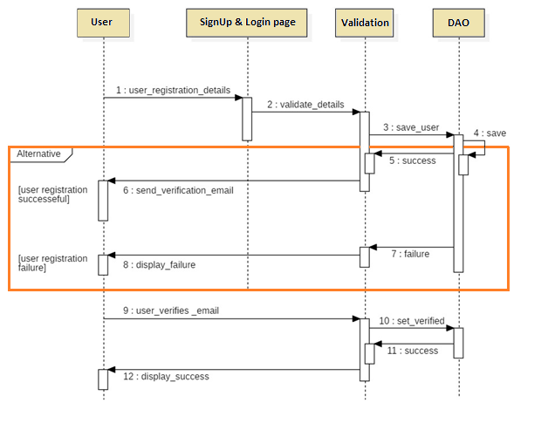- Upload -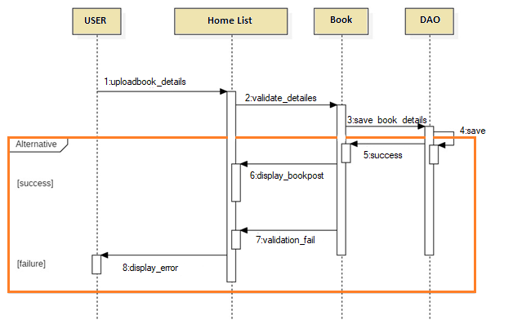

# **DEVELOPEMENT:**

## Tools & Programs:

* **StarUML** is used for creating all the UML DBR diagrams.
* **SpringToolSuite4**-(sts 4.8.1 RELEASE) IDE  for development environment tool.
* **Thymeleaf** used to bring elegant natural templates to the development workflow (frontend).
* **MySQL** Community Server 8 – MySQL community server will be used as a relational database backend.
* **Apache** **Tomcat 7** – Apache Tomcat server will be the server environment to host the java code and Rest Api (embedded into spring boot).
* **Windows 10 OS** –The development platform will be Windows 10 OS.

# **PAGES & LAYOUT:**

## SignUp page :



## Login page:



## Home page:



## Upload book page:



## Examine book page:

