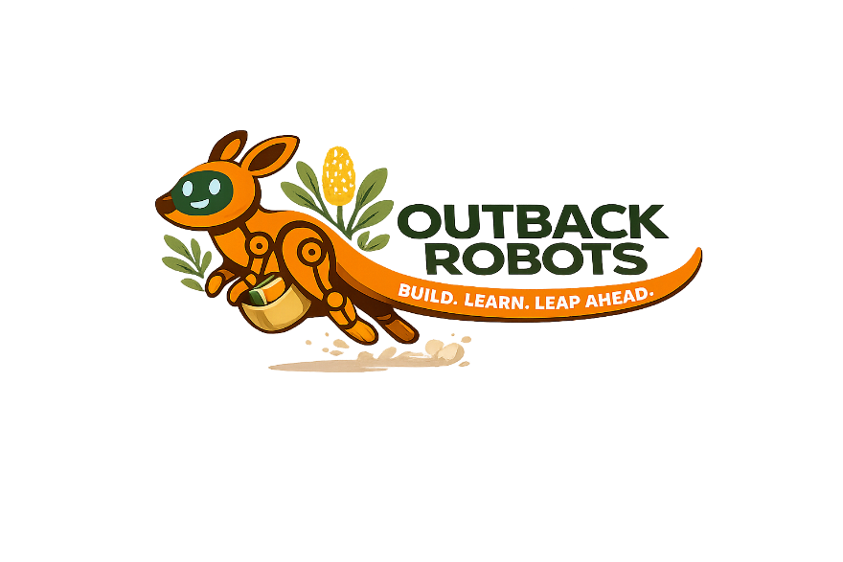
IS IT AI?
Calculator | Mum’s TikTok For You Page
Spotify personalised playlist | Smoke alarm
Face ID | Microwave timer
Google Maps directions | Amazon Alexa giving us a recipe
Traffic lights changing on timers | A robot trained to assemble tables
Tesla braking for pedestrian | A vending machine giving you change
Google showing search results | Siri suggesting a restaurant
Student Sheet


IS IT AI?
Teacher Guide
Calculator  NOT AI. Follows fixed rules — it does exactly what you type, every time. No learning, no patterns. | Mum’s TikTok For You Page  AI. Learns from what you watch, like, and skip to predict what to show next.
Spotify personalised playlist  AI. Analyses your listening history and patterns from millions of users to predict songs you’ll enjoy. | Smoke alarm  NOT AI. A sensor detects smoke above a fixed threshold and triggers an alarm — a simple precoded rule.
Face ID  AI. Uses a neural network trained on thousands of faces to recognise yours, even in different lighting. | Microwave timer  NOT AI. Counts down a set time and stops — a fixed rule with no learning involved.
Google Maps directions  AI. Learns from real-time traffic data and millions of past trips to predict and reroute the fastest path. | Amazon Alexa giving us a recipe  AI. Uses natural language processing to understand your question and retrieve a relevant answer.
Traffic lights changing on timers  NOT AI. Switches on a fixed schedule — it doesn’t observe or adapt to traffic conditions. | A robot trained to assemble tables  DEBATABLE. The word “trained” suggests AI, but most factory robots follow precoded steps. Ask: does it learn, or just repeat?
Tesla braking for pedestrian  DEBATABLE. Basic braking uses a sensor and a fixed rule (not AI). Full self-driving systems that identify what the obstacle is use AI. | A vending machine giving you change  NOT AI. Calculates change using fixed maths — no pattern recognition or learning involved.
Google showing search results  DEBATABLE. Basic keyword matching is not AI, but Google uses AI to rank results based on what people click on. | Siri suggesting a restaurant  AI. Uses natural language understanding and learns from your habits and location to make personalised suggestions.
AI NOT AI DEBATABLE

