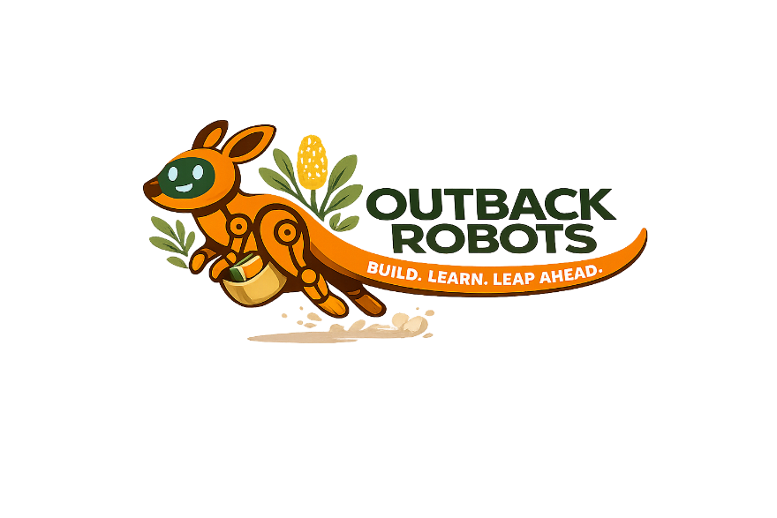
LLM PROMPT LIST
Prompt | Next Word
Roses are red, violets are…
The dog wagged its…
Once upon a…
He was so hungry he could eat a…
The wizard raise his wand and shouted…
She slipped on a…
He opened the wooden box and inside was a…
The fish jumped out of its bowl and…
The purple elephant quietly…
For breakfast the moon ate a bowl of…

