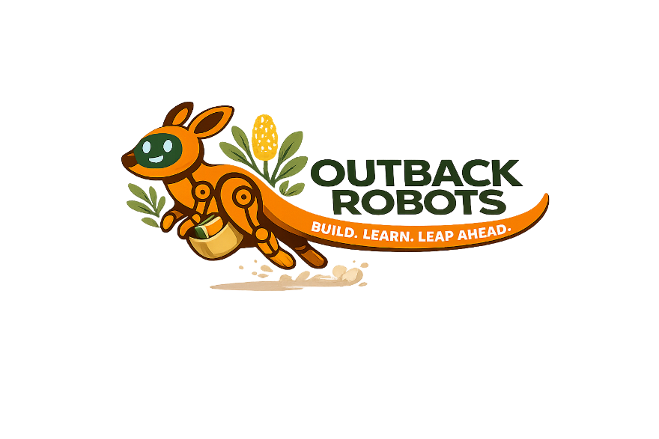
Presentation
Our robot
What can we make it do?
Explain the control process

What’s it sensing?

How is that sent to the computer?

What is it coded to do?

How is it sent back to the motors?

What does it do?


Presentation
Our code

IF statement
Loop
Custom block


Presentation
Our skin

What material did you use?
How do you want your Blossom to be perceived

Smart?
Helpful?
Kind?
How is the material sustainable?

Is it recycled?
Repurposed?
How is the material equitable?

Cost?
Access from home?


Presentation
Our reflection

Something that surprised you
An example of AI you come across every day
Something you found difficult but overcame
Something you would do differently next time

