
Encode a Mystery Word in Binary

Choose a word that has between 4 and 8 characters. Use the letter-to-binary code below to translate your word to binary.
Letter-to-Binary Code
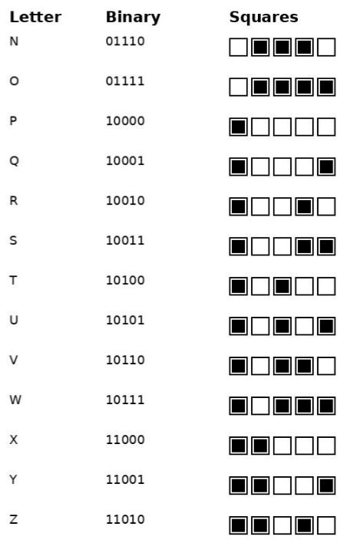
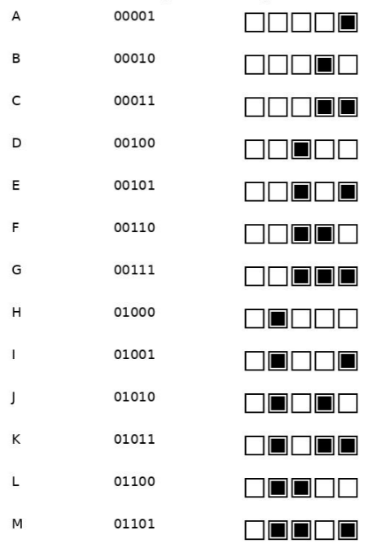

Letter Binary Squares




Fill the ‘bit boxes’ with the corresponding zeros and ones (0 and 1).
Leave the lines below the boxes blank for your classmate to fill in.

