Look at pin name on ATMEGA32U4 (i.e. PF1… PF0… ETC)

Find the pin name on the LEONARDO PINOUT picture

Find the Pin on the physical leonardo board corresponding with the PIN you want to decode…   
  
I.e: PF0 = A5.

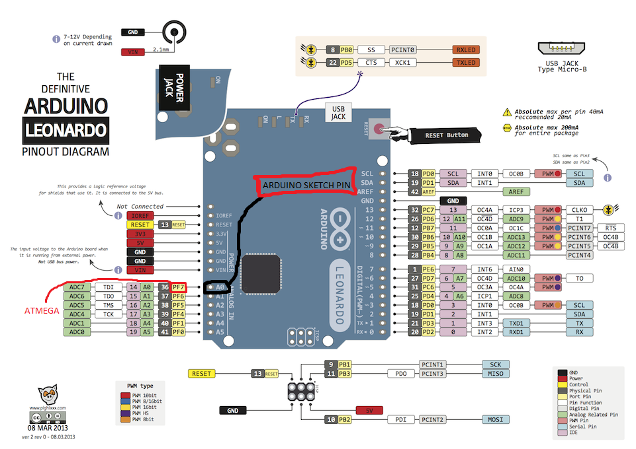

|  |  |
| --- | --- |
| ATMEGA32U4 | ARDUINO SKETCH PIN NAME |
| MISO | 14 |
| MOSI | 15 |
| SCLK | 16 |
| MEM_EN (PF1) | A4 (22) |
| XM_EN (PF4) | A3 |
| GYR_EN (PF5) | A2 |
| RED_LED (PB6) | 10 |
| GREEN_LED (PB5) | 9 |
| BLUE_LED (PB4) | 8 |

0xCE

0xD0

0xFF

0xFF