Brandon Everett
CSC505
Module 8
1/12/2025

For module 8 we were asked to build an ATM. At first, I thought it would be super easy. Like, how hard could it be? You put in a PIN, get some money, but there are always things that you don’t account for.
Before writing any code, I used PlantUML to draw out how the ATM should work. It really helped me see the whole picture of what needed to happen. I look at things like checking PINs and making sure people don't take out more money than they have.
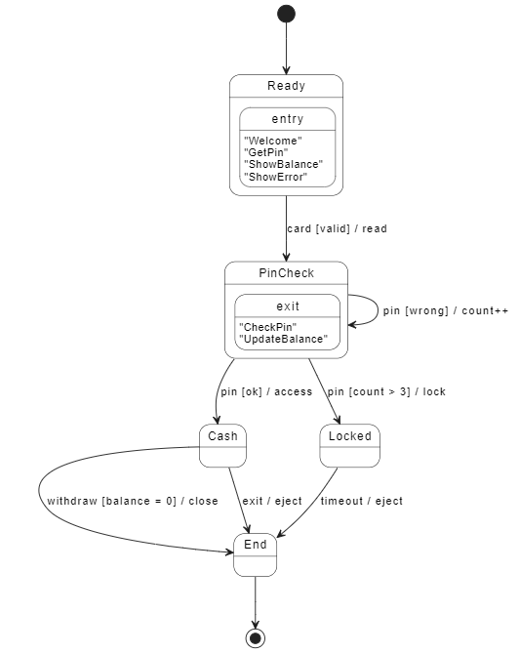
I learned quickly that breaking down big problems into smaller ones makes everything easier. Instead of trying to do it all at once, I started small. First, I just got the PIN part working. Then I added the part that keeps track of wrong PINs. After that, I worked on the money stuff.
The hardest part was thinking about all the things that could go wrong. What if someone types their PIN wrong three times? Or tries to take out more money than they have? I never thought about all these little problems until I had to actually make them work.

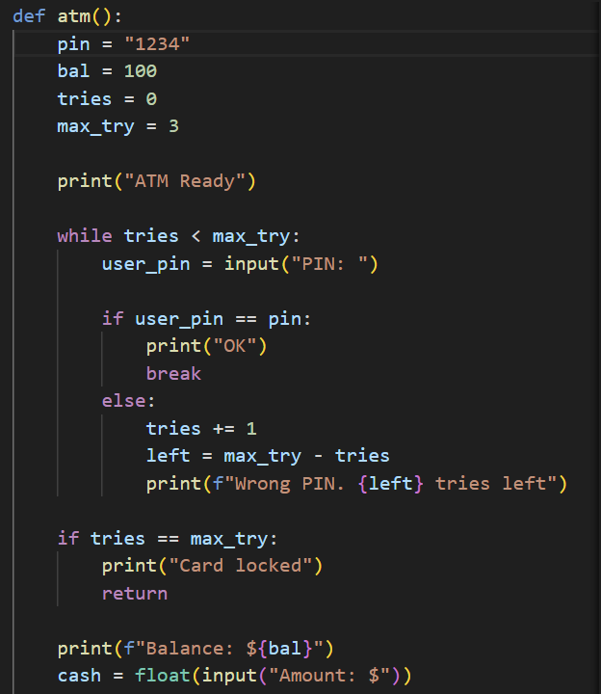
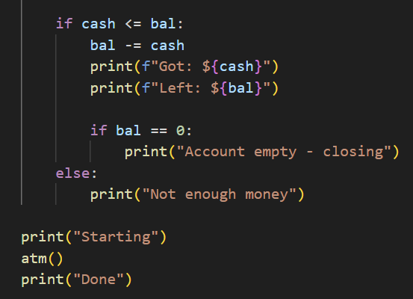
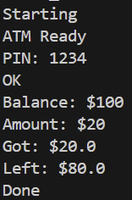
Works Cited
"PlantUML Guide." PlantUML.com, 2024, plantuml.com/guide. Accessed 12 Jan. 2025.
Pressman, Roger S., and Bruce R. Maxim. Software Engineering: A Practitioner's Approach. McGraw-Hill Education, 2020.
"Python Documentation." Python Software Foundation, 2024, docs.python.org/3/. Accessed 12 Jan. 2025.

