CE/CS/SE 3354 · Software Engineering · Fall 2026
CE/CS/SE 3354 · Software Engineering · Fall 2026
Project Milestone P2
Analysis and High-Level Design Campus Map
Team | Team 11, section .003
Document version | 1.0
Date | 11/05/26
Repository URL | https://github.com/OuterBeatle/CS3354-Campus-Map
Git tag for this milestone | P2
Submitted on Canvas by | Arsh Heer

Team member | NetID | GitHub username
Riven Amdal | RTA230000 | RivenAmdal
Arsh Heer | ASH230010 | Arsh-Heer
Cyril Canete | CCC220007 | cyrilcanete
Michael Dezeeuw | MGD220000 | OuterBeatle
Kaylee Vo | KPV220001 | kaeylvee
Jay Windisch | dal887067 | LongerNights

0 Revision History, Contribution Record and Changes Since P1

Version | Date | Author | Summary of change
0.1 | Oct. 17 2026 | Riven Amdal, Cyril Canete, Michael Dezeeuw, Arsh Heer, Kaylee Vo, and Jay Windisch | P1 proposal and requirements baseline.
1.0 | Nov. 4 2026 | Riven Amdal, Cyril Canete, Michael Dezeeuw, Arsh Heer, Kaylee Vo, and Jay Windisch | P2 draft: requirements carried forward; use-case analysis added; proposed changes recorded for team review.

0.1 Individual Contribution Record (P2)
Team member | Sections and artifacts this person produced for P2 | Evidence in the repository (commit hashes, PR numbers) | Reviews given (PR numbers)
Riven Amdal | Section 6 (Architectural Design) | 2a548cfb84bc1843f603c938343b6338a2cc96e7, 0c48cf46484139a59ab107572351f8088982b872 | None
Cyril Canete | Sections 10-12 | 9d48e2b1e1b2b92c5d24fc585c201265e519c6c0 | None
Michael Dezeeuw | Section 9 (Traceability) | 248497db0a13e7db00d4bf66af7424f37dbdb243 | None
Arsh Heer | Sections 5.1-5.3, 8, and 10.4 – Analysis models, design rationale, architecture spike draft, and repository documentation | 267d6fb4264d71bb56874c85f58ef59799ba4068, 19fca1ab602698a99c28000ec249e96179f329bb, e5d54fb191b510600c5bf2e3cf7f95bbf2ebec8b | None
Kaylee Vo | Section 4 (Use Cases) | 263b3c3461cc14d5aab45522c6cf42e2feb21da8 | None
Jay Windisch | Section 7 | 38e2b652ef04d4d25db20698244c1d6ffc13500e | None
0.2 Changes Since the P1 Baseline
Change ID | What changed (IDs affected) | Why (feedback / finding) | Knock-on effect | Agreed on
CH-01 | Specify UT Dallas as the target campus instead of leaving the institution unspecified. | Current project direction identifies UTD. Official campus boundary and data source still need team confirmation. | Update project context, sources, and requirement sources; verify data-use terms. | 11/6/26
CH-02 | Analyze UC-01 Find a Campus Location, UC-02 Get Walking Directions (conditional), and UC-03 Filter Campus Places. | P2 requires at least three expanded use cases, including the two specified in P1. | Add actor/system steps and use these cases in Section 5 analysis. | 11/6/26
CH-03 | Carry QR-01 through QR-06 forward for refinement into P2 quality-attribute scenarios. | P1 draft already contains measurable targets; no instructor feedback about threshold changes was provided. | Create QAS entries and link them to architecture decisions; preserve QR IDs. | 11/6/26

1 Introduction
1.1 Purpose
This document defines the scope, stakeholders, assumptions, constraints, feasibility, requirements, and use cases for the CampusCompass — UTD Campus Map System. It is intended for the project team, instructor, and relevant campus representatives. This P2 version carries forward the P1 baseline and adds analysis and high-level design.
The proposed system helps students and visitors find buildings and campus services at The University of Texas at Dallas. It provides a searchable campus map, location details, and category filtering. Walking directions and staff editing remain conditional until suitable data, permissions, and implementation feasibility are confirmed.
1.2 Scope
In scope | Out of scope
Display a map of UTD and approved campus locations; search by name/keyword; filter by category; show available location details; support desktop/mobile browsers. | Indoor turn-by-turn navigation; live GPS tracking; room scheduling/course registration; emergency dispatch; live shuttle tracking; public unmoderated edits; native mobile apps.
1.3 Definitions
Term | Meaning
Campus location | Mapped places such as a building, library, dining area, parking area, or service office.
Location record | Name, category, map position, and optional descriptive details for one campus location.
Wayfinding | Helping a user identify a place and determine how to reach it.
Routing service | External service or data source that calculates a path; not yet confirmed.
FR / QR / CON | Functional requirement / quality requirement / constraint requirement.
MoSCoW | MUST, SHOULD, COULD, and WON'T priority labels.
1.4 References
R1 — CS 3354 Fall 2026 P2 template and project description.
R2 — UT Dallas official campus map: https://www.utdallas.edu/maps/.
R3 — Stakeholder notes.
R4 — Map/routing service documentation.

2 Overall Description
2.1 Product perspective
The system sits between campus users and approved campus-location information. Students and visitors search, filter, and view locations. If routing is retained, the system also uses an approved routing service or campus path dataset. External map/location and routing sources remain outside the system boundary.
2.2 Stakeholders
Stakeholder | Need / role | Basis
Students | Find lecture buildings, libraries, dining, parking, and services. | Initial hypothesis; interviews not supplied.
Visitors / prospective students | Find destinations without campus knowledge. | Initial hypothesis; validate.
People with accessibility needs | Use accessible controls and view verified accessible routes/entrances. | Consult users and the campus accessibility office.
Campus facilities / map office | Accurate location data and correction process. | Potential data owner.
University IT / web services | Hosting, privacy, policy, and approved services. | Potential stakeholder.
Team / instructor | Scoped, testable, traceable project. | Course context.
2.3 User characteristics
Students may know some building names but not abbreviations or the campus layout. Visitors may have little campus knowledge. Users may access the map on a phone while walking, so controls and text should work on small screens. Users with accessibility needs may require keyboard operation, screen-reader support, readable text, and verified accessible-route information. Staff are relevant only if editing is retained.
2.4 Constraints
Follow the CS 3354 deliverable structure and submission rules. Use campus location data only where access and display are permitted. Any external mapping or routing service must comply with documented terms and attribution requirements. Confirm the selected data source and exact constraints.
2.5 Assumptions and dependencies
ID | Assumption / dependency | What breaks if false
A1 | A permitted UTD location dataset can be identified or curated. | Reduce map coverage or curate an approved dataset manually.
A2 | Users have a modern browser and network connection. | Offline access is not supported.
D1 | Campus map/location information is available under usable terms. | Search/display coverage may be limited.
D2 | If routing is included, permitted routing API or campus path data is available. | Remove UC-02 and FR-10/FR-11 from release or mark future scope.
2.6 Feasibility summary
Gate | Verdict | Evidence / remaining check
Technical | Conditionally feasible | Search/map display is bounded; selected map source and P2 spike still need validation.
Operational | Conditionally feasible | Users are plausible; campus data owner and update process unconfirmed.
Schedule | At risk pending role agreement | Six members are listed; role ownership and repo activity must be verified.
Economic/resource | Conditionally feasible | No hosting, API, license, or budget decision confirmed.

3 Specific Requirements
Carry forward P1 identifiers without renumbering. Summaries below are from the available P1 draft; compare against the exact P1 PDF before finalizing.
3.1 Functional requirements
ID | Requirement summary | Priority
FR-01 | Display the campus map and approved locations. | MUST
FR-02 | Allow search of campus locations by name/keyword. | MUST
FR-03 | Display matching location search results. | MUST
FR-04 | Allow selection of a location and identify/highlight it on the map. | MUST
FR-05 | Display available details for a selected location. | MUST
FR-06 | Filter locations by category. | SHOULD
FR-07 | Search-related behavior in the P1 baseline. | Verify exact wording/priority
FR-08 | Map/location result-selection behavior in the P1 baseline. | Verify exact wording/priority
FR-09 | Display available location information/details. | Verify exact wording/priority
FR-10 | If routing is included, display a walking route for valid origin/destination. | COULD — conditional
FR-11 | If routing is included, show a clear no-route message. | COULD — conditional
FR-12 | If staff editing is included, allow authorized staff to add a valid location record. | COULD — conditional
FR-13 | If staff editing is included, reject records missing required fields. | COULD — conditional
FR-14 | Display required attribution for external map/location sources. | MUST
3.2 Quality requirements
ID | Threshold / condition | Priority
QR-01 | Up to 500 records, agreed devices/browsers, stable network: at least 95% of 50 searches return results within 2 seconds. | SHOULD
QR-02 | Map becomes usable within 5 seconds in at least 90% of 20 fresh loads. | SHOULD
QR-03 | At 360 px and 1280 px widths, map, search, and details usable without horizontal scrolling. | MUST
QR-04 | Primary search and location selection operable using keyboard only. | SHOULD
QR-05 | 20 invalid/empty searches show helpful feedback with no unhandled error in all 20 cases. | MUST
QR-06 | 100% of required location names, categories, and map positions match approved release dataset. | MUST
3.3 Constraint requirements
ID | Constraint
CON-01 | Submit the course deliverable as one team PDF by the course deadline.
CON-02 | Remove template instructions and guidance boxes from the submitted document.
CON-03 | Use external map/location data in accordance with documented permissions and attribution; verify exact P1 wording/ID.
3.4 Initial use cases
ID | Use case | Actor | Goal
UC-01 | Find a campus location | Student or visitor | Search for a building/service and view its location/details.
UC-02 | Get walking directions | Student or visitor | Request a route between two locations; conditional on routing feasibility.
UC-03 | Filter campus places | Student or visitor | Narrow results to a configured category.
UC-04 | View location details | Student or visitor | Review details for a selected place.
UC-05 | Maintain location data | Authorized staff editor | Add/correct records; conditional on approved editing process.

4 Use-Case Analysis
4.1 Use cases selected for analysis
Use case | Name | Why it was selected | Non-trivial  steps
UC-01 | Find a campus location | Without the ability to find a location on campus, most of the map’s functions would not be able to be implemented. This is the most important use case. | Take user input  Return location based on user input
UC-02 | Get walking directions | Most users use the map in order to figure out how to get to a certain location, so implementing directions within the map will be an important feature. | Take user input  Return shortest possible walking path between two locations
UC-03 | Filter campus locations | Users may want to find specific buildings, like dining halls or residential buildings. This will be relatively easy to implement while also being useful to users. | Provide a list of filters for the user to select from  Display the correct buildings when specific filters are selected

4.2 Expanded use cases
UC-01 Find campus location
Primary actor | Anyone on campus (e.g. students, staff)
Supporting actors and external systems | Campus map data source
TUCBW (this use case begins when) | The user searches for a location.
TUCEW (this use case ends when) | The campus map displays the desired location.
Preconditions | The campus map is available.  The map data source contains the desired location.
Postconditions | The location is highlighted and centered on the map.
Traces to requirements | FR-01, FR-02, FR-03, FR-04, FR-05, FR-08, FR-09

Actor input / action | System response
 | (0) The campus map is displayed with a search bar available.
(1) The user inputs a location into the search bar.
 | (2) The system shows a list of the most relevant locations to the user’s search.
(3) The user selects a location from the list.
 | (4) The selected location is highlighted and centered on the map.

Alternate  flow | At step | Condition | What happens | Ends or rejoins at
A1 | 2 | There are no locations that match the user’s search. | An error message will be displayed, with a prompt that encourages the user to try another search. | 1

UC-02 Get walking directions
Primary actor | Anyone on campus (e.g. students, staff.)
Supporting actors and external systems | External routing service or campus path data source
TUCBW (this use case begins when) | The user selects a location.
TUCEW (this use case ends when) | A path is generated between two locations.
Preconditions | The starting and end location are both valid and on campus.  A valid routing source is configured.
Postconditions | A walkable route is displayed between the two selected locations.
Traces to requirements | FR-01, FR-04, FR-10, FR-11

Actor input / action | System response
 | (0) The campus map has a location selected.
(1) The user requests directions to the selected location.
 | (2) The system prompts the user to input a starting location.
(3) The user inputs a starting location.
 | (4) A route is generated between the two locations.

Alternate  flow | At step | Condition | What happens | Ends or rejoins at
A1 | 2 | Directions to this location are not available. | Display an error message that directions to this location are currently unavailable, and prompt the user to select another location or try again later | 1
A2 | 4 | The starting location is invalid. | Display an error message that the starting location is invalid, and prompt the user to select another starting location | 3
A3 | 4 | There is no valid route between the two locations. | Display an error message that there is no available route between the two locations, and prompt the user to select another starting location | 3

UC-03 Filter campus locations
Primary actor | Anyone on campus (e.g. students, staff, etc.)
Supporting actors and external systems | Campus locations data source
TUCBW (this use case begins when) | The user selects a filter.
TUCEW (this use case ends when) | A list of filtered buildings is displayed.
Preconditions | A list of filters is available.  Each building corresponds to one of the filters.
Postconditions | A list of locations is displayed accurately according to the filter.
Traces to requirements | FR-01, FR-06, FR-08

Actor input / action | System response
 | (0) The campus map is displayed with a list of filters available.
(1) The user selects a filter from the list.
 | (2) The system displays a list of locations according to the selected filter.

Alternate  flow | At step | Condition | What happens | Ends or rejoins at
A1 | 2 | No locations fit the selected filter. | Display a message that no locations fit the selected filter, and prompt the user to choose another filter. | 1

4.3 Self-review log
Use case | Check from the Lesson 13 review checklist | Defect found | How it was fixed
UC-01, UC-02, UC-03 | Is the actor a ROLE, not a person, a department or “user”? | N/A | N/A
UC-01, UC-02, UC-03 | Is there a step (0) saying what the actor finds before acting? | N/A | N/A
UC-01, UC-02, UC-03 | Does every row hold exactly ONE turn? | N/A | N/A
UC-01, UC-02, UC-03 | Does every item the actor supplies exist as a domain model attribute? | N/A | N/A
UC-01, UC-02, UC-03 | Does the use case end with an acknowledgement the actor can perceive? | N/A | N/A
UC-01, UC-02, UC-03 | Are the pre-conditions things you may ASSUME, not failures you must handle? | N/A | N/A
UC-01, UC-02, UC-03 | Is there a post-condition a tester could turn into a test? | N/A | N/A
UC-01, UC-02, UC-03 | Is every alternate named by the step it branches from? | N/A | N/A

5 Analysis Models
Chapter 7, second half. What has to exist inside the system for the use cases in section 4 to happen, and how those parts talk to each other.
5.1 Domain model 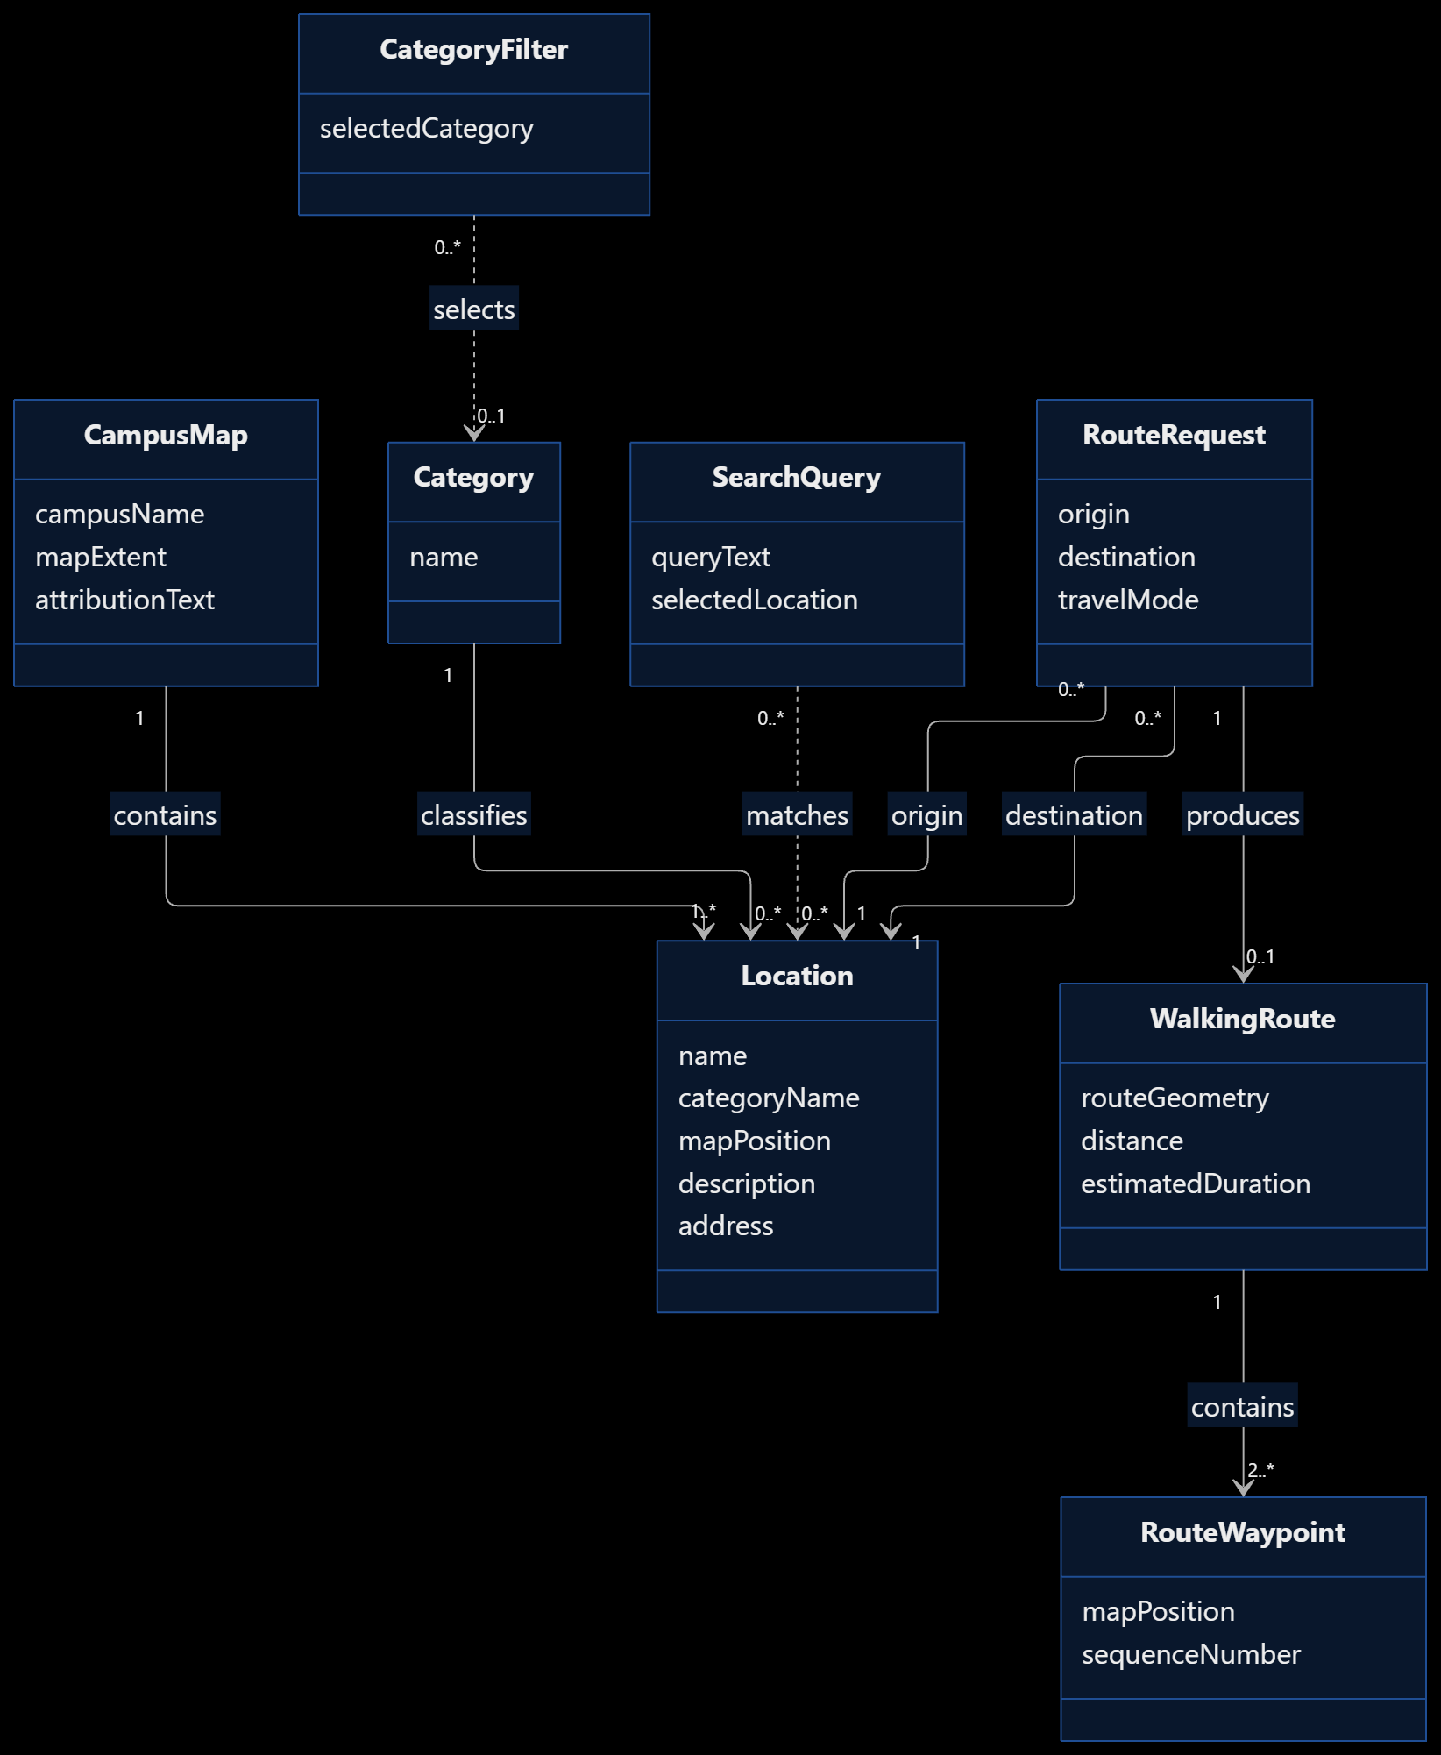

Figure 5.1 Domain model (conceptual classes, attributes, associations with multiplicities)
Class | What it represents (one line) | Key attributes | Associations (with  multiplicity)
CampusMap | Represents the overall UTD campus map. | campusName, mapExtent, attributionText | Contains Location (1 to 1..*)
Location | Represents a campus building, service, or place. | name, categoryName, mapPosition, description, address | Belongs to CampusMap (1); belongs to Category (1); can match SearchQuery (0..); can serve as RouteRequest origin or destination (0..)
Category | Represents a group used to organize campus locations. | name | Classifies Location (1 to 0..); can be selected by CategoryFilter (0..)
SearchQuery | Represents a user's search for a campus location. | queryText, selectedLocation | Matches Location (0..* to 0..*); references selected Location (0..1)
CategoryFilter | Represents the category selected to filter campus locations. | selectedCategory | Selects Category (0..1); filters Location (0..*)
RouteRequest | Represents a user's request for walking directions. | origin, destination, travelMode | References one origin Location (1); references one destination Location (1); produces WalkingRoute (0..1)
WalkingRoute | Represents the walking directions generated for a route request. | routeGeometry, distance, estimatedDuration | Belongs to RouteRequest (1); contains RouteWaypoint (2..*)
RouteWaypoint | Represents a point along a walking route. | mapPosition, sequenceNumber | Belongs to WalkingRoute (1)

5.2 Object interaction models
5.2.1 UC-2
(a) Non-trivial steps.
Step | Explanation
1 | The user enters a location or keyword, which the system must use to search for matching locations.
2 | The system finds and displays the most relevant locations based on the search query.
3 | The user selects a location from the search results.
4 | The system highlights and centers the selected location on the campus map.

Step | Subject (who acts) | Subject action (what it does) | Other data / objects (what is used) | Object acted upon (who receives)
1 | User | Enters a location name or keyword into the search. | Search term, SearchQuery | SearchCoordinator
2 | SearchCoordinator | Finds and displays the most relevant matching locations. | SearchQuery, LocationCatalog, matching Location records | User
3 | User | Selects a location from the displayed search results. | Matching Location records, selectedLocation | SearchQuery
4 | MapDisplay | Highlights and centers the selected location on the map. | Selected Location, mapPosition | User

(c) Analysis sequence diagram.
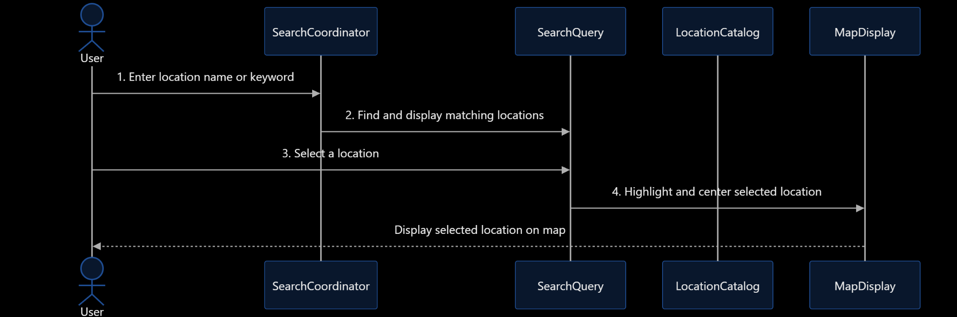
5.2.2 UC-2
(a) Non-trivial steps.
Step | Explanation
1 | The user requests directions to a selected campus location.
2 | The system asks the user to provide a starting location.
3 | The user enters a starting location.
4 | The system generates and displays a walking route between the starting location and destination.

(b) Scenario table.
Step | Subject (who  acts) | Subject action (what it does) | Other data / objects (what is used) | Object acted upon (who receives)
1 | User | Requests directions to the selected destination | Selected destination location, RouteRequest | DirectionsCoordinator
2 | DirectionsCoordinator | Prompts the user to enter a starting location | RouteRequest, destination Location | User
3 | User | Enters a starting location | Starting Location, origin | Directions Coordinator
4 | DirectionsCoordinator | Requests and displays a walking route between the orgin and destination | RouteRequest, RouteService, WalkingRoute, RouteWaypoint | User

(c) Analysis sequence diagram.
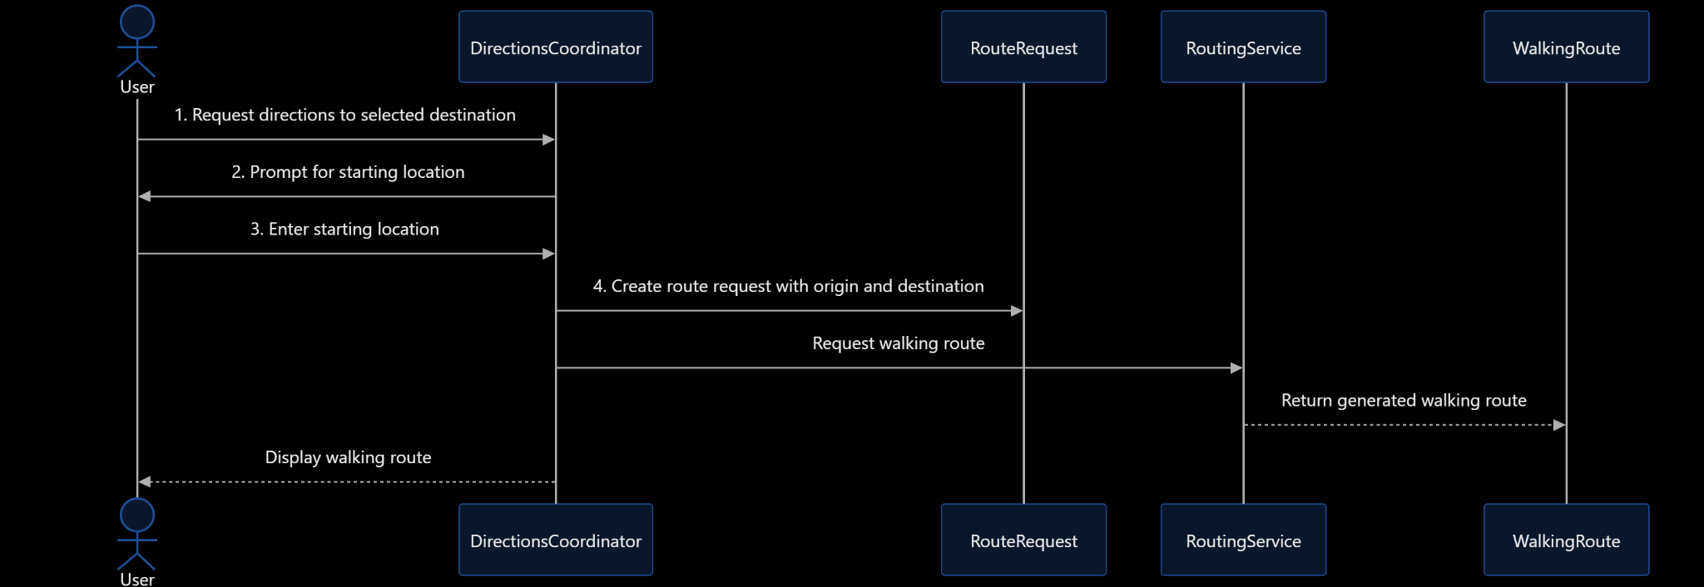
Figure 5.2.x Analysis sequence diagram for UC-xx; message numbers match the scenario table

5.3 Consistency cross-check
Check | Result (pass, or what  failed) | Fixed in
K1 Every item in an actor column (4.2) is an attribute in the domain model (5.1) | Pass after revision. UC-01 search input is represented by SearchQuery.queryText, and the selected location by SearchQuery.selectedLocation. UC-02 destination and starting location are represented by RouteRequest.destination and RouteRequest.origin. UC-03 selected filter is represented by CategoryFilter.selectedCategory. | Section 5.1
K2 Every object on a sequence diagram is a domain class or a declared interaction object | Pass. Domain classes include SearchQuery, Location, RouteRequest, and WalkingRoute. SearchCoordinator, LocationCatalog, MapDisplay, DirectionsCoordinator, and RoutingService are declared interaction objects or external systems. | Section 5.1 and 5.2
K3 Every message on a sequence diagram  corresponds to exactly one scenario-table row | Needs final alignment. The numbered messages must match the scenario table one-to-one. Remove any extra unnumbered interactions or add corresponding scenario rows. | Section 5.2
K4 Every non-trivial step in 5.2 (a) has at least one scenario-table row | Pass. Steps 1–4 for both UC-01 and UC-02 are represented in their scenario tables. | Section 5.2
K5 Every analyzed use case traces to at least one functional requirement | Pass. UC-01 traces to FR-01, FR-02, FR-03, FR-04, FR-05, FR-08, and FR-09. UC-02 traces to FR-01, FR-04, FR-10, and FR-11. | Section 4.2
K6 The last messages of each diagram make the use case postcondition true | Pass after final message alignment. UC-01 ends with the selected location highlighted and centered on the map. UC-02 ends with a walking route displayed between the two selected locations. | Section 5.2

6 High-Level Design (Architecture)
6.1 Architectural drivers: quality-attribute scenarios
QAS | Quality  attribute | Stimulus | Artifact | Response | Response  measure | From
QAS-01 | Performance | Search of a database with no more than 500 records | Search engine + renderer | Returns matching locations to the interface | Within 2 seconds for 95% of 50 test searches | QR-1
QAS-02 | Usability | Using a 360px and 1280px viewport | UI Engine and viewport controller | Adjusts dynamically to fit the dimensions | UI elements remain usable without horizontal scrolling | QR-3
QAS-03 | Reliability | An empty/invalid string is used for the search query | Input validation/error handling | Catches and updates the UI to reflect | Display a message with zero unhandled errors across 20 tests | QR

Our project has only one constraint relevant to high-level design: CON-03, where the team is only allowed to use data/information it has permission to access, redistribute, and display.
6.2 Architectural style and alternatives
Style considered | Drivers it serves | What it costs | Verdict
Single Page Web Application | Performance, Usability, accessibility | Reliance on network connection | Chosen
Desktop Application | High compute speed for geospatial calculations, no network connection needed | Requires manual installation | Rejected
Static HTML | Low cost hosting and high availability | Cannot support dynamic/real time features | Rejected

We chose a single page web application architecture because it fulfills drivers QAS-01 and QAS-02 the best. It fulfills QAS-01 by offloading the query to a server, and it fulfills QAS-02 by rendering the application window locally. We rejected a layered desktop application because it is not accessible: manual installation is a high up-front cost to the user. We also rejected a static website since it restricts the type of features we could possibly add. We will call this ADR-01.

6.3 Component view
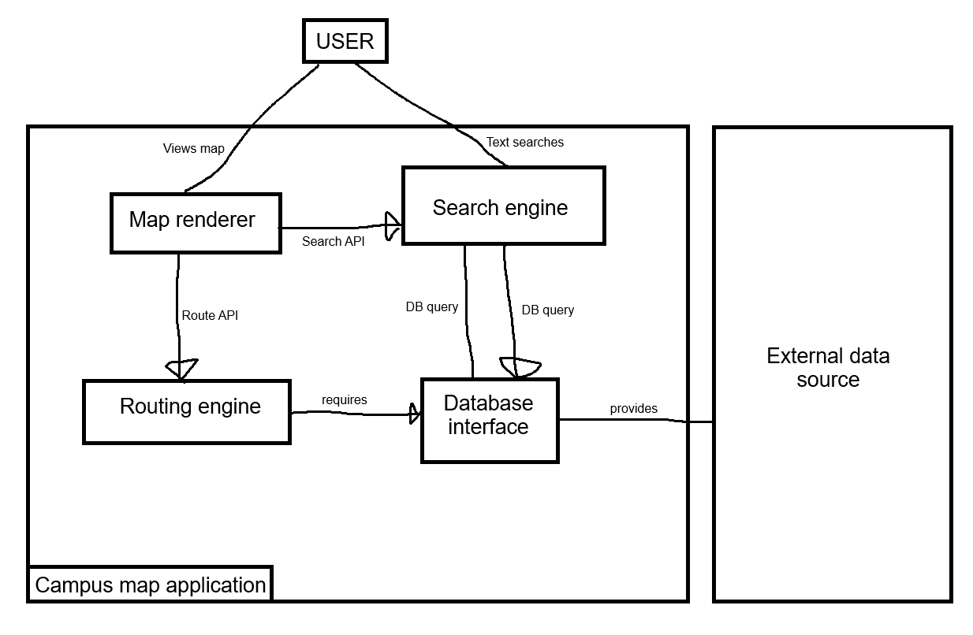
Figure 6.3 Component diagram: components, provided and required interfaces, external systems

Component | Responsibility (one sentence) | Provides | Requires | Answers to (UC / QAS / ADR)
Map renderer | Manages client viewport and user interactions | Map display | Route API, Search API | UC-01, UC-02, UC-03 UC-04, QAS-02, ADR-01
Search engine | Provides user with data based on an inputted query | Search API | DB Query | UC-01, UC-03, QAS-01, ADR-01
Routing engine | Calculates optimal route between locations | Route API | DB Query | UC-02, QAS-01
Database interface | Retrieves data from external data source | DB Query | None | UC-04

6.4 Deployment view
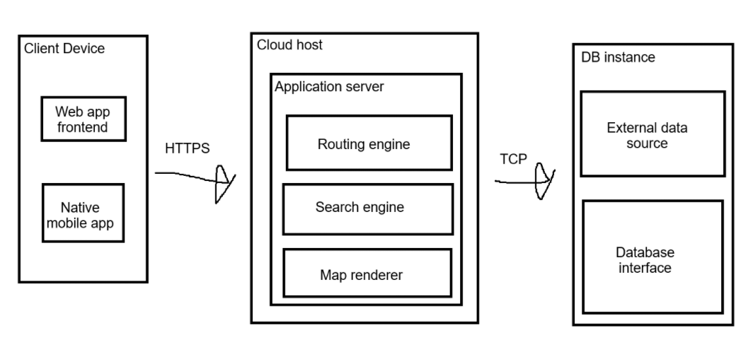
Figure 6.4 UML deployment diagram: nodes, execution environments, deployed artifacts, communication paths with protocols, trust boundaries

Node | What runs on it (artifacts,  components) | Communicates with  (protocol) | Trust zone
Client device | Web browser/mobile app | HTTPS | Public internet (untrustworthy)
Could host | Routing engine, search engine, map renderer | TCP | Secure application
DB Instance | External data source, DB interface | Cloud application server | Private database (full trust)

6.5 From analysis to architecture
Analysis object (from 5.1 and 5.2) | Component that owns it (6.3) | Note (split, merged, external)
CampusMap, Location, Category | Database interface | Merged into DB
SearchQuery, CategoryFilter | Search Engine | Split between client input and backend processing
RouteRequest, WalkingRoute, RouteWaypoint | Route Engine | Internal route calculation and waypoint coordinates are external
SearchCoordinator | Search Engine | Split between client input and backend processing

6.6 Design principles applied
Principle | Where it shows in your design | Evidence (component,  interface, ADR)
Separation of concerns | Splitting map rendering from routing and search logic | Map rendering UI vs. Search and Routing engine
Information hiding | Database is hidden behind a data interface | Data interface providing DBQuery interface
Low coupling | Independent backend services | SearchAPI and RouteAPI
High cohesion | Backend services focus on one task | Search engine and routing engine
Design for change | Isolated external data | External data source
Keep it simple (KISS) | Lightweight single page web application | ADR-01
CE/CS/SE 3354 · Software Engineering · Fall 2026

7 Design Rationale
7.1 Architecture decision records

ADR-01: Single-Page Web Application Architecture
Status | Accepted
Date and owner | November 2026 — Project team
Context (drivers) | QAS-01 (Performance) and QAS-02 (Usability) require the application to support fast location searches and a responsive interface. UC-01, UC-02, and UC-03 require users to search, view, and filter campus locations.
Options considered | 1. Single-Page Web Application. 2. Desktop Application. 3. Static HTML Website.
Decision | Use a Single-Page Web Application architecture for CampusCompass.
Consequences | Favors accessibility, usability, and performance by allowing users to access the application through a browser and handling search operations through a server. The accepted cost is dependence on an internet connection and the need to maintain web services.
Evidence | Documented in Section 6.2. Performance and usability measurements are not yet available. Architecture spike evidence is pending in Section 8.
Related | QAS-01, QAS-02, UC-01, UC-02, UC-03, ADR-02, ADR-03.

ADR-02: Separate Application Components
Status | Accepted — pending team confirmation
Date and owner | November 2026 — Project team
Context (drivers) | UC-01, UC-02, and UC-03 require map display, location searching, filtering, and potentially walking directions. QAS-01 and QAS-02 require good performance and usability.
Options considered | 1. Separate Map renderer, Search engine, and Routing engine components. 2. Combine map rendering, searching, and routing into one component.
Decision | Separate the Map renderer, Search engine, and Routing engine into independent components with defined interfaces.
Consequences | Favors separation of concerns, maintainability, and high cohesion. Each component has a specific responsibility. The accepted cost is additional communication between components and the effort required to maintain their interfaces.
Evidence | The component responsibilities and interfaces are documented in Section 6.3. Implementation and integration measurements are not yet available.
Related | UC-01, UC-02, UC-03, QAS-01, QAS-02, ADR-01.

ADR-03: Use a Database Interface for Campus Location Data
Status | Accepted — pending team confirmation
Date and owner | November 2026 — Project team
Context (drivers) | UC-01 and UC-03 require campus location data for searching and filtering. CON-03 requires the team to use only data it has permission to access, redistribute, and display.
Options considered | 1. Use a separate Database interface to retrieve external campus data. 2. Allow each application component to access the external data source directly.
Decision | Use a Database interface that provides the DB Query interface to the application components.
Consequences | Favors information hiding and low coupling because application components do not need to know the details of the external data source. The accepted cost is the additional effort of developing and maintaining the Database interface.
Evidence | The Database interface is documented in Section 6.3. The availability and permissions of the campus data source still need to be verified through the Section 8 architecture spike.
Related | CON-03, UC-01, UC-03, R1, ADR-01, ADR-02.
7.2 Trade-off summary
Quality favored | Architectural move | Cost accepted | Recorded in
Accessibility and usability | Use a Single-Page Web Application | Dependence on a network connection | ADR-01
Maintainability and separation of concerns | Separate map rendering, search, and routing into components | More component interfaces and coordination | ADR-02
Information hiding and low coupling | Access campus data through a Database interface | Additional interface to develop and maintain | ADR-03

8 Prototype Evidence: Architecture Spike

Spike ID and title | S-01 — UTD Campus Location Data Loading
Risk or decision it addresses | R1 — The team may not be able to obtain an authoritative campus location dataset with permission to use and display its information. Related to ADR-01 and the campus map data requirements.
Question (answerable yes or no) | Can the system retrieve and successfully load an approved UTD campus location dataset for use in the campus map?
Set-up | Build a small prototype that reads a candidate approved campus location dataset. Use a small sample containing building names, categories, and map positions. Store the experiment in /spikes/S-01/.
How it was measured | Record the number of location records provided, the number successfully loaded, the number rejected or missing required information, and the time required to load the dataset. Also verify that the data source permits the intended use.
Result (numbers) | Pending experiment. Record the actual number of records tested, successfully loaded, rejected, and the measured loading time. Do not enter estimated results.
What it changed or confirmed | The result will determine whether the selected data source can support the campus map. If successful, it supports continuing with the proposed architecture. If unsuccessful, the team must find another approved source or prepare a permitted alternative dataset.
Where to see it | https://github.com/OuterBeatle/CS3354-Campus-Map — create this folder and commit the prototype code, README, and measurement evidence here. Add the actual commit hash after pushing.

9 Traceability
9.1 Extended traceability matrix

Requirement | Use case | Analysis classes | Component(s) | QAS / ADR | Evidence
FR-01 | UC-01, UC-02, UC-03 | CampusMap, Location | Map renderer | QAS-02, ADR-01 | UC-01, UC-02, UC-03 scenarios
FR-02 | UC-01 | Location, SearchQuery | Search engine | QAS-01, ADR-01 | UC-01 scenario
FR-03 | UC-01 | SearchQuery, Location | Search engine | QAS-01, ADR-01 | UC-01 scenario
FR-04 | UC-01, UC-02 | Location, RouteRequest | Map renderer, Routing engine | QAS-02, ADR-01 | UC-01 and UC-02 scenarios
FR-05 | UC-01 | Location | Map renderer | QAS-02, ADR-01 | UC-01 scenario
FR-06 | UC-03 | Category, CategoryFilter, Location | Search engine | QAS-01, ADR-01 | UC-03 scenario
FR-07 | UC-01 | SearchQuery, Location | Search engine | QAS-01, ADR-01 | Search scenario
FR-08 | UC-01, UC-03 | Location, Category | Map renderer, Search engine | QAS-01, ADR-01 | UC-01 and UC-03 scenarios
FR-09 | UC-01 | Location | Map renderer | QAS-02, ADR-01 | UC-01 scenario
FR-10 | UC-02 (conditional) | RouteRequest, WalkingRoute, RouteWaypoint | Routing engine | QAS-01, ADR-01 | UC-02 scenario; routing spike needed
FR-11 | UC-02 (conditional) | RouteRequest, WalkingRoute | Routing engine | QAS-03, ADR-01 | UC-02 alternate flows
FR-12 | Not included in current analyzed use cases | Location | No component assigned | Scope decision required | Staff editing is conditional
FR-13 | Not included in current analyzed use cases | Location | No component assigned | Scope decision required | Staff editing is conditional
FR-14 | Cross-cutting | CampusMap, Location | Map renderer, Database interface | CON-03, ADR-01 | Attribution source and display must be verified
QR-01 | UC-01, UC-03 | SearchQuery, Location | Search engine | QAS-01, ADR-01 | 50-search performance measurement required
QR-02 | All map use cases | CampusMap | Map renderer | QAS-02, ADR-01 | 20-load performance measurement required
QR-03 | All map use cases | CampusMap | Map renderer | QAS-02, ADR-01 | 360px and 1280px viewport checks required
CON-03 | All use cases using external data | CampusMap, Location | Database interface, Map renderer | ADR-01 | Verify source permissions and attribution
9.2 Gap analysis
Gap | Items | What you did about it
Requirements with no component | FR-12 and FR-13 | Staff editing is not included in the current three analyzed use cases. Keep it out of the first release or add a separate use case and component if the team approves it.
Components with no requirement, QAS or ADR | No known orphan components in the current architecture | The Map renderer, Search engine, Routing engine, and Database interface are connected to use cases or requirements. Confirm this after the component diagram is finalized.
Use cases not analyzed (and why that is acceptable) | UC-04 View location details and UC-05 Maintain location data from the P1 draft | UC-01 includes displaying location information. UC-05 is conditional and can remain outside the current release. Confirm that these scope decisions agree with Section 3.

10 Project Plan
10.1 Roles and working agreement
Team member | Proposed responsibility
Riven Amdal | Section 6 – High-Level Design architecture and component-mapping review.
Cyril Canete | Revisions to sections 10-12 and integration review.
Michael Dezeeuw | Repository owner; proposed repository and implementation coordination.
Arsh Heer | Section 5 analysis and diagrams; shared-document updates; named P2 submitter on document cover.
Kaylee Vo | Section 4 – Use-Case Analysis; proposed quality and usability review.
Jay Windisch | Original Section 7– Design Rationale; proposed architecture, repository, and schedule review.

10.2 Plan to P3
Milestone | Date | Owner | Done when
Finalize P2 analysis and high-level design | Before P2 submission | All team members, Arsh coordinates | Sections 4–9 are reviewed, the measured spike is complete, contribution evidence is corrected, and the final PDF and p2 commit are prepared.
Confirm campus data source and permissions | Before Data use/Before P3 implementation | Cyril | The selected source, usage permission, and attribution are documented. The P2 experiment uses permitted input
Finalize system architecture and technology choices | Before implementation | Riven+Jay | Components, deployment, database, service placement, and conditional features agree across sections 6-9
Implement the core campus map features | Before P3 testing | Michael and the Team | Map display, search, filtering, and location details work with approved records. Routing and staff editing remains conditional.
Complete System and quality testing | Before P3 submission | Kaylee and Riven | Retained requirements are tested and quality targets are tested; results, defects, and limitations are documented.
Finalize P3 system, report, and demonstration | December 9 2026 | All Team Members | The final system, tests, report, contribution evidence, Ai-use log, and demonstration are complete.

10.3 Risks (updated)
Risk | Status since P1 | Likelihood / impact | Mitigation and owner
R1: The team cannot find an authoritative campus map or location dataset with usable terms. | Open; source permissions remained unconfirmed. | Medium / High | Cyril documents source, permission and attribution before use; use a small permitted alternative if needed. A successful load does not prove permission.
R2: The team spends too much time on routing or external integrations before the basic map works. | Open; walking directions remain conditional | High / High | Riven and Jay time-box feasibility to one day. Prioritize map, search, and filtering; record any routing scope change in section 0.2
R3: The selected scope is too large for the course schedule. | Open; core scope and design need final alignment. | Medium / High | Jay+riven prioritize core features, reconcile the section drafts, and defer optional features when necessary.
R4: Requirements are based on assumptions rather than actual stakeholder needs. | Open; stakeholder feedback has not been supplied. | Medium / Medium | Kaylee and Riven collect student or visitor feedback on finding and filtering locations, then document assumptions and requirement changes.
R5: Individual contributions cannot be verified because repository setup or task records are missing. | Open; ownership and repository evidence need updating. | Medium / High | Each member commits their own work and reviews a teammate’s PR. Michael and Jay check contribution links and final repository evidence.
R6: The web application depends on a stable network connection and external data services. | Open; failure behavior remains unmeasured. | Medium / High | Riven and Michael test timeouts and unavailable states. Arsh and Riven record the agreed spike setup and actual results in section 8.

10.4 Repository
Repository URL: https://github.com/OuterBeatle/CS3354-Campus-Map
The repository is public and uses Git for source-code and document management. The main branch is named main.
The following folder structure will be used to organize the P2 and P3 project materials:
Folder | Purpose
/docs/p2 | P2 documentation and final PDF
/docs/p2/diagrams | UML diagrams and their source files
/spikes | Technical experiments and feasibility test results

10.5 Use of AI tools in P2
Member | Tool | What it was used for | What you checked or changed
Jay Windisch | ChatGPT | Used to help organize as well as distributing the work evenly | Made sure that the AI model was fact checked multiple times and that everyone agreed on how the distribution was handled.

11 Open Questions
ID | Question | Raised by | Owner and due date | Status or answer | Assumption meanwhile
Q1 | Which university and campus is the map for? | Project team | Team; resolved | UTD was selected as the project campus. | Use the UTD campus as the project target.
Q2 | Is an official campus map or location dataset available, and what are its usage permissions? | Project team | Cyril; before data use | A candidate UTD map is listed; the dataset and usage terms remain unconfirmed. | Use only location information the team is permitted to access and display.
Q3 | Are walking directions required for the first release, and is an approved routing source available? | Project team | Riven and Jay; before routing work | Routing remains conditional; source and feasibility are unconfirmed. | Keep UC-02 and FR-10/FR-11 conditional until routing feasibility is confirmed.
Q4 | Should authorized staff be able to add or edit location records in the first release? | Project team | Team, coordinated by Jay; before P3 scope approval | Editing is absent from the three analyzed cases; the account proposal needs scope approval. | Exclude staff editing from the first release unless the team approves it.
Q5 | Which browsers, devices, and accessibility requirements must be supported? | Project team | Kaylee and Riven; before P3 testing | QR-03 specifies 360px/1280px widths: QR-04 specifies keyboard search and selection. Browser/device versions remain open | Use responsive desktop and mobile browser support as the initial goal.
Q6 | Who owns each team role, the final submission, and repository coordination? | Project team | All team members; before P3 | Arsh is named submitter; Michael owns the repository. Section 10.1 records section ownership; future roles remain proposed. | Confirm roles, final PDF, p2 tag, and Canvas upload.
Q7 | Which hosting environment and external services will be used for the single-page web application? | Architecture analysis | Riven and Jay; before implementation | A browser single-page application is selected; hosting, database, and service placement remain unconfirmed. | Retain the high-level style and agree on the technology stack before implementation.
Q8 | Does the architecture meet the search performance target of 95% of 50 searches within two seconds? | Architecture analysis | Arsh and Riven; during spike/testing | Search timing and actual S-01 results remain unrecorded. | Treat QAS-01 as a target, not a verified result.

12 Baseline v1.0 Declaration
We declare this document, version 1.0, the baseline for P2. Sections 1 to 9 describe what we will build in P3. Any later change to them is recorded in section 0.2 with its reason.
Team member | Signature or initials | Date
Riven Amdal | RA | 11/04/26
Cyril Canete | CC | 11/06/26
Michael Dezeeuw | MD | 11/04/26
Arsh Heer | AH | 11/06/26
Kaylee Vo | KV | 11/05/26
Jay Windisch | JW | 11/05/26

