Practical No : 01

Aim :- Write a C++ program to declare two integer , one float variables and assign 10, 15, and 12.6 to

them respectively and then prints these values on the screen.

Solution :-

#include <iostream.h>

int main()

{

int x;

int y;

float z;

x=10;

y=15;

z=12.6;

cout<<"x= "<<x <<"\t"<<"y= "<<y<<"\t"<<"z= "<<z;

cout<<"\n";

return 0;

}

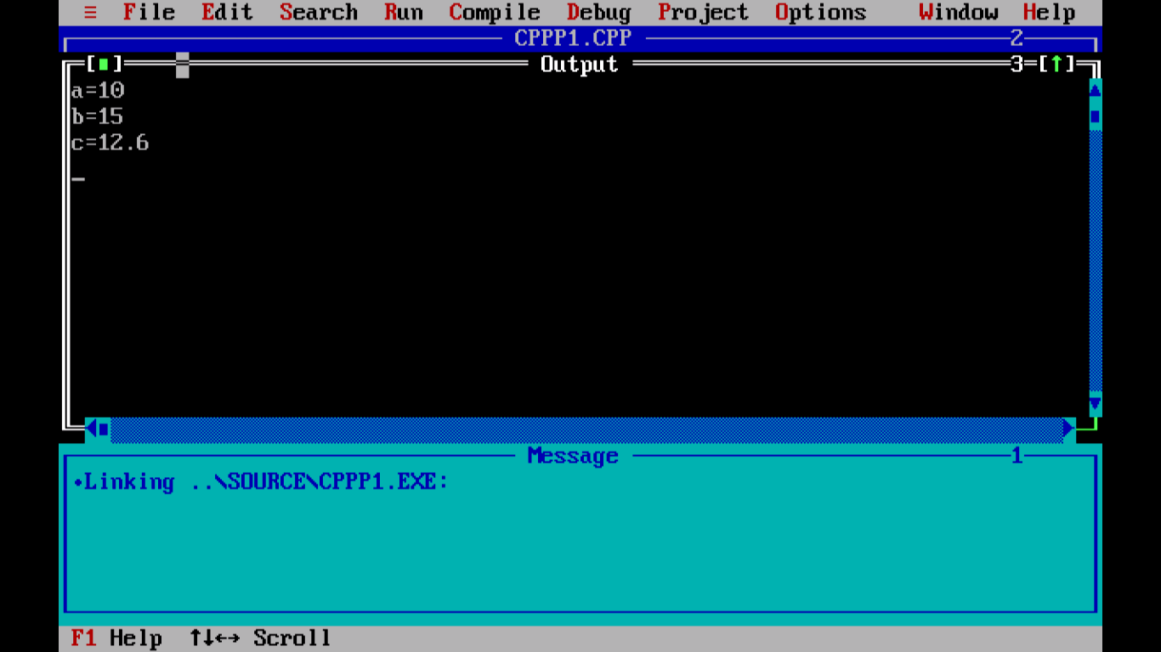

Practical No : 02

Aim :-

|  |
| --- |
| Write a C++ program to prompt the user to input her/his name and |
| print this name on the screen, as shown below. The text from |
| keyboard can be read by using cin>> and to display the text on the |
| screen you can use cout<<. |

Solution :-

#include <iostream.h>

int main()

{

char name[20];

cout<<"Enter your name:";

cin>>name;

cout<<"Hello "<<name<<endl;

return 0;

}

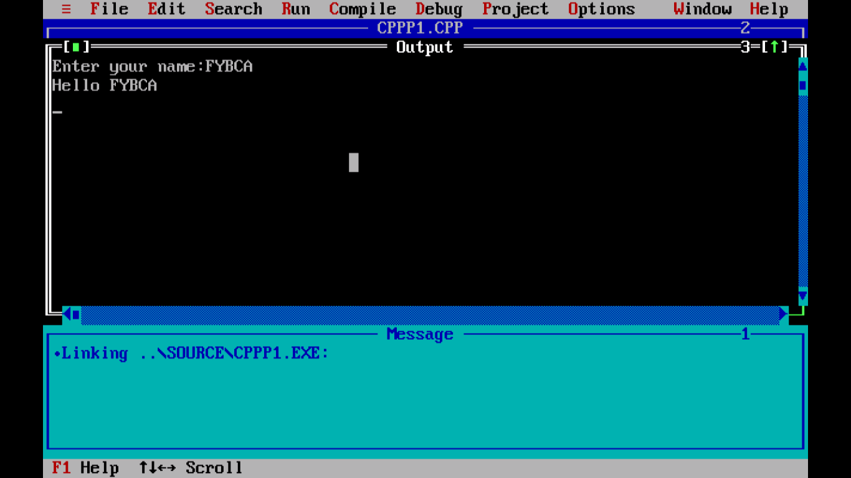

Practical No : 03

Aim :-

|  |
| --- |
| Write a C++ program that prompts the user to input three integer |
| values and find the greatest value of the three values. |

Solution :-

#include <iostream.h>

int main()

{

float n1, n2, n3;

cout << "Enter 1st number: ";

cin >> n1 ;

cout << "Enter 2nd number: ";

cin >> n2 ;

cout << "Enter 3rd number: ";

cin >> n3 ;

if(n1 >= n2 && n1 >= n3)

cout << "Largest number: " << n1;

if(n2 >= n1 && n2 >= n3)

cout << "Largest number: " << n2;

if(n3 >= n1 && n3 >= n2)

cout << "Largest number: " << n3;

return 0;

}

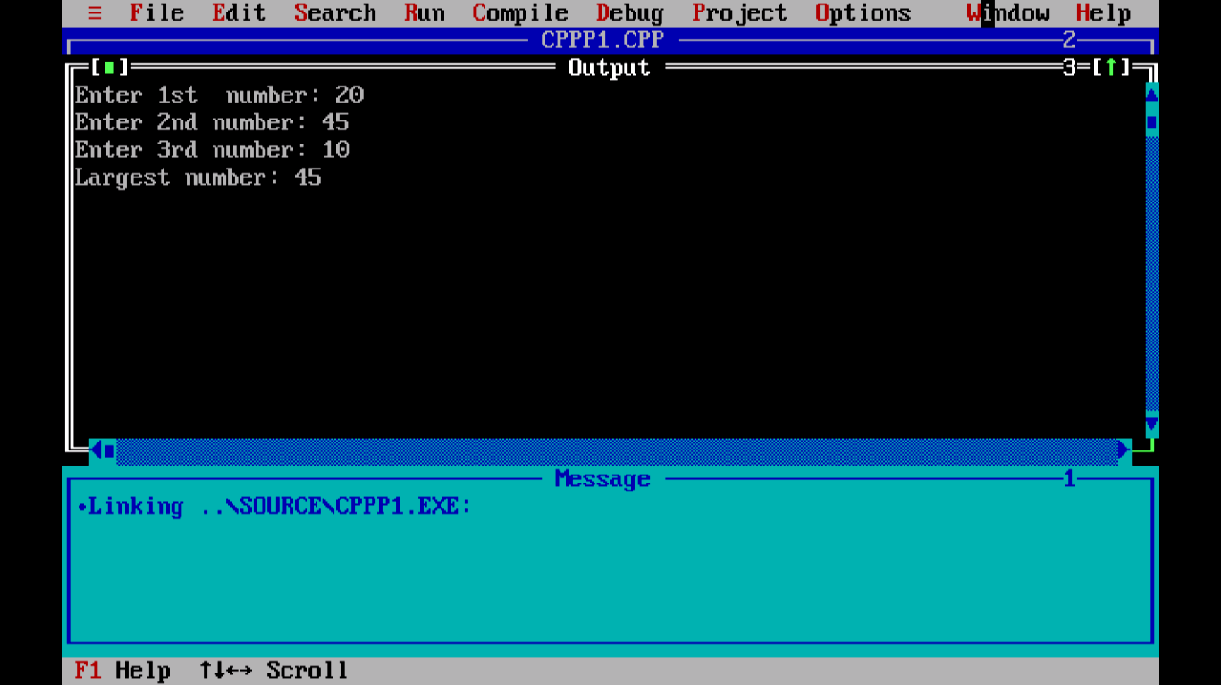

Practical No : 04

Aim :-

|  |
| --- |
| Write a program that determines a student‟s grade. The program |
| will read three types of scores (quiz, mid-term, and final scores) |
| and determine the grade based on the following rules: |
| -if the average score =90% =>grade=A |
| -if the average score >= 70% and <90% => grade=B |
| -if the average score>=50% and <70% =>grade=C |
| -if the average score<50% =>grade=F |

Solution :-

#include<iostream.h>

int main()

{

float x,y,z,avg;

cout<<"enter first subject marks"<<endl;

cin>>x;

cout<<"enter second subject marks"<<endl;

cin>>y;

cout<<"enter third subject marks"<<endl;

cin>>z;

avg=x+y+z/3;

if (avg>=90)

{

cout<<"Result: grade is A"<<endl;

}

else if(avg>=70&&avg<90)

{

cout<<"Result: grade is B"<<endl;

}

else if(avg>=50&&avg<70)

{

cout<<"Result: grade is C"<<endl;

}

else

{

cout<<"Result: grade is F"<<endl;

}

}

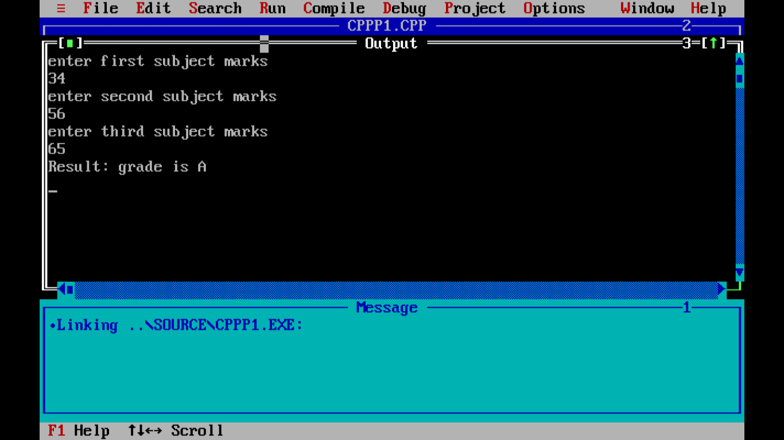

Practical No : 05

Aim :- Write a program in C++ to find the area and circumference of a circle.

Solution :-

#include <iostream.h>

int main()

{

float radius, area, circum;

cout<<" Input the radius of a circle : ";

cin>>radius;

circum = 2*3.14159*radius;

area = 3.14159*radius*radius;

cout<<" The area of the circle is : "<< area << endl;

cout<<" The circumference of the circle is : "<< circum << endl;

return 0;

}

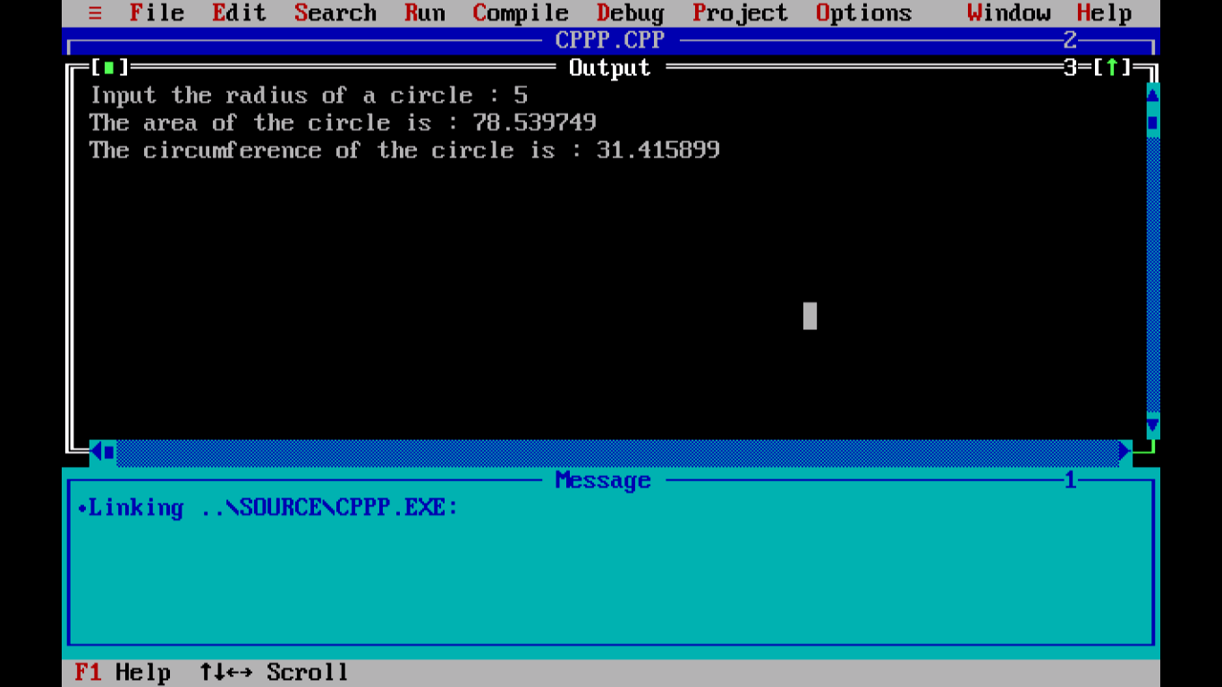

Practical No : 06

Aim :-

|  |
| --- |
| Create a class to demonstrate use of constructor |

Solution :-

#include <iostream.h>

class A

{

private:

int num1, num2 ;

public:

A()

{

num1 = 5;

num2 = 7;

}

void display()

{

cout<<"num1 = "<< num1 <<endl;

cout<<"num2 = "<< num2 <<endl;

}

};

int main()

{

A obj;

obj.display();

return 0;

}

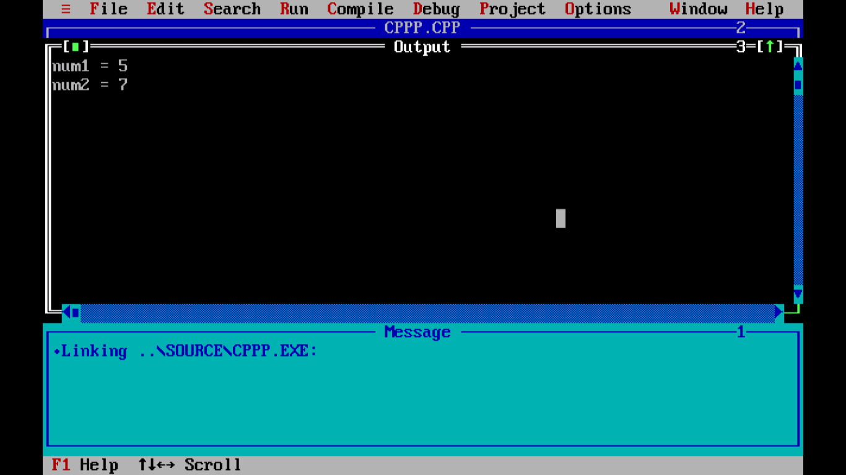

Practical No : 07

Aim :-

|  |  |
| --- | --- |
| write a program to | |
| perform the mathematical operations such as addition, subtraction |
| multiplication, division and mod of two numbers. | |

Solution :-

#include <iostream.h>

int main()

{

int x, y;

int sum,sub,mul,div,mod;

cout << "Type a number: ";

cin >> x;

cout << "Type another number: ";

cin >> y;

sum = x + y;

sub=x - y;

mul=x * y;

div=x / y;

mod=x % y;

cout << "Sum is: " << sum;

cout << "Sub is: " << sub;

cout << "Mul is: " << mul;

cout << "Div is: " << div;

cout << "Mod is: " << mod;

return 0;

}

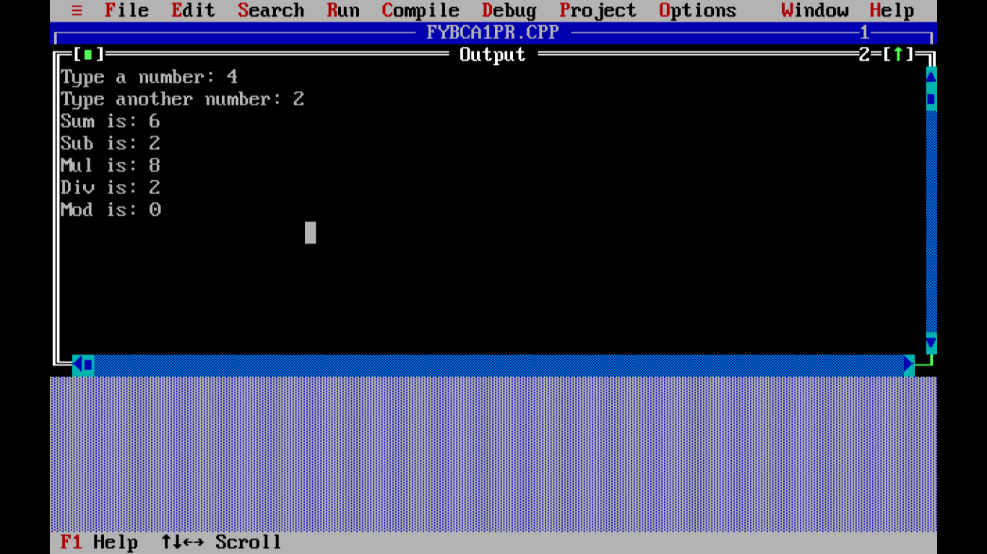

Practical No : 08

Aim :-

|  |
| --- |
| Write a program to find smallest among the 3 numbers using |
| conditional operators |

Solution :-

Solution :-

#include <iostream.h>

int main()

{

float n1, n2, n3;

cout << "Enter 1st number: ";

cin >> n1 ;

cout << "Enter 2nd number: ";

cin >> n2 ;

cout << "Enter 3rd number: ";

cin >> n3 ;

if(n1 <= n2 && n1 <= n3)

cout << "Smallest number: " << n1;

if(n2 <= n1 && n2 <= n3)

cout << "Smallest number: " << n2;

if(n3 <= n1 && n3 <= n2)

cout << "Smallest number: " << n3;

return 0;

}

