Practical No : 01

Aim :-

|  |
| --- |
| write a program to perform the mathematical operations such as addition, subtraction multiplication, division and mod of two numbers. |

Solution :-

#include <stdio.h>

int main()

{

int num1, num2, sum,sub,mul,div,mod;

printf("Enter first number: ");

scanf("%d", &num1);

printf("Enter second number: ");

scanf("%d", &num2);

sum = num1 + num2;

sub = num1 - num2;

mul = num1 * num2;

div = num1 / num2;

mod = num1 % num2;

printf("Sum of the entered numbers: %d", sum);

printf("\n");

printf("Sub of the entered numbers: %d", sub);

printf("\n");

printf("Mul of the entered numbers: %d", mul);

printf("\n");

printf("Div of the entered numbers: %d", div);

printf("\n");

printf("Mod of the entered numbers: %d", mod);

printf("\n");

return 0;

}

Output:

Enter first number: 12

Enter second number: 10

Sum of the entered numbers: 22

Sub of the entered numbers: 2

Mul of the entered numbers: 120

Div of the entered numbers: 1

Mpd of the entered numbers: 2

Practical No : 02

Aim :-

|  |  |
| --- | --- |
| Write a program to find greatest among the 3 numbers using if | |
|  | statements |

Solution :-

#include<stdio.h>

int main()

{

int num1,num2,num3;

//Ask user to input any three integer numbers

printf("\nEnter value of num1, num2 and num3:");

//Store input values in variables for comparsion

scanf("%d %d %d",&num1,&num2,&num3);

if((num1>num2)&&(num1>num3))

printf("\n Number1 is greatest");

else if((num2>num3)&&(num2>num1))

printf("\n Number2 is greatest");

else

printf("\n Number3 is greatest");

return 0;

}

Output:

Enter value of num1, num2 and num3: 15 200 101

Number2 is greatest

Practical No : 03

Aim :-

|  |
| --- |
| Write a program to find smallest among the 3 numbers using |
| conditional operators |

Solution :-

#include <stdio.h>

int main()

{

int a = 4, b = 10, c = 5;

if (a <= b && a <= c)

printf ("Smallest no is %d",a);

else if (b <= a && b <= c)

printf ("Smallest no is %d",b);

else

printf ("Smallest no is %d",c);

return 0;

}

**Output**

4 is smallest

Practical No : 04

Aim :-

|  |  |  |  |
| --- | --- | --- | --- |
| Write a program to input name and marks of 3 subjects. Calculate | | | |
|  | | total, percentage and grade the students according to the slab: | |
|  | **Per** | | **Grade** |
| >=75 and <=100 | | ‟O‟ | |
| >=60 and <75 | | ‟A‟ | |
| >=50 and < 60 | | ‟B‟ | |
| >=40 and < 50 | | ‟C‟ | |
| >=0 and < 40 | | ‟D‟ | |

Solution :-

#include<stdio.h>

#include<conio.h>

void main ()

{

float m1,m2,m3,per,avg,total;

printf(" enter the marks of m1 ");

scanf("%f", &m1);

printf(" enter the marks of m2 ");

scanf("%f", &m2);

printf("enter the marks of m3 ");

scanf("%f", &m3);

total= m1+m2+m3;

printf("\n the total mark is %.2f ",total);

per = (total/300)*100;

avg = (total/3);

printf("\n the percentage mark is : %.2f ", per);

printf("\n the average mark is: %.2f", avg);

if(per>=80)

printf("\n Grade : A");

else if(per>=60)

printf("\n Grade : B");

else if(per>=40)

printf("\n Grade : C");

else if(per<40)

printf("\n Fail ");

else

printf("\n Something went wrong ");

getch();

}

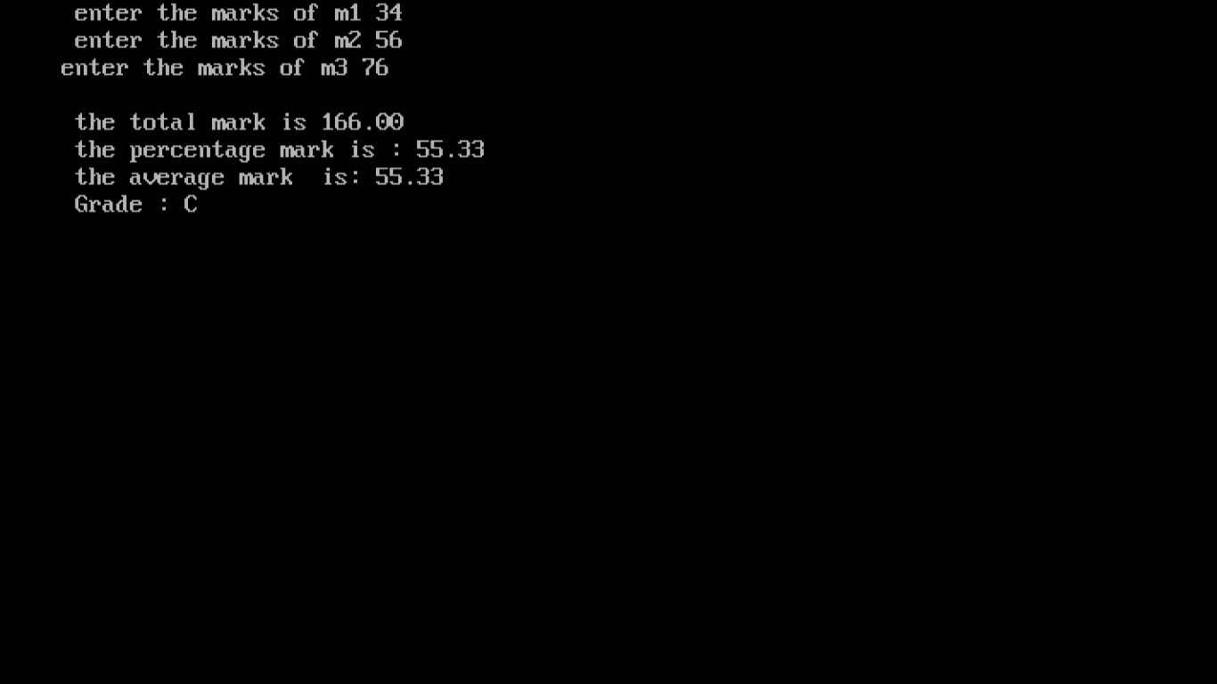

Practical No : 05

Aim :-

|  |
| --- |
| Write a program to find factorial of number. |

Solution :-

#include<stdio.h>

**int** main()

{

**int** i,fact=1,number;

 printf("Enter a number: ");

  scanf("%d",&number);

**for**(i=1;i<=number;i++){

      fact=fact*i;

  }

  printf("Factorial of %d is: %d",number,fact);

**return** 0;

}

**Output:**

Enter a number: 5

Factorial of 5 is: 120

Practical No : 06

Aim :-

|  |
| --- |
| Write a program to find sum and average of “n‟ numbers. |

Solution :-

#include<stdio.h>

int main()

{

int s1,s2,s3,Sum=0;

float Average;

printf("\nPlease Enter the 1st Number\n");

scanf("%d",&s1);

printf("\nPlease Enter the 2ndNumber\n");

scanf("%d",&s2);

printf("\nPlease Enter the 3rd Number\n");

scanf("%d",&s3);

Sum=s1+s2+s3;

Average = Sum/3;

printf("\nSum is = %d",Sum);

printf("\nAverage is = %.2f", Average);

return 0;

}

**OUTPUT :-**

Please Enter the 1st Number

45

Please Enter the 2ndNumber

85

Please Enter the 3rd Number

75

Sum is = 205

Average is = 68.00

Practical No : 07

Aim :-

|  |  |
| --- | --- |
| Write a menu driven program to convert dollars to rupees and rupees to dollars. | |
|  |  |

Solution :-

#include <stdio.h>

int main()

{

float dollars,r2d,rupees,d2r;

printf("Please enter dollars:");

scanf("%f", &dollars);

printf("Please enter rupees:");

scanf("%f", &rupees);

d2r = dollars * 74;

printf("%f Rupees", d2r);

printf("\n");

r2d = rupees / 74;

printf("%f Dollers", r2d);

}

### Output:

Please enter dollars:10

Please enter rupees:10000

740.000000 Rupees

135.135132 Dollers

Practical No : 08

Aim :- Write a Program to swap 2 numbers

Solution :-

#include <stdio.h>

int main() {

int a, b, temp;

a = 11;

b = 99;

printf("Values before swapping - \n a = %d, b = %d \n\n", a, b);

temp = a;

a = b;

b = temp;

printf("Values after swapping - \n a = %d, b = %d \n", a, b);

}

Output

Values before swapping -

a = 11, b = 99

Values after swapping -

a = 99, b = 11