Practical No : 01

Aim :- Design a web page using different text formatting tags.

Solution :-

<html>

<head>

<title>www.sybca.com </title>

</head>

<body bgcolor="pink">

<b> This is SY BCA CLASS</b> <br><br>

<i>This is SY BCA CLASS</i><br><br>

<u>This is SY BCA CLASS</u><br><br>

<s>This is SY BCA CLASS</s><br><br>

H<sub>2</sub>So<sub>4</sub><br><br>

X<sup>2</sup> + Y<sup>2</sup>=Z<sup>2</sup><br><br>

<h1>This is SY BCA CLASS</h1>

<h2>This is SY BCA CLASS</h2>

<h3>This is SY BCA CLASS</h3>

<h4>This is SY BCA CLASS</h4>

<h5>This is SY BCA CLASS</h5>

<h6>This is SY BCA CLASS</h6>

</body>

</html>

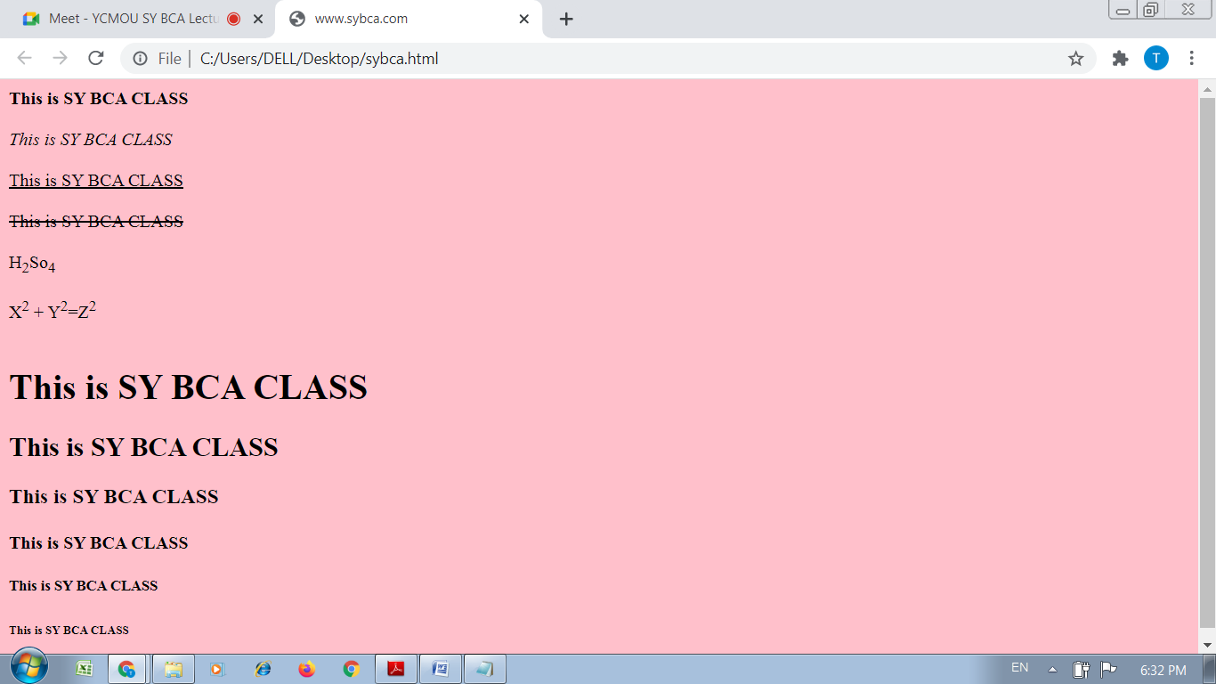

Practical No : 02

Aim :- Design a web page with different types of Marquee

Solution :-

<html>

<head>

<title>Scrolling Text</title>

</head>

<body bgcolor="pink">

<marquee width = "100%" direction = "right">

This is basic example of marquee</marquee>

</body>

</html>

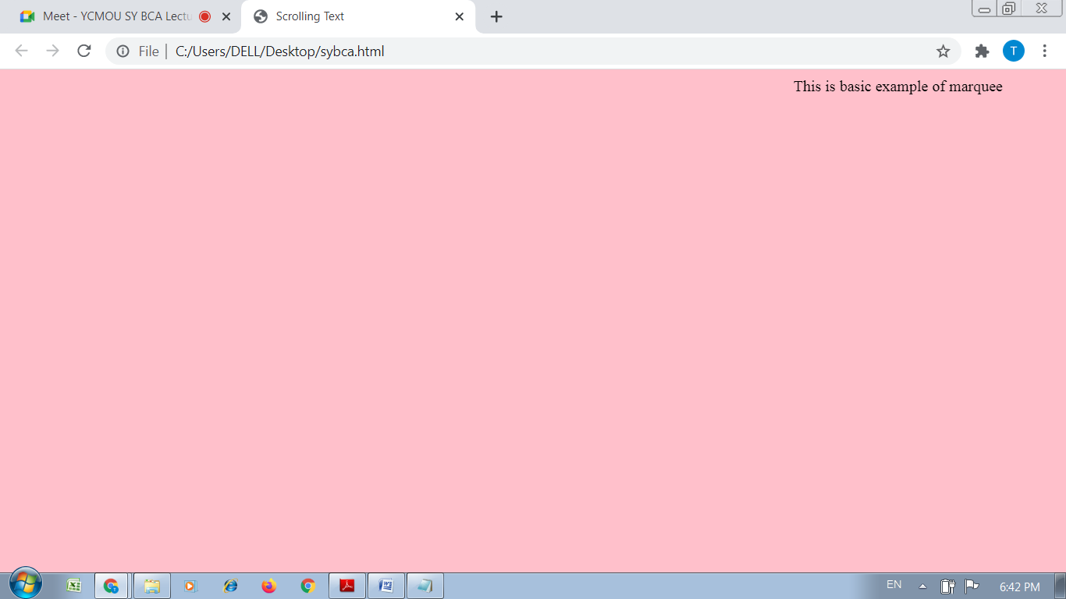

Practical No : 03

Aim :- Design a web page with links to different pages and allow

navigation between pages

Solution :-

A)

<html>

<head>

<title>Practical</title>

</head>

<body bgcolor="#00ffff">

<a href="https://www.google.com/">This is google.com </a>

<br> <br> <br> <br>

<a href="C:\Users\DELL\Desktop\links\test.html">This is test.html </a>

</body>

</html>

B)

<html>

<head>

<title>Practical</title>

</head>

<body bgcolor="pink">

<a href="https://www.gmail.com/">This is gmail.com </a>

<br><br>

<br>

<br>

<a href="C:\Users\DELL\Desktop\sybca.html">Click to back </a>

</body>

</html>

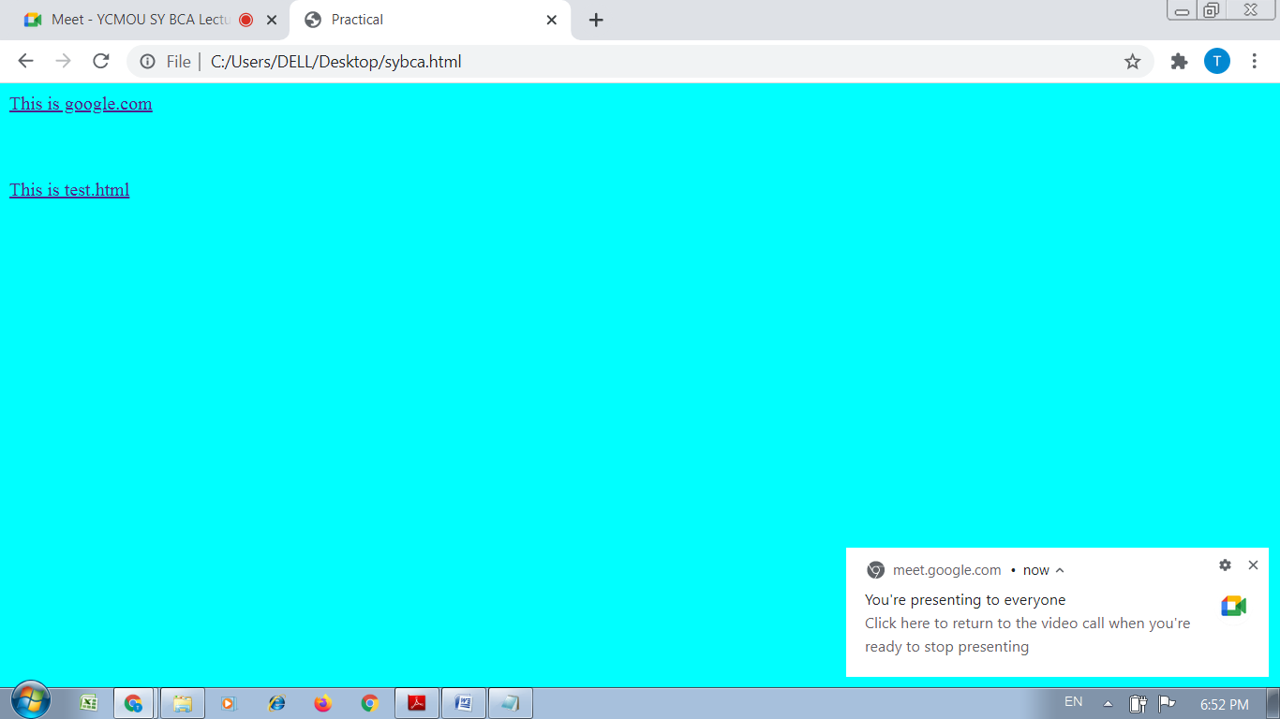

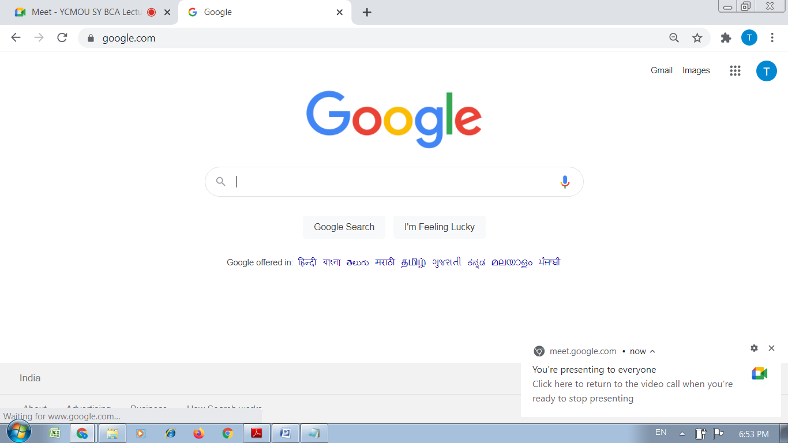

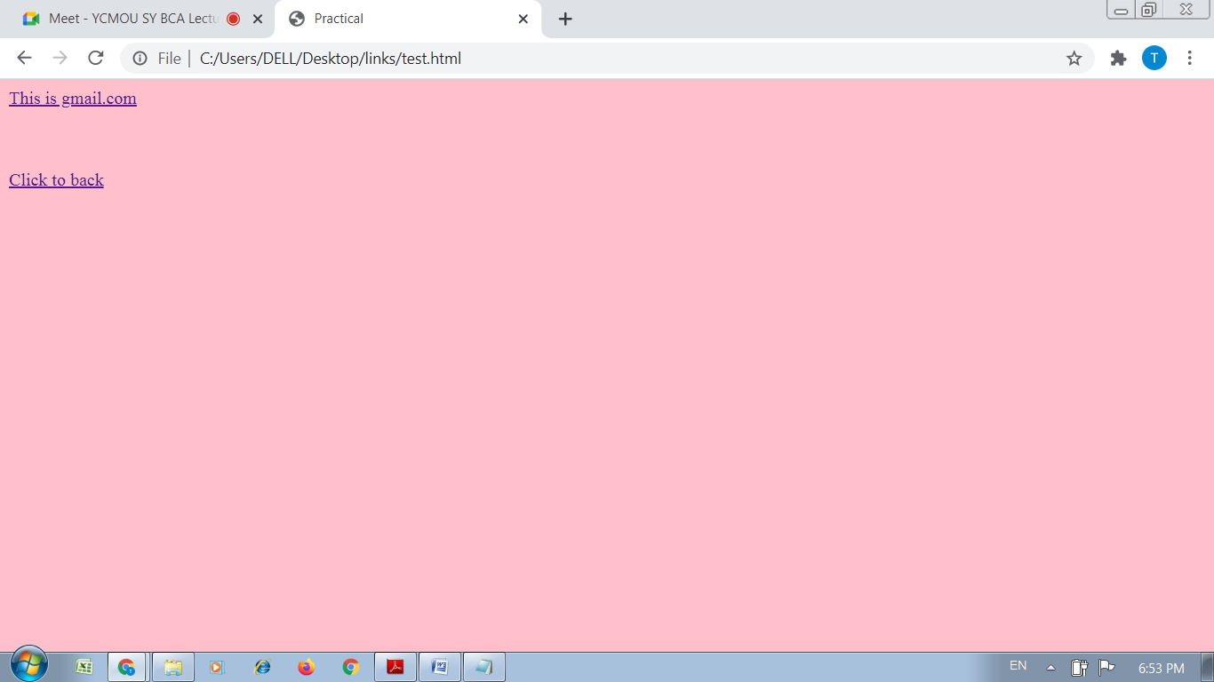

Practical No : 04

Aim :- Design a web page with Image and Imagemaps.

Solution :-

<html>

<head>

<title>Practical</title>

</head>

<body bgcolor="#00ffff">

<img src="D:\IMG\a.jpeg"

height=400 width=400 alt="Workplace" usemap="#workmap">

<map name="workmap">

<area shape="rect" coords="34,44,270,350" alt="Test1" href="Test.html">

<area shape="rect" coords="290,172,333,250" alt="Test2" href="Test2.html">

<area shape="circle" coords="337,300,44" alt="Test.html" href="Test.html">

</map>

</body>

</html>

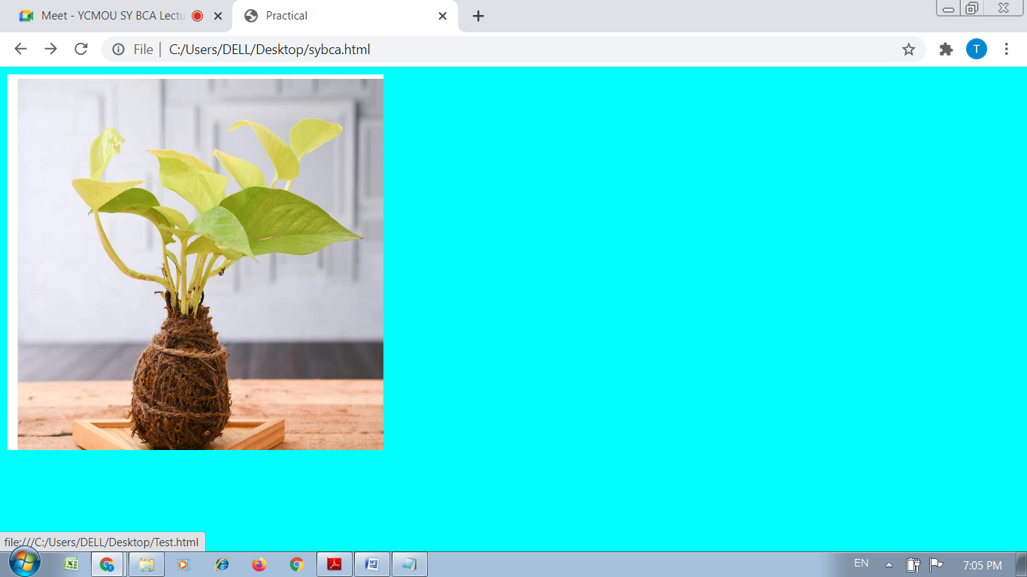

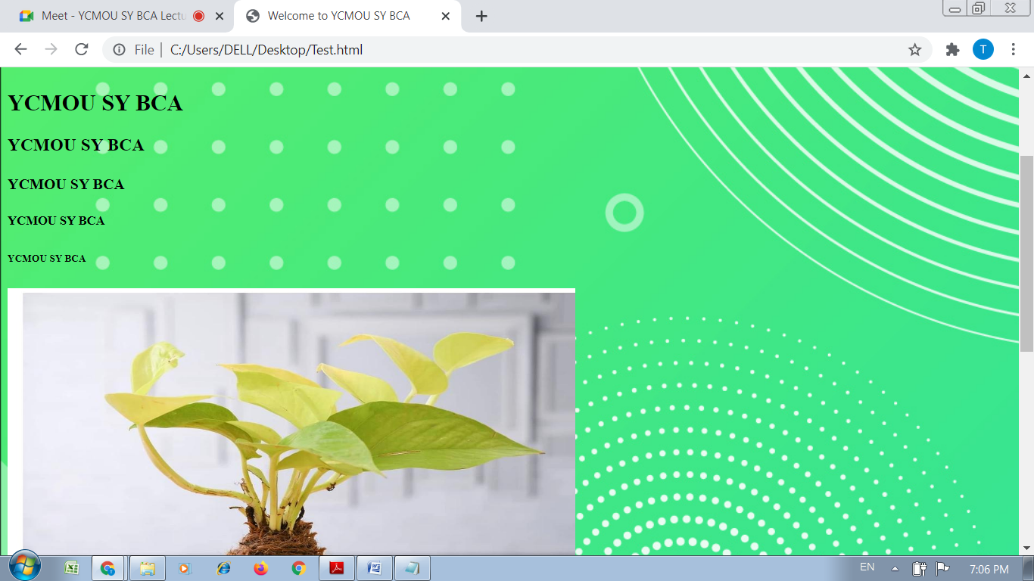

Practical No : 05

Aim :- Create a student table with the following fields.

Solution :-

<html>

<head>

<title>Practical</title>

</head>

<body background="D:\ASC_Workshop\Certificate_Templet\a.jpg">

<table border="1">

<th>Sr.No</th>

<th>Name</th>

<th>Address</th>

<th>Contact</th>

<tr>

<td>111</td>

<td>Student</td>

<td>Thane</td>

<td>0000000000</td>

</tr>

<tr>

<td>112</td>

<td>Sachin</td>

<td>Thane</td>

<td>0000000001</td>

</tr>

<tr>

<td>113</td>

<td>Mangesh</td>

<td>Kalyan</td>

<td>0000000002</td>

</tr>

<tr>

<td>114</td>

<td>Priyanka</td>

<td>Kalyan</td>

<td>0000000003</td>

</tr>

</table>

</body>

</html>

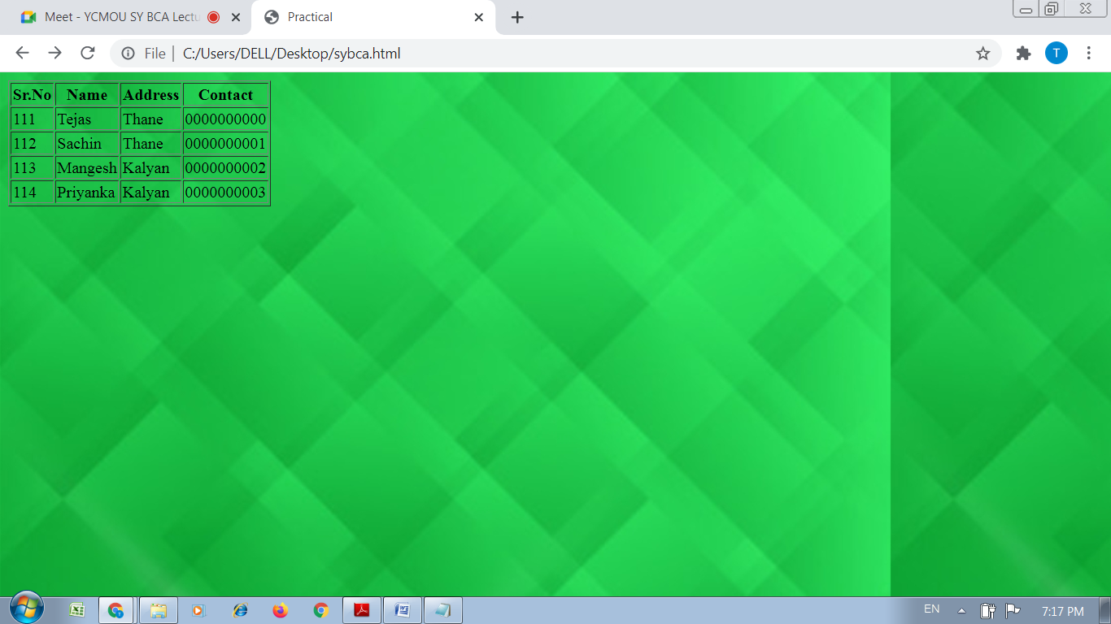

Practical No : 06

Aim :- Create an external CSS for above and apply to the web page.

Solution :-

<html>

<head>

<link rel="stylesheet" href="mystyle.css">

</head>

<body>

<h1>This is a heading</h1><br>

<h2>This is a heading</h2><br>

<h3>This is a heading</h3>

</body>

</html>

**CSS // mystyle.css**

**body {**

**background-color: lightblue;**

**}**

**h1 {**

**color: navy;**

**margin-left: 20px;**

**}**

**h2 {**

**color: red;**

**margin-left: 20px;**

**}**

**h3 {**

**color: yellow;**

**margin-left: 20px;**

**}**

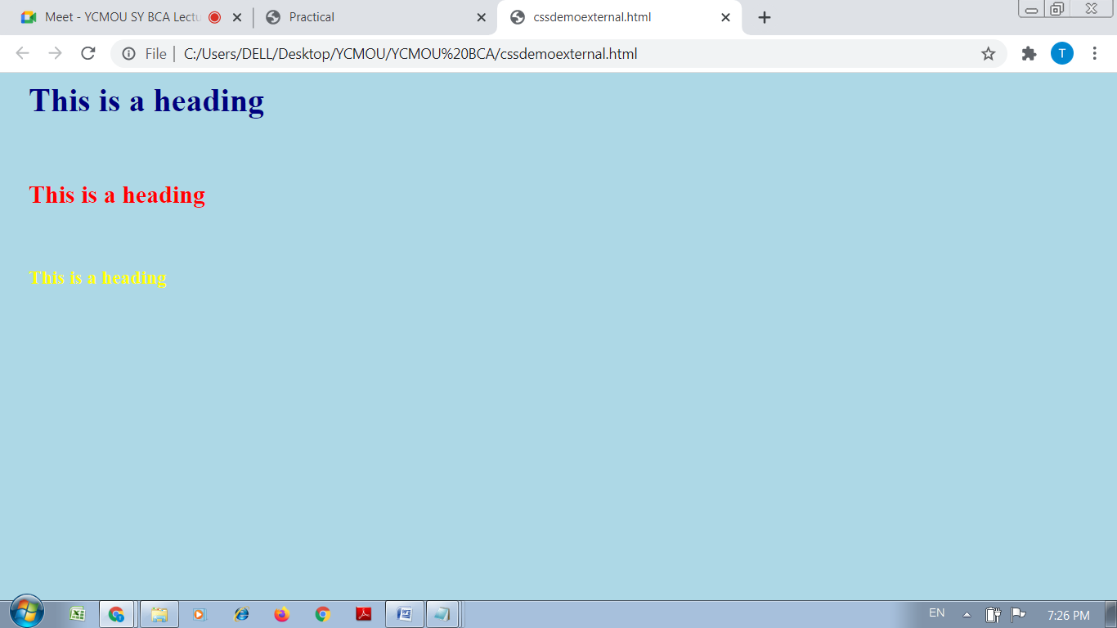

Practical No : 07

Aim :-

|  |
| --- |
| Create a frameset that divides browser window into horizontal |
| and vertical framesets |

Solution :-

<html>

<head>

<title>HTML Frames</title>

</head>

<frameset cols = "30%,50%,20%">

<frame name = "rowtop" src = "cssdemoexternal.html" />

<frame name = "main" src = "cssdemointernal.html" />

<frame name = "bottom" src = "C:\Users\DELL\Desktop\YCMOU\YCMOU BCA\Test3.html" />

</frameset>

</html>

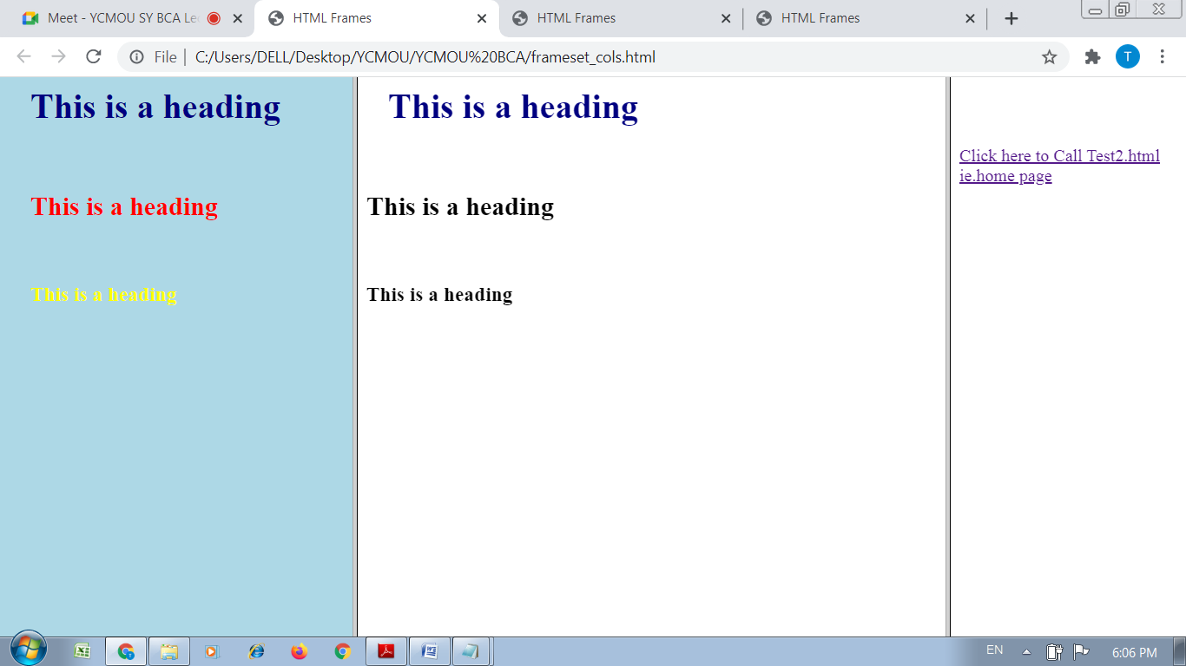

<html>

<head>

<title>HTML Frames</title>

</head>

<frameset rows = "30%,50%,20%">

<frame name = "top" src = "cssdemoexternal.html" />

<frame name = "main" src = "cssdemointernal.html" />

<frame name = "bottom" src = "C:\Users\DELL\Desktop\YCMOU\YCMOU BCA\Test3.html" />

</frameset>

</html>

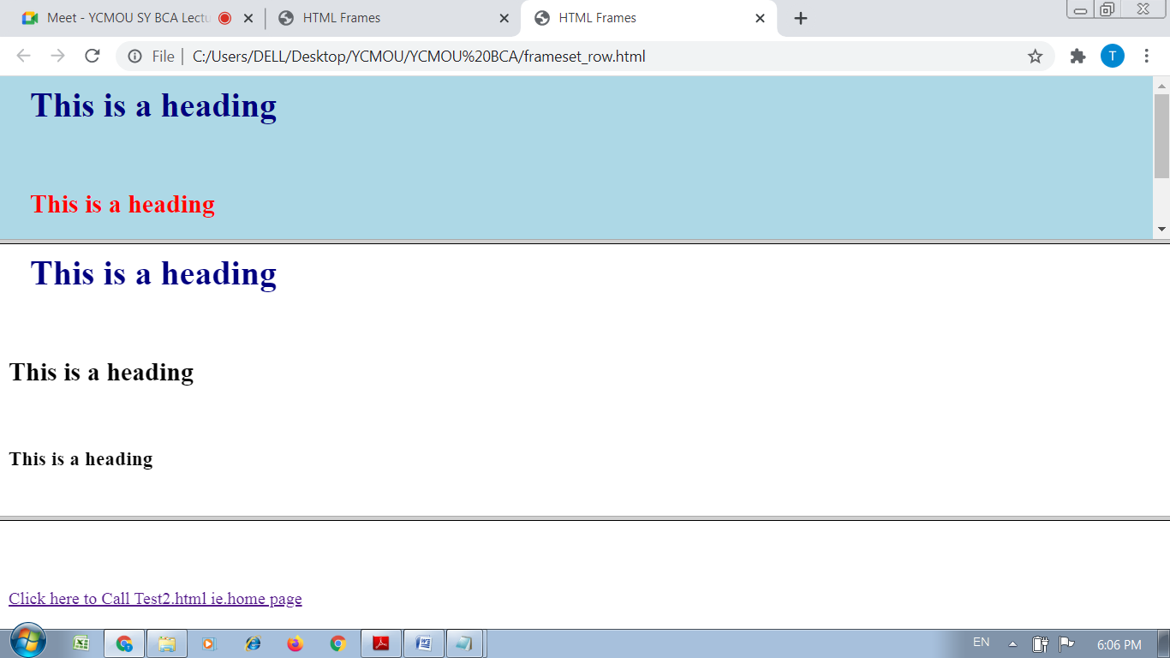

<html>

<head>

<title>HTML Frames</title>

</head>

<frameset cols = "30%,50%,20%">

<frameset rows = "50%,50%">

<frame name = "rowtop" src = "cssdemoexternal.html" />

<frame name = "rowbot" src = "cssdemointernal.html" />

</frameset>

<frame name = "main" src = "cssdemointernal.html" />

<frame name = "bottom" src = "C:\Users\DELL\Desktop\YCMOU\YCMOU BCA\Test3.html" />

</frameset>

</html>

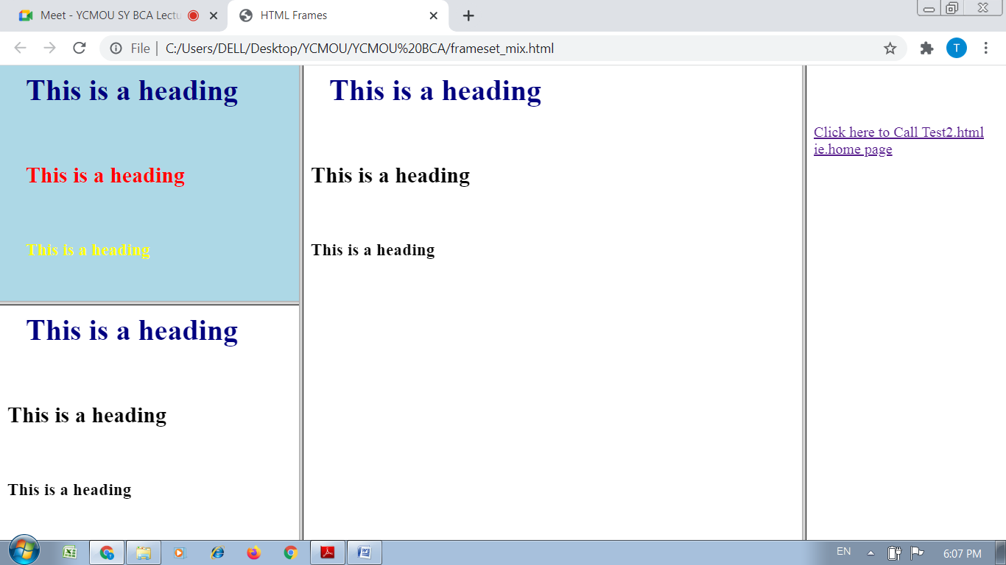

Practical No : 08

Aim :-

|  |
| --- |
| Write the javascript code to enter five numbers in the prompt |
| box. Calculate addition of the numbers & average. |

Solution :-

<html>

<head>

<title>JavaScript

</title>

</head>

<body>

<form>

1st Number : <input type="text" id="firstNumber" /><br>

2nd Number: <input type="text" id="secondNumber" /><br>

3rd Number: <input type="text" id="ThirdNumber" /><br>

4th Number: <input type="text" id="ForthNumber" /><br>

5th Number: <input type="text" id="FifthNumber" /><br>

<input type="button" onClick="addBy()" Value="SUM" />

</form>

<p>The Result is : <br>

<span id = "result"></span>

</p>

<p>The AVG is : <br>

<span id = "AVG"></span>

</p>

</body>

</html>

<script>

function addBy()

{

num1 = document.getElementById("firstNumber").value;

num2 = document.getElementById("secondNumber").value;

num3=document.getElementById("ThirdNumber").value;

num4=document.getElementById("ForthNumber").value;

num5=document.getElementById("FifthNumber").value;

num6=num1+num2+num3+num4+num5;

document.getElementById("result").innerHTML =num6 ;

num7=num6/5;

document.getElementById("AVG").innerHTML =num7 ;

}

</script>

