Practical No : 01
Aim :-
Write a servlet to determine whether the number is prime or not.

Solution :-
<html>
<head>
<title>TODO supply a title</title>
<meta charset="UTF-8">
<meta name="viewport" content="width=device-width, initial-scale=1.0">
</head>
<body>
<form action="prime" method="post">
Enter the Number :- <input type="text" name="txt1" size="20">
<br>
<br>
<input type="submit" value="submit" name="submit">

</form>

</body>
</html>

/*
* To change this license header, choose License Headers in Project Properties.
* To change this template file, choose Tools | Templates
* and open the template in the editor.
*/
package prime;

import java.io.IOException;
import java.io.PrintWriter;
import javax.servlet.ServletException;
import javax.servlet.http.HttpServlet;
import javax.servlet.http.HttpServletRequest;
import javax.servlet.http.HttpServletResponse;

/**
*
* @author DELL
*/
public class prime extends HttpServlet {

/**
* Processes requests for both HTTP <code>GET</code> and <code>POST</code>
* methods.
*
* @param request servlet request
* @param response servlet response
* @throws ServletException if a servlet-specific error occurs
* @throws IOException if an I/O error occurs
*/
@Override
protected void doPost(HttpServletRequest request, HttpServletResponse response)
throws ServletException, IOException {

String n=request.getParameter("txt1");
int number=Integer.parseInt(n);

response.setContentType("text/html;charset=UTF-8");
try (PrintWriter out = response.getWriter()) {

int flag=0;

for(int i=2;i<=(number-1);i++)
{
if(number%2==0)
{
flag=1;
break;
}
}

if(flag==0)
{
out.println("Number is Prime");
}
else
{
out.println("Number is not prime");
}

/* TODO output your page here. You may use following sample code. */
out.println("<!DOCTYPE html>");
out.println("<html>");
out.println("<head>");
out.println("<title>Servlet prime</title>");
out.println("</head>");
out.println("<body>");
out.println("<h1>Servlet prime at " + request.getContextPath() + "</h1>");
out.println("</body>");
out.println("</html>");
}
}
}

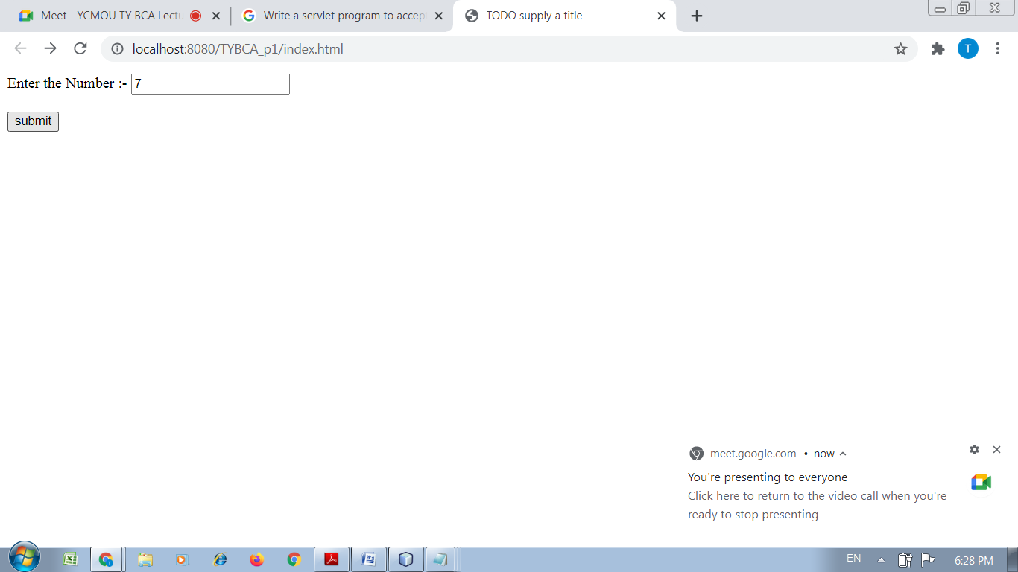
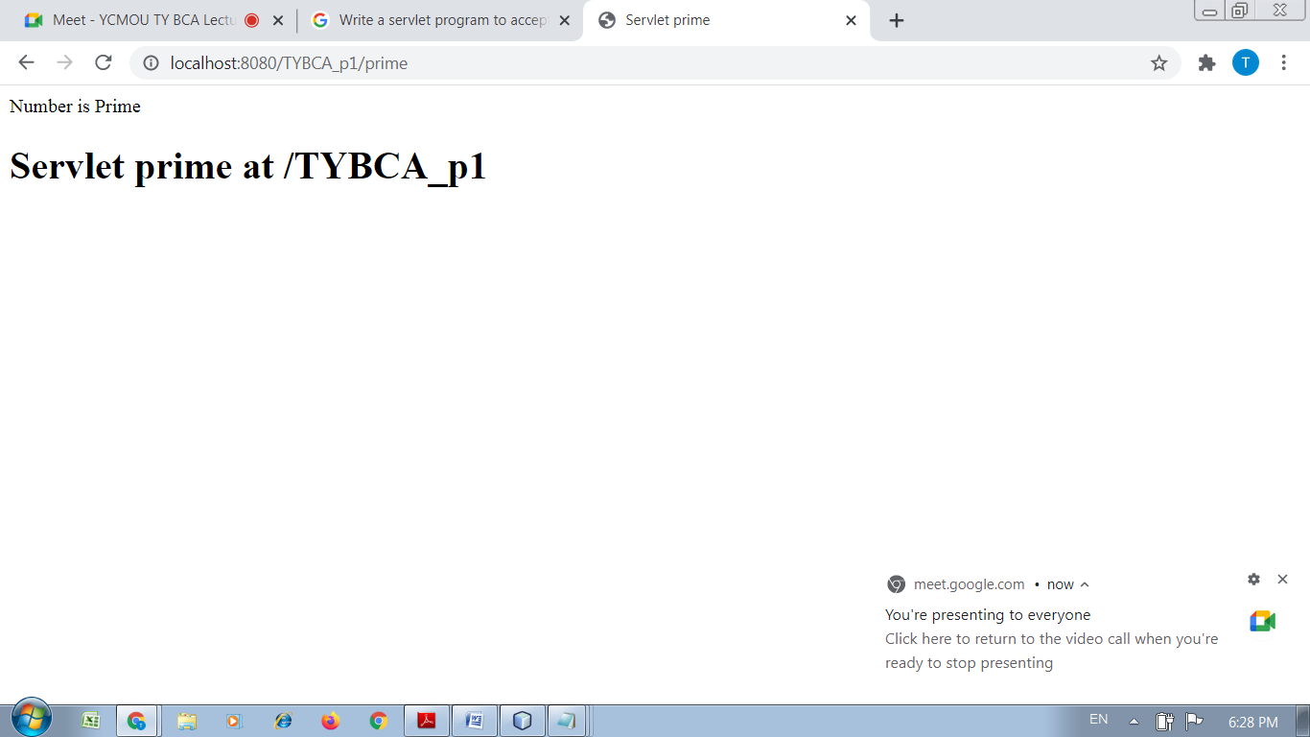

Practical No : 02
Aim :-
Write a servlet to determine whether the entered name from the html form is palindrome or not.

Solution :-
<html>
<head>
<title>TODO supply a title</title>
<meta charset="UTF-8">
<meta name="viewport" content="width=device-width, initial-scale=1.0">
</head>
<body>

<form action="palin" method="post">
Enter the String :- <input type="text" name="txt1" size="20">
<br>
<br>
<input type="submit" value="submit" name="submit">

</form>

</body>
</html>

/*
* To change this license header, choose License Headers in Project Properties.
* To change this template file, choose Tools | Templates
* and open the template in the editor.
*/
package palin;

import java.io.IOException;
import java.io.PrintWriter;
import javax.servlet.ServletException;
import javax.servlet.http.HttpServlet;
import javax.servlet.http.HttpServletRequest;
import javax.servlet.http.HttpServletResponse;

/**
*
* @author DELL
*/
public class palin extends HttpServlet {

/**
* Processes requests for both HTTP <code>GET</code> and <code>POST</code>
* methods.
*
* @param request servlet request
* @param response servlet response
* @throws ServletException if a servlet-specific error occurs
* @throws IOException if an I/O error occurs
*/
@Override
protected void doPost(HttpServletRequest request, HttpServletResponse response)
throws ServletException, IOException {

String name=request.getParameter("txt1");

response.setContentType("text/html;charset=UTF-8");
try (PrintWriter out = response.getWriter()) {

StringBuffer sb=new StringBuffer(name);
String reverse=sb.reverse().toString();

if(name.equalsIgnoreCase(reverse))
{
out.println("It is a palindrome");
}
else
{
out.println("It is not a palindrome");
}

/* TODO output your page here. You may use following sample code. */
out.println("<!DOCTYPE html>");
out.println("<html>");
out.println("<head>");
out.println("<title>Servlet palin</title>");
out.println("</head>");
out.println("<body>");
out.println("<h1>Servlet palin at " + request.getContextPath() + "</h1>");
out.println("</body>");
out.println("</html>");
}
}}

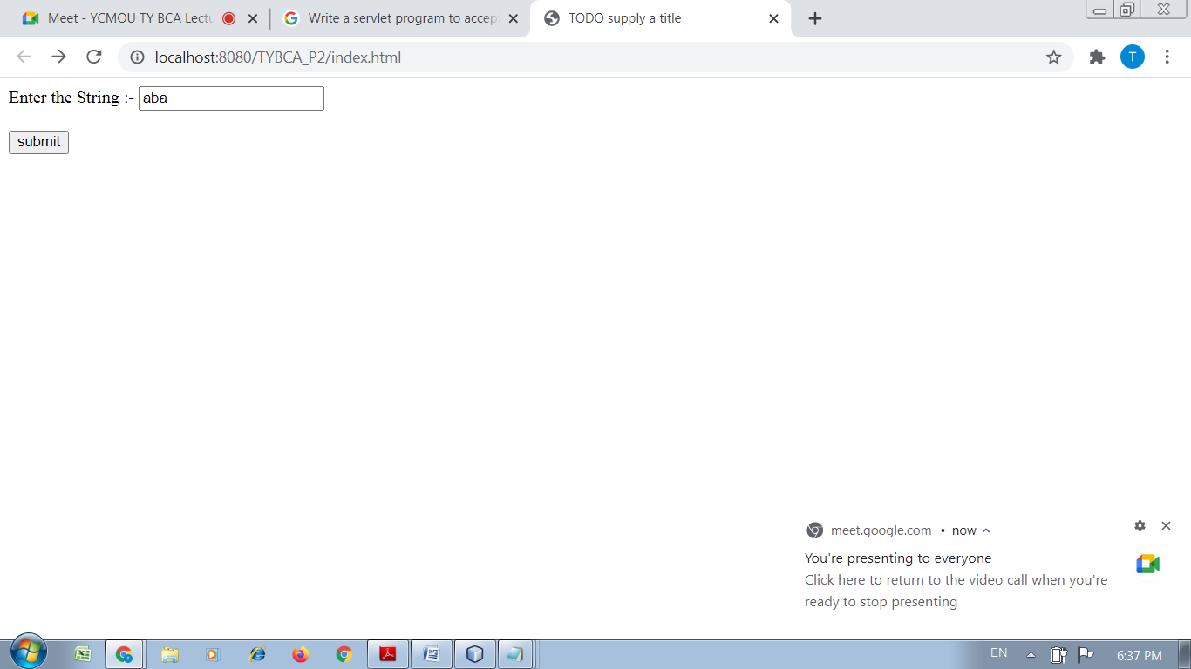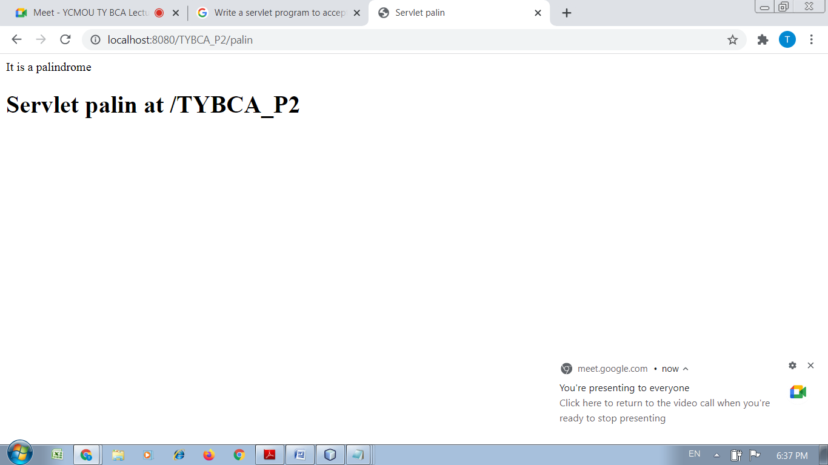

Practical No : 03
Aim :-
Write a Servlet program to print all the even numbers between the two entered numbers by the user, let say user enters 5 and 500 , so print the even numbers between 5 and 500

Solution :-
<html>
<head>
<title>TODO supply a title</title>
<meta charset="UTF-8">
<meta name="viewport" content="width=device-width, initial-scale=1.0">
</head>
<body>

<form action="prime" method="post">
Enter the 1st No :- <input type="text" name="txt1" size="20">
<br>
<br>
Enter the 2nd No :- <input type="text" name="txt2" size="20">
<br>
<br>
<input type="submit" value="submit" name="submit">

</form>
</body>
</html>

/*
* To change this license header, choose License Headers in Project Properties.
* To change this template file, choose Tools | Templates
* and open the template in the editor.
*/
package prime;

import java.io.IOException;
import java.io.PrintWriter;
import javax.servlet.ServletException;
import javax.servlet.http.HttpServlet;
import javax.servlet.http.HttpServletRequest;
import javax.servlet.http.HttpServletResponse;

/**
*
* @author DELL
*/
public class prime extends HttpServlet {

/**
* Processes requests for both HTTP <code>GET</code> and <code>POST</code>
* methods.
*
* @param request servlet request
* @param response servlet response
* @throws ServletException if a servlet-specific error occurs
* @throws IOException if an I/O error occurs
*/
@Override
protected void doPost(HttpServletRequest request, HttpServletResponse response)
throws ServletException, IOException {

String s=request.getParameter("txt1");
int start=Integer.parseInt(s);
String s1=request.getParameter("txt2");
int end=Integer.parseInt(s1);

response.setContentType("text/html;charset=UTF-8");
try (PrintWriter out = response.getWriter()) {

for(int i=start;i<=end;i++)
{
if(i%2==0)
{
out.println(i+"<br>");
}
else
{

}
}

/* TODO output your page here. You may use following sample code. */
out.println("<!DOCTYPE html>");
out.println("<html>");
out.println("<head>");
out.println("<title>Servlet prime</title>");
out.println("</head>");
out.println("<body>");
out.println("<h1>Servlet prime at " + request.getContextPath() + "</h1>");
out.println("</body>");
out.println("</html>");
}
}}

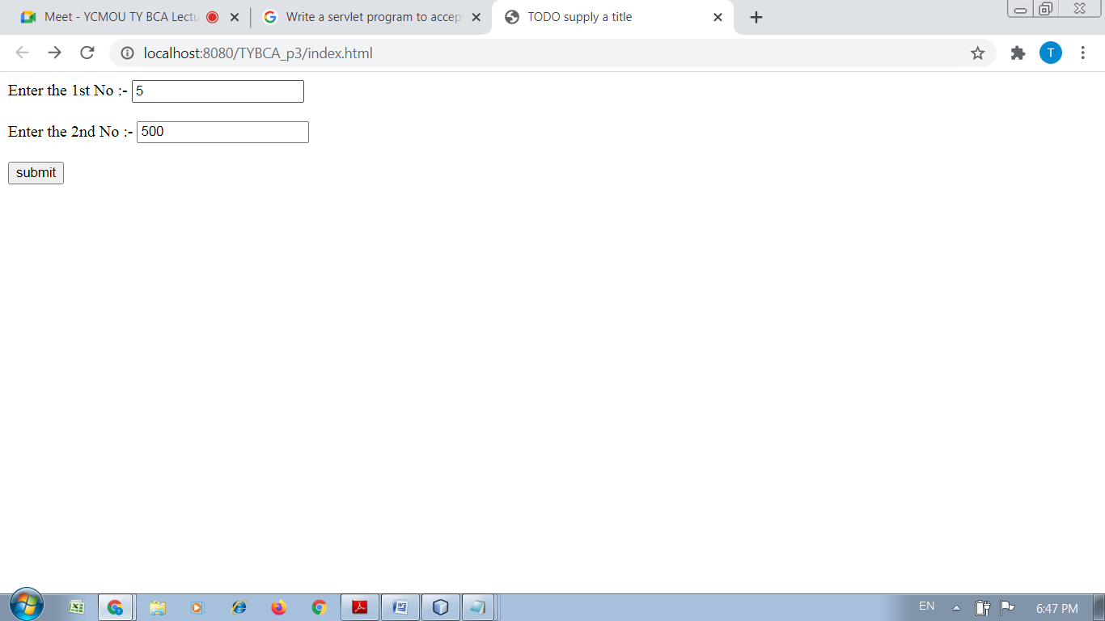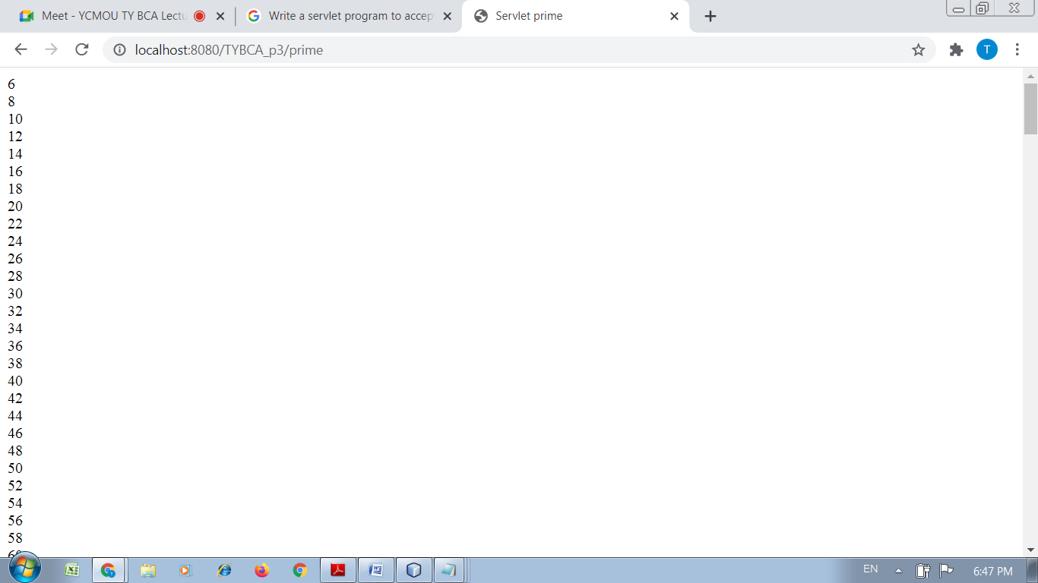
Practical No : 04
Aim :-
Write a servlet program to accept a number, if number is even redirect to purplesq.com if number is odd redirect to google.com

Solution :-
<html>
<head>
<title>TODO supply a title</title>
<meta charset="UTF-8">
<meta name="viewport" content="width=device-width, initial-scale=1.0">
</head>
<body>

<form action="evenodd" method="post">

Enter the Number :- <input type="text" name="txt1" size="20">
<br>
<br>
<input type="submit" value="submit" name="submit">
</form>

</body>
</html>

/*
* To change this license header, choose License Headers in Project Properties.
* To change this template file, choose Tools | Templates
* and open the template in the editor.
*/
package evenodd;

import java.io.IOException;
import java.io.PrintWriter;
import javax.servlet.RequestDispatcher;
import javax.servlet.ServletException;
import javax.servlet.http.HttpServlet;
import javax.servlet.http.HttpServletRequest;
import javax.servlet.http.HttpServletResponse;

/**
*
* @author DELL
*/
public class evenodd extends HttpServlet {

/**
* Processes requests for both HTTP <code>GET</code> and <code>POST</code>
* methods.
*
* @param request servlet request
* @param response servlet response
* @throws ServletException if a servlet-specific error occurs
* @throws IOException if an I/O error occurs
*/
@Override
protected void doPost(HttpServletRequest request, HttpServletResponse response)
throws ServletException, IOException {

String s=request.getParameter("txt1");
int n=Integer.parseInt(s);

response.setContentType("text/html;charset=UTF-8");
try (PrintWriter out = response.getWriter()) {

if(n%2==0)
{
out.println(n+"<br>"+"is a even number");
RequestDispatcher rd = request.getRequestDispatcher("www.purplesq.com");
rd.include(request, response);
}
else
{
out.println(n+"<br>"+"is a odd number");
RequestDispatcher rd = request.getRequestDispatcher("www.google.com");
rd.include(request, response);
}

/* TODO output your page here. You may use following sample code. */
out.println("<!DOCTYPE html>");
out.println("<html>");
out.println("<head>");
out.println("<title>Servlet evenodd</title>");
out.println("</head>");
out.println("<body>");
out.println("<h1>Servlet evenodd at " + request.getContextPath() + "</h1>");
out.println("</body>");
out.println("</html>");
}
}
}

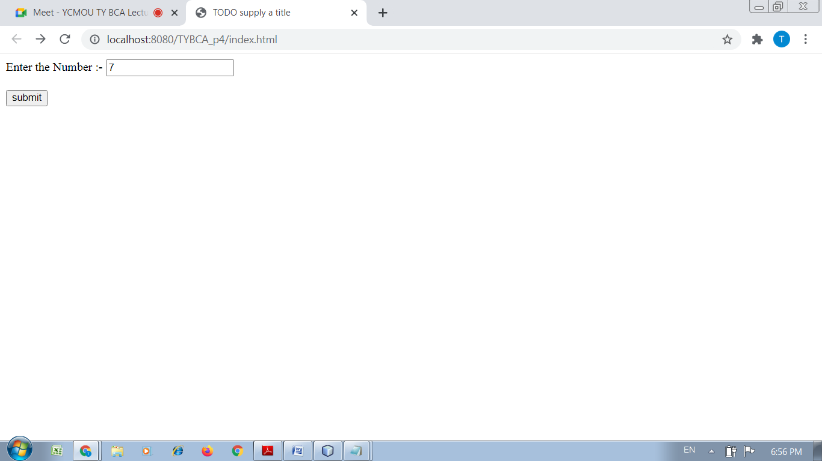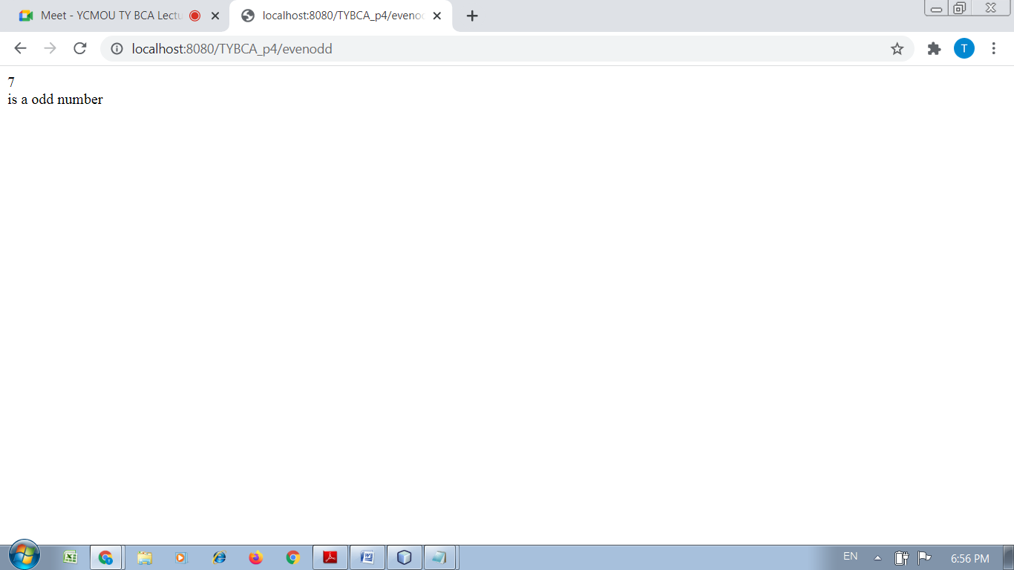

Practical No : 05
Aim :-
Write a servlet program to redirect the request to another servlet which requires a String as the parameter and the other servlet converts the string to lower case.

Solution :-
<html>
<head>
<title>TODO supply a title</title>
<meta charset="UTF-8">
<meta name="viewport" content="width=device-width, initial-scale=1.0">
</head>
<body>

<form action="conv" method="post">
Enter the String :- <input type="text" name="txt1" size="20">
<br>
<br>
<input type="submit" value="submit" name="submit">
</form>

</body>
</html>

/*
* To change this license header, choose License Headers in Project Properties.
* To change this template file, choose Tools | Templates
* and open the template in the editor.
*/
package conv;

import java.io.IOException;
import java.io.PrintWriter;
import javax.servlet.ServletException;
import javax.servlet.http.HttpServlet;
import javax.servlet.http.HttpServletRequest;
import javax.servlet.http.HttpServletResponse;

/**
*
* @author DELL
*/
public class conv extends HttpServlet {

/**
* Processes requests for both HTTP <code>GET</code> and <code>POST</code>
* methods.
*
* @param request servlet request
* @param response servlet response
* @throws ServletException if a servlet-specific error occurs
* @throws IOException if an I/O error occurs
*/
@Override
protected void doPost(HttpServletRequest request, HttpServletResponse response)
throws ServletException, IOException {

String s=request.getParameter("txt1");

response.setContentType("text/html;charset=UTF-8");
try (PrintWriter out = response.getWriter()) {

out.println(s.toLowerCase());

/* TODO output your page here. You may use following sample code. */
out.println("<!DOCTYPE html>");
out.println("<html>");
out.println("<head>");
out.println("<title>Servlet conv</title>");
out.println("</head>");
out.println("<body>");
out.println("<h1>Servlet conv at " + request.getContextPath() + "</h1>");
out.println("</body>");
out.println("</html>");
}
}
}

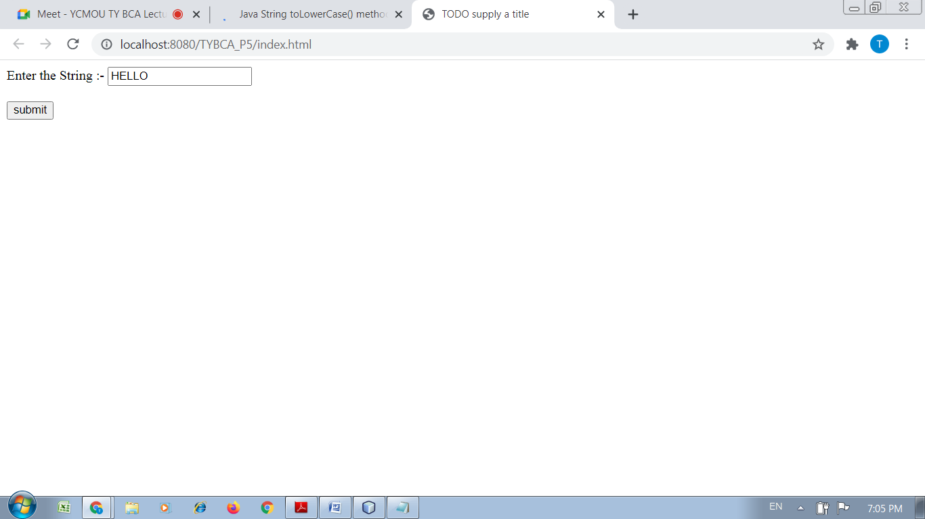
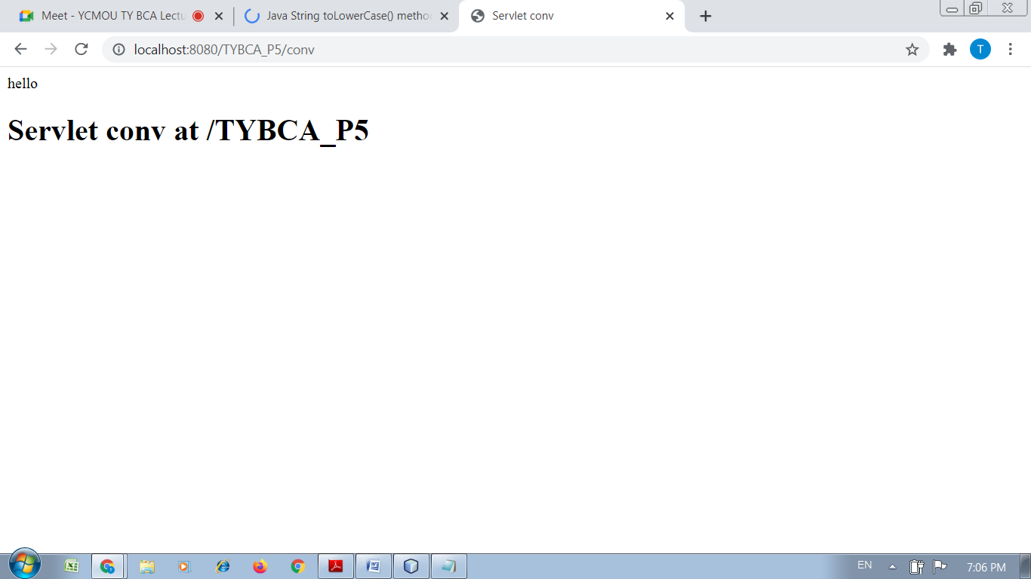

Practical No : 06
Aim :-
Write a Java program to get the name from a html form, put the name in session and redirect the flow to another servlet and the other servlet displays the name put into the session.

Solution :-
<html>
<head>
<title>TODO supply a title</title>
<meta charset="UTF-8">
<meta name="viewport" content="width=device-width, initial-scale=1.0">
</head>
<body>

<form action="session1" method="post">
Enter the Name :- <input type="text" name="txt1" size="20">
<br>
<br>
<input type="submit" value="submit" name="submit">
</form>

</body>
</html>

/*
* To change this license header, choose License Headers in Project Properties.
* To change this template file, choose Tools | Templates
* and open the template in the editor.
*/
package session1;

import java.io.IOException;
import java.io.PrintWriter;
import javax.servlet.ServletException;
import javax.servlet.http.HttpServlet;
import javax.servlet.http.HttpServletRequest;
import javax.servlet.http.HttpServletResponse;

/**
*
* @author DELL
*/
public class session1 extends HttpServlet {

/**
* Processes requests for both HTTP <code>GET</code> and <code>POST</code>
* methods.
*
* @param request servlet request
* @param response servlet response
* @throws ServletException if a servlet-specific error occurs
* @throws IOException if an I/O error occurs
*/
@Override
protected void doPost(HttpServletRequest request, HttpServletResponse response)
throws ServletException, IOException {

String s=request.getParameter("txt1");

response.setContentType("text/html;charset=UTF-8");
try (PrintWriter out = response.getWriter()) {

out.println("Welcome"+s);

/* TODO output your page here. You may use following sample code. */
out.println("<!DOCTYPE html>");
out.println("<html>");
out.println("<head>");
out.println("<title>Servlet session1</title>");
out.println("</head>");
out.println("<body>");
out.println("<h1>Servlet session1 at " + request.getContextPath() + "</h1>");
out.println("</body>");
out.println("</html>");
}
}
}

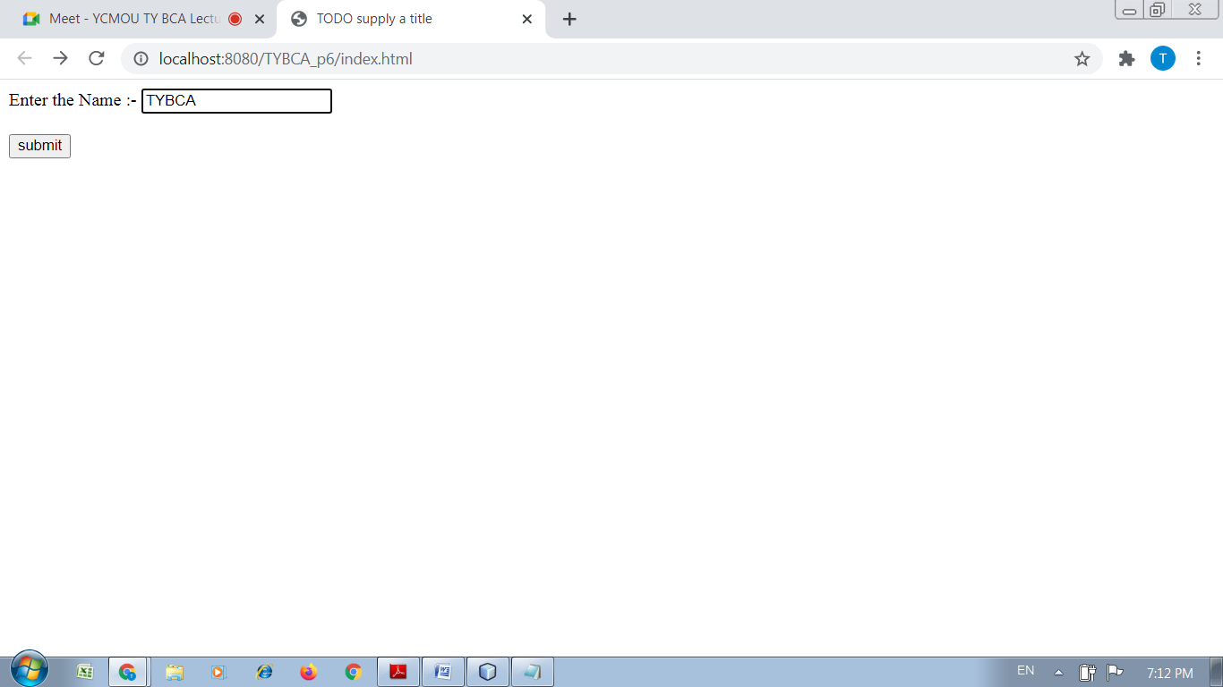
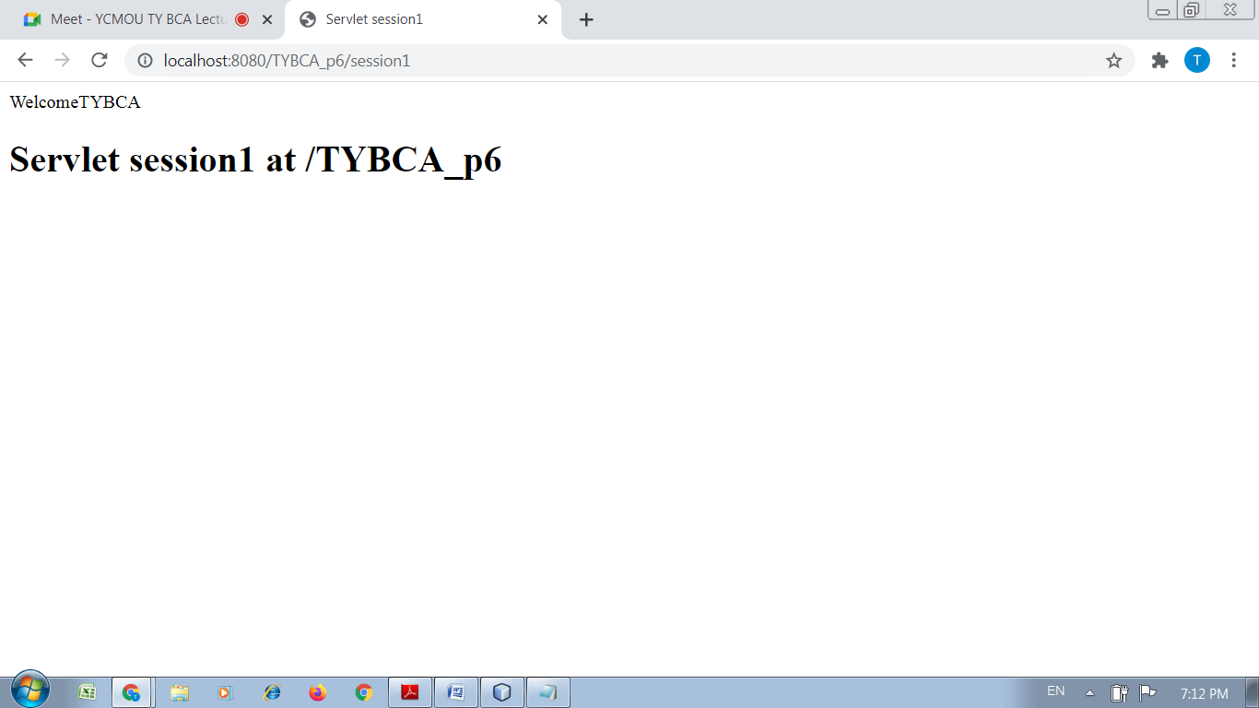

Practical No : 07
Aim :-
Write a JSP code to accept a number and revert whether the number is prime or not.

Solution :-
<html>
<head>
<title>TODO supply a title</title>
<meta charset="UTF-8">
<meta name="viewport" content="width=device-width, initial-scale=1.0">
</head>
<body>

<form action="prime.jsp" method="post">

Enter the Number :- <input type="text" name="txt1" size="20">
<br>
<br>
<input type="submit" value="submit" name="submit">
</form>

</body>
</html>

<%--
Document : prime
Created on : Nov 11, 2021, 7:17:37 PM
Author : DELL
--%>

<%@page contentType="text/html" pageEncoding="UTF-8"%>
<!DOCTYPE html>
<html>
<head>
<meta http-equiv="Content-Type" content="text/html; charset=UTF-8">
<title>JSP Page</title>
</head>
<body>

<%

String n=request.getParameter("txt1");
int number=Integer.parseInt(n);

int flag=0;

for(int i=2;i<=(number-1);i++)
{
if(number%2==0)
{
flag=1;
break;
}
}

if(flag==0)
{
out.println("Number is Prime");
}
else
{
out.println("Number is not prime");
}

%>

</body>
</html>

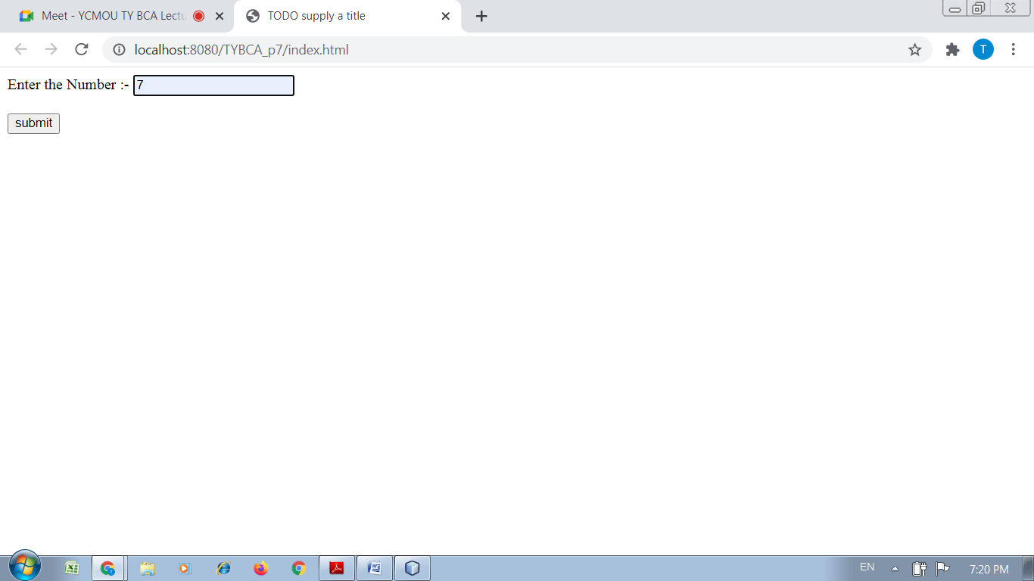
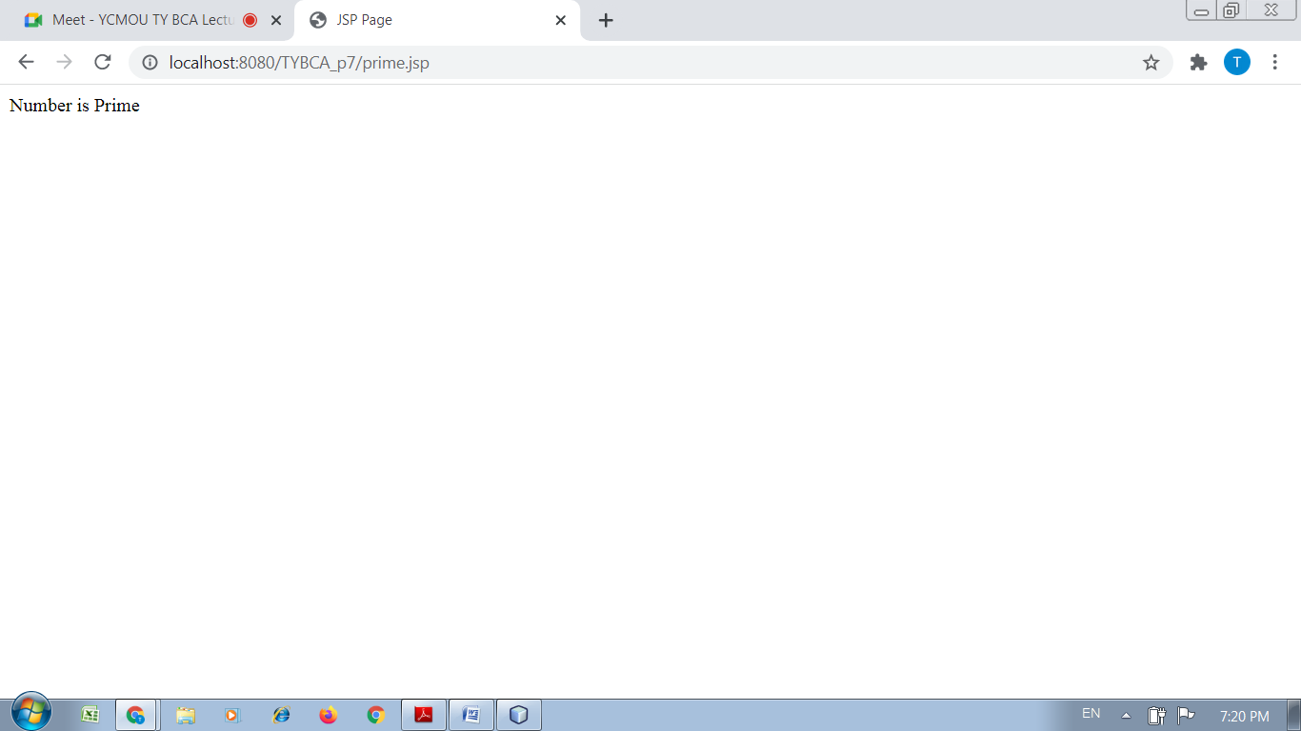

Practical No : 08
Aim :-
Write a servlet Program to accept a String and determine whether the String‟s length is greater than 6. And also jsp

Solution :-
<html>
<head>
<title>TODO supply a title</title>
<meta charset="UTF-8">
<meta name="viewport" content="width=device-width, initial-scale=1.0">
</head>
<body>
<form action="len" method="post">

Enter the String :- <input type="text" name="txt1" size="20">
<br>
<br>
<input type="submit" value="submit" name="submit">

</form>
</body>
</html>

<%--
Document : len
Created on : Nov 11, 2021, 7:24:17 PM
Author : DELL
--%>

<%@page contentType="text/html" pageEncoding="UTF-8"%>
<!DOCTYPE html>
<html>
<head>
<meta http-equiv="Content-Type" content="text/html; charset=UTF-8">
<title>JSP Page</title>
</head>
<body>

<%

String s=request.getParameter("txt1");

int l=s.length();

if(l>=6)
{
out.println("Length of the string is:"+l);
}
else
{
out.println("Length of the String is not equals or more than 6. Length :"+l);
}

%>

</body>
</html>
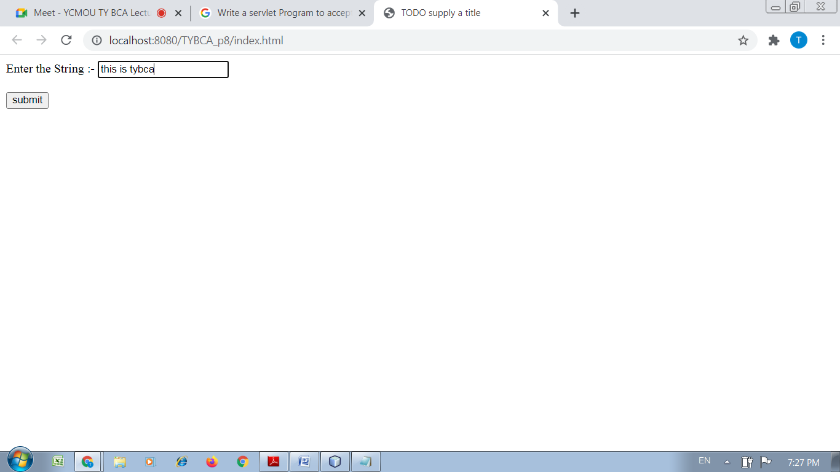
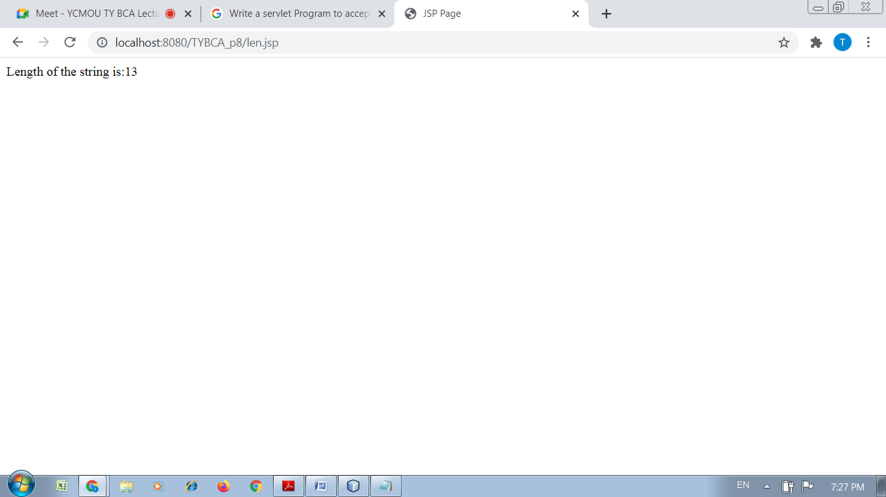
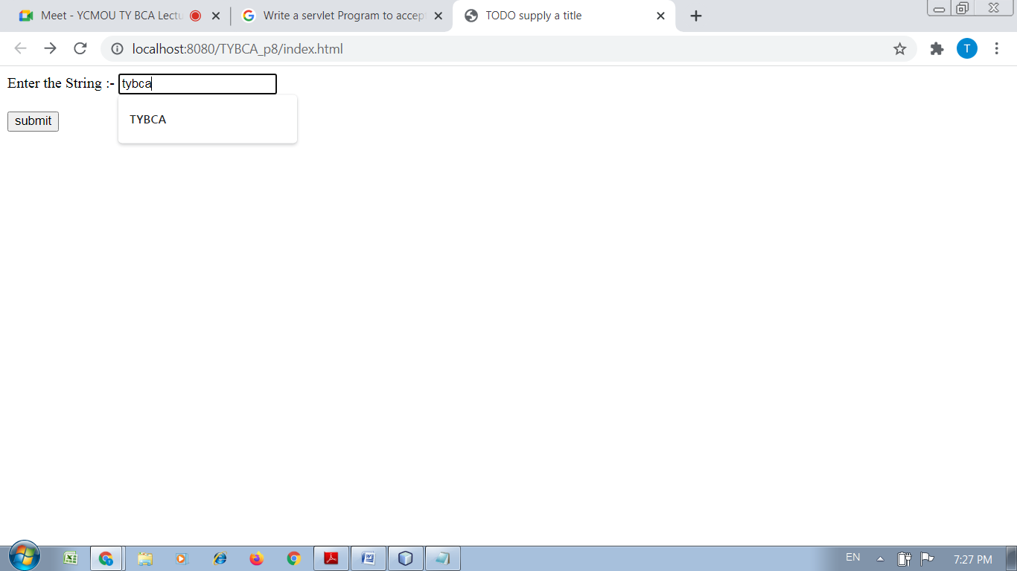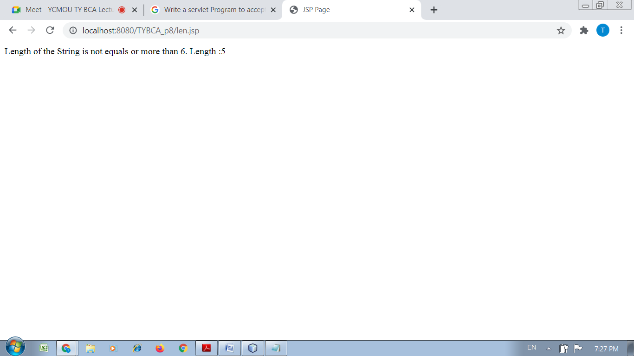

Practical No : 08
Aim :-
Write a JSP Program to redirect to Google.com

Solution :-
<%--
Document : redirect
Created on : Nov 11, 2021, 7:31:28 PM
Author : DELL
--%>

<%@page contentType="text/html" pageEncoding="UTF-8"%>
<!DOCTYPE html>
<html>
<head>
<meta http-equiv="Content-Type" content="text/html; charset=UTF-8">
<title>JSP Page</title>
</head>
<body>

<%

// New location to be redirected
String site = new String("http://www.google.com");
response.setStatus(response.SC_MOVED_TEMPORARILY);
response.setHeader("Location", site);

%>

</body>
</html>

