# Apache Webserver

You may optionally set up an Apache Web server with PHP7, WordPress, Joomla/jOpensim, or other Content Management (CMS) systems. The default purpose of Apache/PHP is to serve a detailed map, object search and other useful functions. It is optional. You may disable it and still run Opensimulator. If you do not need the extra maps or JOpenSim, then you can leave Apache & PHP disabled.

## Web Port

Defaults to 80. If your ISP blocks port 80, try 8000. You may need to open this port in your PC’s firewall.

## Enable Apache Web Server

The checkbox for [Enable Apache Web Server] must be set so the web server and PHP will work.

When enabled a map will appear at your URL on port 80. You can hover on any square and see its size, location, name, and other details. Apache will then start when your PC is booted. No DOS boxes will appear. The advantage is less clutter and 24-hour operation of the web server. But if you run from another folder, the server will still attempt to run from the original folder.

Manually disable Apache as a Service:

1. Type this in your Windows Search: **cmd**
2. Right click the Command Prompt App and select "Run as Administrator".
3. Now type this in the command prompt:
4. sc delete ApacheHTTPServer<enter>
5. Change to the folder for OutworldzFiles\Apache\bin.
6. Type this in the same admin-level prompt.
7. httpd -k install<enter>
8. net start ApacheHTTPServer<enter>

That should get it all going again.

## Content ManageR

A **content management system** (**CMS**) is computer software used to manage the creation and modification of digital content. CMS’s are typically used for enterprise content management (ECM) and **web** content management (WCM)

For the default web page, use Diva. See the Diva Wifi Management Web Page section in this manual.



**Enable WordPress** will redirect all traffic to the home page to the WordPress folder in Outworldzfiles\Apache\htdocs\WordPress. You must install Wordpress there. Instructions are located in that folder.

**Enable jOpensim** will redirect all traffic to the home page to the JOpensim folder in Outworldzfiles\Apache\htdocs\JOpensim. Instructions are located in that folder.

Enable Other will redirect all traffic to the Other folder in Outworldzfiles\Apache\htdocs\other. You can make a different folder.

## Apache & Search setup

In each of the respective OpenSim viewers available, such as Firestorm, Singularity, etc... You have a Search feature. It might look like this inside each respective viewer:

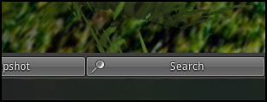

This brings up the following dialog with the respective search categories:

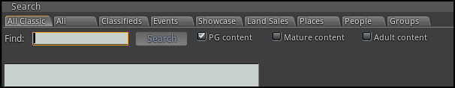

### Enable Search

If enabled, any regions or prims marked in the viewer for *Show In Search* will be registered and indexed by the <https://hyperica.com> server, and is thus available for anyone to look at. Turning off your system will remove it from search, as will unchecking this box.

### Events

By just clicking on the Search button without specifying a search term you will see all events that are up and coming

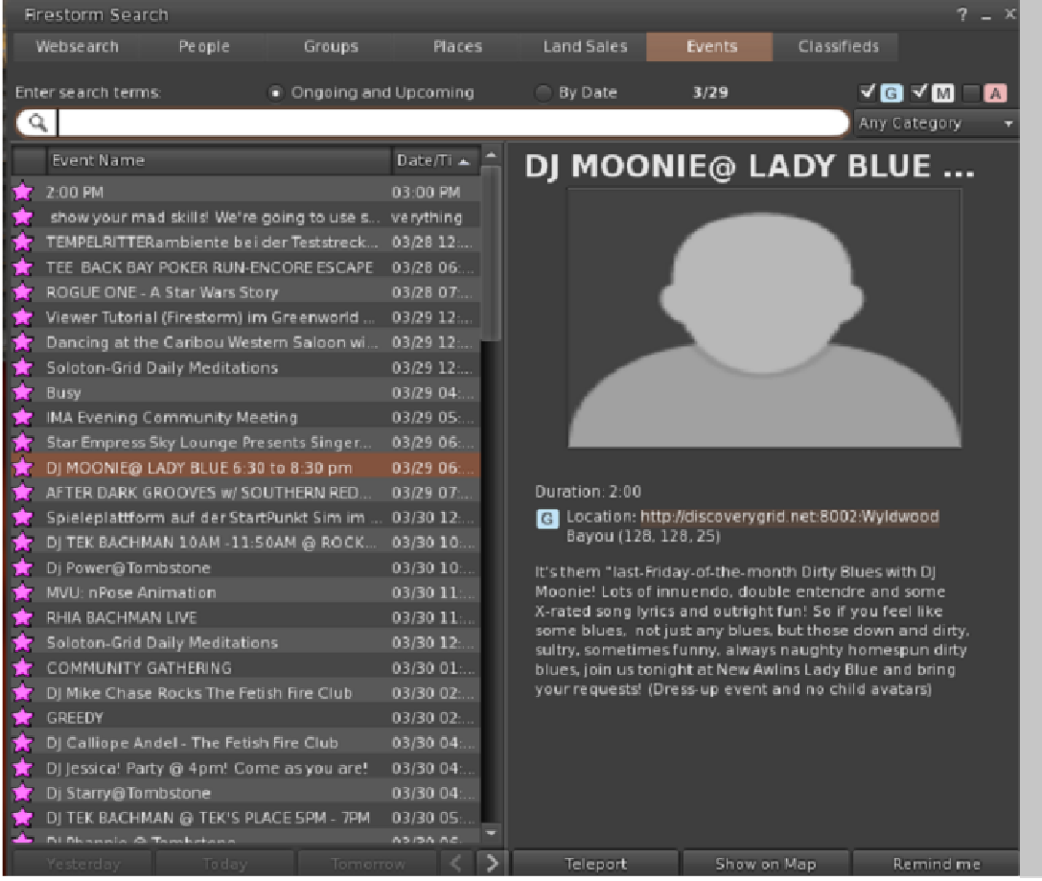

### Search for Objects

This viewer screen lets you search for objects marked as “Show in Search”. There is a search button ‘magnifying glass’ at lower left to refine your search. You can select 100, 250, or 500 rows. You can sort by any column header by clicking the title.

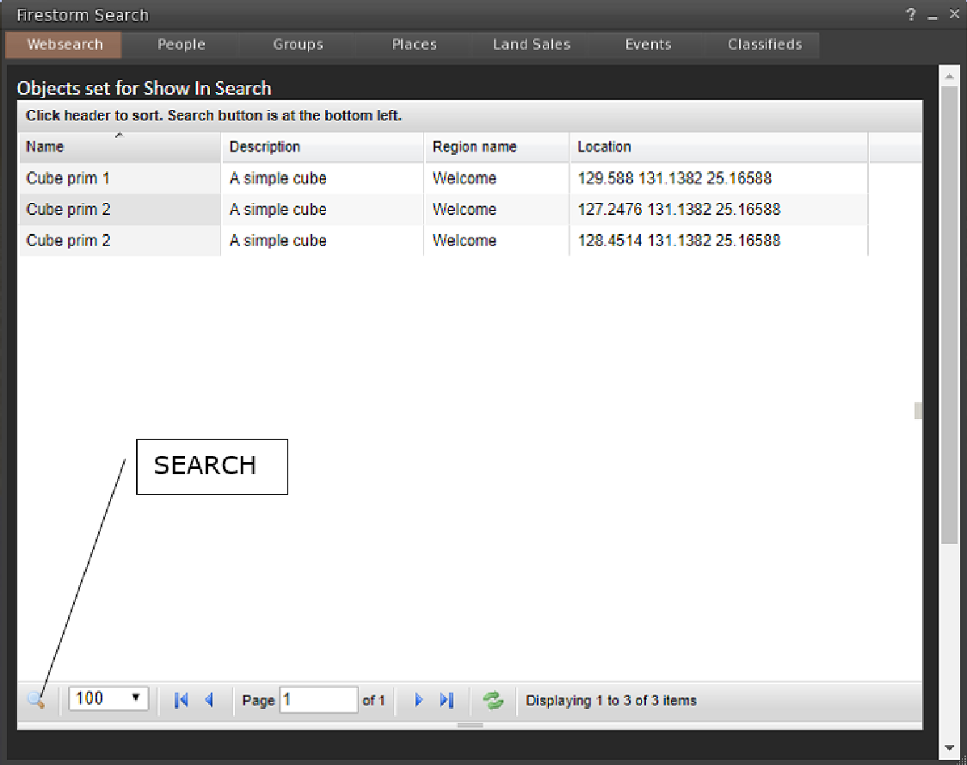

### Places search:

Any parcel marked as “Show in Search” is located in this viewer screen.

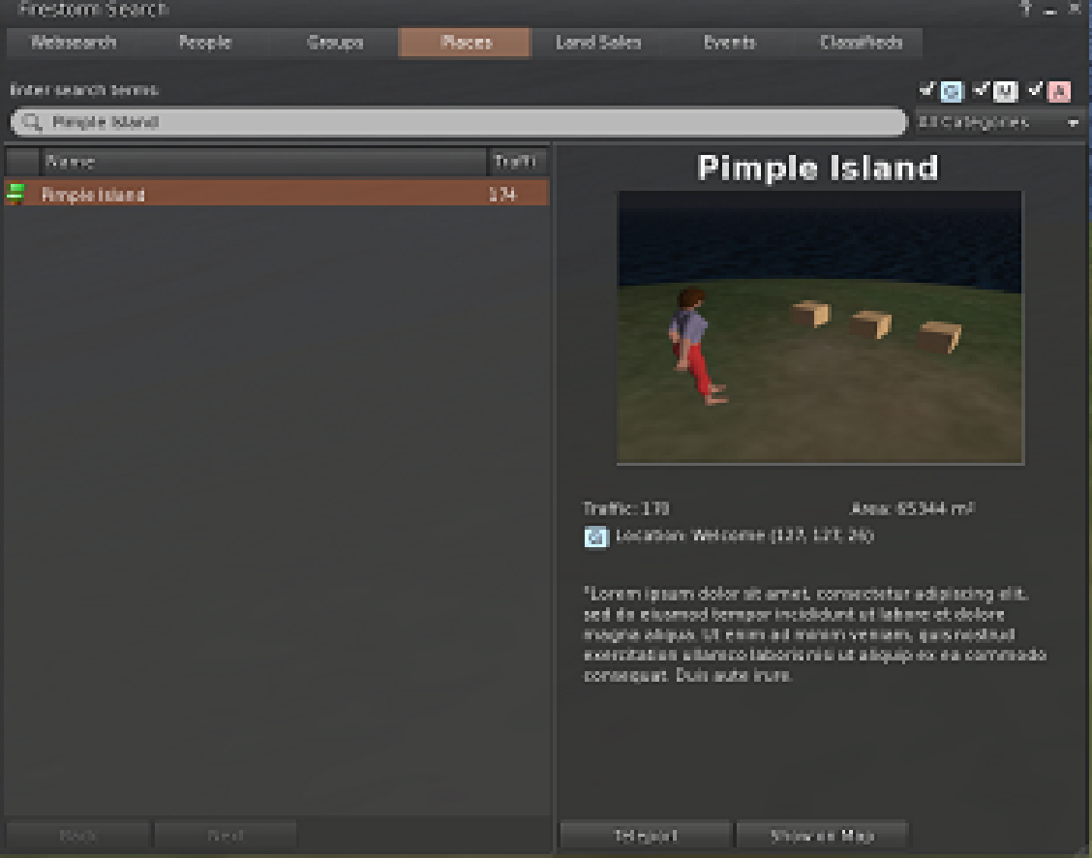

### Land Sales:

Parcels marked for-sale and “Show in Search” can be located in this screen:

