# Backup - Autobackup

The AutoBackup module periodically saves data to a folder.

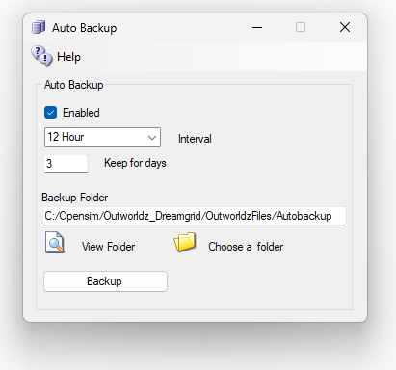

When AutoBackup is enabled, Opensim will make various backups of each region. For example, Opensim will make OAR after Opensim has run for **Interval** time. If there are checkboxes set in the [Backup Type], then those files will be backup up, too. The files will appear in the Outworldzfiles\AutoBackup folder.

**Keep for Days** will remove any folder older than this period.

**Save To Folder:** You can click on “AutoBackup” folder name, or the folder Icon, and set a different location.

**CAUTION:** These backups may use a great deal of room! **It is critical to save them to a different drive** so that a full drive does not crash your Database and Opensim system. DreamGrid will check for free disk space and warn you if you are low. It will freeze all Opensim Region activity if disk space gets low. If the disk space is > 100 MB, it will resume operation.

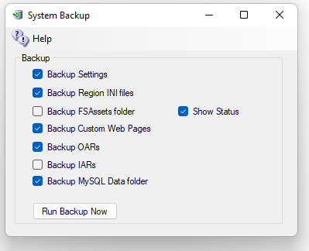

**Backup Settings** saves the Settings.INI files in a Zip.

**Backup Region INI files** saves all Region INI files from OutworldzFiles\Opensim\Bin\Regions to a Zip.

**Backup FSAssets folder** will make a copy of all the (Very Large) FsAsset folder.

**Backup Custom Web Pages** are the two Wifi-Custom folders.

**Backup Oars** will manually backup all regions if the Rub Backup Now button is pressed. It does not boot them again on a timer.

**Backup IARs** will start a new region named Temp ands back up all IARs one at a time. This can take a Very Long Time.

**Backup Custom Web Pages** are the two Wifi-Custom folders.

**Backup MySQL Data Folder** will back up the main database. You need a copy of FsAssets, too!

**Robocopy**: The **FSASSETS** system uses robocopy, a built in DOS program for FsAssets. It follows two rules for visibility that you set for regions, such as Always Show or Never Show. It runs with the following switches:

/E - Everything including empty folders.

/M –Modified files are copied that have the A bit set, then clears the bit.

/IM - Include Modified files that have changed times.

/J – Use Unbuffered IO for large files.

Robocopy will also add this LFSM switch on Windows 10. It will not do so on Server or Windows 7.  
  
/LFSM:50M – Will work in low free space mode, enabling copy pause and resume. Robocopy will pause whenever a file copy would cause the destination volume's free space to go below 50 Megabytes.

See the manual on “Manual Backups” for ways to back up manually.

This is what DreamGrid backs up if you check all the boxes:

* OutworldzFiles\Apache\htdocs\jOpensim\ folder  
  OutworldzFiles\Opensim\WifiPages-Custom\ folder
* OutworldzFiles\Settings.ini file
* OutworldzFiles\XYSettings.ini file
* OutworldzFiles\Opensim\bin\LocalUserStatistics.db database of traffic and viewers.
* OutworldzFiles\Photo.png Custom Hyperica Photo
* OutworldzFiles\NewBlack.png Custom Theme
* OutworldzFiles\NewWhite.png Custom Theme
* OutworldzFiles\NewCustom.png Custom Theme
* OutworldzFiles\Opensim\bin\Regions All the region Ini files
* Mysql Robust as .sql a portable database of Robust
* Mysql Opensim as .sql a portable database of Opensim regions
* Joomla as .sql a portable database of joomla data.
* Opensim\bin\FSassets ALL the assets, which must be backed up last on a live machine.

## BACKUP TO EXTERNAL Media:

Get a USB drive, preferably USB 3.0 plug it into a Blue or Teal colored jack for fastest speed. If you do not have the colored jacks, use any Black-colored jack. Format it for NTFS, with a 4096-sector size. ExFAT is a standard format that works on all machines, including Mac’s, Linux, and Windows. **You must select a smaller sector size in ExFAT,** or you will waste most of the space! A smaller sector size lets you put more data on the disk.

## How to format an **external** drive:

You can easily change an external hard drive to NTFS or ExFAT file system via Disk Management by following the steps listed below.

1. Connect the external hard drive to your computer and make sure that it is detected by Windows.

2. Press**Windows** +**X** at the same time and choose “**Disk Management**”.

3. Right-click the hard drive partition that you intend to format and choose “**Delete Volume**” to delete the partition.

4. Right-click the unallocated disk space and choose “**New simple volume”** and do like the prompts.

5. In the Format Partition window, set the file system as and click “**Next**” and “**Finish**” to start the operation.

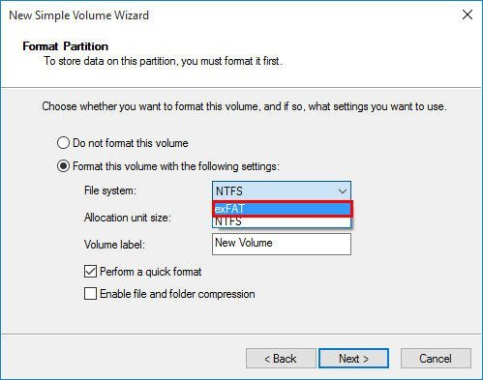

## Backup up to the external drive

Set a path to this drive in AutoBackup. Here I have my dev system set for my E: drive, a 14 TB Western Digital Easystore USB 3.0 HDD. Got it on Black Friday for $189 at Best Buy. These are usually the best deals in the USA.

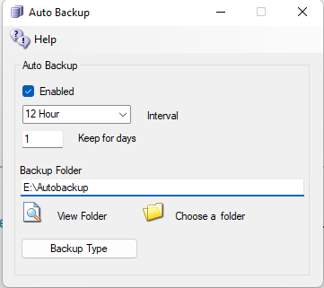

Set it for a week’s worth of backups. The default was 1 day, the default now is 3 days. But that applies only to new grids.

Now click **Backup Type**

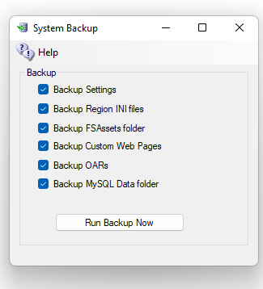

Check all the boxes.

* A FULL backup is to check all boxes except Backup OARS.
* Backup OARS is an effective way to get to the regions in a portable way, but this leaves out your users, your inventory, settings, and other important things.
* To get an immediate backup of your grid, manually, click on the button that says: Run Backup Now.

Click **Run Backup Now.**

**This may take days to finish because FSASSETS is going to be HUGE and will grow every time you touch the grid.**  
Now run the grid a week and check on the disk space. If there are lots left over, make it hold 14 days and check again in another week. When the disk looks like it will not make it a week, plug it into your concrete and steel Fire Safe that is bolted to the floor and go buy another USB hard drive. Your need TWO backups, and one MUST be offline.  
  
This is only steps 3 and 2 of the 3:2:1 Backup method. You should put at least the most recent copy in the cloud to handle the ‘1’ part. There are many solutions such as Google Drive, Microsoft’s OneDrive, or iDrive. Forget Dropbox. It crashes on large zips and lots of files, such as bin\fsassets. Google is scanning your files and will call the police on you if they find something suspicious. I have not tried OneDrive even though I have a free 1T with my 365 subscriptions. I know that iDrive works well for some and never crashes.

IAR AND OAR ARE NOT BACKUPS OF YOUR GRID

IARS are portable. They have that going for them. You can easily back them all up. Just look in Content under IARs, click the Backup All IARS link and choose a region that will be remarkably busy for perhaps several days or longer. I did 909 people recently. Works great. Used up 156 GB of disk. Spotted one person who had 32 GB of inventory.

IARS are backups of portions of one inventory. IARs have no usernames, passwords, no UUIDs and until the latest opensim (as of yesterday) no alphas for your avatars. IARs cannot reconstruct Appearances. The UUIDs change when an IAR load, so the appearance links will be broken. You can easily repair them, but it is tedious. They are good for moving to another grid. You can use the Diva Wifi Panel on any DreamGrid to populate your IAR from another grid. IARs have their uses but they are not a full backup.

Same goes for OARS. Very handy. But not a backup of a region. What size is the region? X or Y Engine? That information is in bin\regions, which DreamGrid backs that up for you.

Mysql\data and bin\fsassets are the things you must have to get a full backup to restore a grid. FSAssets will be huge. Millions of files. Mysql must be backed up before you backup FSAssets as it points to the files. If done in the wrong order on a live grid, you will lose assets if you try to restore from the FsAsset + MySQL backup. Do it in the order of MySQL, then Fsassets.

Links:

<http://opensimulator.org/wiki/Load_Oar_0.9.0%2B>