Bird Module

The bird module makes flocks of birds possible.

You will need a bird. There is a button at the top of the Setup Page that will ask you for your Avatar Name and password. It will load a pair of Seagulls into your inventory.

You should log in and rez "SeaGull1" on the ground in one or more of your regions.



You will need to enable the bird module in each region's control panel.

Check this Box to Enable Birds in this region

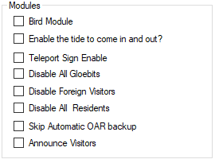

## Global Settings

There are many settings for the Bird Module. You can use the defaults. You must also click Enable and reboot the grid. Birds must also be enabled in each Region. See each Region’s edit screen for the checkbox.

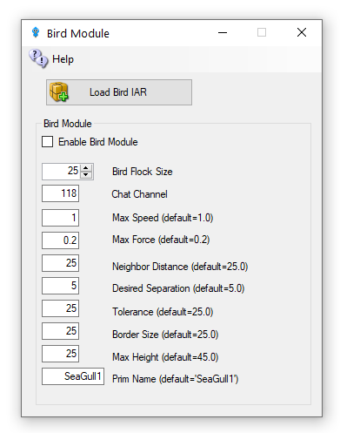

* + - Enable Bird Module: Determines whether the module does anything.
    - BirdsFlockSize = 50: The number of birds to flock
    - BirdsMaxFlockSize = 100: The maximum flock size that can be created (keeps things sane)
    - BirdsMaxSpeed = 3: How far each bird can travel per update. An update is 11 FPS
    - BirdsMaxForce = 0.25: The maximum acceleration allowed to the current velocity of the bird
    - BirdsNeighbourDistance = 25: Max distance for other birds to be considered in the same flock as others
    - BirdsTolerance = 5: How close to the edges of things can we get without being worried
    - BirdsBorderSize = 5: How close to the edge of a region can we get?
    - BirdsMaxHeight = 25: How high are we allowed to flock
    - BirdsUpdateEveryNFrames = 1: Update bird positions every N simulator frames
    - BirdsPrim = SeaGull1: By default, the module will create a flock of plain wooden spheres, however this can be overridden to the name of an existing prim that needs to already exist in the scene - i.e., be rezzed in the region.

## Console Commands

The following commands can be issued on the Console or via in-world chat or scripted chat on the Chat Channel to control the birds at runtime:

* birds-stop or /118 stop   
  stop all birds flocking
* birds-start or /118 start   
  start all birds flocking
* birds-enable or /118 enable   
  enable the flocking simulation if disabled and rez new birds
* birds-disable or /118 disable   
  stop all birds and remove them from the scene
* birds-prim <name> or /118 prim <name> changes the name of the bird prim that it loads
* framerate <num>   
  only update the flock positions every frame, only useful for photography and debugging bird behavior.

These commands are great for playing with the flock dynamics in real time:

* birds-size or /118 size   
  change the size of the flock
* birds-speed or /118 speed   
  change the maximum velocity each bird may achieve
* birds-force or /118 force   
  change the maximum force each bird may accelerate
* birds-distance or /118 distance   
  change the maximum distance that other birds are to be considered in the same flock as us
* birds-separation or /118 separation   
  sets how far away from other birds we would like to stay
* birds-tolerance or /118 tolerance   
  sets how close to the edges of things can we get without being worried. If distance is less than separation, then the birds will never flock. The other way around and they will always eventually form one or more flocks.

## Security

By default, anyone can send commands to the module from within a script or via the in-world chat on the 'BirdsChatChannel' channel. You should use a high negative value for this channel if you want to allow script access, but not in-world chat.

## Bird Prims

Any currently rezzed in-scene-object can be used as the bird prim. However, fps is very much affected by the complexity of the entity to use. It is easier to throw a single prim (or sculpty) around the scene than it is to throw the constituent parts of a 200 linked prim dragon.

Tests show that <= 500 single prims can be flocked effectively - depending on system and network. However maybe <= 300 simple linksets can perform as well.

## Network Traffic

I tested the amount of network traffic generated by bird updates. 20 birds (each with 4 linked prims) take up about 300kbps in network position updates. 50 of the same birds generates about 750kbps traffic. Each bird uses roughly 15kbps of network traffic. This is all measured using an update framerate of 1, i.e., birds' position is updated every simulator frame.

## Statistics

The stats command in-world or via script returns data to BirdsChatChannel. The console command returns stats to the console. All the modules parameters are returned including a list of the active bird prims currently rezzed in the region, and the UUIDs of those prims' root prim. Also included is a list of any avatar UUIDs that may be sitting on those prims.

Here is an example output:

birds-started = False  
birds-enabled = True  
birds-prim = SeaGull1  
birds-framerate = 1  
birds-maxsize = 100  
birds-size = 20  
birds-speed = 1.5  
birds-force = 0.2  
birds-distance = 25  
birds-separation = 10  
birds-tolerance = 5  
birds-border = 5  
birds-prim0 = OpenSimBirds0: 01abef79-7fb2-4c8d-831e-62ce1ce878f1 :  
birds-prim1 = OpenSimBirds1: af85996d-af4d-4dda-bc89-721c51e09d0c :

**Links:**

<https://github.com/JakDaniels/OpenSimBirds>