# Hypergrid and Domain Name Setup

Hypergrid needs a DNS name or a Public IP. You can register and use your own domain, or use your routers public IP, or use the Outworldz system’s’ free Dynamic DNS system (DYN DNS).

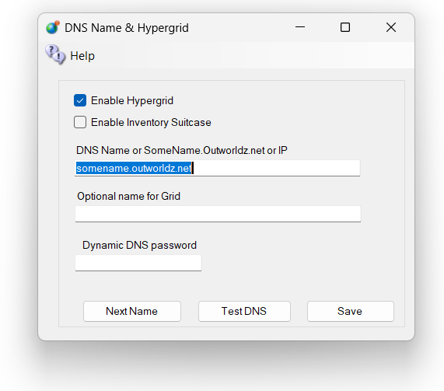

**DNS name:** For a Free Dynamic DNS name, use the format "somename.outworldz.net" or “somename.inworldz.net.” You can also just make up a name, so choose a name and add “.outworldz.net" or “.inworldz.net”. For domain names, the letters, numbers a-z, digits 0-9 and a dash (-) are the only allowed characters.

You may add an alternate name to be registered in the dynamic DNS system. This is typically used if you have moved grids. This name will also work on your grid.

Do not add anything else other than a name, periods ‘.’ and either ‘inworldz.net’, or ‘.outworldz.net’.

IP addresses may be used. If you don’t want anyone to get to this machine from the outside world, use 127.0.0.1 or localhost. If you need it to accessible from inside the LAN, use the IP address of the server.

If blank, the PC's LAN address will be used. Hypergrid will not be available, but other LAN PC's will be able to connect. This is ideal for schools and other types of private work grids.

## Running on the LAN only

When there is no network connection, such as when travelling, use localhost, or 127.0.0.1. These allow only the viewer on the server to connect.

**DynDNS Password**: This is a random number that may be used to keep your DNS Name from being used by others. It is first come, first served. Your password must be copied from one installation to another to use the same DYN DNS name. If you need help with this, or wish to remove your DNS name, please email me at [fred@outworldz.net](mailto:fred@outworldz.net).

**Enable Hypergrid**: If unchecked, the Hypergrid will not be available. The grid will be only a Private Grid, with access possible only by logging into the grid directly.

**Enable My Suitcase**: If checked, Hypergrid travel uses a viewer suitcase. The purpose of the Suitcase is to prevent a foreign "rogue" grid from stealing your inventory while you are visiting. However, any items in your suitcase are exposed to other grids. You can only rez or give items in other grids that are already in your suitcase.

The My Suitcase folder is special: it is the folder tree that receives objects you collect while you are visiting other grids. But now it is even more special: it is the **only** folder tree that is accessible to you (and therefore to the rest of the Internet) while you are traveling. Period.

If you disable the suitcase by unchecking this box, as OsGrid does, you will be able to rez and give items while on other grids from anywhere in your inventory. Items you take or are given will still end up in your suitcase.

**Next Name**: to use the free Outworldz Dynamic DNS, click "Next Name" to get a name. The DreamGrid Dynamic DNS system will automatically register your PC's ever-changing IP address and keep your sim running.

**Test DNS**: Will register the DNS name and check that it is resolvable. The result should be the Public IP address of your router.

## Troubleshooting Network:

1) Go back to running locally. Set the DNS name or IP to 127.0.0.1 and press Save.

Start the grid up.

2) Now that the grid is running, use http://www.canyouseeme.org on port 8002 to verify your router has ports forwarded. If not, work on the router/firewalls so you can see the Opensim Robust service on 8002.

3)   Try to get to that same IP address plus :8002 in a web browser from the server. My IP was 24.173.0.66, so I would try http://24.173.0.66:8002.

If you get no web page, your router does not support loopback.

4)Add the Windows Device driver for loopback. Use the exact same IP address that http://www.canyouseeme.org reported. This is what mine looks like

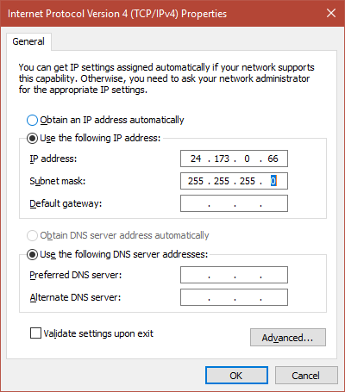

1. Click Start, then type cmd in the search box.  
2. In the command prompt, type hdwwiz.exe and press Enter.  
3. Click Next.  
4. Select Install the hardware that I manually select from a list (Advanced), then click Next.  
5. Select Network adapters, then click Next.  
6. Select Microsoft as the manufacturer, select Microsoft KM-TEST Loopback Adapter as the adapter for Windows10, then click Next.  
7. Select Next to confirm the installation.  
8. Select Finish to complete the installation.  
  
To configure the newly created adapter:  
  
1. Click Start > Control Panel > Network Connections.  
2, Select the newly created connection (named Local Area Connection #, where # is its order number).  
3. Right-click on the selected connection and choose Properties from the menu.  
4. Confirm that Microsoft Loopback Adapter or Microsoft Loopback Adapter # is displayed in the Connect Using: field.  
5. If it is not, return to step 2 and retry properties for another adapter.  
6. Select Internet Protocol IPV4 and click Properties to open Internet Protocol (TCP/IP) Properties.  
7. Select Use the following IP address. Fill in the IP address and Subnet mask fields.  
  
Example: 10.10.10.10, 255.255.255.0 <=====But use the IP address shown by http://www.canyouseeme.org  
  
8. Click OK to close the Internet Protocol (TCP/IP) Properties.  
9. Click OK to close the connection properties.  
10. Right click the Microsoft Driver and rename it to just "Loopback". DreamGrid will automatically update the driver if your Public IP changes.

11. You should be able to reach your grid at the IP Address:8002. If so, you can go back to the Hypergrid Setting and choose a DNS name.

## links:

<http://www.canyouseeme.org>