# Diva Web Control Panel

The Management Web page is at <http://127.0.0.1:8002> if the checkbox is enabled and Robust is running.

For other users, it will be [http://YourDomainName:8002](http://yourdomainname:8002), where YourDomainName is your Public, Internet-facing IP or DNS name.

The features of Wifi are:

* Account creation, optionally controlled by the Wifi Admin Account
* Configurable default avatars for new accounts
* Account updates by both users and administrator
* Account deletion by administrator
* Password recovery via email
* Simple user inventory management

You can change many of the parameters of Wifi in this panel:

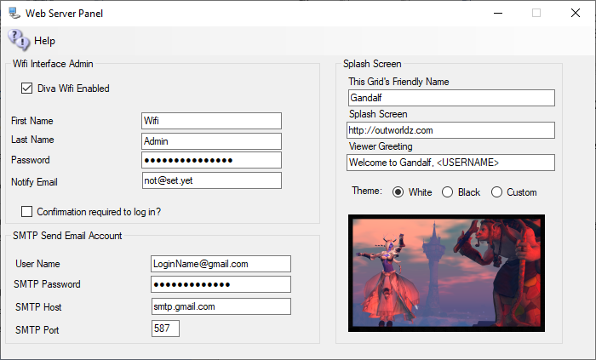

There are three sections that can be modified:

* Wifi Interface Admin: A super-user that administers the system. This can be you. It comes with Wifi Admin as a default login.
* Splash Screen: Things that affect the page that shows in the viewer window.
* SMTP Email: Settings to send email for things such as password changes and confirmation off emails.

The system automatically makes several accounts the first time. One of these is "Wifi Admin'. This user has special rights in the web panel. It can administer all other accounts, change passwords, enable and disable, or delete and approve them.

A random password is created at startup. You may change it. As the Hypergrid exposes this login page to the Internet, please choose a strong password.

You must already have a user with levels set to 100 or higher to change the name from Wifi Admin. You can add another user and set it to that elevated level too.



## Wifi Admin

There are three Opensim users made at startup. One is for the grid to use. GRID MANAGER is the main user If you mess with it your grid will die. It does things that require a User account to do, such as send a user an IM.

**Wifi Admin** is used to control users and run the Web page. It can rename, delete, stop, or allow a user on the grid by the web page. The robust console can do all this, but it is arcane and easier to use the web page.

Wifi Admin is created with a random password. Go to settings->Web Page and click the password field. It will show it to you. You can change this passwort by typing in a new name when Robust is running.

Go to Help-Web Page and it will open your grid Wifi Panel. It is also at <http://localhost:8002>.

Log in as Wifi Admin using that password. and you will see a Manage Accounts section.

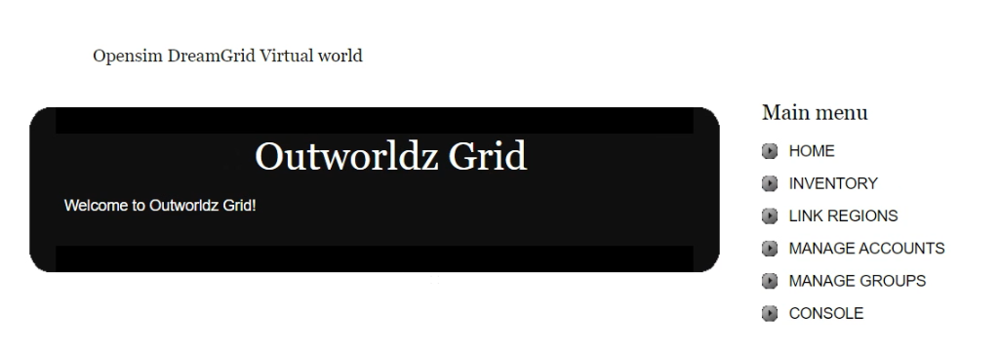

Go to it, press a space bar in search, and it will show you the three users.

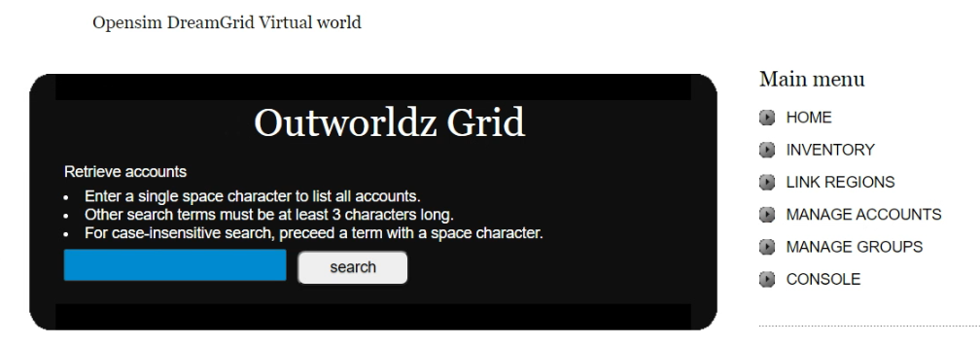

## User Levels:

If you any users the level to -1, they cannot log in.

Level 0, they can log in.

Level 100 is a Wifi Admin.

Level 200 allows them to be a god if Allow User Gods switch is enabled in Setup->Settings->Permissions

## Confirmation Required to Log In:

Wifi Admin can create new accounts in two manners: uncontrolled and controlled. If you choose to have controlled account creation, every time someone creates an account, the Wifi Admin account will receive an email notifying of such an event (make sure you have the Wifi Admin’s email address properly set).

You should then login to Wifi as administrator and choose USER MANAGEMENT. You are presented with a list of all pending accounts, which you can then approve or ignore.

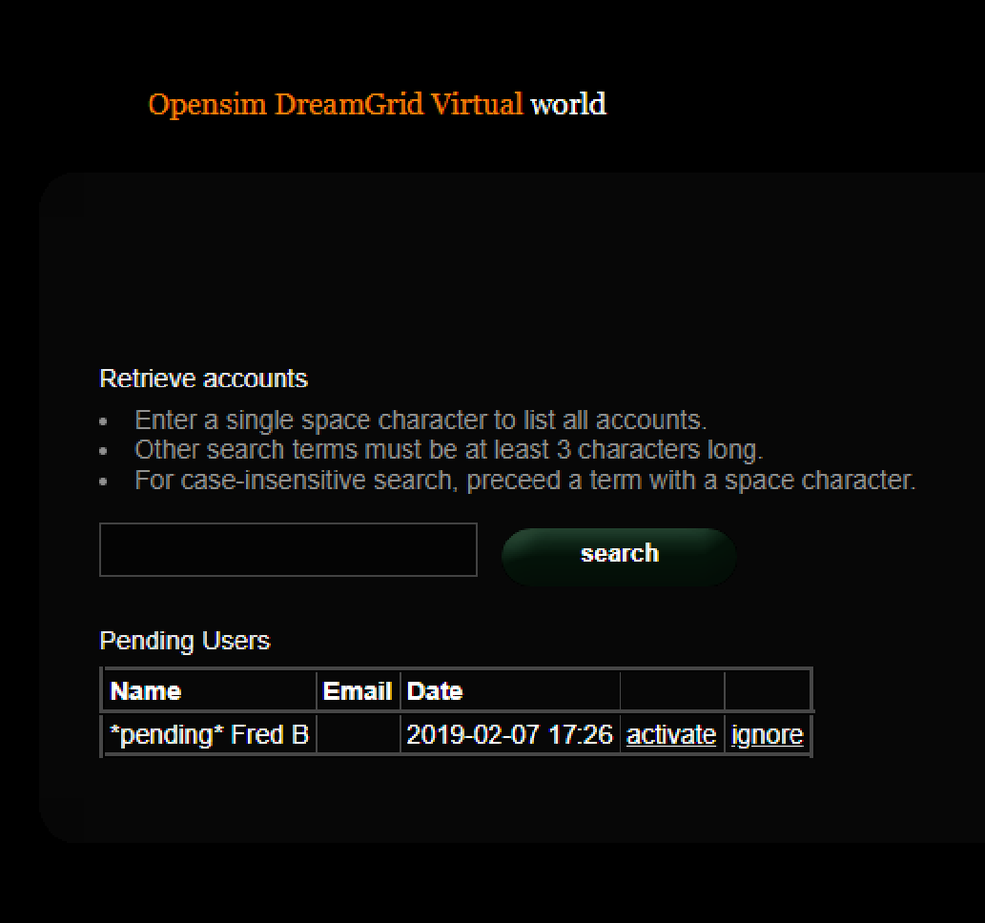

If you choose to have uncontrolled account creation, then anyone can create an account in your world without going through your approval.

## SMTP Email

You may optionally set up Simple Mail Transport Protocol to send email for events such as password changes.

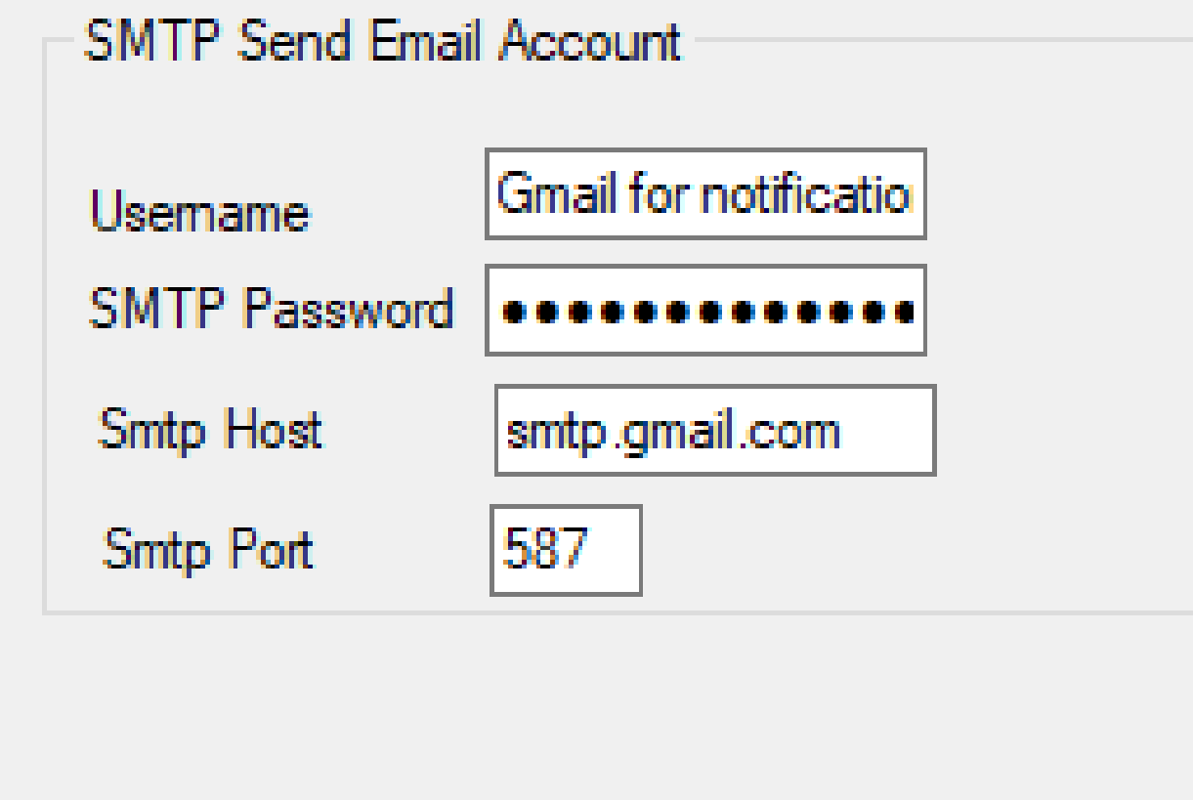

**If you use Gmail for SMTP, you will need to enable Less-Secure mail settings at Gmail in your account.**

**You can find information about this at** [**https://support.google.com/accounts/answer/6010255**](https://support.google.com/accounts/answer/6010255)

## Theme

There are three theme colors, Black on White, White on Black, and Custom. The default theme is Black, or the selected theme will be set by DreamGrid into the real WifiPages folder on startup.

Custom starts out as the White theme. You can modify this theme according to instructions down below.

Click the photo to change it for the theme.



## Viewer Splash Screen URL:

The Splash screen URL appears on the login screen as a web page. You can use any web page. If you change this URL, you must delete the grid setting in your viewer, and re-add it to get it updated.

**If you change this, you must delete and re-add the grid to the viewer.**

The Splash Screen URL is shown below.



Set this to http://(URL of your grid):8002 so they can see the Login Page. It can be any web page.

## Greeting

This message appears when a person logs in.



## Friendly Name

The friendly name appears on the login screen at the top. It is broadcast to viewers as the grid name in the grid Selector Pulldown. If you change this, you must delete and re-add the grid to the viewer.



## Default Avatars:

A “Wifi.ini” file lets you select one of three default appearances for a newly created avatar. In a new environment you must set those avatars up first.

1. Create the avatars with names “Female Avatar”, Male Avatar”, “Neutral Avatar”. and authorize them via the Wifi Admin.
2. Login as each avatar in turn. They will usually appear as a cloud initially and then after a short while rez to appear as “Ruth” wearing four basic body parts, new pants, and new shirt. These parts come directly from the Opensim Library and MUST NOT be worn in your final appearance for the default avatars. You can COPY these library parts into the avatar’s inventory if you wish, or create new body parts and clothing, but before you finish you should remove any items that show as “worn” in the Opensim Library as those will not rez on avatars based on these models.
3. Create new body parts and clothing and edit them and/or add any other mesh, clothing, attachments, or HUDs you wish to appear on the avatars.
4. You can extend (or change the avatars names or labels) for the default appearances and/or change the preselected default by altering Wifi.ini.

;;Syntax: AvatarAccount_<AvatarType> = "<FirstName> <LastName>"  
;;(replace spaces in <AvatarType> with underscore)  
AvatarAccount_Female="Female Avatar"   
AvatarAccount_Male="Male Avatar"   
AvatarAccount_Neutral="Neutral Avatar"   
;; Preselection for default avatar in new account registration   
AvatarPreselection="Neutral"

5. When you create a new avatar via the Wifi web interface based on these predefined avatars the items worn will appear in the newly created avatar’s inventory under Clothes -> Default Avatar <AvatarType>.

## Customizing your theme

You can change the theme with this switch to one of several sets of folders, White, Black, or Custom.

**White theme** consists of two folders:

* Outworldzfiles\Opensim\WifiPages-White
* Outworldzfiles\Opensim\bin\WifiPages-White

**Black theme** consists of two folders:

* Outworldzfiles\Opensim\WifiPages-Black
* Outworldzfiles\Opensim\bin\WifiPages-Black

If you want to make modifications, please use a custom theme. Otherwise, your changes to the -Black, -White or WifiPages folders will be over-written in an update.

First copy both the two Black, or the two White folders to the WifiPages-Custom folder next to them. Each set of files goes in these places:

* Opensim/WifiPages-Custom
* Opensim/bin/WifiPages-Custom

The updater will never overwrite these custom pages. If you make changes to the custom pages, they will be set into the Wifi page on startup.

Click the photo to change it for the theme.



## Changing the HTML

Diva Canto uses some advanced, Opensim-specific code in her Diva pages.

The site starts from Opensim\bin\WifiPages\index.html.

**#includes** There are several include directives that bring in the rest of the web site. Diva uses a series of <!--#include file=header.html --> statements to bring in files from the other folder set in Opensim\WifiPages. Includes in those files then bring in increasingly of the web pages from Opensim\Bin\Wifipages.

**#get** There are several statements that are replaced by server data:

**Users in World:** <!-- #get var=UsersInworld -->

**Regions:** <!-- #get var=RegionsTotal -->

**Total Users:** <!-- #get var=UsersTotal -->

**Active Users last** <!-- #get var=UsersActivePeriod --> **days**

**Active Users:** <!-- #get var=UsersActive -->