# FIREWALL

**DreamGrid Automatically adds rules to the Windows security system for Robust, Opensim, Icecast, and Apache. There is no need to adjust these rules.**

If you accidentally denied the firewall rule request, you would have to find the NO symbol in the firewall and drop it.

You may want to block certain IP addresses from accessing your system. This manual shows how. **The Ban list Manual shows how to do it with DreamGrid.**

The Windows security system is automatically opened for TCP and UDP for any ports that DreamGrid needs. It closes those ports if you reduce the number of regions and increases the open port count if you add regions. This also works on Icecast and Apache.

You can use the Windows security system to block specific IP addresses and ranges of Ip addresses.

Open the windows firewall and click **Advanced Settings** on the upper left side.

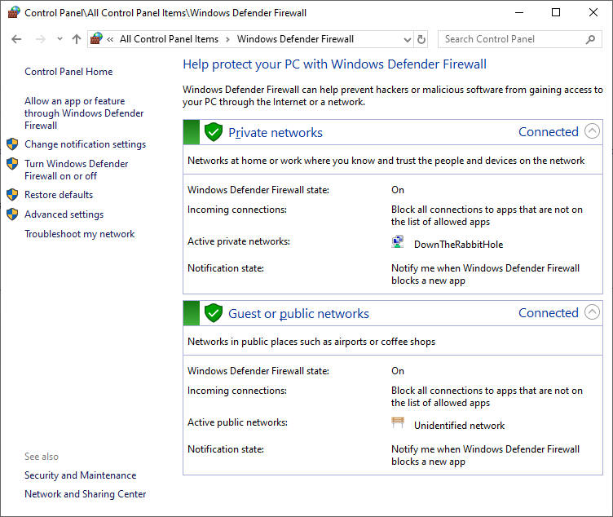

 Advanced settings screen:

[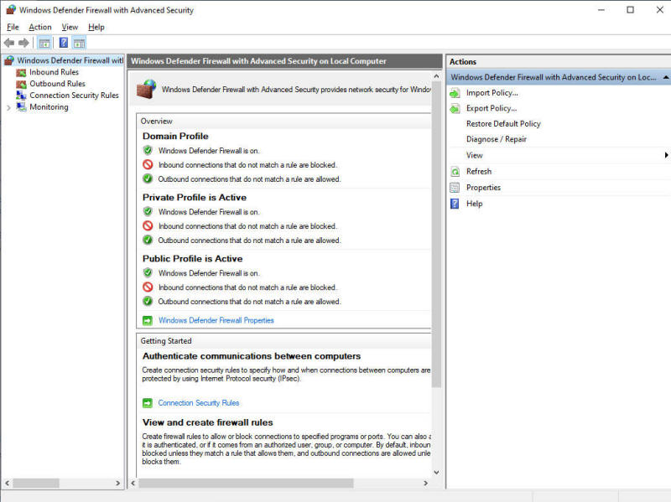](https://outworldz.com/opensim/posts/firewall/imgD.jpg)

Right click **Inbound Rules** and select **New Rule:**

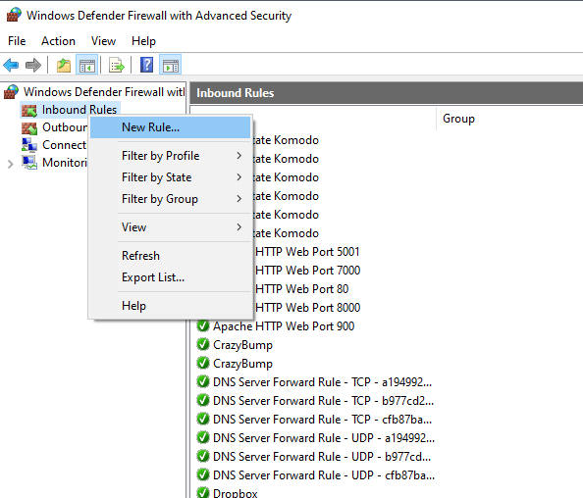

Select **Custom Rule**

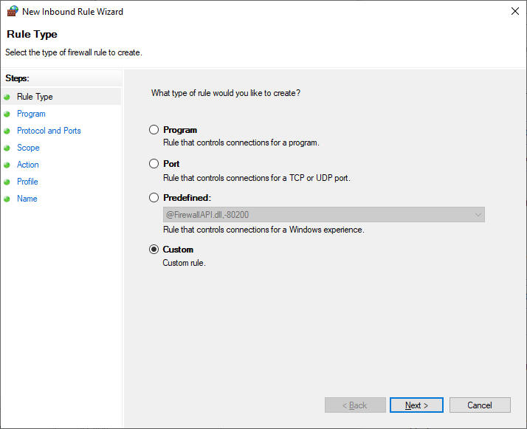

Select **All programs:**

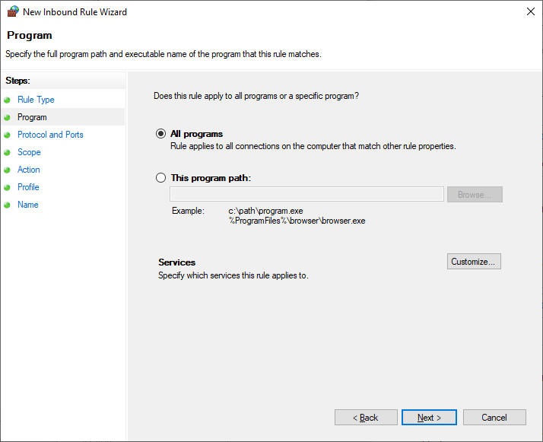

Enter the port for your grid login. Yours is likely to be **8002**. TCP is used to log in, so we will block it.

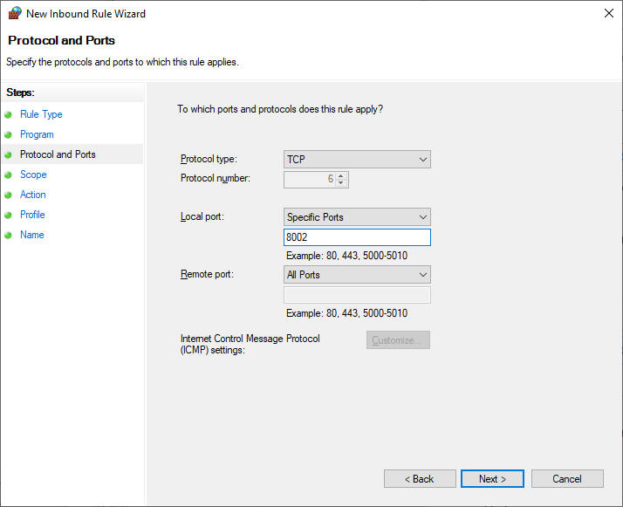

Select **Which Remote IP does this rule belong to** and click **These IP addresses**and click **Add.**

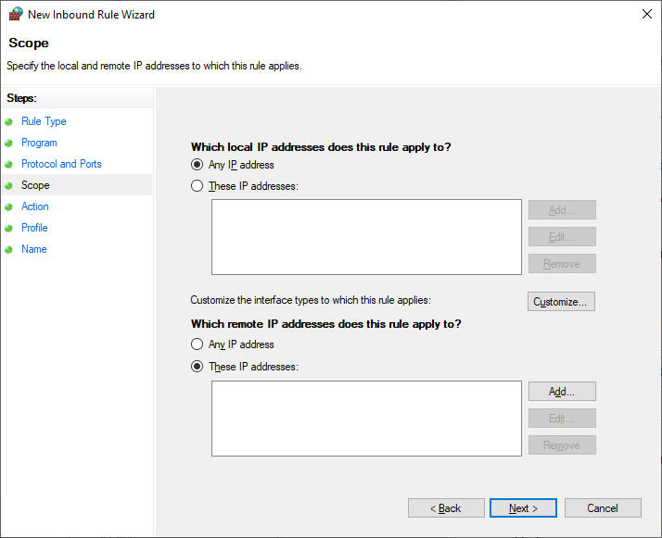

Enter the IP or range of IP's.

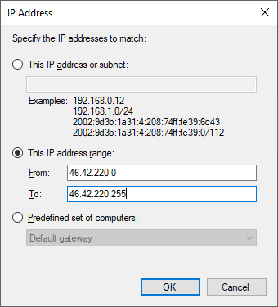

Click **OK**

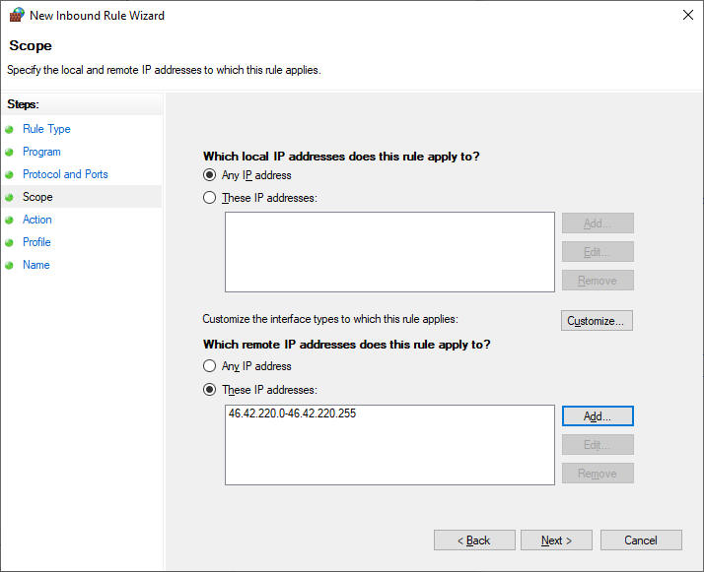

Click Next

Click "**Block this connection**.”

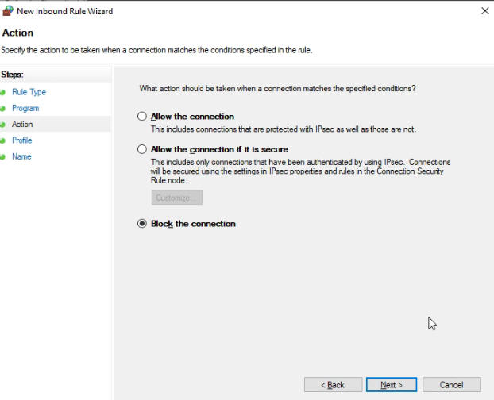

Which firewalls? Do all of them. These are for machines that may travel to public places such as McDonalds. Your grid should be set for Private. In corporate environments, it would be Domain.

Is safe to just do them all.

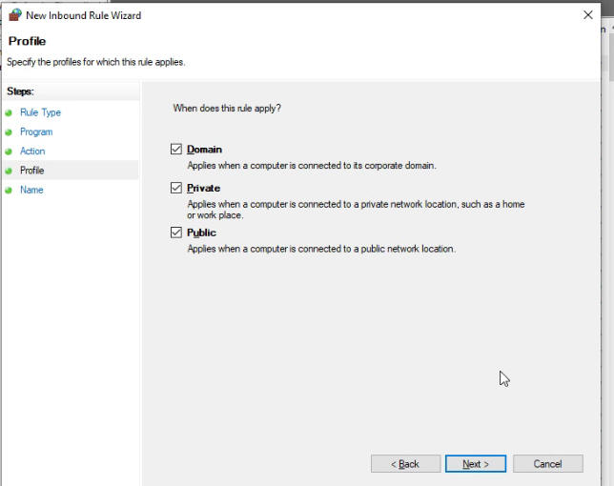

Enter a descriptive name.

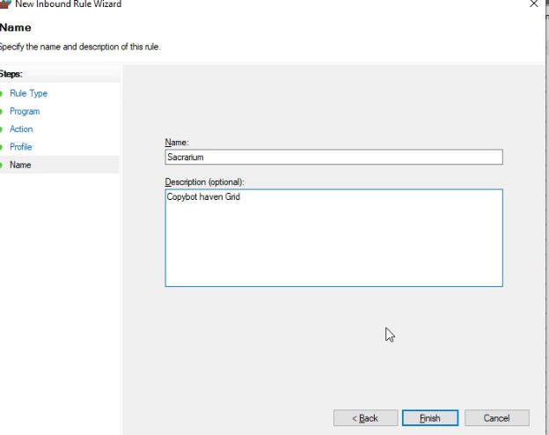

Click **Finish**.