# Outworldz GloeBit Curreny server

Outworldz DreamGrid has a Gloebit Money Server.

Gloebit is by <http://gloebit.com>. Gloebits are the tokens in this system, the digital currency. Think of them like little digital coins. You purchase Gloebits from Gloebit. Then you can exchange them for goods or services within [partner applications](https://gloebit.com/apps/?u=0&r=)which have chosen to accept Gloebits.

## Step1: Request account permission to create apps

If you haven't already, create a Gloebit account at <https://www.gloebit.com/signup/>. From your Gloebit account, fill in and submit their form for requesting app creation permission. They need some basic contact info.

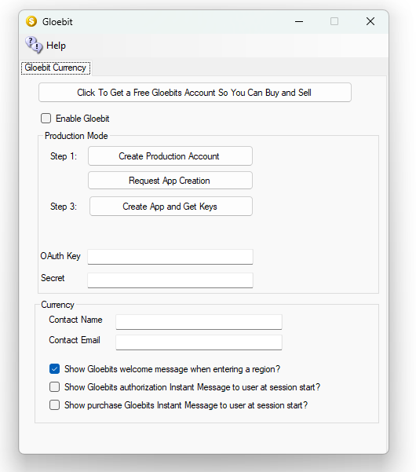

* Company name and address are optional. If your grid or space is owned by a company, you should enter the company information.
* Product name should probably be the grid name for a private grid, or what you call your space on the grid if you are on a public grid.
* Product url should be the url of the website for your grid or space if you have one.
* The Contact name, email and phone number should be the real-life info of someone in charge of this grid or space (probably you who is signing up).
* Click submit once you have entered your information.

## Step 2: Request App Creation

You'll need to wait for them to review your request before you can move to creating your app. They will email you.

## Step 3 – Create App and Get Keys

Once your account has been granted permission to create apps, you'll gain access to your merchant tools page where you can create and edit your apps. Go there and either click *Configure* next to an existing app the *Add an Application* button, which will take you to an app settings page. Follow the instructions below to set up your app.

* Enter a **Name** (probably the grid name or name of the space on which Gloebit will be enabled) and **Short Description** for your app. These are what users will see when they are asked to authorize your app to access their Gloerbit account (as well as the logo below).
* **Publisher** can be left blank. It is displayed on the app discovery page and is a way that a company with many apps could show they are all owned by the same company. You can put your grid/company name here. You could also put the name of your hosting provider here if you like.
* Upload a **Logo**. This is important because users see it when authorizing. We recommend rough dimensions of 169px wide x 108px high. We will shrink the image down to fit inside those dimensions.
* **Return-to Text** can be left blank.
* **Default Return-To URI** should be set to the web page for your grid or space or some URL which explains what their space is or how to connect. It can be left blank if you don't have a website. This URL will be provided alongside your app on certain sections of our site.
* If you check the **Make application findable** box, once we review it, your app will show up on the app discovery page.
* In the Gloebit Authorization section below, copy the **OAuth Key** and **OAuth Secret**. You'll need these (or will need to provide them to your hosting provider) to configure the Gloebit Money Module to connect to this app. You can also retrieve these later by clicking on *Configure* next to this app on your merchant tools page.
* Scroll to the bottom of the page and click the *Save* button. You can ignore the other settings on this page, as well as the warning at the top about callback prefixes as they are not designed for the OpenSim money system

Now get your OAUTH key and Secret key and add them to the form and save it. Restart your grid and you should have Gloebit.