# Grid Type

Grid Type lets you choose from either a Grid Server with Robust, or from 3 Region Server choices to connect to another grid.

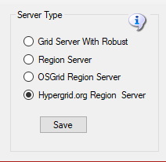

## Grid Server with Robust

**Grid Server with Robust** is a complete DreamGrid, with your own inventory, logins, and name. This is the default. When you start your grid, a Robust Box will open to control all your users’ inventory.

One server must have a running copy of Robust. More PC's can connect to the Robust server to add more regions.

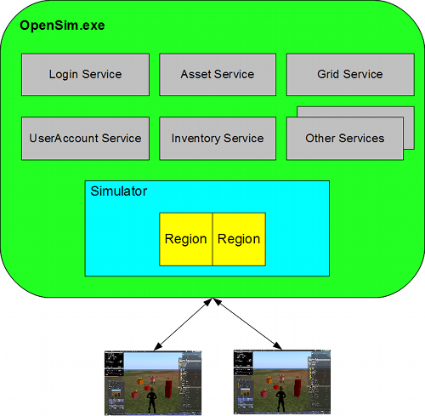

<http://opensimulator.org/wiki/Configuration>

## Region Server

**Region Server** is an add-on to an existing DreamGrid. You can connect additional regions on one or more PC's to an existing Grid Server. You must have access to port 8003 on the Robust server to do this.

A region Server can connect to another Dreamgrid, provided it can reach the Dream Grid’s Port 8003. You connect to the Dreamgrid server by changing the DNS name on the Region Server to the name of the grid. For example, my grid is normally named ‘<www.outworldz.com:9000>’. So I change the DNS to [www.outworldz.com](http://www.outworldz.com), and change the HTTP port to 9000 and the robust port to what the grid runs on (which happens to be 9003).

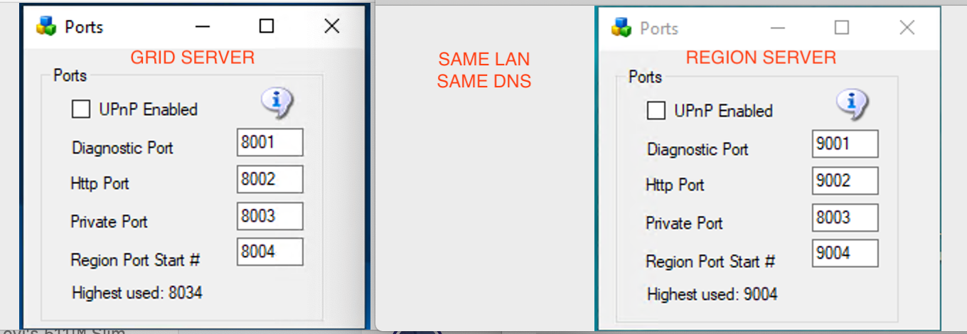

pic courtesy of Michael Bradley

The firewall must also be opened between the two machines. This is not normally an issue on a LAN. But if the region Server(s) are on the Internet, you should not allow access to the port 8003 from everyone. Set up a firewall rule to allow only the Region Servers to access your servers port 8003.

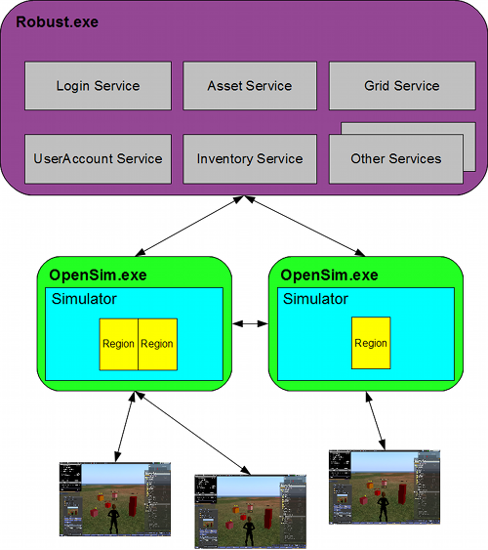

<http://opensimulator.org/wiki/Configuration>

## OSGrid Server

**OsGrid Server** This choice is much like running a Region server. OsGrid Servers connect to OsGrid.org. OsGrid is already configured to accept your connections. There are some simple rules you must follow to connect to OsGrid

You will need to choose an empty spot on OsGrid's map for each region.

Your viewer login must be set to hg.osgrid.org.



<http://opensimulator.org/wiki/Configuration> CC-BY-SA 2.5

## Hypergrid.org Server

**Hypergrid.org Server** This choice is also much like running a Region server. These servers connect to hypergrid.org, commonly called **"Metropolis Grid"**. Metropolis is already configured to accept your connections. There are some simple rules you must follow to connect to Metro in the section below.



<http://opensimulator.org/wiki/Configuration> CC-BY-SA 2.5

## Metropolis Server

Metro has a monthly charge to connect your region(s) to their grid, there is also a one-time one Euro charge to register/verify your avatar/account which you need to do to connect a region and login.  
  
See [https://hypergrid.org/metropolis/wiki/en/index.php?title=SIM](https://hypergrid.org/metropolis/wiki/en/index.php?title=SIM&fbclid=IwAR0EfU2ajm8jxRk6TdZLnIxtINao5_ngDwppnAiwqpCe1y54Fg1MY1nyqLc)  
  
When connecting a self-hosted region, the grid services will be charged a fee of 1.50 euros per month. This contribution is automatically collected monthly from the owner of the respective region.  
  
Any avatar registered in METROPOLIS can move freely within the grid and, if interested, visit most regions freely. Furthermore, he can also collect and use freebies.   
  
Only two functions require verification of the user:  
  
- if a self-hosted region should be connected  
- if the user wants to build on sandboxes or on the DUNE regions.  
  
Since copyright-relevant objects can also be loaded into the grid for the aforementioned functions, we are obliged to verify the respective user for legal reasons.  
  
**How can I verify?**  
  
To verify an avatar, a one-off symbolic Euro (1 Euro) will be paid to the Metropolis grid via PayPal. Upon payment, PayPal transmits an ID number of the payer. This ID tag (and only these) is stored in the METRO database. No RL names or other RL details are requested and / or stored.  
  
Subsequently, the name of the avatar name indicates the user for whom the verification is to be performed. IMPORTANT: After payment has been made via PayPal, you must return to the METRO page via the link on the PayPal confirmation page.  
  
For the verification a PayPal account is required, which can be created for free on paypal.de . The account is available within a few minutes."

<https://hypergrid.org/metropolis/wiki/en/index.php?title=SIM>