LSL Scripting

There are several extra features in DreamGrid to help Opensim LSL work better.

The Library has been extended in DreamGrid to hold 261 example LSL Scripts. These are located in plain text in Opensim\bin\assets\ScriptAsset as well as in the Viewers Library at the bottom of your inventory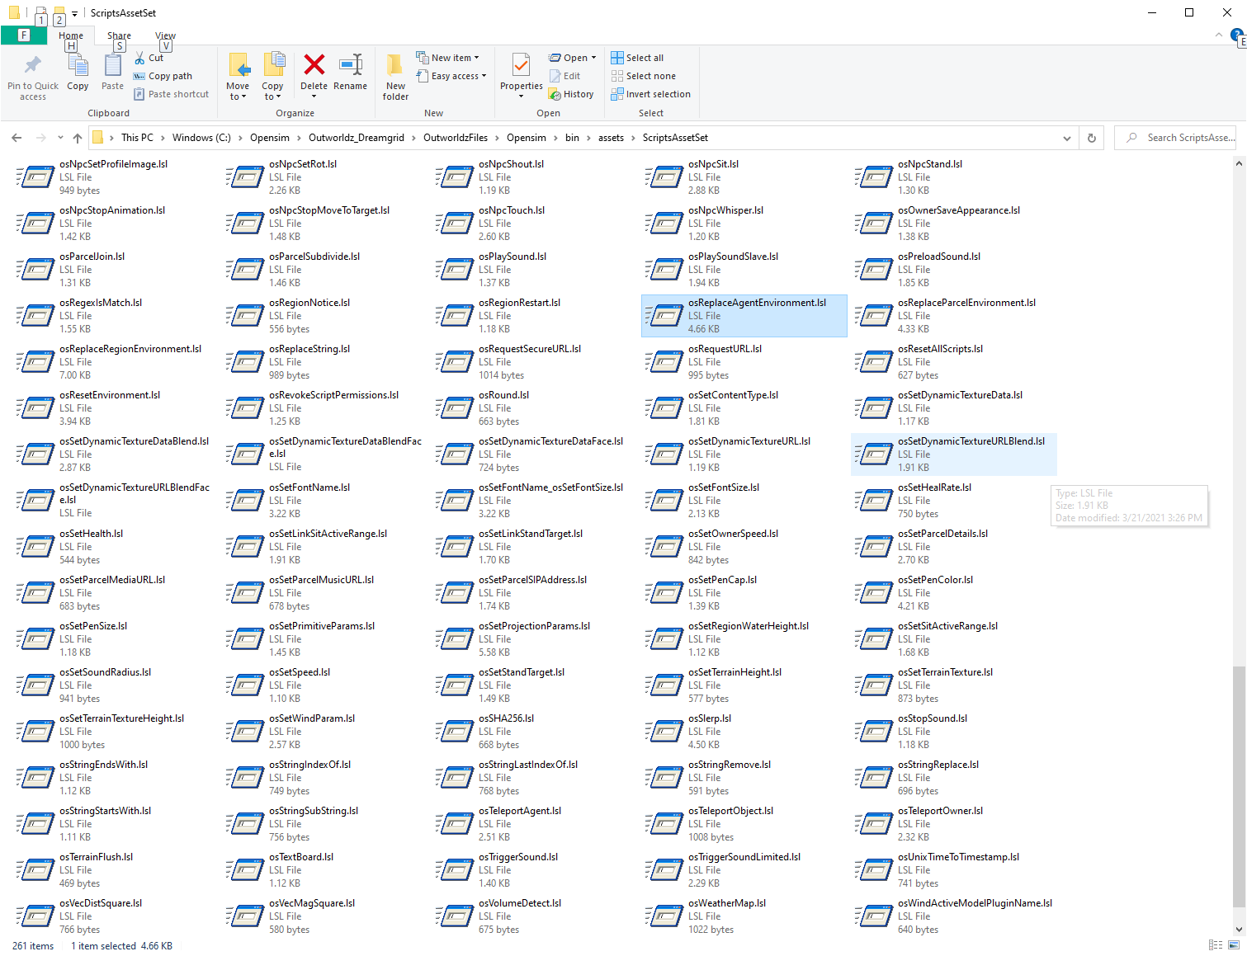

**EasyDatabase** is a way to store name=Value parameters from any script, region, or grid to any other script. See the manual for EasyDatabase.rtf

**Online Regions** can be fetched from <http://YourGrid::8002/Teleports.htm>. This is used by the Region signs you will find in Content->Load Local IARs.

**Item Giver with Notice Script** uses LSL to save the current date, a Name, and a Region to a CSV file. This makes it easy to see what and who got what item by touching a LSL giver script.

You need the password from the file Outworldzfiles\Opensim\bin\ AddinExample.ini.

To test this, fill in some sample data in <http://YourGrid::8004/diva/AddinExample.htm> This is data associated with the very first region. You must use the port for the region you are in to write, and it must be a POST action.



After clicking submit, you should see a confirmation the data was stored.

The data will be in Outworldzfiles\Opensim\bin\Name.csv

Sample Script:

//  
// Give with notice via HTTP  
//  
// Fill in your server and port, if necessary, port 80 is a default. It will connect to this with the parameter: ?name=(Prim Name)

string SERVER = "http://outworldz.com";

// * This function cases the script to sleep for 3.0 seconds.  
// * If inventory is missing from the prim's inventory then an error is shouted on DEBUG_CHANNEL.  
// * Avatar must be, or have recently been, within the same Region as sending object.  
// * Does not create a folder when avatar is a prim UUID.  
// o The prim must be in the same region.

//Examples  
// When a user clicks this object, this script will give a folder containing everything in the objects inventory  
// This can serve as a unpacker script for boxed objects

default {

http_request(key id, string method, string body) {  
 llOwnerSay("Someone just got " + llGetObjectName());  
 }

touch_start(integer total_number) {

llHTTPRequest(SERVER + "?Name=" + llGetObjectName(),[], "");

list inventory;  
 string name;  
 integer num = llGetInventoryNumber(INVENTORY_ALL);  
 integer i;

for (i = 0; i < num; ++i) {  
 name = llGetInventoryName(INVENTORY_ALL, i);  
 if(llGetInventoryPermMask(name, MASK_NEXT) & PERM_COPY)  
 inventory += name;  
 else  
 llSay(0, "Don't have permissions to give you \""+name+"\".");  
 }

//we don't want to give them this script  
 i = llListFindList(inventory, [llGetScriptName()]);  
 inventory = llDeleteSubList(inventory, i, i);

if (llGetListLength(inventory) < 1) {  
 llSay(0, "No items to offer.");

} else {  
 // give folder to agent, use name of object as name of folder we are giving  
 llGiveInventoryList(llDetectedKey(0), llGetObjectName(), inventory);  
 llHTTPRequest(SERVER,[],llGetObjectName());  
 }  
 }  
}