# Physics Engine

The Physics selection box lets you set basic physics, where the only collidable object is a box shape. It supports the original Open Dynamic Engine physics. The **ubODE** engine, by Ubit Umarov, is an advanced version of ODE that is closer to Second Life compatibility with vehicles.  Bullet is an award-winning physics engine.

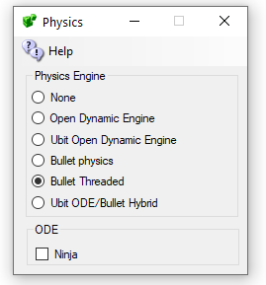

* ODE is a very old physics engine with many limitations. It does support Ninja Physics.
* UBODE is closer to Second Life in vehicle performance.
* Both BulletSim and UBODE support varregions.
* BulletSim provides the best performance and most functionality.
* Bullet in a separate thread prevents physics crashes from crashing the region. It is the default physics engine.
* ODE Ninja physics are documented in another manual.

## Links:

<http://www.ode.org/>

<https://en.wikipedia.org/wiki/Bullet_(software)>