# Publicity – Publish your Grid

Publish Grid sends shows your grid in the list at [Hyperica.com](http://hyperica.com/):

Categories are used to put you grid into the Destination Guide.

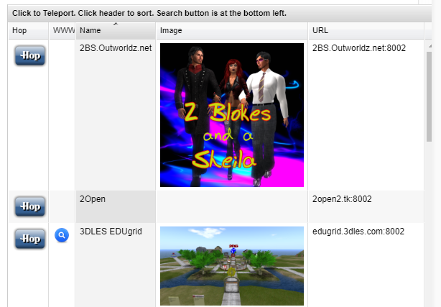

**Photos:** Click the box to load a PNG image and it will appear in your listing.