# Region Panel

This panel has setting that are is specific to this one region. As an example, if you want maps to made Best quality for just one region, you can set it here. It will override the global maps setting for this region.

## Region Basics

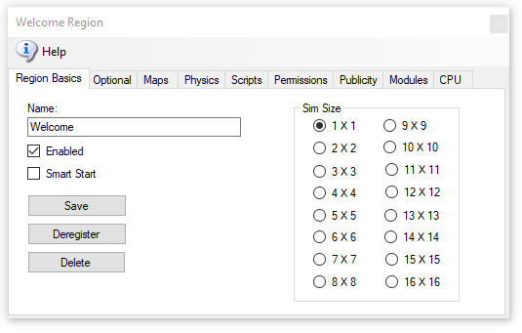

Give your region a name and click [Save].

Make sure it is Enabled. Smart Start is discussed in the Manual “Smart Start”.

Sims can be any size from 1X1 (256 X 256 Meters) to 16X16, with 64 regions. Larger regions take more RAM and cut the frame rate down considerably.

If you click [Delete], the region INI file will still be there, but the file name will change to .bak from .ini and will be ignored. This should automatically Deregister the region.  
  
[Deregister] will remove the region from the Robust reservation list but not remove the region. A region that shuts off is deregistered automatically. But a crashed region cannot deregister itself.   
  
The result is that you cannot place another region with a different UUID in the same registered place. Deregistering the region lets you move another region to the original position.  
  
Smart Start Regions remain registered when powered down so that they appear on the map and appear as available. If your region still will not start due to it overlapping, type this into the Robust console:

deregister region id <UUID Goes Here>

Regions are stored by DreamGrid in OutworldzFiles\opensim\bin\Regions in folders by each DOS box name. The DOS box folder has a Region folder in it that holds the Region.ini file. See Rules for INI files at the bottom of this Help file for more details.

## Options

This has optional items that are part of standard Opensim you may choose to change.

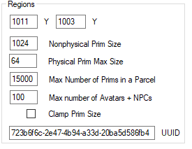

The Options page has the (x, y) Global location of the region on the grid. You can set regions next to each other by changing the X and Y coordinates and restarting the region. The X and Y is the lower left point on the global map.

If you get messages saying that regions overlap, change the coordinates to some substantial number and retry the region boot.

**UUID**: You can only change the UUID of the grid is stopped. Never change the UUID unless you want to start with a blank region again. Altering the UUID will force the system to create a new, blank region the next time the grid starts, and you will be forced to move your region to another spot if it is not deregistered. This is a read-only field when the grid is running. You can only change this by stopping the grid.

**MaxAgents**: The maximum number of agents that can be in the in the region at any given time. The default is 100.

**MaxPrims**: The maximum number of prims that the region will be listed as supporting. However, this limit is not currently enforced by OpenSimulator. Due to LL protocol constraints, the maximum limit that can be shown is 45000.

**PhysicalPrimMax**: The maximum dimensions of a physical prim. This is a single number which applies to X, Y and Z co-ordinates. This will affect resizing of existing prims. Default is 10.

**NonphysicalPrimMax**: The maximum dimensions for a non-physical prim. This is a single number which applies to X, Y and Z co-ordinates. This will affect resizing of existing prims. Default is 256.

**ClampPrimSize**: If true then if a viewer attempts to create a prim which has any dimension larger than the NonphysicalPrimMax, then that dimension is reduced to NonphysicalPrimMax. Default is false.

## Map Overrides

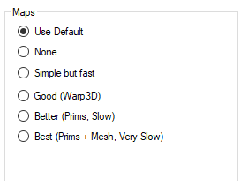

The Map Overrides change this one region’s map making.

1. **None**: No maps will be made. This is a good setting as the regions will boot very quickly. Any existing maps are kept.
2. **Simple but Fast**: MapImageModule is used with just Land showing
3. **Good**: Uses Warp3D module with just Land showing
4. **Better**: Uses Warp3D module with Land, Prims, and land Textures showing
5. **Best**: Uses Warp3D module with Land, Prims, Mesh, Sculpts, and all Textures including prims showing.

## Physics Overrides

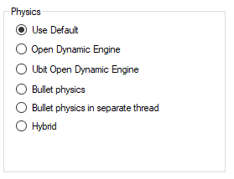

* ODE is a very old physics engine with many limitations. It does support Ninja Physics.
* UBODE is closer to Second Life in vehicle performance.
* Both BulletSim and UBODE support varregions.
* BulletSim provides the best performance and most functionality.
* Bullet in a separate thread prevents physics crashes from crashing the region. It is the default physics engine.
* ODE Ninja physics are documented in another manual

## Script Overrides

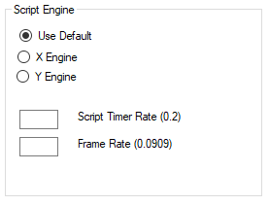

* **XEngine** is and older and very stable Opensimulator script engine.
* **YEngine** is a new engine that has better support for the llSleep() command. YEngine offers some features that improve performance and prevent timeouts. The problem with using llSleep function in Opensim scripts is that it may cause a script to freeze, requiring a reset. This is due to the way XEngine deals with running multiple scripts at once.
* The parse in Yengine is also like Second Life as it uses the same order when evaluating a series of expressions. XEngine parsed the order in the opposite direction from Second Life.
* **Script Timer Rate** is normally no faster than 1/5th of a second. It should rarely, if ever be faster than this. There are many less laggy ways to code a LSL system!
* **Frame rate** is how fast physics and other ‘steps’ are run. It is normally set to 1/11ths of a second, which is 1/5th of Second Life’s rate. Some systems can benefit by running this slower or faster.

## Permission Overrides

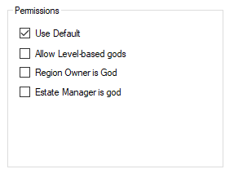

**Allow Gods:** God mode is available to selected people if enabled.   These levels can be set for individual users in the Web control panel.

·         Level = 0 is a normal user

·         Level = 50 (or a level you set) is used to indicate a privileged user (e.g. who can set up new Hypergrid linked regions)

·         Level = 100 is a Wifi admin account user

·         Level >= 200 can become a God

**Estate Owner is God:** If enabled, the region owner may go into God mode.

**Estate Manager is God:** If enabled, any region estate manager may go into God mode.

## Publicity Overrides

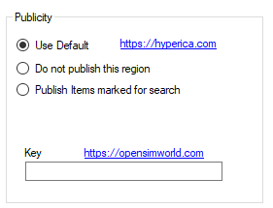

* Publicity override can be used to publish or unpublish one region at a time to Hyperica.com.
* **Use Default**  uses the Settings->Publicity.
* **Do Not Publish** will not send data to Hyperica.
* **Publish Items marked for search** will send your grid location, description and any items you have martked for Show In Search in world.
* **OpensimWorld Key:** You can enter your OpensimWorld key here for this region. Then you do not need to scriptred box.

## Modules

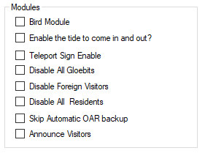

* **Bird module** makes flocks of birds possible. See the help manual on Birds. This must be enabled for birds to appear in a region.
* **Enable Tides** makes the water level rise and fall in this region. See the help manual on Tides. This must be enabled for tide to appear in a region.
* **Teleport Sign Enable** lets you use a standardized Outworldz Teleport Sign to direct visitors in your world. This sign is located in the Content-Inventory IAR Load and Save ->Local IAR menu. There are multiple variations of the sign.
* **Outworldz Teleport System V2.5.iar** is a standardized sign for all uses.
* **Outworldz Teleport System V3.9.iar** is for testing of the Smart Start system and is subject to change.
* **Disable all Gloebits** should stop the Gloebits system on this region.
* **Disable Foreign Visitors** will prevent hypergrid visitors from entering your region.
* **Disable Residents** will prevent all resident from entering your region. Only Estate managers or owners can get in.
* **Skip Automatic OAR backup** will prevent the automatic OAR system from backing up this region.
* **Announce visitors** will chat any arrivals or departures.

## CPU

The CPU tab lets you choose one or more cores for the region to run on. You can also set priority for the region.

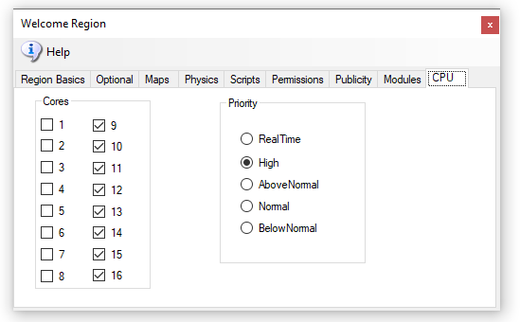

You can choose to set the process priority to Normal, High, Above Normal, Below Normal, or RealTime. Based on the time elapsed or other boosts, the base priority level can change when a process needs to be put ahead of others for access to the processor.

The processor affinity is the set of processors it has a relationship to. In other words, those cores it can be scheduled to run on.

A process thread can migrate from processor to processor, with each migration reloading the processor cache. Specifying a processor for a thread can improve performance under heavy system loads by reducing the number of times the processor cache is reloaded. The system schedules threads on their preferred processors whenever possible.

## **“Real Time,” “High”, or using “low”**

A scenery/low script region has no need for any optimization. It is already low lag, and load load. You need to think about these system-wide, and what the regions are doing under load.

You could just dedicate all such regions to Core 1 and set priority normal. If one person was in one of those regions, it would seem 'normal to them even if all other cores were hard at work. Opensim loves cores, so this may not be ideal, but it does protect that region from the other CPU cores.

**Limit:** Scripts or physics may need to be limited. A limit may be needed on large Satyr Farms. They make a great number of changes to prims which can swamp a server with MySQL writes. I can show you a half dozen regions on two different grids that write to SSD's as fast as possible - 7 to 15 MB a second! I upgraded one to more cores and it just wrote even faster. So these sims really need to be much lower in priority for CPU. It's horrible - a Contabo machine costing $50 a month is barely capable of running one region because of Satyr Farm!

**Unlimited:** The opposite example would be a racing simulation, where you want more responsiveness. Set that region to a higher priority. Look at ﻿[@Cuteulala Artis](https://mewe.com/group/5bc12bdc322b35103f0965d3/members/profile/5d463db2ea9ee17fa4d50a61)﻿ wonderful organ simulation in your free OARs list near the bottom. This wonderful creation requires a faster script timer in region settings to play properly. It could potentially benefit from a higher priority above 'Normal' on a heavily loaded server.

**Dedicated Cores** is something else. To increase performance even more, you can dedicate one or more cores or more to a DOS box. Default is all cores are served to all DOS boxes. A dedicated core is more efficient as the system does not share the cores with other tasks and the hardware scheduler can make smarter decisions about this one DOS box.

Dedicated Cores are a marketable product. SL sells a dedicated core with one 256 X 256 region in it for $209 a month. We are not SL, obviously, but if someone wanted to sell a dedicated core for more than the usual fee, they can now.

Src: <https://secondlife.com/land/private-pricing>. It has a higher value than sharing a machine with all others.

Assume you are running a high CPU load on an 8-CPU Intel machine with hyperthreads so 16 cores are available. (AMD is not hyperthreadable). Assume also that the GUI in DreamGrid is lagging, or Windows is not being very responsive. You can set all your regions to use, lets say 14, of those 16 cores so two cores would be left for Windows and DreamGrid GUI, Robust, and Mysql, and other tasks without being bothered by Satyr Farm. ( I currently do not have code to dedicate a core to Robust and Mysql, but I will add that soon)

## Rules for INI files

DreamGrid has several simple rules for *.INI files that differ slightly from stock Opensim.

* No Duplicates:  Do not leave a Region.ini in one folder and the same Region.ini in another.  All files such as Region.bak are ignored.
* The only thing you need to put in the **SOME DOS BOX NAME**\**Region**\ is one or more Region.INI files.
* All other files, such as Opensim.ini  are automatically re-created when you start the region.
* The INI file name must match the [Region Name] inside it. This example region [Welcome] must be saved as “Welcome.ini”.
* Only one [Region Name] is allowed in an INI file.
* Use multiples of 256 such as 256X256, 512X512, and so on.
* Each region size can be anything from 256 X 256 to 1024 X 1024, or higher. Huge region sizes such as 4096 X 4096 can be used for flying or car racing. If you go over 8192 X 8192, you can expect it to be slow and laggy as the land size gets exceptionally large as it grows exponentially.
* You can replace 4 single regions with a single 2X2 region and there will be no lag when crossing the (nonexistent) border. Vehicles can move smoothly anywhere. Also, NPCs can move about freely. Look in any region settings panel and you will see a "size" box. Check the 2X2 box, save it, and restart the region. It will grow North and East and will be 4 times larger, overall. You will also need to move it in X and/or Y or delete the other regions as regions cannot overlap. You can shrink them, too, but objects that fall off the right and top edge will be lost.

Example of how regions are organized in the file system:

* Opensim\bin\Regions\**SOME DOS BOX NAME**\Region\**Fred**.ini
* Opensim\bin\Regions\**SOME DOS BOX NAME**\Region\**Rak**.ini

These two regions **Fred** and **Rak** will be in a single Dos box named "**SOME DOS BOX NAME**".

If you rename the folder "**SOME DOS BOX NAME**" to "**Internet**", they will be in a DOS box named "**Internet**". If you create a new folder named "**HEY**", like this:

Opensim\bin\Regions\**HEY\**

And then MOVE Region\**Rak**.ini into it:

Opensim\bin\Regions\**HEY\Region\Rak.ini**

You will end up with a DOS box named "**Hey**" with the Region named **"Rak"** in it.  
The other Dos box will have just Fred in it:

Opensimulator\bin\Regions\**SOME DOS BOX NAME**\Region\**Fred**.ini