# Region List

Open the Region Panel with Ctrl-R or go to Setting-Region.

There may be many Region.INI files in your system. These show up in this panel. The default is an island called "Welcome".

## Refresh button

Click Refresh to rescan the system status and update this panel.

## Details button

This screen shows the regions plus all the details on each region.

The Detail view can be sorted by Name, Group, Agents or Status by clicking the column name.

## Icons button

This screen shows the Icon on each region. Clicking a Region opens the Region Editor.

## Avatars button

This screen shows the Hypergrid and Local Visitors to your regions. If you have a viewer on the server, you can click the person and it will generate a Teleport link to that person.

## Users button

This screen has a list of all registered users on your system.

You can Checkmark each user to send an email to them. The Email button appears to top right

## Add

Click the Add button to make a new region. You only need to give it a name and save it.

## Run All Button

Runs all Checked regions.

## Stop All Button

Stops all regions.

## Restart Button

Restarts all checked regions.

## Import Button

This button lets you find region.ini files from other system, such as the standalone Dream World or backups, and import the file into DreamGrid in a new or existing DOS box.

### File Folder Arrangement

DreamGrid uses a slightly different folder setting than stock Opensim. You cannot just copy them over in a file explorer unless you make a special pattern of folders, with an extra set of folders inside it.

The format is:

Opensim\bin\Regions\DOS Box Name\Region\RegionName.ini

DreamGrid has several simple rules for *.INI files that differ slightly from stock Opensim.

* The INI file name must match the [Region Name] inside it. This example region [Region Name] must be saved as “Region Name.ini”.
* Only one [Region Name] is allowed in an INI file.
* All contents of a Region file are made by Dreamgrid and will be overwritten. See the Region Control Panel to change the settings.

# Clicking a Region

A new panel appears if you click a region:

## View Console Button

Shows the DOS Box console window.

## Start Button

Starts this one region.

## Restart Button

Restarts this one region.

## Stop Button

Stop this one region.

## Teleport Button

Generates a Teleport to the region in the viewer.

## Send Alert Message Button

Send a region wide message to all users in the region

## Load Region OAR Button

Loads an OAR into the region

## Save Region OAR button

Saves an Oar from the region

## View Log Button

Views the Opensim.log file

## View Map Button

Shows the region Map.

## Edit Button

Edits the region.

## Region Stats

The region stats are a web-based data collector. First, choose a region:

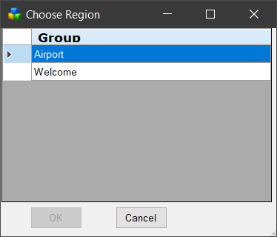

The first screen shows general statistics:

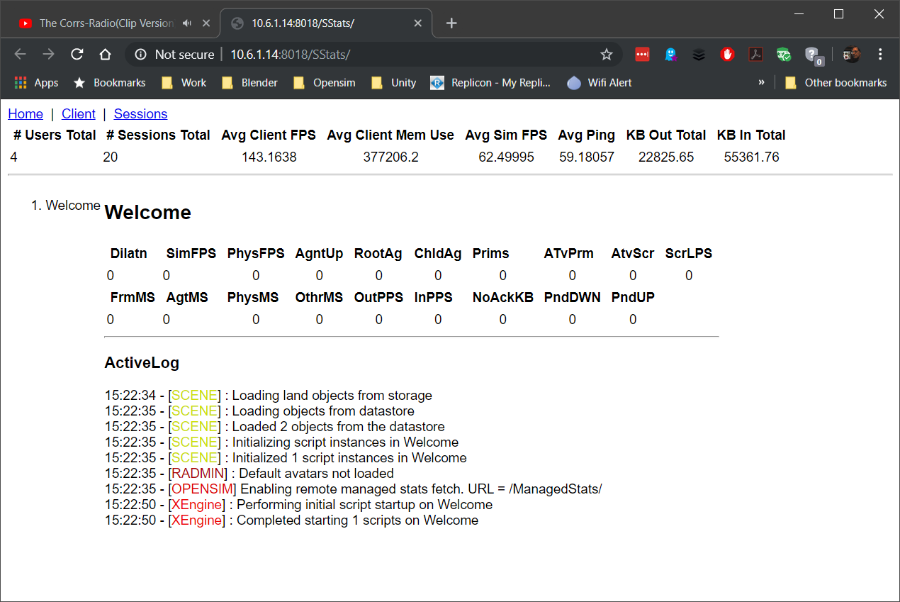

The client screen shows the types of viewers that have visited

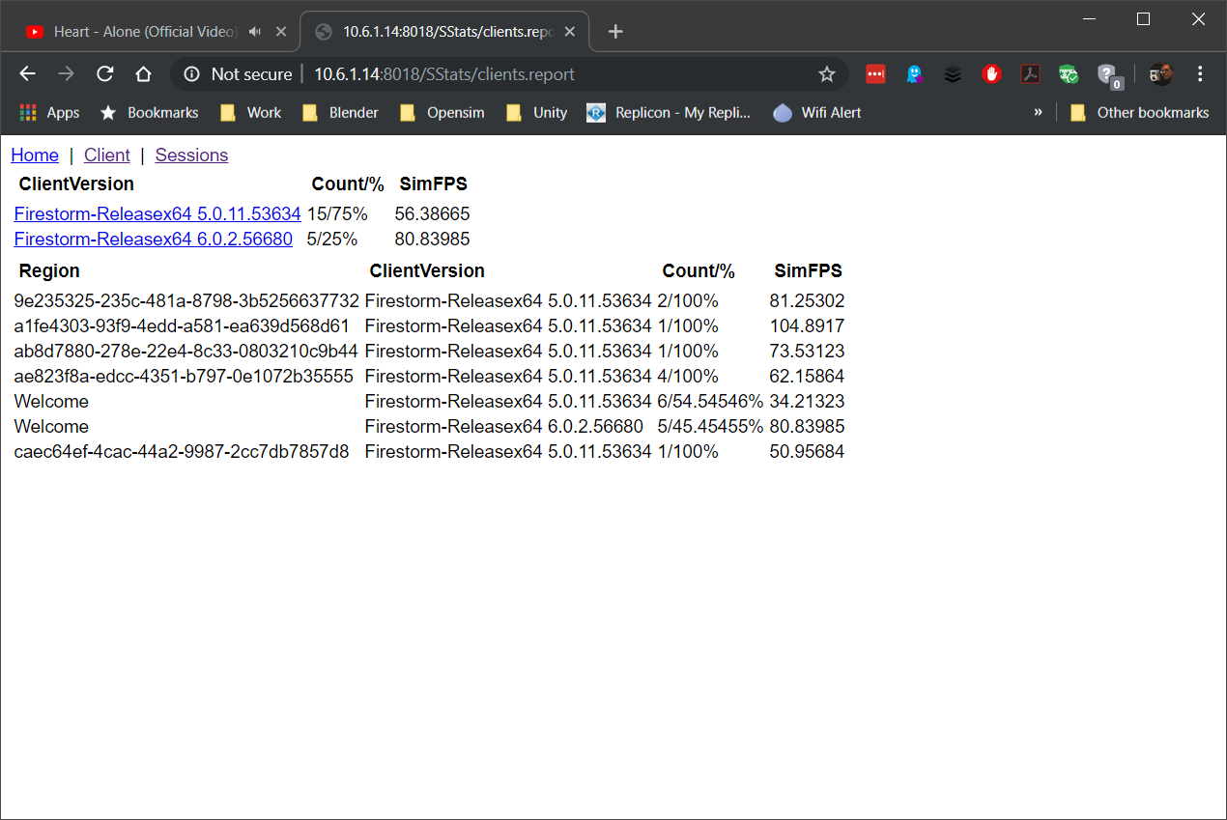

The Sessions screen shows the visitor list

