# Auto Restart and Startup Settings

Opensim uses up increased RAM as people arrive and leave. Periodic restarting of regions is necessary to clear memory. You can set up a restart timer here.

DreamGrid will not restart a region if avatars are present. It will restart the region only after all avatars leave.

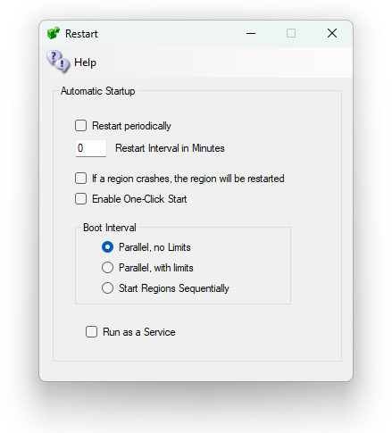

**Enable:** If enabled, the auto restart interval will be set to 1440 minutes, which is one day. If disabled, the regions will try to run forever.

**Auto restart Interval:** The number of minutes a region runs before it restarts.

0 = Off

720 is 1/2 day. 1440 is one day. 2880 is 2 days.

If Autobackup is enabled, this interval will be extended beyond the Autobackup Interval by 30 minutes to allow Autobackup to complete.

**Start Regions Sequentially:** Unchecked= start a new region every few seconds. This can overwhelm the database, memory and/or CPU on some systems. Checking this box will start each region sequentially it will wait for it to boot completely before starting the next. It will extend the waiting period up to 3 minutes. per region.

**Enable One Click Start**: If set, running Start.exe will automatically start Opensim without needing to click the second [Start] button.