# Script Settings

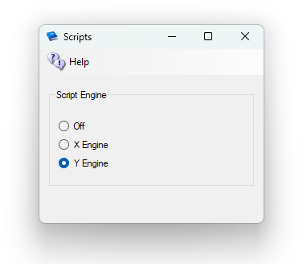

YEngine is a new engine that has better support for the llSleep() command. YEngine offers some features that improve performance and prevent timeouts.

The problem with using llSleep function in Opensim Xengine scripts is that it may cause a region to freeze, requiring a reset. llSleep blocks all threads from running.

The parse in Yengine is also like Second Life as it uses the same order when evaluating a series of expressions. XEngine parsed the order in the opposite direction from Second Life.