# Robust and Server Type

This menu item “Server Type” lets you choose from either a Grid Server with Robust, or from different Region Server choices to connect to another grid.

**You MUST first run as a regular grid, then switch to a region server. DreamGrid needs certain tables in robust, even though regions do not use them.**

**After it boots, stop the grid, drop the Welcome region it created, and make a new region at a free spot coordinate on the OsGrid map. Then you can change to a region server.**

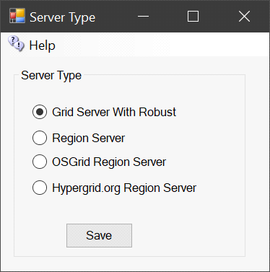

## Grid Server with Robust

A grid server is modeled after the World Wide Web, with independent domains. Content is spread across small, independent and on large domains, independently, yet interlinks. Robust is the service that lets Hypergrid users enter each world. A Grid Server can also support regions locally. A grid server can host as many Region servers as its memory and CPU capacity allows.

## Region Server

A Region server uses a separate DreamGrid Robust Grid Server for all assets and login services. Only regions and their content are stored locally. The grid server may be on the same LAN, or on another WAN. A Region Server always uses the same Domain Name and port as the Hosting server.

In cases where the Grid server is on a different WAN IP address, you must also enter the Region Servers IP address or domain name in the Region Ports setting:

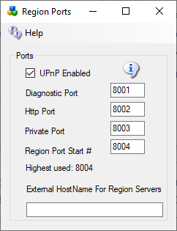UPNP may be checked, if so, there is no need to port forward. It will be unchecked if it does not work. If you have more than a few regions, it is faster to port forward all ports and leave UPNP off.

The Diagnostic port default is 8001. This is

The HTTP port is set to 8002, or whatever your Host server is set to. 8002 is the default.

Private Port MUST be the same as the Robust Private Port. Default is 8003. This port is blocked at the Robust server. You must go to the host server and port forward that Port 8003 and make sure that the Windows firewall only allow the region server in by its IP Address.

Region Port Start # Default is 8004.

Highest Used shows how many ports MUST be open and forwarded. DreamGrid can do this with UPNP in the router and it does it automatically in the Windows Firewall.

External Hostname: If on the same LAN as the Host Robust machine, this can be left alone, as port forwards do the work. If on a Different WAN, the IP address of DNS name of the Region Server MUST be entered here.

## OsGrid Region Server

The **OsGrid** region server is a preconfigured region server already set up to connect to **OsGrid**.

**The port values are hard coded in a separate set of INI files used for OsGrid.**

## Hypergrid.org Region Server

The **Hypergrid.org** region server is a preconfigured region server already set up to connect to **Hypergrid.org**.