# Startup - Starting up the System the First Time

You can install DreamGrid by saving ”DreamGridInstaller.exe” in an empty folder and running it.

Or you can install DreamGrid by unzipping the zip file into a new, blank folder.

Then click “Start.exe”. You may get a popup warning. All my binary code is digitally signed and is cryptographically verified to protect you and to assure you that the code you get is what is originally authored. It is virus-free and has no ads. It should say "Verified Publisher: Outworldz, LLC”.

Click [Start] in the top left of the menu:

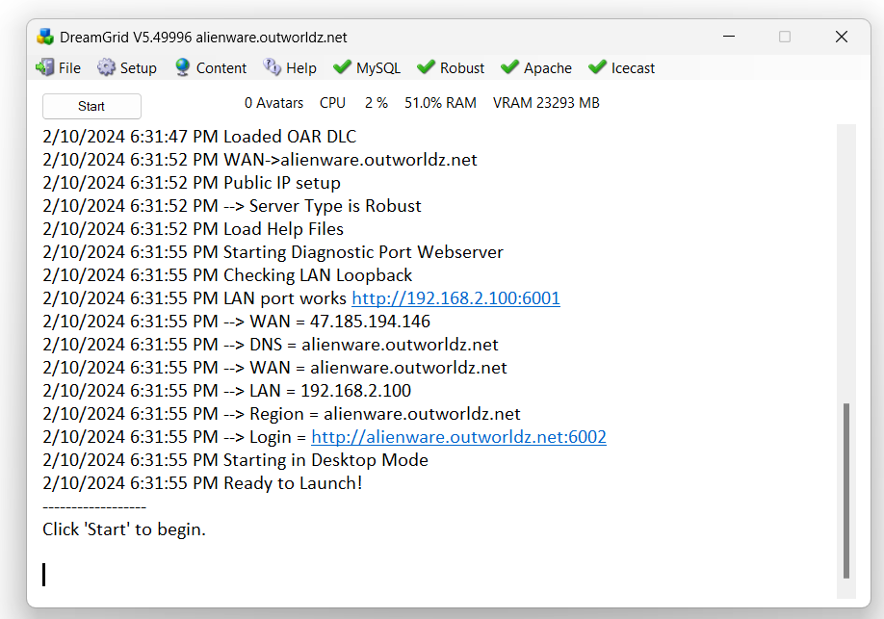

This box will appear for you to claim ownership of the Grid.

Use a unique, new long password as this is the avatar that owns the grid.

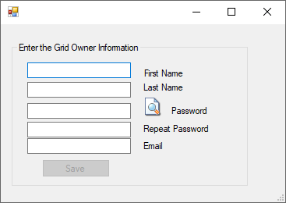

Another DOS box will appear. This will be your first region. The region is named "Welcome".  You can change this name later. The system will ask you for an estate name.  You can just press enter to name it “My Estate”, or type in a new name.

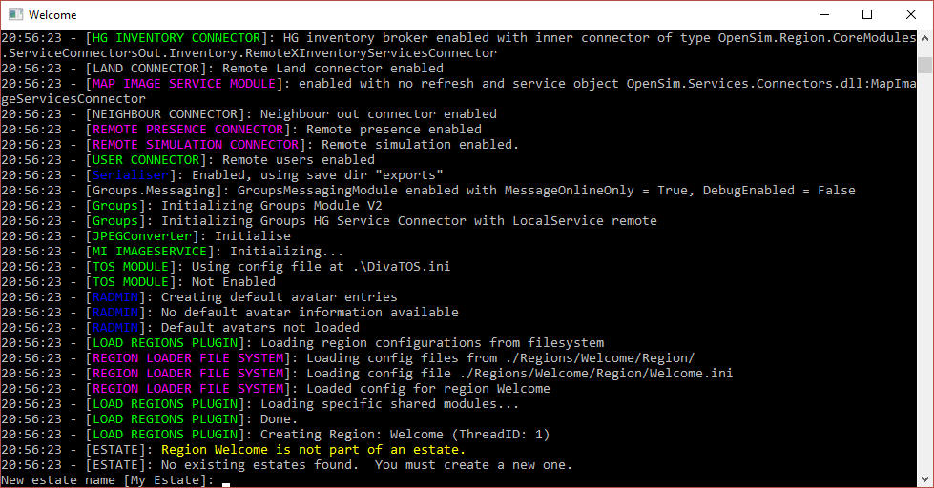

It will then ask you for the owner’s name of this region.   **Use the same name that you first entered.**

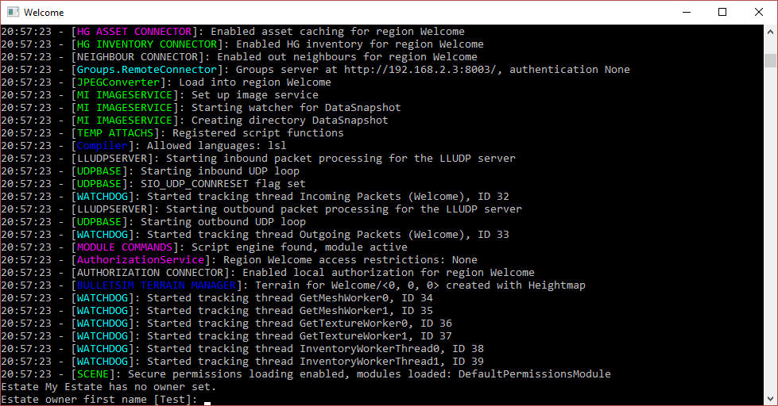

The system will eventually tell you "INITIALIZATION COMPLETE FOR Welcome - LOGINS ENABLED"

## Setup Your Viewer:

Click the first item in the Help menu - Show Hypergrid address. It may print a name, or an IP address.

If it is an IP Address, your system will only run on your local area network at this time. The Hypergrid will not be available until you set up the router. See the help section at the bottom of this article on Ports and Loopback.



The system will print the address.

Download the Firestorm viewer for Opensim. You can get it from <https://www.firestormviewer.org/>

Launch the viewer and go to the Viewer Preferences menu (Ctrl-P).

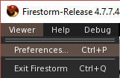

Go to the Opensim Grid manager screen:

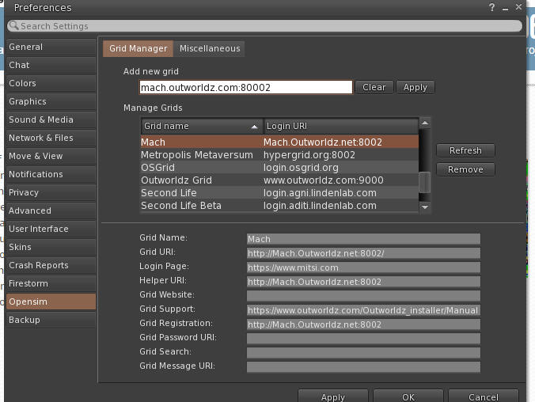

Add the http:// + IP address it showed in Blue, + :8002 to the Firestorm or other viewers "Add new Grid" field and click "Apply".

You should now be able to select your new DreamGrid in the Viewers pulldown for grid login and log in with the same First and Last Name and password you originally entered. You should then appear in an empty sim on a small 1X1 flat island named Welcome.

If this does not work, please use the troubleshooting link at the bottom of this help file.