Terms of Service

The TOS form lets you change the HTML for your TOS. A SAMPLE TOS is included here.

Feel free to delete it or change it as you see fit.

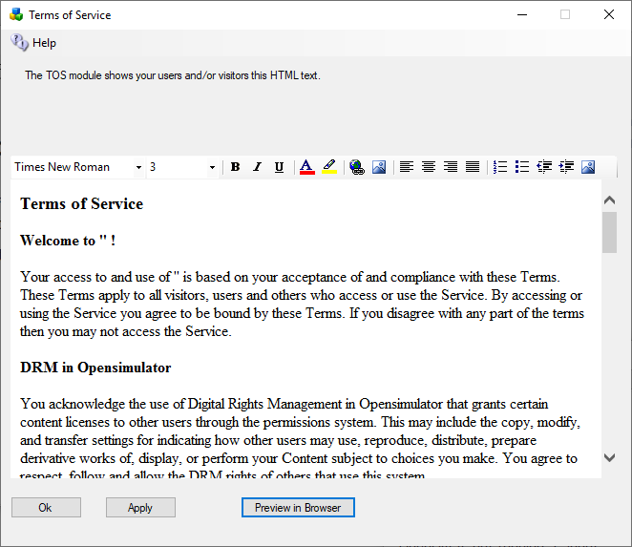

**#includes** There are several include directives that bring in the rest of the web site. Diva uses a series of <!--#include file=header.html --> statements to bring in files from the other folder set in Opensim\WifiPages. Includes in those files then bring in increasingly of the web pages from Opensim\Bin\Wifipages.

**#get** There are several statements that are replaced by server data:

**Users in World:** <!-- #get var=UsersInworld -->

**Regions:** <!-- #get var=RegionsTotal -->

**Total Users:** <!-- #get var=UsersTotal -->

**Active Users last** <!-- #get var=UsersActivePeriod --> **days**

**Active Users:** <!-- #get var=UsersActive -->